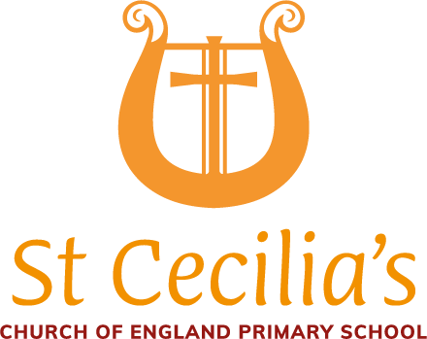


St Cecilia’s CofE Primary School

Teaching Assistant (Grade 3)

Person Specification

Qualifications and Training | Essential | Desirable
Maths and English skills, appropriate to the age range e.g Maths and English GCSE C+ | x
NVQ level 3 or similar qualification. |  | x
SEND/EAL training or experience. |  | x
Paediatric First Aid training (or willingness to qualify) |  | x
Training on delivering Read Write Inc Phonics | x
Competence Summary | Essential | Desirable
Skills / abilities
Knowledge of the National Curriculum for EYFS, KS1 and/or KS2 |  | x
Excellent communication and interpersonal skills. | x
Ability to maintain confidentiality and sensitivity | x
An ability to model grammatically correct English | x
Ability to use IT for different purposes in the setting | x
Ability to work independently and in a team | x
Ability to cope with personal hygiene needs and respond sensitively to pupils needs. | x
Ability and confidence to plan (with support), deliver and evaluate interventions for individuals or groups. |  | x
Ability to manage behaviour positively | x
Experience
Experience of working with primary-age children. | x
Previous TA or teaching experience. |  | x
Experience leading learning activities for small groups/ whole class |  | x
Experience of working closely with parents | x
Personal qualities
A kind, warm and caring attitude | x
Energetic and enthusiastic | x
Ability to be calm under pressure | x
A good listener and sensitive to pupils’ needs. | x
A sense of responsibility | x
Honest and transparent | x
A good sense of humour | x
Flexibility and use of initiative | x
Other Work Requirements | Essential | Desirable
Suitability to work with children. | x
Flexibility to accommodate educational trips | x
willingness to engage with out-of-school activities (e.g. school fayres). | x

