

ROLE PROFILE

*Red Kite Learning Trust is committed to supporting work–life balance and recognise the benefits of flexible working. We welcome requests for flexible working arrangements as part of the recruitment process. While flexibility may be possible for many roles, each request will be considered on an individual basis.
Job Title: | Teacher of Geography | School: | Temple Learning Academy
Salary Grade: | M1-UPS3 | Working Hours: | Full time
Contract Type: | Permanent | Location: | Leeds
Responsible to: Curriculum Leader of Humanities
Role summary: We are seeking a passionate and skilled Teacher of Geography to join our secondary school and become part of our successful Humanities department at Temple Learning Academy. The successful candidate will be an inspiring classroom practitioner with strong subject knowledge and the ability to engage and motivate learners of all abilities.
This is a predominantly Geography post with responsibility for delivering other Humanities subjects as required. The role offers the opportunity to support strong outcomes across all key stages while playing an active role in the wider life of the school. We are looking for a committed professional who shares our values and is keen to contribute to a positive ambitious and inclusive learning environment.
Special conditions of service:
No smoking policy, including e-cigarettes/vaping.
Role specific responsibilities:
- fulfil the professional responsibilities of a teacher, as set out in the School Teachers’ Pay and Conditions Document
- meet the expectations set out in the Teachers’ Standards
- enhance pupils’ learning and experience by providing high quality teaching and learning, allowing pupils the opportunity to achieve their individual potential
- inspire in pupils a love for learning, acting as a role model, and demonstrating enthusiasm in the delivery of subject areas
- use appropriate, high-quality teaching, expectations and classroom management strategies to encourage and motivate pupils
- manage student learning through effective teaching in accordance with the school’s schemes of work and policies
- take responsibility for planning and co-ordinating specific elements of the curriculum, as directed by the Principal and Deputies
- plan high quality learning experiences to meet the needs of all allocated pupils in a consistent and effective way. Use a variety of methods and approaches to match curricular objectives and the range of pupil needs, ensuring equal opportunities for all pupils
- work with others on curriculum and pupil development to secure co-ordinated outcomes
- develop pupils’ literacy, numeracy, ICT capability and other key skills, including those of working with other pupils and building personal learning confidence
- uphold public trust in the profession and maintain high standards of ethics and behaviour, within and outside school
- have proper and professional regard for the ethos, policies and practices of the school and maintain standards of attendance and punctuality
- understand and act within statutory frameworks setting out the professional duties and responsibilities.
For colleagues appointed to our school at Upper Pay Spine level, then responsibilities and expectations will complement this career and pay stage.
All colleagues, regardless of career stage, will make a positive contribution to the wider life and community of our school, for example through sport, music, hobbies etc.
RK People responsibilities:
- Contribute to the overall aims and values of our Trust, appreciate and support the roles of other members of the wider team and attend and participate in relevant meetings as required
- Comply with all Trust policies and procedures including child protection, health, safety, welfare, security, confidentiality and data protection etc., reporting any concerns to the appropriate person
- Contribute to ensuring safeguarding procedures are in place and used effectively at all times.
The role holder must demonstrate a flexible approach to the delivery of the role. Consequently, the role holder may be required to perform work not specifically identified in the role profile but which is in line with the general scope, grade and responsibilities of the role.
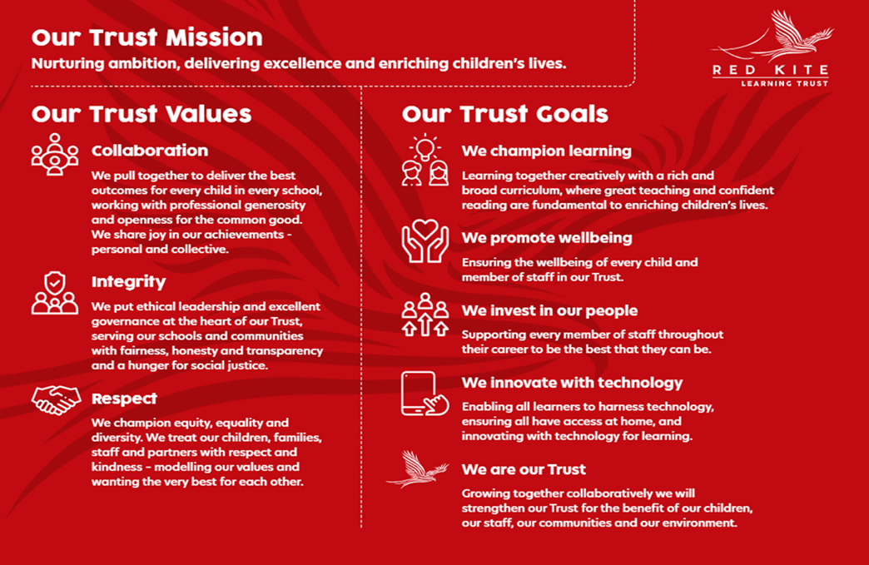
PEOPLE PROFILE
Aptitudes and Characteristics |  |  | Essential | Desirable
Ability to deliver KS3 lessons using central planning resources in History and Modern Studies if needed. |  |  | *
Ability to work flexibly and collaboratively as part of a team as well as on own |  |  | *
Able to use own initiative and motivate others |  |  | *
Ability to plan effectively using a cross-curricular skills-based approach |  |  | *
Willingness to proactively take part in training. Take responsibility for and be keen to improve upon own professional development |  |  | *
Ability to investigate, evaluate, solve problems and make decisions |  |  | *
Ability to demonstrate a commitment to equality of opportunity for all pupils |  |  | *
Ability to contribute to wider school life |  |  | *
High level of skill in dealing with issues relating to student behaviour |  |  | *
Ability to work under pressure and to meet deadlines |  |  | *
Effective written and oral communication and organisation |  |  | *
Qualifications, Knowledge and Experience |  |  | Essential | Desirable
Degree Level Qualification |  |  | *
Qualified teacher status e.g. PGCE |  |  | *
Subject expertise or willingness to lead a subject area |  |  |  | *
Experience of delivering evidenced based interventions and accelerated learning |  |  | *
Competent ability in ICT, able to demonstrate high-level skills and working knowledge of school systems |  |  | *
Recent experience in Geography and the provisions of the National Curriculum |  |  | *
Recent experience in Humanities subjects and the provisions of the National Curriculum |  |  |  | *
Up to date knowledge of curriculum related issues 11-16 |  |  | *
Thorough understanding of best practice in raising pupil attainment |  |  | *
Experience managing people and resources, including planning and organisational skills. Plan, allocate, support and evaluate work undertaken by other colleagues in the classroom |  |  | *
Expertise and knowledge required to lead CPD for colleagues |  |  |  | *
Safeguarding and Promoting the Welfare of Pupils |  |  | Essential | Desirable
An appropriate motivation to work with children and young people |  |  | *
Ability to maintain appropriate relationships and personal boundaries with children and young people |  |  | *
Emotional resilience in working with challenging behaviours and appropriate attitudes to the use of authority and maintaining discipline |  |  | *

