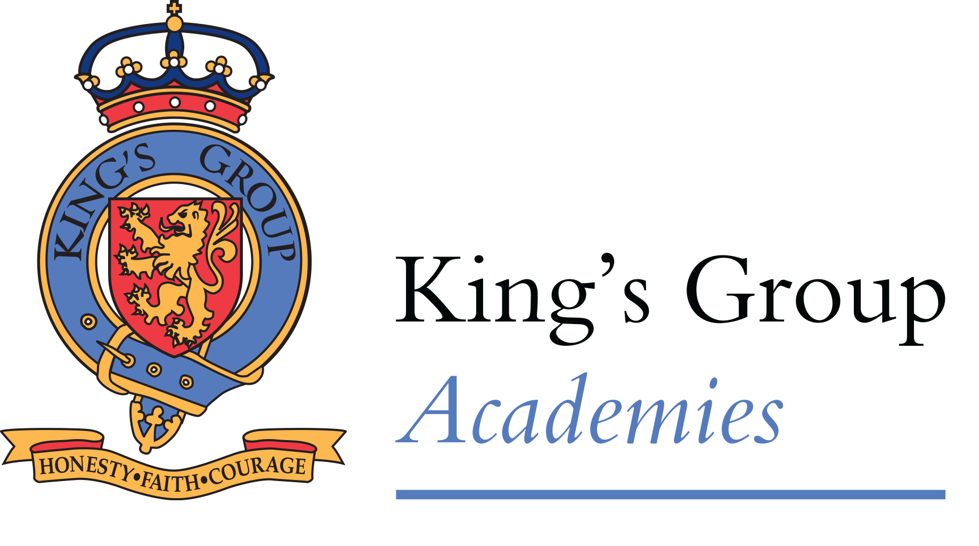

Job Description
Location | King’s Academy Binfield & King’s Academy Oakwood
Job Title | IT Technician Level 3 (School Network Manager)
Reporting to  (which position line manages this role) | Regional or Trust IT Manager
This role line manages the following positions | IT Technician Levels 1 and 2 (if applicable)

Main Job Purpose
Insert a description of the main reason this job is created. | To deliver comprehensive IT support, strategically and operationally manage IT support services, infrastructure, and projects within a secondary school environment, including line management responsibilities where applicable.
What will the post holder deliver?  What impact will they have? | The Level 3 Technician will deliver robust IT services, provide strategic direction, and manage technical staff, significantly influencing the quality and reliability of IT infrastructure and its alignment with educational outcomes. They will ensure secure, efficient, and innovative IT practices that facilitate enhanced learning environments, improved administrative processes, and strategic IT growth across the school.
Working with whom? | KGA IT Team

Responsibilities/duties/activities
Customer Service and Incident Management
- Provide face-to-face and remote technical support and guidance to staff and students at base school and any smaller schools supported by the team, acting as a routine contact point, handling a wide range of inquiries and service requests and providing information or assistance to enable fulfilment or resolution.
- Document and communicate outcomes of requests and incidents to staff, students and team members and close resolved incidents.
- Analyse service delivery performance to identify, initiate and report on actions required to maintain or improve levels of service.
- Contribute to the development and implementation of service standards and procedures. Provide technical and procedural guidance to team members.
- Collaborate with other department leaders to enhance the overall customer experience. Engage with staff and students to understand requirements and recommend appropriate solutions.
- Provide advice and guidance within the team and school to support the adoption of methods and tools and adherence to policies and standards.
- Tailor processes to meet school specific needs while ensuring they align with the established standards within the Trust and are informed by evaluations of methods and tools.
- Monitor and manage incident queues to ensure incidents are handled according to procedures and service levels.
- Contribute to developing, testing and improving incident management procedures, using analytics tools to track trends.
- Support team members in the correct use of the incident process, ensuring resolved incidents are properly documented and closed.
- Identify and investigate problems and issues and recommend corrective actions, initiating and monitoring those actions to resolve problems in systems, processes and services.
- Determine problem fixes and remedies, acting as the main line of escalation for team members.

Hardware and Network Support
- Identify and diagnose network problems/faults using the required troubleshooting tools and network management software, including addressing security-related issues.
- Implement and maintain scripts, automation tools and orchestration platforms to optimise network support processes.
- Apply technical expertise to maintain and optimise network infrastructure, executing updates and employing automation tools. Implement agreed network changes and maintenance routines.
- Contribute to the planning and implementation of network maintenance, updates, and security enhancements.
- Use network management tools to monitor load, performance, and security statistics. Investigate and enable the resolution of network-related operational and security issues.
- Develop, configure and maintain tools to identify, track, log and maintain accurate, complete and current information about the School network and its configuration.
- Contribute to the planning and implementation of infrastructure maintenance and updates. Implements agreed infrastructure changes and maintenance routines.

Application and System Software Support
- Execute standard operational procedures, including backups and restorations.
- Maintain application support processes and check that all requests for support are dealt with according to agreed procedures.
- Apply technical expertise to investigate and resolve complex system software issues, requesting action from suppliers if required.
- Apply technical expertise to maintain and optimise technology infrastructure, executing updates and employing automation tools.
- Maintain operational procedures and check that they are followed, including adherence to security policies, using infrastructure management tools to monitor load, performance, and security metrics.
- Develop comprehensive software implementation procedures with robust contingency plans, including planning and executing deployments of complex software releases and updates.

Information Security and Assurance
- Follow standard approaches for the technical assessment of information systems against information assurance policies and business objectives, contributing to the identification of risks that arise from potential technical solution architectures and maintaining records to support and justify decisions.
- Offer authoritative advice on identity and access management, ensuring services align with and support evolving business needs, Trust procedures and security protocols.
- Oversee the integration of identity and access management services with new technologies.
- Provide specialised support for complex identity and access management operations and support implementation of policies and standards.
- Carry out school-specific risk management activities relating to IT systems, technical areas or projects.

Asset Management

Control IT assets within school ensuring full lifecycle of assets is administered appropriately.

Produce and analyse asset registers and histories of authorised assets and verify that all of these assets are in a known state and location.

Act to highlight and resolve potential instances of unauthorised assets.

Engage proactively and collaboratively with suppliers and other School Network Managers to identify new purchasing opportunities and resolve incidents, problems, or unsatisfactory performance

Strategy and Planning
- Define, document and execute school specific or other small projects or sub-projects. Track activities against the project schedule, managing stakeholder involvement, monitor costs, times, quality and resources used. Take action where these exceed agreed tolerances.
- Support the monitoring of external changes in IT and the assessment of emerging technologies.
- Contribute to the creation of reports, technology roadmapping and the sharing of knowledge and insights.
- Assess and report on how different IT decisions affect sustainability.
- Design specific network components using agreed architectures, design standards, patterns and methodologies. Translate logical designs into physical designs that meet specified parameters.
- Contribute to the development of recovery routines and contingency procedures.

People Management
- Provide operational direction, support and guidance to assigned colleagues, conducting performance reviews and staff training.
- Allocate routine tasks or project work, in line with team objectives and individual capabilities, monitoring quality and performance against agreed criteria to make learning recommendations or to escalate concerns.
- Coach colleagues in developing target skills and capabilities in line with team and personal goals.
- Facilitate effective working relationships between team members.

Safeguarding
- Ensure personal understanding of the duties and responsibilities in relation to child protection and the safeguarding of children and young people. This includes an understanding of the academy's Child Protection Policy, Safeguarding policy and Code of Conduct.
- Ensure all issues relating to pupils are reported immediately to the delegated member of staff
- Attend mandatory training and refreshers to ensure a personal and up-to-date understanding of safeguarding requirements

Health, Safety & Security
- Ensure a personal awareness of and compliance with, policies and procedures related to health, safety, and security, confidentiality, and data protection
- Ensure concerns are reported immediately to the delegated member of staff
- Attend mandatory training and refreshers to ensure a personal and up-to-date understanding of relevant policies and practices

Equity, Diversity & Inclusivity
- Contribute to the development of a workplace culture that promotes equity, diversity and inclusivity

Person Specification
Experience, Skills & Knowledge
Essential | Desirable
- Experience managing IT infrastructure.  - In depth knowledge of computer operating systems such as Microsoft Windows, Apple macOS, iOS, iPadOS, ChromeOS and Android  - Expertise in supporting Microsoft Active Directory, Group Policy, Microsoft Office 365, Google Workspace, and other user and computer identity management platforms.  - Proficiency supporting Google products including Chromebooks, Google Mail, Google Docs, Google Drive, Google Meet and Google Classroom.  - Ability to communicate effectively in a variety of situations including formal and informal, both within their team and externally.  - Strong customer service skills including the ability to understand how the end-user context influences priorities and solutions. | - Relevant professional certifications, for example  - Google Professional ChromeOS Administrator  - Google Certified Enterprise Administrator  - Microsoft Certified: Windows Server Administrator  - CompTIA Linux+ Certification  - Proficiency with common education sector IT systems.  - Proficiency with administering Arbor MIS.  - Proven experience in line management and project leadership.
Personal Attributes
Essential | Desirable
- A demonstrable aptitude for Effective troubleshooting and problem-solving with the ability to identify appropriate solutions using both logical and creative thinking.  - Strategic thinker with excellent organisational abilities.  - Resilience and a calm, professional approach to complex problem-solving.  - Friendly, approachable, and patient manner, demonstrating standard business courtesies and professional ethics.  - Enthusiasm for technology and learning.  - High level of integrity and accountability, taking responsibility and initiative as appropriate. | - Ability to contribute to broader Trust-wide IT initiatives.  - Commitment to professional growth and development.  - Strong leadership and management skills.

Date reviewed:

