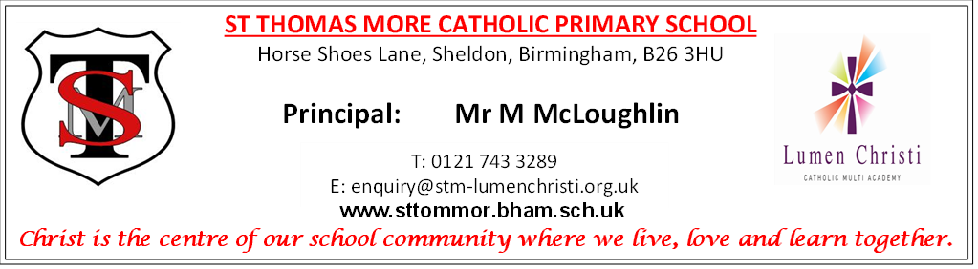

JOB DESCRIPTION

Class Teacher

At St. Thomas More Catholic Primary School, it is expected that:

the teacher will promote the Catholic life of the school within lessons, collective worship and in all relationships in school.
- the teacher will adhere to all Teacher Standards.
- teaching is consistently good or better in lessons.
- the teacher will promote the general progress and well-being of individual pupils and of any class or group of pupils assigned to; and/or when undertaking other activities for, or relating to, pupils.

Duties and Responsibilities
Set high expectations which inspire, motivate and challenge pupils by:
- establishing a safe and stimulating environment for pupils, rooted in mutual respect.
- setting goals that stretch and challenge pupils of all backgrounds, abilities and dispositions.
- demonstrating consistently the positive attitudes, values and behaviour which are expected of pupils.
- promoting good progress and outcomes for pupils.
- being accountable for pupils’ attainment, progress and outcomes.
- planning teaching to build on pupils' capabilities and prior knowledge.
- guiding pupils to reflect on the progress they have made and their emerging needs.
- demonstrating knowledge and understanding of how pupils learn and how this impacts on teaching.
- encouraging pupils to take a responsible and conscientious attitude to their own work and study.
- teaching consistently good or better lessons.

Demonstrate good subject and curriculum knowledge by:
- having a secure knowledge of the relevant subject(s) and curriculum areas, foster and maintain pupils’ interest in the subject and address misunderstandings demonstrating a critical understanding of developments in the subject and curriculum areas, and promote the value of scholarship.
- planning and teaching well-structured lessons by imparting knowledge and develop understanding through effective use of lesson time.
- promoting a love of learning and children’s intellectual curiosity.
- reflecting systematically on the effectiveness of lessons and approaches to teaching, contributing to the design and provision of an engaging curriculum within the relevant subject area(s).
- adapting teaching to respond to the strengths and needs of all pupils; knowing when and how to differentiate appropriately, using approaches which enable pupils to be taught effectively.
- having a secure understanding of how a range of factors can inhibit pupils’ ability to learn, and how best to overcome these challenges.
- demonstrating an awareness of the physical, social and intellectual development of children, and know how to adapt teaching to support pupils’ education at different stages of development.
- having a clear understanding of the needs of all pupils, including those with special educational needs; those of high ability; those with English as an additional language; those with disabilities; and be able to use and evaluate distinctive teaching approaches to engage and support them.

Making accurate and productive use of assessment by:
- knowing and understanding how to assess the relevant subject and curriculum areas, including statutory assessment requirements.
- making use of formative and summative assessment to secure pupils’ progress.
- using relevant data to monitor progress, set targets, and plan subsequent lessons.
- giving pupils regular feedback, both orally and through accurate marking, and encouraging pupils to respond to the feedback.

Managing behaviour effectively to ensure a good and safe learning environment by:
- having clear rules and routines for behaviour in classrooms and taking responsibility for promoting good and courteous behaviour both in classrooms and around the school, in accordance with the school’s behaviour policy.
- having high expectations of behaviour and establishing a framework for discipline with a range of strategies, using praise, sanctions and rewards consistently and fairly.
- managing classes effectively, using approaches which are appropriate to pupils’ needs in order to involve and motivate them.
- maintaining good relationships with pupils, exercise appropriate authority and acting decisively when necessary.
- taking all reasonable steps to maintain good order and discipline amongst pupils and safeguarding their health and safety, both when they are authorised to be on the school premises and when they are engaged in authorised school activities elsewhere.
- Fulfil wider professional responsibilities.

By making a positive contribution to the wider life and ethos of the school:
- developing effective professional relationships with colleagues; knowing how and when to draw on advice and specialist support; and to deploy support staff effectively.
- contributing to meetings – phase, staff or other.
- supporting Masses, Sacramental preparation and school events outside school hours.
- taking responsibility for improving teaching through appropriate professional development, responding to advice and feedback from colleagues.
- communicating effectively with parents regarding pupils’ achievements and well-being.
- demonstrating consistently high standards of personal and professional conduct both inside and outside school hours.

Whilst every effort has been made to outline the key duties and responsibilities of the role, it is not
an exhaustive list. The duties and responsibilities of the role may vary from time to time,
commensurate with and without changing the general character of the duties or the level of
responsibility entailed and would not in itself justify a reconsideration of the grading of the post.
The Multi-academy will endeavour to make any necessary reasonable adjustments to the job and
the working environment to enable access to employment opportunities for disabled applicants or
continued employment for any employee who develops a disabling condition.

For further information please see the Link to Candidate brochure

https://www.lumenchristi.org.uk/Candidate-Brochure/

