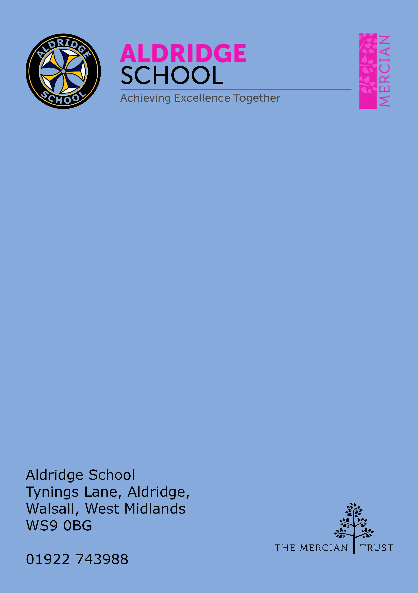

Application Pack

Learning Support Assistant


About Aldridge School

About The Mercian Trust

Person Specification
How to Apply

Job Description

About Aldridge School

Thank you for taking the time to find out more about Aldridge School. This pack is intended to give you information about this role and our school's broader vision and ethos. Further background information is available in our Prospectus and Sixth Form Prospectus on our website.

We are a comprehensive school of over 1600 students situated near the centre of Aldridge village. We believe that it is our responsibility to work to meet the needs of every individual student, challenging them to achieve their best, supporting them to become responsible young adults and preparing them for their next steps into the world of work or further education.

Aldridge School is a good school (Ofsted 2022). It is a school which is proud of its traditions and successes which have been achieved through hard work and high expectations.

Aldridge School has a dedicated, talented and conscientious team of staff who work together to provide a high standard of teaching, excellent pastoral care and professional support services. Our broad curriculum is designed to meet national expectations, be relevant and interesting, support our students in achieving the best possible standards in external examinations and to equip them with the skills they need to be successful in adult life.

At Aldridge School we have a popular and thriving Sixth Form. We are very proud of our students' success with over 80% securing places at some of the top Universities and on Higher Apprenticeships last year. We offer a very broad range of both academic and vocational courses at level 3, ensuring that Aldridge School Sixth Form is an option for a wide range of students.

We also enjoy strong links with surrounding primary schools, working with students in Years 5 and 6 including work in Science, Maths, English, Performing Arts and Enterprise. We are proud of our community and we work hard to promote this pride in all our partnerships, so that we can make sure that future students from these schools enjoy an easy, enjoyable transition to Aldridge School.

Students at Aldridge School are friendly, polite and respectful. Strong relationships between staff and students contribute significantly to ensuring that students are happy and feel safe.

If you would like to find out more, please contact us to arrange a visit to see our school at work. We look forward to meeting you.

Benefits of Working at Aldridge School

- Everyone has the highest expectations of behaviour, with all staff reinforcing those expectations
- A clear system of sanctions which is applied consistently so staff don't have battles with students
- Senior Leadership are very visible
- Excellent pastoral support offered through Year Offices
- CPD tailored specifically to staff needs, based off their feedback
- Time for staff to put new things into action
- Non-hierarchical approach to professional development - there are things a senior leader can learn from an ECT and vice versa
- Targeted support plans for teachers who are struggling
- Regular Staff, Faculty and Pastoral briefings to support good communication
- Comprehensive support for ECTs with dedicated mentors and regular meetings
- We are constantly streamlining all systems and processes so they take less time
- Open door Senior Leadership Team - no concern is ever too small
- Countless opportunities to get involved with the wider life of the school - Duke of Edinburgh, school performances, sports teams, music
- Contributions of staff recognised through 'Above and Beyond' draws each half term
- MAT ‘Employer of Choice’ opportunities such as UK Health Healthcare plan

About the SEN Department and PLC

The SEN team is led by the SENCO. We have a team of Higher-Level Teaching Assistants, Senior Learning Support Assistants and Learning Support Assistants and an Assistant SENCO. The team work well together to provide effective support for students. We also have a Personalised Learning Centre where the PLC manager works alongside two HLTAs to support our students that face varied challenges in accessing their education.

Our aim is to remove barriers to students’ learning so that all students can achieve their potential.

The team work with students who have special educational needs across all year groups. This consists of support in the classroom, including the PLC classroom. There is also a range of 1-1 or small group support outside of the classroom. The learning support assistants use data to analyse students’ progress and to provide targeted interventions to meet the students’ needs.

The team work closely with parents/carers, as well external agencies. Support staff play an important role in supporting students with some of the most complex needs and promoting their inclusion within the school community.


The Mercian Trust

Aldridge School is an academy in The Mercian Trust.

The Mercian Trust brings together twelve very different and individual schools together as a single Multi-Academy Trust or MAT.

The twelve schools are unique in their identity and united by their ambition to offer the best possible future for their students.

The twelve schools are:
- Aldridge School
- Queen Mary’s Grammar School
- Queen Mary’s High School
- Shire Oak Academy
- The Ladder School
- Walsall Studio School
- Q3 Academy Great Barr
- Q3 Academy Langley
- Q3 Academy Tipton
- New Leaf
- Rushall Primary School
- Oakwood School

Each school has its own distinct ethos and approach, but we have this over-arching aim in common: we prepare all our students to enjoy life to the full by inspiring them to:
- Realise their potential as learners
- Thrive in the world of work
- Make a positive contribution to the local, national and international community

The Mercian Trust respects the autonomy of its member schools but, through collaboration, fosters strengths that are greater than the sum of its parts. Working together as a Multi-Academy Trust provides a framework for sharing expertise and enthusiasm, resources and ideas.



Job Description

Duties

This job description describes in general terms the normal duties which the postholder will be expected to undertake. However, the job or duties described may vary or be amended from time to time without changing the level of responsibility associated with the post.

Teaching and learning

- Assist in the educational and social development of key pupils under the direction and guidance of the head teacher, SENCO and PLC manager.
- Support in the implementation and running of programmes aimed to promote pupil progress and social development.
- Provide support for individual students, who have recently made the transition to secondary education, inside and outside the classroom to enable them to fully participate in activities
- Support with the differentiation of teaching and learning.
- Work with other professionals as necessary
- Support students with emotional or behavioural problems and help develop their social/emotional skills.
- Keep a record of the nature and effectiveness of support/intervention strategies used with students and assist in the implementation of learning
- Plans for students and help monitor their progress via Support Records

Administrative duties

- Support class teachers in differentiation and other tasks to support teaching
- Support tracking of pupil progress data
- Undertake other duties from time to time as the head teacher requires

Standards and quality assurance

- Support the aims and ethos of the school
- Set a good example in terms of dress, punctuality and attendance
- Attend team and staff meetings
- Undertake professional duties that may be reasonably assigned by the head teacher
- Be proactive in matters relating to health and safety
- Be committed to safeguarding and promoting the welfare of children and young people



Person Specification

The employee will need to demonstrate the following requirements in order to perform each of the main activities of the job safely and effectively.

Skills / Knowledge

- Ability to show initiative in supporting the effective inclusion of an individual child and small groups of students.
- Use of other equipment technology, e.g. laptop, photocopier.
- Understanding of the principles of child development and learning processes.
- Ability to differentiate for the needs of students effectively
- Ability to self–evaluate learning needs and actively seek learning opportunities.
- Ability to relate well to children and adults
- Empathy and understanding for children who have social, emotional and mental health/communication needs
- Work constructively as part of a team, understanding classroom roles and responsibilities and your own position within these.
- Very good literacy and numeracy skills.

The following will be advantageous but not a requirement.

Experience

- Experience of working with students who are working significantly below age expectations
- Experience and knowledge of working with the Primary School curriculum and/ or experience of working in a Special School setting.
- Supporting children with Special Educational Needs
- Supporting children with behavioural needs



How to Apply
Grade 3 Point 4 – 6 Pro-rata

Term Time including 5 training days
30.33 hours

Closing Date
9am on 05th June 2026
Interviews will be held w/c 08th June 2026

Start Date
September 2026

Applying
To apply please submit an application on The Mercian Trust portal.

For further information please contact Mrs R Knight 01922 743 988 (ext. 2224)
