


JOB PROFILE
Job Title: | Teaching Assistant – SEND/SEMH | School/Department: |  | Rossett School
Salary Grade: | Band 5 points 4 to 6 | Working Hours: |  | 27
Contract Type: | Part time, part year | Location: |  | Harrogate
Responsible to: Headteacher & Senior Leadership Team
Role summary:
A general Teaching Assistant post to be deployed across the SEND and the Learning Support provision.
- To work under the direct instruction of the SENDCo/teaching staff, usually within the classroom or other learning areas, to support access to learning for students.
- To assist teaching/senior staff in the management of students.
- To work under the guidance of the SENDCo to implement agreed work programmes with individuals/groups to support access to learning for students.
- To provide assistance for the faculty where necessary.

Red Kite Learning Trust is committed to safeguarding and promoting the welfare of students and expects all colleagues and volunteers to share this commitment.
Special conditions of service:
No smoking policy, including e-cigarettes.
Role specific responsibilities:
Teaching & Learning
Assist in the educational and social development of students under the direction and guidance of the SENDCo and class teachers.
- Support students consistently both inside and outside the classroom to enable them to fully participate in activities.
- Work with the teacher to establish and maintain an appropriate learning environment.
- Assist in the implementation of Individual Provision Maps for students and help monitor and evaluate their progress.
- Under the direction of the teacher, work with small groups of students and take responsibility for their learning including planning, evaluating and adjusting lessons/work plans as appropriate.
- Establish constructive relationships with students and interact with them according to individual needs.
- Support the paired reading programme during form time.
- Promote the inclusion and acceptance of all students.
- Be aware of students' problems/progress/achievements and report to the teacher as agreed and pass on information from parents/carers.
- Support students with emotional or behavioural problems and help develop their social skills.
- Encourage students to interact with others and engage in activities led by the teacher.
- Provide feedback to students in relation to progress and achievement.
- Promote good student behaviour, dealing promptly with conflict and incidents in line with school policy and encourage students to take responsibility for their own behaviour.
- Provide support to students for whom English is an additional language.
- Promote independence and employ strategies to recognise and reward achievement.
- Assist teaching staff with maintaining student records and tasks within the school’s assessment procedures.
- Provide exam access services for identified students sitting internal and external examinations as required.
- Determine the need for, prepare and maintain general and specialist equipment and resources as appropriate.
- Support teaching staff with administrative tasks to support teaching and prepare and present displays of students’ work.
- Work with other professionals, such as speech therapists and occupational therapists, as necessary.
- Recognise own strengths and areas of specialist expertise and use these to advise and support others.
- Attend team and staff meetings as required and be a proactive member of the school and faculty team.

Other duties and responsibilities
- Accompanying students on educational visits and out of school activities.
- Support with the delivery of engaging outdoor education lessons.
- Exam invigilation.
- Be aware of and comply with policies and procedures relating to child protection, health, safety, security, confidentiality and data protection, reporting all concerns to the appropriate person.
- Contribute to the overall ethos/work/aims of the school.
- Participate in training and other learning activities and the school’s performance appraisal process.

RK People responsibilities:
- Contribute to the overall aims and values of our Trust, appreciate and support the roles of other members of the wider team and attend and participate in relevant meetings as required
- Comply with all Trust policies and procedures including child protection, health, safety, welfare, security, confidentiality and data protection, reporting any concerns to the appropriate person
- Contribute to ensuring safeguarding procedures are in place and used effectively at all times
The role holder must demonstrate a flexible approach to the delivery of the role. Consequently, the role holder may be required to perform work not specifically identified in the job profile but which is in line with the general scope, grade and responsibilities of the role.
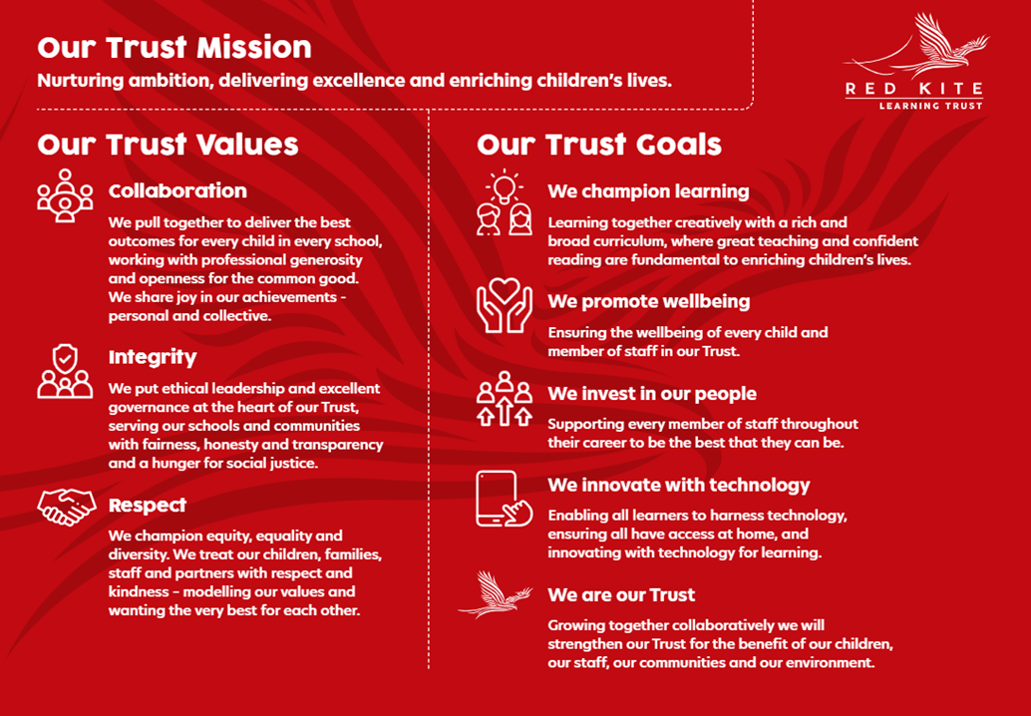
PEOPLE PROFILE
Aptitudes and Characteristics |  |  | Essential |  | Desirable
Ability to work flexibly and collaboratively as part of a team as well as on own |  |  | *
Hard working, well-motivated, positive |  |  | *
Excellent attendance and punctuality record |  |  | *
Ability to use own initiative and have a flexible approach |  |  | *
Ability to cope with stressful situations |  |  | *
Ability to deal with sensitive information in a confidential manner |  |  | *
Empathy towards young people facing barriers to their learning |  |  | *
Ability to provide a good role model for young people |  |  | *
Excellent communication skills and ability to work in partnership with students, parents, staff and outside agencies |  |  | *
Good organisational/administrative skills |  |  | *
Enthusiasm and commitment to aims/objectives of the school |  |  | *
Willingness to participate in wider school activities |  |  | *
Qualifications, Knowledge and Experience |  |  | Essential |  | Desirable
Good numeracy and literacy skills (GCSE Mathematics and English grade C or above or equivalent) |  |  | *
Good standard of IT skills |  |  | *
A Level qualifications or a degree |  |  |  |  | *
Evidence of relevant learning strategies eg dyslexia, sign language |  |  |  |  | *
Experience of working with or caring for young people |  |  | *
Experience working in a school in a similar role |  |  |  |  | *
Understanding of behaviour management strategies |  |  |  |  | *
Safeguarding and Promoting the Welfare of Students |  |  | Essential |  | Desirable
An appropriate motivation to work with children and young people |  |  | *
Ability to maintain appropriate relationships and personal boundaries with children and young people |  |  | *
Emotional resilience in working with challenging behaviours and appropriate attitudes to the use of authority and maintaining discipline |  |  | *

