

JOB PROFILE
Job Title: | Chef | School/Department: |  | Harrogate Grammar School
Salary Grade: | Salary Band 7 SCP 8 - 12  Actual salary circa £23,562 based on 37 hours a week | Working Hours: |  | 37 hours per week Term time plus 1 week and training days
Contract Type: | Permanent | Location: |  | Harrogate
Responsible to: Chef Manager
Role summary:
This is a hands-on role to work alongside and with the catering management team producing a fantastic product & service and enhancing team performance with excellent leadership skills.
Red Kite Learning Trust is committed to safeguarding and promoting the welfare of students and expects all colleagues and volunteers to share this commitment.
Special conditions of service:
No smoking policy, including e-cigarettes. Requirement to work outside of school hours and off school premises, as required by the school.
Role specific responsibilities:
- Role model to colleagues in terms of professionalism, presentation and hard work.
- Effectively support management team providing leadership, support, training and advice within the team.
- Ensure quality delivery in a high-volume operation with tight deadlines at break and lunchtimes
- Demonstrate craft skills to team members and encourage creative flair with food. Keeping up to date with food trends.
- Attend and contribute to meetings where required.
- Encourage a good team ethos and a happy working environment.
- Lead with integrity and have a hands-on approach, but have the ability to see and react to the big picture and overall business aims.
- Assist in the planning, help produce and cook the food to the highest quality standards, controlling food wastage.
- Willing to work flexibly in terms of working hours to meet the needs of the school.
- Delegate tasks in a way which maximises the use of available talent, experience and enthusiasm.
- Engage positively with the school’s CPD programmes and Appraisal systems.
- Engage with networks both within and beyond the school that support continuous improvement.
- Ensure health and safety regulations are strictly observed.
- Ensure the you and the team are working to the school’s sustainability goals.

RK People responsibilities:
- Contribute to the overall aims and values of our Trust, appreciate and support the roles of other members of the wider team and attend and participate in relevant meetings as required.
- Comply with all Trust policies and procedures including child protection, health, safety, welfare, security, confidentiality and data protection, reporting any concerns to the appropriate person.
- Contribute to ensuring safeguarding procedures are in place and used effectively at all times.
The role holder must demonstrate a flexible approach to the delivery of the role. Consequently, the role holder may be required to perform work not specifically identified in the job profile but which is in line with the general scope, grade and responsibilities of the role.
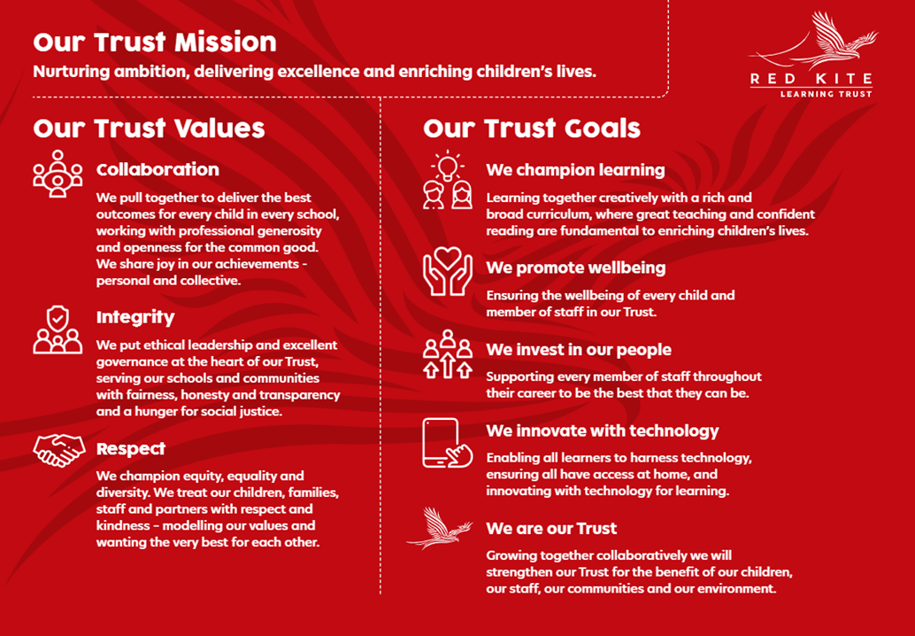
PEOPLE PROFILE
Aptitudes and Characteristics |  |  | Essential |  | Desirable
Ability to relate well to children and adults |  |  | *
Highly effective communication skills |  |  | *
Ability to work within and contribute to an effective team |  |  | *
Good organisational skills, high levels of self-motivation and able to take the initiative |  |  | *
Energy, self-confidence and ability to ‘give more’ when the occasion demands it |  |  | *
Ability to work under pressure and to meet deadlines |  |  | *
Ability to lead and inspire colleagues. |  |  | *
Capacity to evaluate and improve. |  |  | *
Flexible approach to working out-of-hours on occasion including evenings and occasional weekends |  |  | *
Qualifications, Knowledge and Experience |  |  | Essential |  | Desirable
Experience of working at a high volume, quality eatery |  |  | *
Experience of leading, motivating and managing others within a kitchen |  |  |  |  | *
Successful experience of raising standards |  |  | *
Food safety qualification and thorough knowledge of all aspects of Food Safety |  |  | *
High degree of catering craft skills |  |  | *
Awareness of Nutritional standards applying to schools and the importance of providing healthy food to young people. |  |  | *
Safeguarding and Promoting the Welfare of Students |  |  | Essential |  | Desirable
An appropriate motivation to work with children and young people |  |  | *
Ability to maintain appropriate relationships and personal boundaries with children and young people |  |  | *
Emotional resilience in working with challenging behaviours and appropriate attitudes to the use of authority and maintaining discipline |  |  | *

