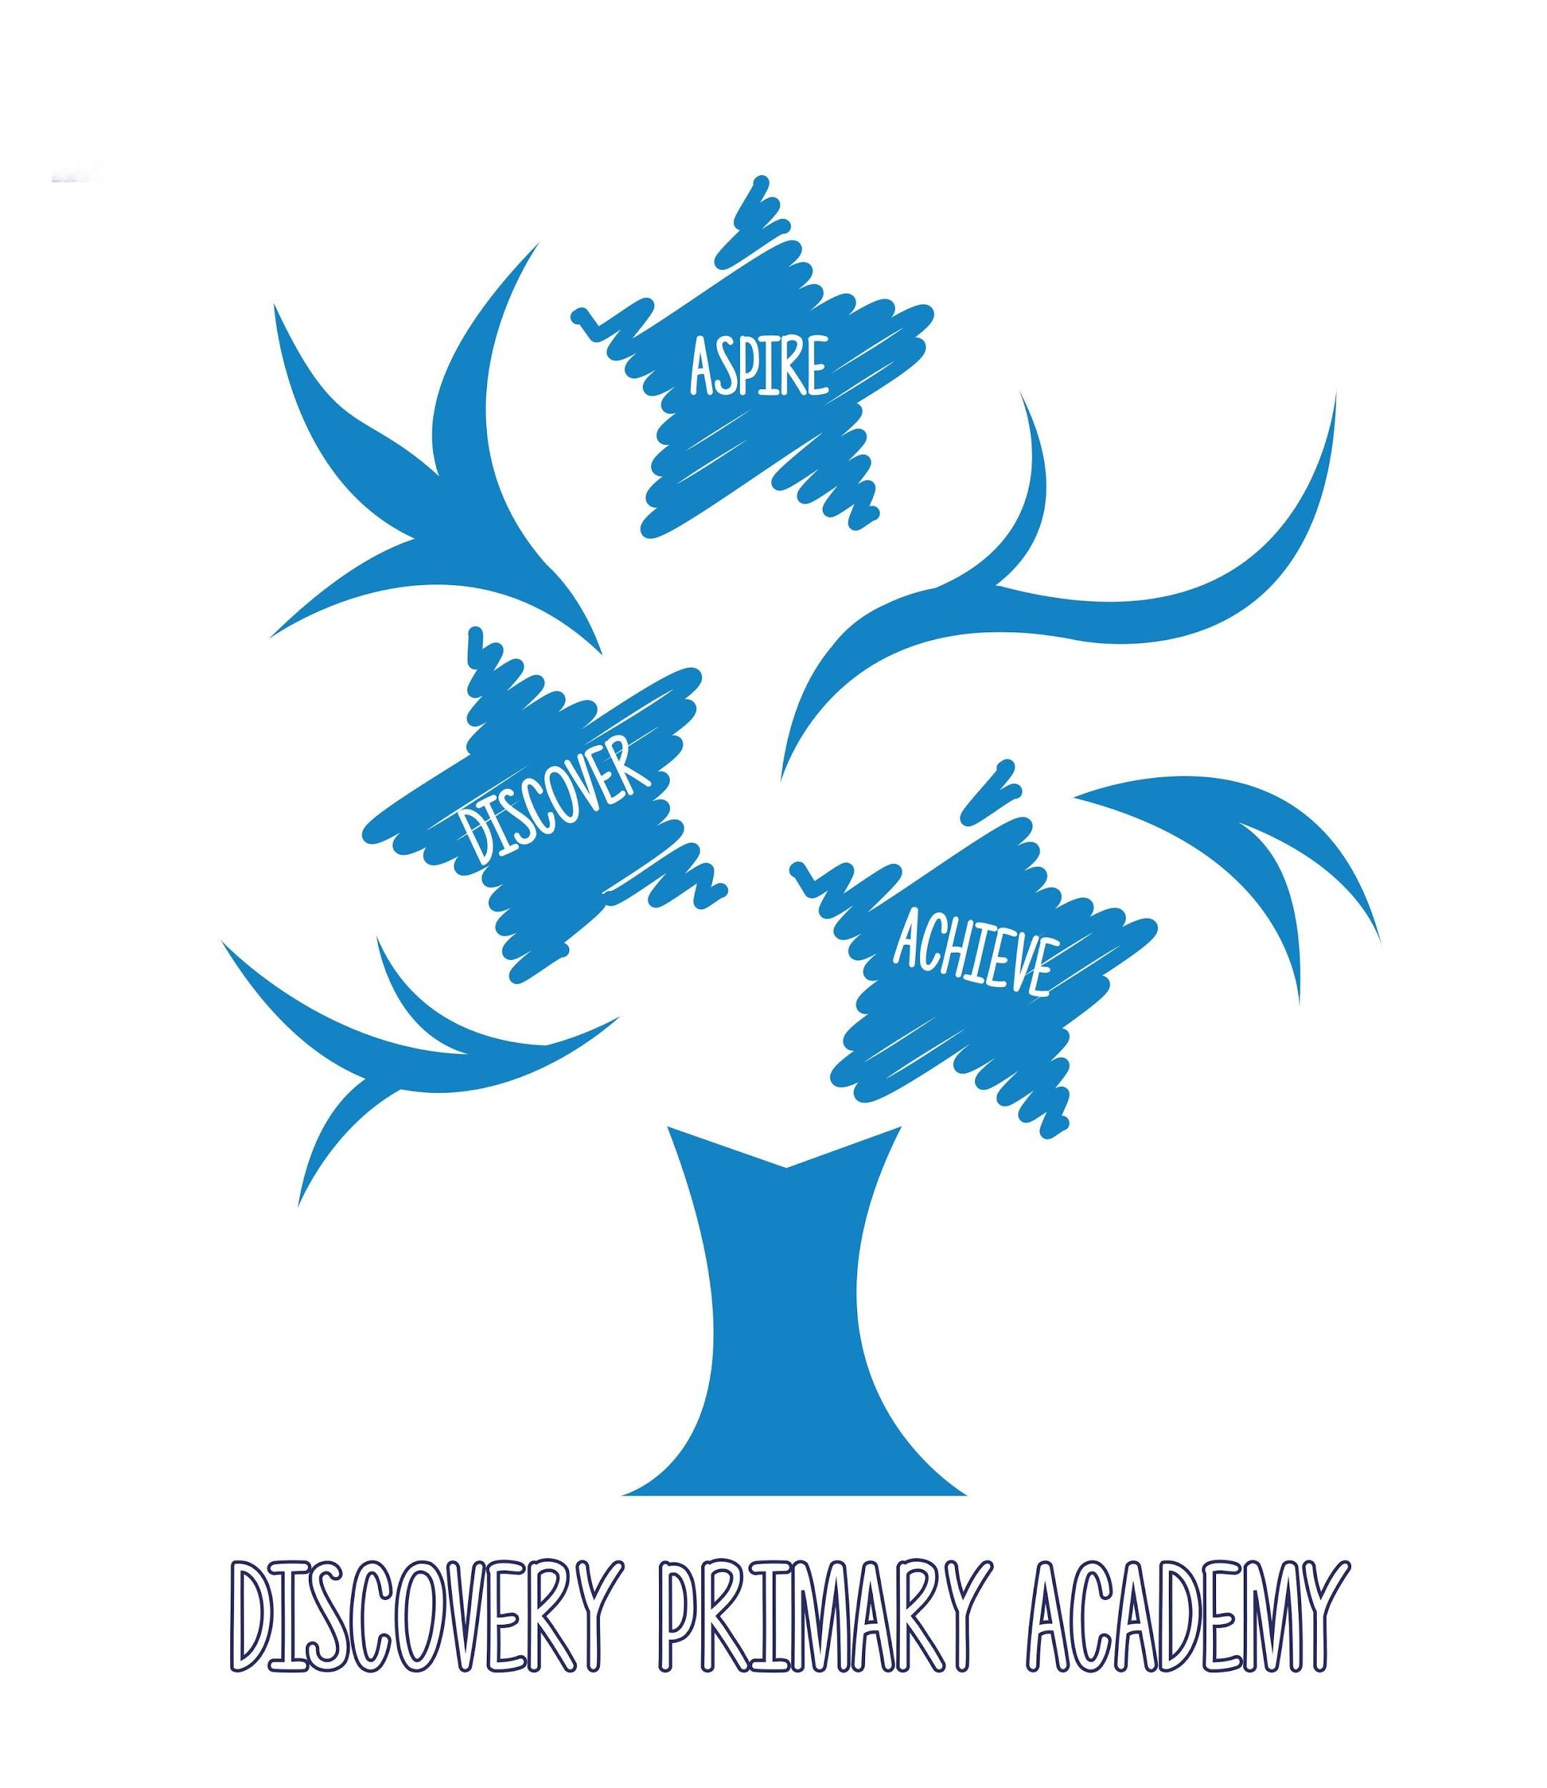
Discovery Primary Academy

Person Specification – Cleaner
 | Essential | Desirable
Experience | - Previous experience in a cleaning role (domestic, commercial, or educational setting)  - Familiarity with using cleaning equipment and materials safely | Working in a primary educational setting
Skills and Abilities | - Ability to work independently and follow instructions  - Good time management and organisational skills  - Attention to detail and commitment to high standards of cleanliness  - Ability to maintain confidentiality and discretion
Personal Qualities | - Reliable and punctual  - Trustworthy and honest  - Friendly and respectful towards children and staff  - Willingness to take responsibility and show initiative | - Flexibility to adapt to changing schedules or tasks
Health and Safety | - Understanding of basic health and safety procedures  - Physically fit to carry out cleaning duties (e.g. lifting, bending, standing for long periods) | - Knowledge of COSHH regulations (Control of Substances Hazardous to Health)  - Basic first aid knowledge
Safeguarding | - Commitment to safeguarding and promoting the welfare of children  - Willingness to undergo an enhanced DBS check

The Four Cs Trust is committed to safeguarding and protecting the welfare of children and young people and expects all staff and volunteers to share this commitment. All appointments involve regulated activity and are subject to an Enhanced DBS disclosure with children's barred list check and two successful references. Online searches are carried out on all shortlisted candidates. We reserve the right to close the job advert early should we receive a high amount of applications.

