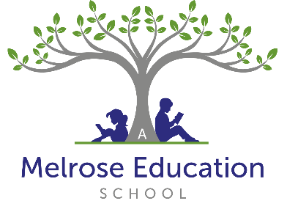

Role | Cleaner
Responsible To | Principal

Purpose of the Job:
The school cleaner will work as part of a team to perform a variety of regular and one-off cleaning tasks and duties as directed by the principal or the Health and Safety Lead. To provide a high standard of hygiene and cleanliness throughout the School.

Main Responsibilities
- Be responsible for ensuring the cleanliness of the school’s designated areas, and for maintaining high and consistent standards.
- Take initiative to perform cleaning and tidying tasks that are not specifically contained within the rota, or job list, but require attention as part of maintaining overall high standards.
- Liaise with the Principal or the Health and Safety Lead and other members of staff, as required, to ensure the cleaning rota operates smoothly.
- Report cleaning supplies requirements and stock levels to the line manager.
- Ensure Health and Safety, quality, COSHH, and general procedures compliance.
- Work as part of a team and support other members of the cleaning team to meet standards and school objectives, where and if applicable.
- Report any compliance issues to the Principal or the Health and Safety Lead.

Person Specification Knowledge
- Some knowledge of Health and Safety Regulations as they relate to the operation of cleaning equipment and the dilution of cleaning materials.
- Knowledge of COSHH and the safe use of chemicals.
- Knowledge of cleaning best practises.

Experience
- Experience of undertaking a range of cleaning duties:
  - Vacuuming
  - Dusting
  - Mopping
  - Scrubbing
  - Buffing
- Disposing of waste safely.
- Replenishing consumables.

Personal Attributes
- Willingness to clean any area of the school as requested.
- Willingness to take personal responsibility for standards of work carried out.
- Willingness to participate in further training and development opportunities offered by the school, to further knowledge
- Willingness to maintain confidentiality on all school matters.
- Be able to manage some heavy lifting.
- Work as part of a team.

Skills
- Ability to work effectively and supportively as a member of the school team.
- Ability to work in an organised and methodical manner.
- Ability to act on own initiative, dealing with any unexpected problems that arise.
- Ability to demonstrate commitment to Equal Opportunities.
- Being physically capable.
- Good communication.
- Efficiency and discretion.
- Honesty and integrity.
- Motivation and flexibility.
- Respect and professionalism.
- Time management and multitasking.
- Understanding and following safety rules.
- Understanding and carrying out set tasks.
- Understanding of health and safety regulations.

PERSON SPECIFICATION

Requirement | Essential | Desirable | Testing Method
1. Qualifications | Health and safety, COSHH, food hygiene qualifications | GCSE Maths and English | Certificate Application form
2. Experience | Experience of cleaning an educational setting | Working in a school | Application form Interview
3. Knowledge and Skills | Organised Pro-active  High standards |  | Application form Interview questions
4. Competence | Professional  Ability to follow procedures/policies  Ability to work as part of a team and independently  Able to complete relevant forms  Understanding of legislation relating to H & S and COSHH |  | Interview questions
5. Personal Qualities | Team player  Can work under pressure and prioritise effectively  Emotionally robust Resilient  Sound communicator Driven  Innovative  Flexible  Sense of humour |  | Interview questions
6. Other |  | Full Driving License &  access to own vehicle | Document verification

Note:
This Job Description sets out the duties of the post at the time when it was drawn up. Such duties may vary from time to time without changing the general character of the duties or the level of responsibility entailed. Such variations are a common occurrence and cannot of themselves justify reconsideration of the salary for the post.

This job description may be amended at any time in consultation with the postholder.

Reviewed March 2026

