BOBBY
MOORE
ACADEMY

Art & Design Technician
Bobby Moore Academy
NJC 06 (Inner London)

Applicant Information Pack
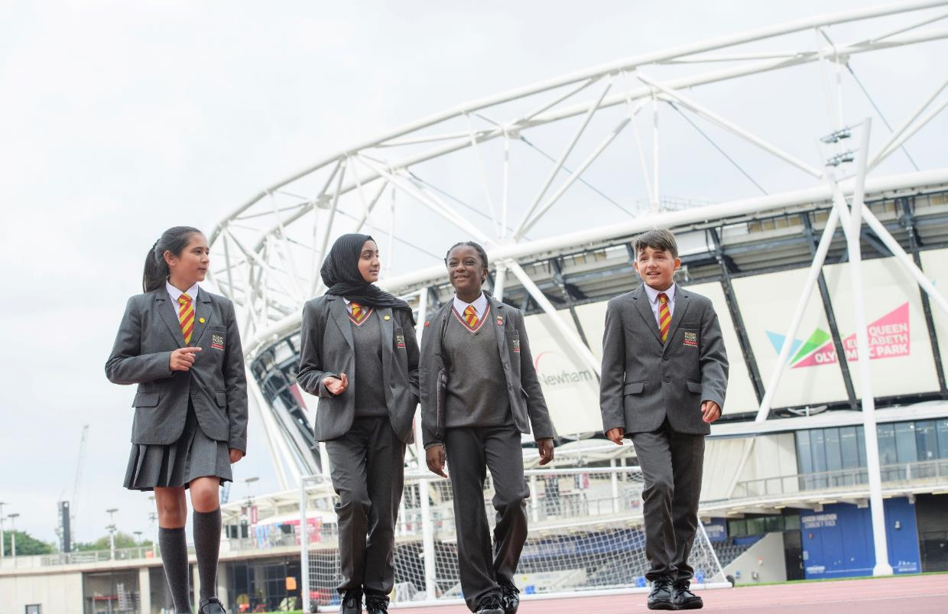
Bobby Moore Academy

Bobby Moore Academy is an all through school, providing a world-class education for the children of east London. A school characterised by ambition and drive it is transformational in its impact on their life chances and we all as a community stand firm in our belief that;

We are the drivers of social mobility.
We address social injustice head on.
We are architects of aspiration.
We are unrelenting in our focus on academic achievement.
Our expectations are uncompromising.
We craft good character.
We are custodians of the ‘master key’

We are situated across two iconic sites on the Queen Elizabeth Olympic Park, and our Secondary phase is now heavily oversubscribed. We are building partnerships with the new East Bank development, including the BBC, UCL, V&A East which is bringing incredible opportunities to the young people of East London.

Since the school was founded in 2017, we have set ambitious academic standards backed up by exciting enrichment opportunities, whilst nurturing and caring for the wellbeing of every child. At capacity, our two sites will accommodate over 1500 pupils, including a Sixth Form.
Built on the legacy of the 2012 London Olympic and Paralympic Games we enjoy world beating facilities including a competition standard 400m running track, full size football pitch and field events space, Astro-turf pitch, and state of the art classrooms and school buildings. Taking leadership inspiration from our namesake and the 1966 World Cup winning team we are inspired to generate transformational change for the young people in our care.
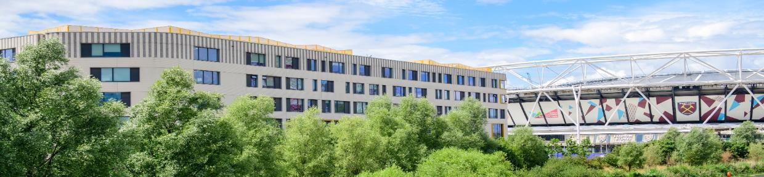

About the David Ross Education Trust

The David Ross Education Trust (DRET), of which the Bobby Moore Academy is part, has a passionate belief that by offering young people an outstanding range of opportunities they will discover what they can excel at and thus transform their life chances.

Such an ethos demands that at Trust and individual school level, we bring together best practice from across the independent and state sectors, to ensure high expectations and outcomes for pupils. In practice, this ethos is driven through four core values, the rules by which our community will thrives:
- Aspiration – Always aiming high
- Ambition – Being the best we can be
- Courage – Nothing holds us back
- Respect – Always leading by example
We are an equal opportunities employer, and as with all roles within Bobby Moore Academy, we welcome and strongly encourage applications from candidates representing ethnically diverse communities.

Benefits of working at Bobby Moore Academy

- World-class facilities
- Comprehensive training, coaching, and mentoring available. We are a school that is
- passionate about the science of learning and implementing evidence-informed practice
- Supportive working culture
- Competitive salary
- Free staff gym on site
- Interest free loans for season tickets and bicycle purchase
- Access to the London Marathon Community Track
- Local staff discount at the View Tube café
- Opportunities to attend Park events
Job Purpose

The main responsibility of the Creative Arts technician is to support teachers across the Creative Art department (Fine Art, Textiles, Graphic communications and Design and Technology); to liaise with them to ensure the efficient running of the departments day-to-day programme of varied timetabled lessons and extra-curricular activities.

Duties include such diverse areas as the preparation of classrooms for practical tasks such as printing, painting, embroidery and woodwork and so on, as well as framing and mounting of pupil art for the purpose of display in corridor spaces around the school.

The technician is also responsible for ordering & collection of art and design materials, organisation of equipment storage and art supplies, ensuring equipment across the department works correctly. It is envisaged that duties will be conducted based on their given priority and with assistance from teachers/Creative Arts lead. Within this context, the Technician will be a committed and professional member of the team and enhance the delivery of Creative Arts at Bobby Moore Academy.

An Arts Degree is not essential, though an interest in the Creative Arts is. Practical skills are important, alongside a willingness to learn and an enthusiasm to work as a team
Main areas of responsibility

Primary duties and responsibilities:

- Preparation of materials in advance of classes
- Display and rotation of Artwork around the school
- Helping with Exhibitions and Art events
- Maintenance and upkeep of classroom spaces across the Creative Arts department and delegated equipment across the department, which includes, weekly maintenance checks on all Machinery. Arranging servicing, technical support and repairs when necessary
- Supporting student practical tasks within lessons, i.e., aiding preparation of prototypes and samples or demonstrating techniques and sharing practical skills with students at the request of teachers within the creative arts
- Playing a role in the extra-curricular life of the Department
- Ordering of Art Materials, helping with their delivery, auditing such material.
- Make a positive contribution to the Department, i.e., attending weekly departmental meetings
- Undertaking other mutual tasks (within reason) as delegated by the Director of Creative Arts
- Supporting with the printing and preparation of cover work if required

Whole school duties and responsibilities:

- Play a lead role in modelling the BMA Way and the development of our culture across the academy
- Commitment and contribution to the co-curricular programme
- Carry out any other reasonable duties as requested by the Principal
- Monitoring the safety of students when using tools and equipment in the busy school environment. Ensuring the security of sharps and dangerous equipment when not in use

Safeguarding
- Committed to promoting the welfare of all children and creating a safe environment in which children can learn; considering, at all times, what is in the best interests of the child.
- Play an important part in the wider safeguarding of children – identifying concerns, sharing information and taking prompt action to safeguard and protect them.
- Aware that the Trust will take all steps to prevent those who pose a risk of harm from working with children.

Whilst every effort has been made to explain the main duties and responsibilities of the post, each individual task undertaken may not be identified.

The duties of this post may vary from time to time without changing the general character of the post or level of responsibility entailed.

The Trust will endeavour to make any necessary reasonable adjustments to the job and the working environment to enable access to employment opportunities for disabled job applicants or continued employment for any employee who develops a disabling condition.

This Job Description is current at the time of printing but will be reviewed on an annual basis and, following consultation with you, may be changed to reflect or anticipate changes in the job requirements which are commensurate with the job title and grade.
This post requires an Enhanced DBS Clearance check.

Person Specification
Area of Focus | What do we need? (Essential) | What do we want? (Desirable) | How will we assess?
Qualifications | - Strong organisational skills  - Strong communication skills  - Self-motivated | A degree or diploma in Art or an Art related field | - Application
Experience | Creative, with a good understanding of art and design materials, tools and equipment.  Experience of woodworking machinery tools, equipment and digital technologies would be advantageous.  Awareness of Health and Safety standards across Art and Design. | Experience of working in a school setting | - Application  - Interview  - References
Knowledge and Skills | - Organised and diligent  - Able To work as part of a team  - Able to prioritise workload  Essential – Computer literate in Microsoft office.  Advantageous – Illustrator, Photoshop, 3D drawing programmes.  DATA training would be beneficial but not essential, access to training will be given. | Flexibility in supporting departments across creative arts - Drama, Music | - Application  - Interview  - References
Character and Ethos | - Aligned with BMA’s commitment to transformational education  - Values-driven with a strong moral purpose  - Motivated, enthusiastic and flexible  - Willingness to give and receive constructive feedback  - Excellent interpersonal skills  - Reflective practitioner, with a commitment to self-improvement  - Communicates well with pupils  - Commitment to co-curricular education  -Passionate about supporting KS3-KS4 students. | Interest in exhibitions (attending) | - Application  - Interview  - References

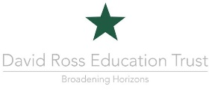

The academy is committed to safeguarding and promoting the welfare of children and young people and expects all staff to share this commitment.
How to Apply

For more information, please visit www.bobbymooreacademy.co.uk

If you would like to discuss this opportunity further, in confidence, or to arrange a visit please contact the Executive Principal, Steve West, via principal@bobbymooreacademy.co.uk

To apply please visit www.dretjobs.co.uk

Thank you for your interest in our school. We look forward to receiving your application.

