Job title: Science Technician
Candidate Briefing Pack
Closing date: 10 July 2026

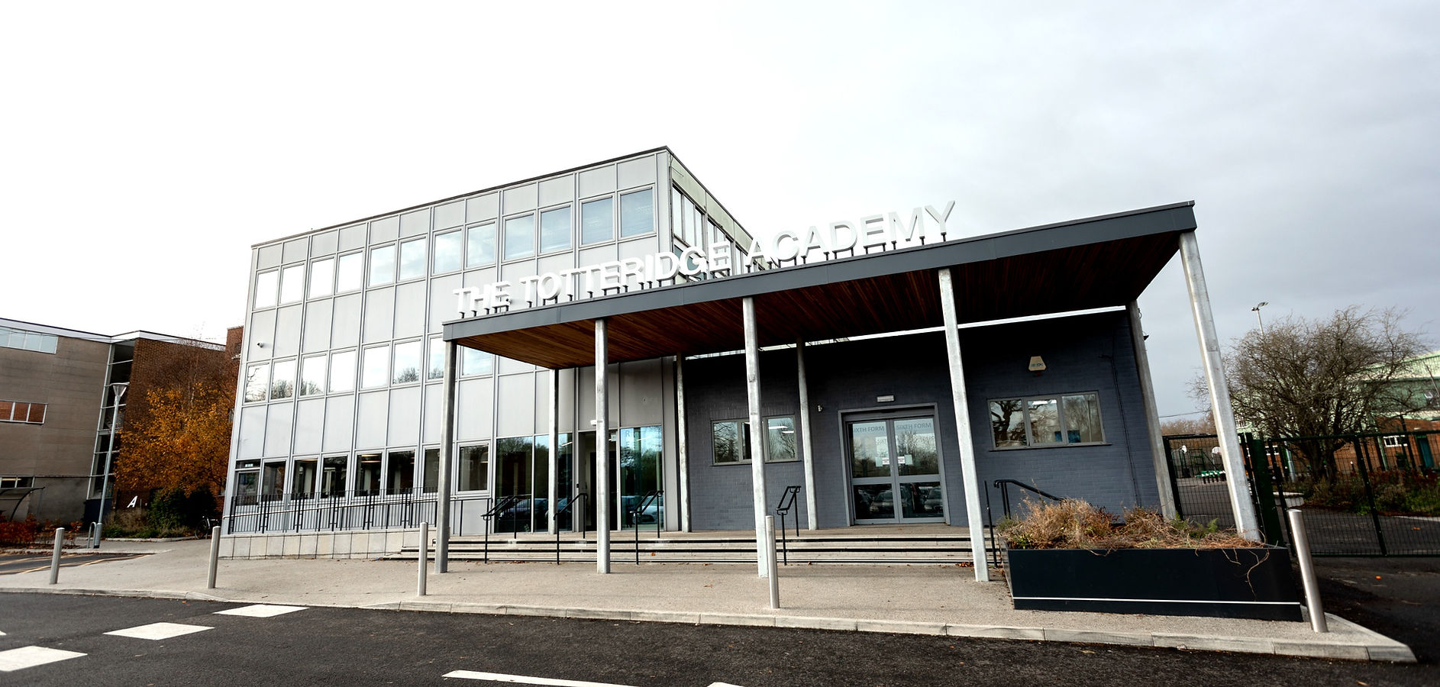

Welcome from our Principal/Headteacher
Dear candidate,
Thank you very much for your interest in joining The Totteridge Academy. I am delighted to introduce you to our academy, and I hope that this application pack provides you with an overview.
The Totteridge Academy (TTA) is a fantastic secondary school in North London and is continuing to grow and develop with over 1000 students currently on roll. The school provides a high-quality education in a safe, caring, and focused environment teaching skills and knowledge, enabling students to become responsible, well-rounded citizens, equipped with the tools to make effective choices for their futures. The school philosophy of kaizen (continuous improvement) enables students and staff to always aim high so that every individual can attain their best. Improving through practice; calm, focused classrooms led by knowledgeable, passionate teachers
Our school is part of United Learning, which means our teachers benefit from the best pay in the sector, three extra INSET days protected for your own planning, guaranteed paid personal days, great training for your career, and more.
If you are aligned with our mission and values, we very much look forward to hearing from you.
Good luck with your application and thank you again for considering The Totteridge Academy for the next stage in your career. If you have any questions regarding this role, please contact Jo Wiles on joanne.wiles@tta.org.uk
Best wishes,

Chris Fairbairn
Principal
The Totteridge Academy


Job Description
Job title: Science Technician
Location: The Totteridge Academy
Contract type: Part time / Full Time/ Term Time
Responsible to: Head of Science
The Role
We are looking for a part time Science Technician to join us at The Totteridge Academy
Hours:
- Minimum of 30 hours per week
- Term time only (39 weeks)
Salary and benefits:
FTE £30,000/ Actual Salary of £20,709 (30 hours) or £25,886 (37.5 hours)

About the role:
As a Science Technician you will be working as part of the technician team to provide effective technical, administrative, and organisational support to science teaching staff. This includes helping deliver high-quality teaching and learning across all science subjects, maintaining efficient systems and structures within the department, and staying up to date with relevant developments. The role also requires contributing to the smooth running of the Science department while ensuring that all work aligns with and supports the overall policies and practices of the academy.
You will contribute to maintaining a calm, focused learning environment and support effective behaviour management. Your patience, adaptability, and proactive approach will help ensure all pupils can achieve their full potential, both academically and socially.

Key Responsibilities

Overview

Support staff play an integral role in The Totteridge Academy’s commitment to kaizen — the continuous pursuit of improvement to enhance the life chances of every student in our care.

Purpose of the Role
As a member of the Science Technician team, you will provide high-quality technical, administrative and organisational support to enable outstanding teaching and learning across all Science subjects. You will contribute to the effective operation of the department, ensuring resources, systems and processes are maintained to the highest standard.

Key Responsibilities
- Provide technical and administrative support to science teaching staff
- Prepare, issue, maintain and store resources, apparatus and equipment
- Set up and clear away materials for practical lessons, ensuring safe handling and disposal
- Assist in the design and preparation of practical activities, experiments and specialist resources
- Maintain laboratories, preparation rooms, and equipment in a safe, clean and organised condition
- Monitor and manage stock levels, including chemicals and equipment, and raise orders where required
- Maintain accurate records, inventories and departmental systems
- Support the organisation and maintenance of learning resources, including textbooks and materials
- Contribute to high-quality displays within the department

Health & Safety
- Promote and maintain a safe working environment for staff and students
- Ensure compliance with Health & Safety regulations, including COSHH
- Carry out risk assessments and contribute to the review of safety procedures
- Provide guidance to staff and students on safe working practices
- Undertake training to obtain Radiation Protection Supervisor status and fulfil associated responsibilities

General Duties
- Support Academy events where required
- Maintain a consistently high standard of professionalism in conduct, communication and presentation
- Carry out additional duties as required to meet the needs of the Academy

Flexibility
This role requires a proactive and flexible approach. The post holder may be required to undertake other duties within the scope of the role, including supporting wider operational needs such as first aid cover, exam invigilation, and assisting students during assessments.

Specification
Education and Qualifications
 | Essential | Desirable
GCSE English and Maths (grade C/4 or higher). | Y
Relevant science qualification (e.g. NVQ Level 3 or equivalent) | Y
Certificate in First Aid / willingness to undertake training |  | Y
Health & Safety/ COSHH Training |  | Y

Experience
Experience working in a laboratary, school or technical environment | Y
Experience using ICT systems for stock control and record keeping | Y
Experience preparing materials and equipment for practical work | Y

Skills and Knowledge
Knowledge of laboratory procedures and safe handling of chemicals | Y
Good working knowledge of science (Biology, Chemistry and Physics) | Y
Understanding of health & safety requirements in a lab environment | Y
Ability to prepare, set up and maintain equipment for practical lessons | Y
Ability to carry out calculations and accurately prepare solutions | Y
Ability to use ICT for stock management and administration | Y
Awareness of safeguarding principles and procedures | Y
Ability to identify and manage risks in a practical environment | Y
Working knowledge of strategies available to support children with additional needs. | Y
Good problem-solving skills. |  | Y

Teamwork
Treats others fairly, with respect and consistently | Y
Works collaboratively and supports colleagues | Y

Personal Attributes and Abilities
High levels of professionalism; acts as a role model | Y
Commitment to the safeguarding of children | Y
Good written and verbal communication skills | Y
High attention to details and accuracy | Y
Self-motivated and able to use initiative |  | Y
Able to remain calm and respond effectively under pressure | Y
Commitment to promoting equality and diversity in what we do. | Y

Other
Commitment to safeguarding young people | Y
Enhanced DBS Check | Y
Right to work in the UK | Y



How to Apply
To join our dedicated and talented team, click apply here.
https://mynewterm.com/jobs/144502/EDV-2026-TA-43560
The closing date for this post is Midnight on Wednesday 8 July 2026.

For more information about this role, please contact:
Name / title: Jo Wiles, HR Manager
Telephone number: 02084459205
Email address: joanne.wiles@tta.org.uk

Please note: we reserve the right to close any vacancies from further applications when we have received a minimum amount of applications from which to make a shortlist. Please ensure you apply without delay if you wish to be considered for this role.

Rewards and Benefits
Our pledge, to all our academy teachers, is that by working for us you will benefit from more pay, more time, and more support. For more information, visit www.unitedlearning.org.uk/careers/rewards-and-benefits
More pay… | more time… | and more support
- We pay an average of 5% above national scales – the best rates of pay in the sector  - Cash towards medical treatment  - Generous staff discount scheme | - Three extra INSET days for planning  - At least one personal day a year | - Great training for your career  - Exceptional curriculum resources  - Expert subject advice  - Support for your wellbeing

Flexible Working
We value the dedication, professionalism and hard work of our teachers, support staff and school leaders, and strongly believe that everyone should be able to do their job without sacrificing a family life or compromising their well-being. We are committed to encouraging and enabling flexible working opportunities throughout our schools wherever possible and will support employees seeking to work more flexibly.
Important information
United Learning is committed to safeguarding and promoting the welfare of all children and young people and expects all staff and volunteers to share this commitment. All positions are subject to an Enhanced Disclosure and Barring check from the Disclosure and Barring Service (DBS) and shortlisted candidates will be subject to an online check. We also kindly request permission to seek references ahead of the interview process.



About United Learning
United Learning is a Group of schools which aims to provide excellent education to children and young people across the country. We seek to improve the life chances of all the children and young people we serve and make it our mission to bring out ‘the best in everyone’ – pupils, staff, parents and the wider community. We uniquely comprise schools in both the state and independent sectors.
As a Group, we can offer more to both staff and young people than any single school could offer alone. The growing range of outstanding group-wide activities that we can provide will mean that more young people will have truly exceptional and inspiring experiences.
We believe that our Group contains the most developed relationships and practical interaction between independent and state schools in the country, creating benefits for all the schools involved.
United Learning comprises both United Church Schools Trust, which operates our fee-paying independent schools, and United Learning Trust, which operates our state-funded academies.
To find out more about United Learning, please visit the website www.unitedlearning.org.uk.
The best from everyone
Our aim is to bring out the best in everyone. So, we must expect the best from everyone, all the time. Every child is a special individual, capable of extraordinary things. Who can know the limits of any child’s potential? So, we expect unreasonably – we constantly challenge children to do what they think they can’t, to persist, to work hard and to be at their best.
From every adult we expect the same: that they are at their best, expect unreasonably of themselves, are determined and resilient and pass those expectations on to the children in all they do. We act with the utmost love, care and good faith – the highest standards come with the greatest attention to the wellbeing of all.

