
Our Vision:
To develop aspirational learners who strive for excellence academically, creatively and culturally, benefitting from a wide range of opportunities led by inspirational educators.

Shirley High Academy
Performing Arts College

Striving for Excellence

Person Specification:
Post: School Improvement Lead - English
Line Manager: Principal

Qualification | Essential | Desirable
Honours degree or equivalent / Graduate status in subject area or related subject | √
Qualified Teacher Status | √
Evidence of commitment to continuing professional development / Evidence of relevant post-graduate training | √
Additional teaching qualifications or training |  | √
NPQSL, Masters or relevant qualification | √
Professional and Experience | Essential | Desirable
Passion for learning and inspiring others | √
Experience of leading training and development | √
Experience of significant line management | √
Experience of 11-18 education and ability to teach all phases of learning | √
Recent experience of working effectively with outside agencies, local community and Governing Body | √
Track record of improving student performance and exceptional student progress | √
Held experience as Head of Department, Director of Faculty or Lead Practitioner within identified Core subject | √
Experience of leadership in a least two schools | √
Has previously held a consultant position |  | √
Ability to form and maintain appropriate relationships and personal boundaries with staff and students | √
Proven track record of sustained strategic impact on middle leadership and above | √
Evidence of raising student achievement above national averages | √
Evidence of strategic thinking | √
Experience of involvement in developing and supporting colleagues through coaching, mentoring, planning and modelling | √
Have overall understanding of National Curriculum and developments affecting secondary education and curriculum developments | √
An understanding of how to lead a team of diverse people with an understanding of issues of EDI |  | √
An awareness of recent developments in Ofsted process |  | √
Experience of observing lessons and providing impactful and developmental feedback | √
Awareness of strategies that ensure engagement and progress of all groups of learners | √
Knowledge of best practice and procedures for safeguarding children and young people | √
Skills | Essential | Desirable
Sound knowledge of current educational developments, including the use of AI, IT and Remote Learning expertise | √
Strong analytical skills with regards leadership and getting the best out of colleagues | √
Ability to use target setting to create an aspirational environment for both students and staff | √
Ability to hold staff to account, drive improvement and challenge underperformance | √
Active involvement in curriculum development initiatives | √
Ability to analyse data to effectively track student progress and specifically all sub groups | √
Experience of managing a budget and resources successfully. |  | √
Ability to recognise individual learning needs and ensure suitable curriculum provision | √
Commitment to raising the achievement of all students of all abilities | √
The ability to lead and motivate colleagues including appraisal and continuous professional development to enhance their ability to deliver on the values of the school | √
Recognition of the need for partnerships and effective collaboration with other schools, agencies and organisations | √
Willingness to offer intervention, extended learning and catch up in line with leadership expectations | √
Personal Attributes | Essential | Desirable
Respect for all and consistently demonstrate the values of the school | √
Relentless drive for improvement and success. Strong belief that students have the potential to be the best | √
Ability to work as a team and create a professional environment where all are valued and heard | √
Excellent organisational skills, ability to work under pressure and meet deadlines | √
Ability to plan, monitor, evaluate and review | √
Communicate clearly and concisely both verbally and in writing, with all stakeholders | √
Ability to create innovative solutions to solve problems | √
Display integrity, be trusted and trust others ensuring commitments are kept and any conflicts resolved in a sensitive manner. The ability to encourage and motivate | √
Respect facts, evidence and show openness, be inclusive of others and seek support, where necessary | √
The ability to effectively manage the process of change with enthusiasm and positivity, including monitoring and setting of targets | √
To be a visible member of SLT who leads by example and is accessible, responsive and accountable | √
Be able to manage time effectively and ensure that the job is always completed to the standards expected | √

We want all at SHS to believe in and maintain the values of our school:

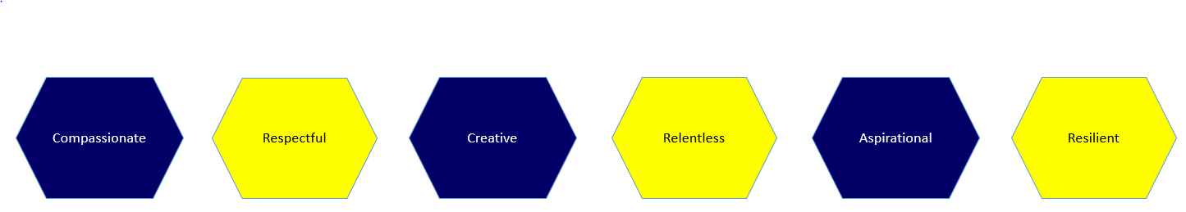

Signed: …………………………………………………………………………………………. Dated: …………………………………………………………

