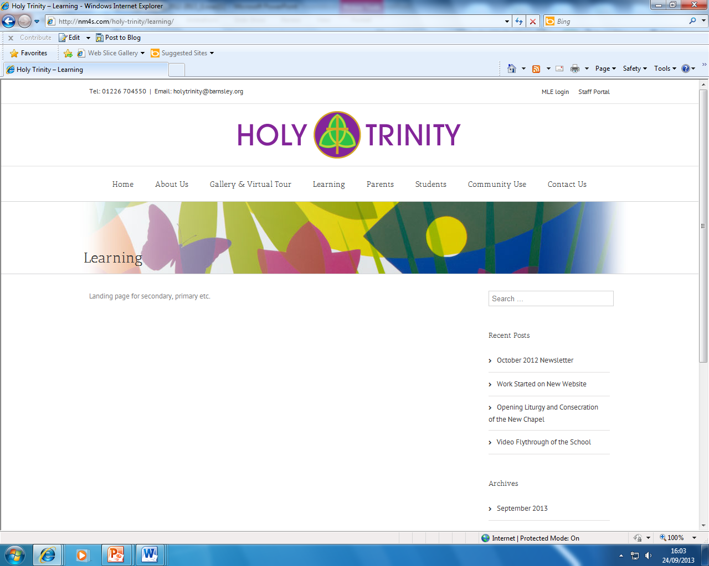

PERSON SPECIFICATION
POST TITLE: Clerical Support Officer – Attendance

ATTRIBUTES |  | ESSENTIAL | DESIRABLE | HOW IDENTIFIED
RELEVANT EXPERIENCE | Experience maintaining accurate, compliant, and up-to-date database records. |  |  | A/R
RELEVANT EXPERIENCE | Experience of working in a school environment |  |  | A
RELEVANT EXPERIENCE | Experience of administering first aid |  |  | A
RELEVANT EXPERIENCE | Proven experience using School Management Information Systems, specifically SIMS. |  |  | A
RELEVANT EXPERIENCE | Experience collaborating with families, pastoral teams, and external support agencies. |  |  | A
EDUCATION AND TRAINING | Level 2 qualifications in English and Maths |  |  | A
EDUCATION AND TRAINING | Evidence of relevant training in administration, data management, or education |  |  | A
EDUCATION AND TRAINING | Recent training in safeguarding and child protection
SKILLS AND ATTRIBUTES AND EXPERIENCE | Accurate keyboard skills and good working knowledge of Microsoft Office applications |  |  | A/I/R
SKILLS AND ATTRIBUTES AND EXPERIENCE | Ability to analyze complex data sets, identify trends, and produce clear reports. |  |  | A/I/R
SKILLS AND ATTRIBUTES AND EXPERIENCE | Good literacy and numeracy skills |  |  | A/I/R
SKILLS AND ATTRIBUTES AND EXPERIENCE | Excellent written, verbal, and interpersonal skills for dealing with sensitive situations. |  |  | A/I/R
SKILLS AND ATTRIBUTES AND EXPERIENCE | Accuracy and attention to detail |  |  | A/I/R
SKILLS AND ATTRIBUTES AND EXPERIENCE | Ability to maintain confidentiality |  |  | A/I/R
SKILLS AND ATTRIBUTES AND EXPERIENCE | Ability to organise and prioritise work and use own initiative |  |  | A/I/R
SKILLS AND ATTRIBUTES AND EXPERIENCE | Advanced skills in Microsoft Office (specifically Excel) and database management. |  |  | A/I/R
 | Ability to relate well to children and adults |  |  | A/I/R
 | Solid understanding of school safeguarding policies and welfare procedures. |  |  | A/I
ADDITIONAL FACTORS | Commitment to work in line with the school ethos and mission |  |  | A/I/R
ADDITIONAL FACTORS | Willingness to work flexibly in accordance with policies and procedures, to meet the needs of the school |  |  | A/I/R
ADDITIONAL FACTORS | Willingness to undertake training and continuous professional development in connection with the post |  |  | A/I/R
ADDITIONAL FACTORS | Ability to take initiative and fast-track urgent welfare checks for missing students. |  |  | A/I/R
ADDITIONAL FACTORS | Satisfactory enhanced DBS disclosure to work in an environment dealing with young people |  |  | A/I/R
ADDITIONAL FACTORS | Ability to form and maintain appropriate relationships and personal boundaries with children and young people |  |  | A/I/R
ADDITIONAL FACTORS | A commitment to safeguarding and promoting welfare for all |  |  | A/I/R
ADDITIONAL FACTORS | Calm under pressure when dealing with challenging conversations with parents or pupils.
ADDITIONAL FACTORS | Ability to build trust with vulnerable families while maintaining professional boundaries.
ADDITIONAL FACTORS | Exceptional accuracy in processing data, registers, and statutory coding.

A: Application, I: Interview, R: Reference

