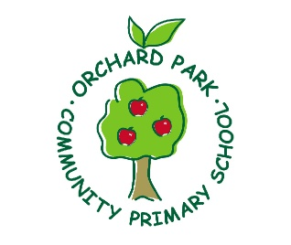

Orchard Park Primary School
Midday Supervisor Job Description
Main Duties and Responsibilities:
- To supervise pupils, during the lunch period, in dining hall, playground areas and school premises, ensuring the safety, welfare, physical and mental well-being of pupils and the maintenance of good order and discipline.
- To report to the co-ordinator at beginning of the lunch period and receive any instructions regarding duties.
- To monitor the behaviour of pupils discouraging in a positive way any anti-social behaviour and reporting any incidents to the class teacher or head teacher as appropriate.
- To ensure the safety and wellbeing of children, providing emotional support where necessary.
- To arrange and supervise appropriate activities under the direction of the head teacher or deputy head.
- To ensure that all pupils who suffer any injury or accident are dealt with appropriately in accordance with the school’s agreed procedures.
- To ensure that all children are safeguarded and their welfare promoted in accordance with school policies.
Dining Hall
- Before pupils enter the dining hall, to ensure that pupils have visited the toilet and washed their hands where appropriate.
- To organise dinner queue and entrance of pupils into dining hall and from dining hall to playground: ensuring good behaviour and calm atmosphere. To deal with any misbehaviour that may occur in accordance with the school’s behaviour policy. Report, as appropriate, incidents to the pupils class teacher or head teacher
- To encourage all pupils to eat but especially those with special needs or disabilities and to assist children with cutting up of food, pouring of water etc. where necessary.
- To encourage social skills and good table manners, ensuring safety with knives and forks.
- To clean up spillages of food and to organise clearing cutlery and crockery off tables.
Playground
• Where appropriate, to collect pupils from classroom ensuring that they are adequately dressed for the weather conditions.
• Monitor and follow the school’s behaviour policy.
Organise activities, games and resources as appropriate under the guidance of the headteacher or deputy head.

General
• To supervise pupils on the school premises in the hall, classrooms and in corridors when they are not allowed outside because of inclement weather.
• To ensure that, when classrooms are used during the Midday break because of inclement weather that the children are quietly occupied and that the classroom is left tidy, ready for afternoon school.
• To check toilet areas regularly to ensure that they are clean and being used appropriately.
To:
• take part in training appropriate to the job of midday supervisor, e.g. first aid
• to attend a half termly meeting
• take part in any appraisal arrangement made by the school.
• undertake any other duties consistent with the purpose of the job.

