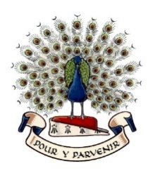
Lady Manners School

Curriculum Area of Physical Education
March 2026

The Physical Education Curriculum Area
The Physical Education Curriculum Area is part of the Personal and Physical Development Faculty. This faculty is led by a Director of Learning supported by three Curriculum Leaders, including the Curriculum Leader for PE.

Physical Education is a highly successful curriculum area renowned for the quality and range of opportunities it offers. The curriculum area is active, forward-thinking and constantly seeking ways of developing links to build on the strong tradition of sport within the school.

The PE Curriculum Area is currently staffed by six specialist teachers of PE. The members of the curriculum area complement each other in their interests and specialisms. All staff are highly committed to the extra-curricular programme offered to students.

Members of staff are encouraged to take on additional responsibilities to support our students and to ensure the continued development of the curriculum area. The curriculum and teaching are totally inclusive, with all students experiencing a full range of activities and all teachers expected to teach across the whole curriculum. Teachers are also encouraged to continue to develop their knowledge and skills to improve the quality of teaching within the curriculum.

Facilities
The curriculum area has the use of a full-size floodlit 3G football pitch, dance studio, fitness suite, additional changing facilities, three classrooms, floodlit tennis courts and an eight-lane grass athletics track. The curriculum area also has use of a sports hall, gymnasium, extensive playing fields, two artificial cricket pitches, outdoor nets and several hard play areas.

Curriculum
The two-week timetable is organised into a 25-period week.

Key Stage 3
Key Stage 3 consists of a balanced programme of activities, in line with the National Curriculum. The curriculum is based around six key areas including games, athletics, health and fitness, dance, outdoor pursuits, and gymnastics. The schemes of work are sequenced through the key stage, giving students the opportunity to develop the full range and level of skills.

The curriculum offers a comprehensive range of experiences to meet the needs of individual students and encourages active involvement in all as performers, observers, and officials. Students have two periods of PE a week, each lesson 60 minutes long. The curriculum covers all major sports, including rugby, football, netball, hockey, basketball, badminton, handball, volleyball, cricket rounders and athletics.

Key Stage 4: Core
Students follow a core curriculum of PE (one lesson a week). This follows the National Curriculum with the opportunity of choosing optional activities in the latter part of Year 10 and Year 11. In Year 10 students can select from two different pathways, either games or creative activities.

Key Stage 4: Examination Courses
In Key Stage 4, students can select from two different examination courses. The curriculum offers AQA GCSE Physical Education and OCR Cambridge National Level1/2 Sport Studies. Both courses are very popular with students achieving high grades. Students study across the following units: sport and exercise physiology, psychology of sport, performance and leadership, contemporary issues, and media.

Key Stage 5
In Key Stage 5, students can select a Level 3 qualification in OCR Cambridge Technical Extended Sport and Physical Activity. This qualification is equivalent to one A Level. The course covers exercise physiology, psychological applications in sport, sports performance and coaching, and contemporary issues in sports organisation. This is taught over 5 lessons per week. The teaching is usually split between two members of staff. Many students continue into Higher Education to follow sports related courses.

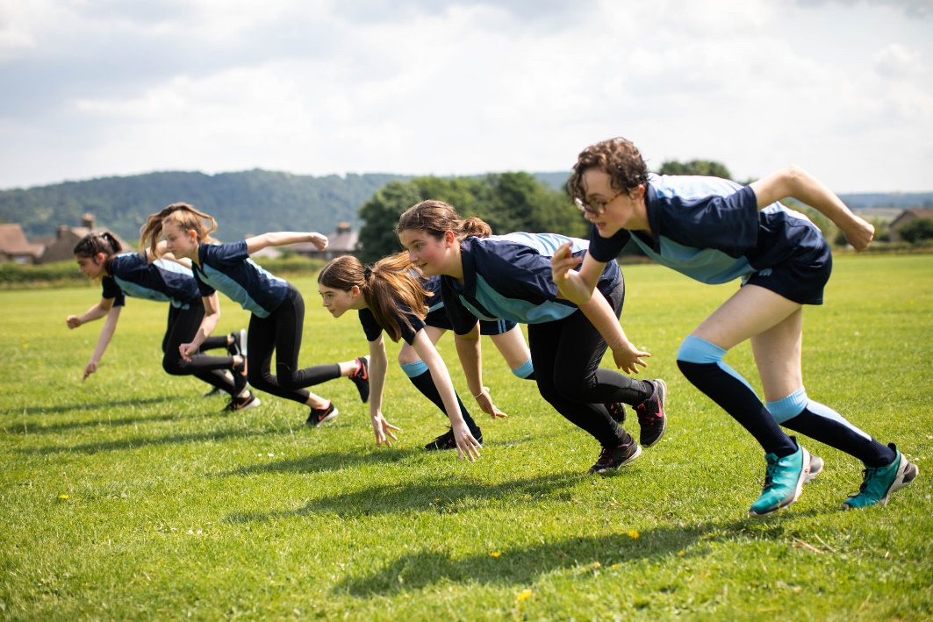

Accredited Courses
Sports Leaders Level 2: Students opt to undertake the Level 2 leadership qualification during their core Year 11 games lessons.

Higher Sports Leaders Level 3: This Level 3 leadership qualification is offered as an option in Year 12. The course is taught over 2 years. Students are given the opportunity to gain a national award in coaching and leadership, and experience planning and leading sporting events.

Extra-Curricular / External Links
The curriculum area offers a wide, varied and highly valued programme of extra-curricular activities during lunchtimes and after school for all abilities. There is a thriving House system which includes competitions in all main curriculum sports for all ages, allowing large numbers of participants to experience competition and team spirit.

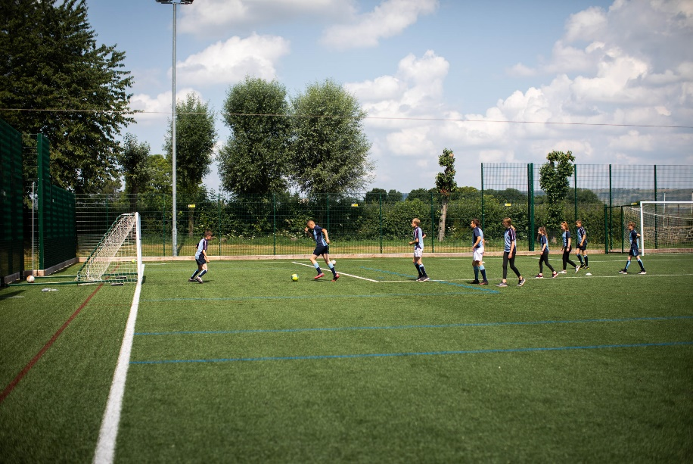
The school competes frequently in a range of activities at inter school, district, county, regional and national levels with great success. Opportunities are provided for students to visit and appreciate foreign culture with sporting tours and fixtures against visiting sides. The curriculum area also has excellent links for local clubs, giving students additional opportunities to participate in competitive and recreational sport.

The PE Curriculum Area offers opportunities to participate within a varied range of activities for all abilities. Clubs and practices are provided to develop students' skills and interests.

Extra-curricular clubs currently include:

Football Netball Dance Weight training
Cricket Gymnastics Tennis Badminton
Rugby Basketball Fitness Volleyball
Rounders Athletics Sports Plus Indoor Athletics

