


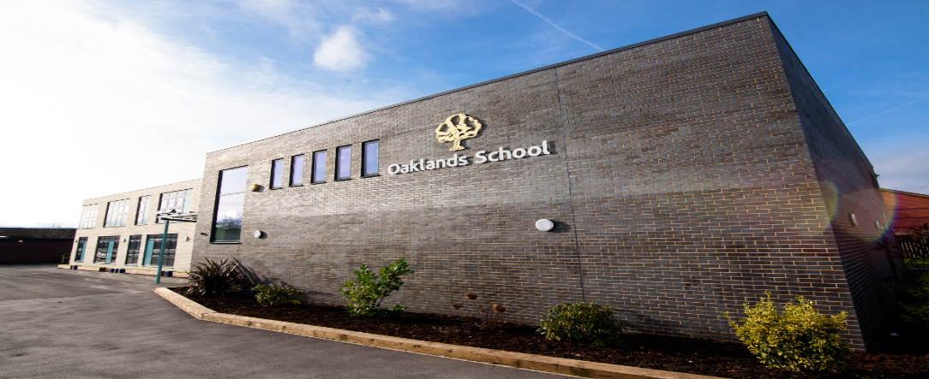

Montgomery Way, Winsford, Cheshire, CW7 1NU

Teaching Assistant
Permanent Appointment - Grade 6

Candidate Application pack
An OFSTED Outstanding School 2024/2025

Montgomery Way, Winsford
Cheshire, CW7 1NU
Telephone: 01606 551048

Head Teacher: Neil Oxley

16th September 2026

Dear Colleague
Re: Teaching Assistant – Permanent contract to start Monday 2nd November 2026 or as soon as available
Grade 6 – Term Time only – 33.5 hours per week

Thank you for showing an interest in this important position within our school. I hope that you find sufficient information enclosed to inform your decision and aid your application.
Are you:
Someone who wants to make a positive difference to young people?
An enthusiastic and committed professional?
Able to work as part of a successful multi-disciplinary team?
Committed to quality and equality of opportunity for all?
Dedicated to providing an excellent level of support for young people with SEND?
A person who is dedicated to supporting young people to thrive?
Then:
We would like to meet you! Visits to the school are welcome – please contact the school office to arrange a convenient time.

If you would like to apply for this exciting post, then please complete the enclosed application form and return to the school with a covering letter by noon on Monday 28th September 2026. Interviews will be held on Monday 5th October 2026.


The school is committed to safeguarding and promoting the welfare of our children and expects all staff and volunteers to share this commitment. Applicants must be willing to undergo child protection screening appropriate to the post, including checks with past employers and the Disclosure and Barring Service. In order to comply with Asylum and Immigration Act 1996 (as amended by S147 of the Nationality, Immigration and Asylum and Immigration Act 2002), all prospective employees will be required to supply evidence of eligibility to work in the UK. All candidates called for interview must bring with them three forms of identification, preferably driving licence, passport, birth or marriage certificate and a document showing their current address. In addition it is a requirement that copies of all relevant qualifications should be brought to interview.

An OFSTED Outstanding School 2013/2014, 2014/2015, 2019/2020 and 2024/2025
www.oaklandsschool.org

An OFSTED Outstanding School 2010/2011, 2013/2014, 2014/2015 and 2019/2020
www.oaklandsschool.org

This is a wonderful opportunity to make a positive difference to the lives of many young people and I look forward to receiving your application. Should you require further information prior to completing your application, please do not hesitate to contact me.

Yours sincerely
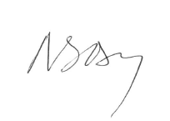
Mr N Oxley
Headteacher




INFORMATION ABOUT OAKLANDS SCHOOL

Type of School: Secondary Special School
School Category: Community
Age Range of Pupils: 11-17
Gender of Pupils Mixed
Number on Roll: 182
School Address: Montgomery Way
Winsford, Cheshire, CW7 1NU
Telephone Number: 01606 551048
E-Mail: admin@oaklands.cheshire.sch.uk
Appropriate Authority: Governing Body
Name of Chair of Governors: Mr John Williamson
Name of Headteacher: Mr Neil Oxley

CHARACTERISTICS OF THE SCHOOL
Oaklands is a child-centred outstanding school, where pupils learn in a nurturing and happy environment. The caring environment provided by the excellent and supportive staff, enables pupils to achieve their potential and experience many enriching and positive experiences. The ‘can do’ attitude and constant strive to improve ensures that Oaklands’ pupils are given the opportunity to succeed to the best of their ability.

Oaklands School is located in Cheshire West and Chester Local Authority and currently serves the whole of the previous Cheshire County. All pupils have an Education, Health and Care Plan with moderate learning difficulties stated to be their most significant difficulty. However, a small number of pupils also have severe learning difficulties, social and emotional difficulties, or speech and communication difficulties. In line with their learning difficulties, the attainment of pupils is well below what is expected for their age when they enter the school. There are three classes in each of the five year groups from Year 7 to Year 11, as well as a small sixth form, and these are organised largely by academic ability and appropriate educational pathways.

“The best for all, the best from all”

The Headteacher/Governing Body seek to appoint with effect from 2nd November 2026 or as soon as available:
An outstanding Teaching Assistant – Permanent contract
Grade 6 (33.5 hours – Term-time only)

We are seeking to appoint an outstanding teaching assistant, committed to raising the aspirations of students with learning difficulties.
Our pupils’ ability ranges begin at working significantly below national expectations on admission with our more able pupils achieving GCSE/level 2 qualifications. Our pupils are genuinely positive about their education and are a pleasure to teach.
Oaklands School is a unique secondary school for pupils with moderate and complex learning difficulties. The school is situated in the heart of Cheshire and our home Local Authority is Cheshire West and Chester.
Closing date for applications: Noon on Monday 28th September 2026.
Oaklands is a 2024/2025 OFTSED Outstanding School. Please see our website for further details.
The school is committed to safeguarding and promoting the welfare of our children and expects all staff and volunteers to share this commitment. Applicants must be willing to undergo child protection screening appropriate to the post, including checks with past employers and the Disclosure and Barring Service. Shortlisted candidates will also be subject to an on line vetting search, and will be required to complete a convictions and cautions declaration prior to interview.

CHESHIRE WEST AND CHESTER BOROUGH COUNCIL

JOB DESCRIPTION QUESTIONNAIRE

JOB TITLE | Teaching Assistant – including class cover (Special School) | JOB REF NO | AAAF5025

BASIC JOB PURPOSE: To support the teaching staff and work with the other support staff to enhance the development and education of pupils in accordance with the aims and policies of the school. Also, deputise in the absence of a teacher and conduct whole class lessons within an appropriate system of supervision by a qualified teacher which is not necessarily in the same classroom.
NO | MAIN RESPONSIBILITIES
1. | Using acquired skills, support and deliver learning activities and contribute to the development of work programmes to facilitate effective teaching and learning.
2. | Provide input into the planning and evaluation of learning activities for individuals and groups of pupils to enable the teaching staff to make informed decisions when developing their plans.
3. | Supervise the activities of individuals or groups of pupils both in and out of the classroom (including educational visits) to ensure their safety and facilitate their physical and emotional development in accordance with the school's behaviour management policy.
4. | Monitor individual pupil’s progress, achievements and development and report these to the teaching staff/line manager to inform decisions taken regarding the Individual Education Plan, Behaviour Plans and Personal Care Programmes for a pupil.
5. | Liaise with parents and carers in conjunction with the teaching staff to ensure effective communication concerning the pupils' well being.
6. | Record pupil information as specified by the teaching staff/line manager to ensure the schools information systems are maintained.
7. | Attend to the personal and physical needs of pupils so that their well being is maintained.
8. | Prepare and maintain learning resources and ensure that the classroom is kept tidy so that the needs of the lesson plans are met in a safe learning environment, which complies with relevant health and safety requirements.
9. | Display and present the pupils' work, under the direction of teaching staff so that it enhances the classroom environment and celebrates achievement.
10. | Attend staff and other meetings and participate in staff training development work and staff reviews as required
Notwithstanding the detail in this job description, in accordance with the School's/Council’s Flexibility Policy the job holder will undertake such work as may be determined by the Headteacher/Governing Body from time to time, up to or at a level consistent with the Main Responsibilities of the job.


PERSON SPECIFICATION

IMPORTANT
THE REHABILITATION OF OFFENDERS ACT
The provisions of the Rehabilitation of Offenders Act relating to the non-disclosure of spent convictions do not apply to this job, YOU MUST, THEREFORE, DISCLOSE WHETHER YOU HAVE ANY PREVIOUS CONVICTIONS ON THE BACK PAGE OF THE APPLICATION FORM.
If successful, you will also be required to apply for a Criminal Record Check from the Criminal Records Bureau. The level of check required for this job is Enhanced Disclosure. Where post holders are required to access ContactPoint, an enhanced disclosure will be required and will be reviewed every three years

JOB TITLE: Teaching Assistant-including class cover (Special School) GRADE: 6 F/T
DEPT/SERVICE: Children’s Services
UNIT/SECTION: Oaklands School JOB REF: AAAF5025
CRITERIA | ESSENTIAL | DESIRABLE | METHOD OF ASSESSMENT
Qualifications | - Experience of working with SEN students.  - Good standards of literacy and numeracy | - Evidence of further professional development | Application form
Experience | - Experience of working closely with a class teacher  - Ability to support teacher and colleagues to implement strategies and education plans  - Experience of primary phase or Secondary SEN support. | - Experience of supporting whole school literacy  - Experience of supporting children with MLD & Complex Needs | Application form and interview
Job Related Knowledge | - An understanding of the needs of pupils with moderate or complex learning difficulties and a willingness to learn and develop this understanding. |  | Interview
Skills and Aptitudes | - Committed to providing the best for our pupils  - High expectations of self and pupils  - Ability to work as part of a team  - Ability to work independently showing initiative  - Good communication skills | - Computer literate (Microsoft Word & Excel)
Other Requirements | - A friendly outgoing personality with a good sense of humour

Note: Cheshire West and Chester Council is committed to supporting people with disabilities and will make reasonable adjustments to these requirements where this enables a disabled person to do the job effectively.

Oaklands School
Montgomery Way, Winsford, Cheshire, CW7 1NU
Tel: 01606 551048
Email: office@oaklandsschool.org
Website: www.oaklands.cheshire.sch.uk
