

Stratton School
Cleaner
Recruitment Pack


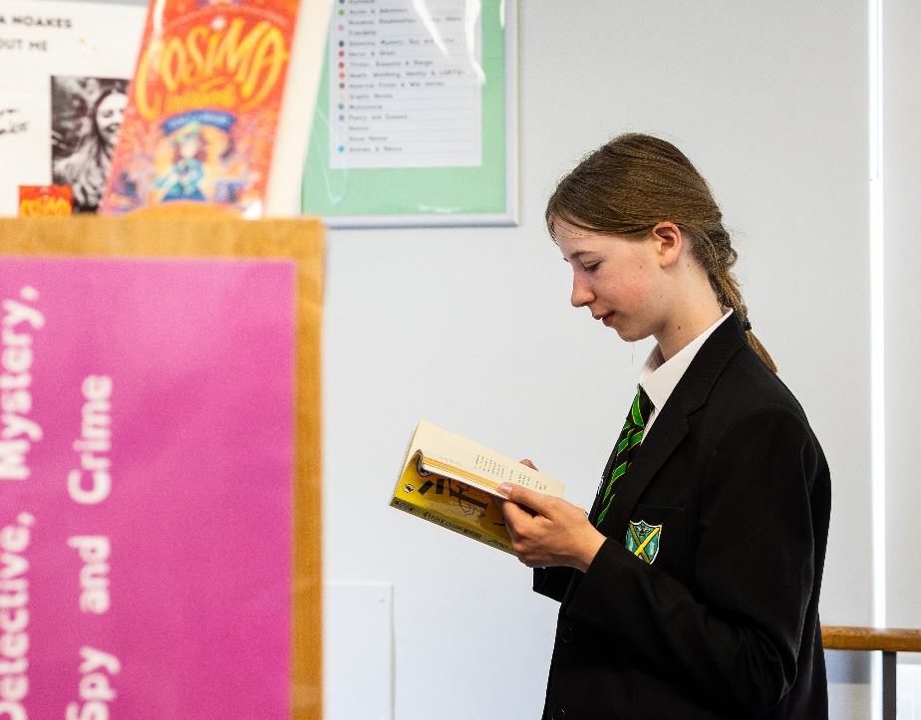

Content

About Stratton School 3

A brief history of our Trust 4

Our Vison, Mission and Values 5

Why work for us 6

How to apply 6

Job description and Person Specification 7

About Stratton School
Principal: Sam Farmer


My journey to Stratton has taken me to many exciting schools and differing roles over my 20 years in education. I am an English teacher at heart but have also enjoyed opportunities to teach a variety of subjects over the years.

I challenge every child at Stratton to be the best they can be, and we promote a ‘can do’ culture in which everyone is encouraged to strive for excellence. We work in partnership with parents and carers to uphold the traditional values of respect and tolerance, resulting in harmony within our community, where the contribution of every individual is valued.

Stratton School is proud to be at the heart of its community and we have a long history of supporting our students in achieving their goals. We are committed to nurturing the abilities of every student in order to equip them with the qualifications and personal skills they need to become confident, independent adults and successful citizens of tomorrow.

At Stratton, we set the highest expectations in terms of learning and behaviour, and follow a broadly academic curriculum that includes English, mathematics, science, humanities and languages supplemented with strong provision in the arts and technology. Most students join our thriving Sixth Form, with many progressing to university. However, recognising that some individuals’ abilities lie in other areas, we provide a wealth of opportunities and courses that allow every student to develop and showcase his or her unique talents.

We will be doing our utmost to ensure every student enjoys ideal conditions for learning. That process starts with the creation and maintenance of a calm and orderly environment where students feel safe and secure. At Stratton School, our identity is built on a foundation of academic excellence, creativity, and a strong sense of community. We value diversity and strive to create a welcoming and inclusive environment where every student can thrive and reach their full potential.


A Brief History
Meridian Trust, formerly known as Cambridge Meridian Academies Trust (CMAT), is a values-led Trust and has risen to be one of the highest performing academy groups in the country. Our Trust was first formed as an educational trust to create a federation of schools in 2006 with a desire to provide high quality and dynamic education for everyone, right in the heart of our community. Through various government policies, our commitment to collaboration has remained consistent.
Meridian Trust was formed in 2011 to deliver more widely on that clear vision to provide high quality and dynamic education for all at the heart of the communities we serve. Our steady growth since then reflects our commitment to the communities we serve and our track record of success. The period since 2018 has seen an increase in speed of growth as many long term projects matured and our relationship with Sharnbrook Academy Federation emerged.
We are currently a family of 35 academies (including 19 primary, 3 special and 13 secondary schools). The secondary schools include a University Technology College, an Upper School, four 11-16 schools and six 11-18 schools. We also have 2 new secondary free schools in development. All within 20 miles of Cambridge and Peterborough and the main communication routes between. We merged with Cambridge Primary Education Trust to become the Meridian Trust in April 2022. In addition to operating schools, we are the home of the Cambridgeshire and Peterborough Teaching School Hub, and train more than 150 new teachers each year through Meridian Trust ITT. We retain a strong commitment to growing and supporting staff throughout their training and career development. We have a proven track record of school improvement and transforming the lives of children and young people over the last 10 years.
Students thrive in Meridian Trust academies as a result of the implementation of our values, our successful and proven systems and our commitment to valuing people. We are among the highest performing multi-academy trusts in the country for student progress. Our academies are well-run and our staff benefit from excellent access to professional development.
Our commitment to the education system goes beyond just our own academies. We operate ’The Cambridge Partnership‘, one of the largest initial teacher training providers in the country which has recently merged with the SAF ITT, and ‘Leadership East’ these further strengthen our capacity and commitment to professional development. We also provide support through various SLAs to a number of other trusts and academies.

As a strong, regional multi-academy trust we currently operate schools across Bedfordshire, Cambridgeshire, Lincolnshire, Peterborough, and Northamptonshire. We are proud to have strong partnerships within all these communities.

Trust Vision, Mission and Values
Our values and who we are:
Meridian Trust is a successful multi-academy trust founded on its commitment to people and communities.
Our proven approach over more than a decade has elevated us to a respected and admired academy trust, a national leader in education and a source of great pride to the communities we serve.
Every child is known, equally valued and supported to achieve their potential in all our academies. Every community we serve benefits from the facilities and services we provide.
Our staff benefit from strong networks, excellent career opportunities and a human approach where they are equally valued and supported.
We ensure that well-run schools retain and develop their distinct contextual identity, while sharing and contributing to Meridian Trust values, practices, curriculum approaches and operational systems.
Our Vision:
High-quality educational provision for all at the heart of local communities.
Our Mission:
To deliver, promote and inspire high quality educational provision in schools at the heart of their local communities so that:
- Young people become successful learners and confident, empowered individuals;
- Young people are encouraged to think for themselves and act for others, equipping them with the values, attributes, knowledge and skills to make a rewarding contribution to society;
- Every school is a hub for community activities, a centre for extended services and a source of immense pride for students, their families, and other local stakeholders;
- Our staff benefit from strong networks, excellent career opportunities and a human approach where they are equally valued and supported;
- Well-run schools retain and develop their distinct contextual identity while sharing and contributing to the Meridian Trust values, practices, curriculum approaches and operational systems.
The enactment of our values for staff:
Engaged, developed, supported, and consulted.

Experts who strive for continual development. Collaborative networks, trusted to deliver.

Set ambitious goals and model what success looks like. Eager to improve.



Make connections, provide opportunities. Generous and sharing of knowledge and
expertise.

Are accountable for the outcomes we contribute towards and strive for the very best.

Why work for us
Meridian Trust aims to be the employer of choice for the communities we serve. Since 2010 we have nurtured and developed the careers of many people. You can read about some of those journeys in the 'Meridian Trust People' section of this website. We are committed to making a difference to young people’s lives and the communities we serve. Help us make our mission a reality.
Benefits:
As a multi-academy trust of 35 schools, Meridian Trust can provide a wide network of opportunities for collaboration and career development for both teaching and support staff. With an initial teaching training facility and a teaching hub network within our Trust, there are ample opportunities to both, get into teaching, and develop within the profession.
- As well as the above we also offer:
- Unlimited access to CPD via Meridian Learning
- Free annual eye tests
- Access to a free Employee Assistance Programme, offering mental health and wellbeing support
- Unlimited value cycle to work scheme

To see the full range of benefits available, please visit Employee Benefits - Meridian Trust

How to apply
To apply please complete the online form on MyNewTerm . Your supporting statement should address and evidence the selection criteria detailed in the Person Specification.
Closing Date: 27.01.2026
Interviews: w/c 02.02.2026
Applying:
For any questions about the application process please contact:
Email: HRRequest@stratton.school

Meridian Trust is committed to safeguarding and promoting the welfare of children. All appointments will be subject to satisfactory pre-employment checks including enhanced DBS disclosure. We are committed to diversity & inclusion and equality of opportunity for all staff and applications from individuals are encouraged regardless of age, disability, sex, gender reassignment, sexual orientation, race, religion or belief and marriage and civil partnerships. Meridian Trust is committed to safer recruitment practice and pre-employment checks will be undertaken before any appointment is confirmed. This post is subject to an enhanced disclosure and barring service check. We expect all adults who work for the Trust to share our commitment to safeguarding and the health and wellbeing of our students.

JOB DESCRIPTION AND PERSON SPECIFICATION
Job Title: | Cleaner
JD Reference: | STD SIT 01
School/Academy: | Stratton
Weeks: | 39
Hours of work: | 10
Salary: | Grade 2
Responsible to: | Cleaning Lead / Supervisor

Role: | Cleaner
Purpose of the job: | To maintain school premises to the required standard of cleanliness. Clean all rooms, toilets, cloakrooms, staircases, corridors, halls, laboratories and all other areas in designated cleaning section.

Responsibilities and Accountabilities:
- To carry out cleaning work to the required standard and as instructed by the Cleaning Supervisor.
- To operate effectively both domestic and industrial type cleaning equipment e.g. floor polishers, vacuum cleaners etc.
- To report to the Cleaning Supervisor matters that are likely to affect their work or other matters they consider that they should be aware of.
- To use cleaning materials appropriately and economically; to inform the Cleaning Supervisor when stocks are low.
- To ensure that tools and equipment are in good working order, reporting any faults to the Cleaning Supervisor.
- To ensure that cleaners’ storage lockers and cupboards are kept clean and tidy.
- To undertake any non-routine cleaning tasks as instructed by Cleaning Supervisor.
- All cleaners are required to contribute to major cleaning tasks during the school summer holiday period where necessary.
- To work to Academy guidelines at all times particularly in relation to the health and safety policy.
- To attend all essential health and safety training courses as determined by the management of the school.
- To maintain confidentiality at all times in respect of school-related matters and to prevent disclosure of confidential and sensitive information.
- To undertake any other duties of a similar level and responsibility as may be required.

Support for School/Academy/Place of work:
- Participation in staff events by arrangement
- Attend Staff Meetings
- Contribute and participate in Trust events and activities where possible
- Develop and maintain effective working relationships with other staff and parents/carers
- Adhere to the Trust values
- Follow school policies, practices, and procedures

Data security:
- Follow the legal provisions regulating confidentiality and security of data and information under GDPR

Health and Safety:
- Be aware of the responsibility for personal Health, Safety and Welfare and that of others who may be affected by your actions or inactions
- Co-operate with the Trust on all issues to do with Health, Safety & Welfare
- Work/operate all equipment within Health and Safety and other legal regulations, including risk assessments
- Contribute to the maintenance of a safe and healthy environment

Continuing Professional Development:
- In conjunction with the line manager, take responsibility for personal professional development, keeping up to date with research and developments related to school/academy/place of work efficiency, which may lead to improvements in the day-to-day running of the Trust
- Undertake any necessary and identified professional development taking full advantage of any relevant training and development available, particularly when related to the use of ICT, for data management and record keeping
- Maintain a professional portfolio of evidence to support the Performance Management process – evaluating and improving own practice

Child Protection and Safeguarding
- The post holder will have a shared responsibility for safeguarding all children and young people. The post holder also has an implicit duty to promote the welfare of all children and young people
- Inform the Child Protection Officer of any issues relating to the safety and well-being of students

The post holder will undertake any other duties commensurate with the grade of the post, in consultation with the line manager.

This job description is subject to review and may be changed following consultation with the post holder. It is not a comprehensive statement of procedures and tasks but sets out the main expectations of the Trust in relation to the post holder’s professional responsibilities and duties.

The Trust is committed to safeguarding and promoting the welfare of children and young people and expects all staff and volunteers to share in this commitment. All staff will be subject to an enhanced check with the Disclosure & Barring Service.
Updated: September 2022

Person Specification:  Cleaner | Assessment Key:  A = Application Form  I = Interview

Education and Qualification |  | Essential | Desirable | Assessment
1 | Basic standard of literacy to read instructions | √
2 | Ability to understand instructions | √
3 | Trained to NVQ standard |  | √
Experience |  | Essential | Desirable | Assessment
4 | Previous experience in a similar post |  | √
Knowledge and understanding |  | Essential | Desirable | Assessment
5 | Ability to work as member of a team | √
6 | Ability to work under pressure at times | √
7 | Knowledge of Health and Safety Regulations, e.g. COSHH Regulations |  | √
Skills and abilities |  | Essential | Desirable | Assessment
8 | Ability to undertake all the physical aspects of the post | √
9 | Ability to move and use domestic and industrial type cleaning equipment (polishers, vacuum cleaners etc) | √
Personal Qualities |  | Essential | Desirable | Assessment
10 | Commitment to achieving high standards of cleanliness and hygiene | √
11 | Willingness to work additional hours when needed | √
12 | Willingness to be flexible | √
13 | Willingness to undertake training if required | √
14 | Trustworthy and reliable | √
Child Protection |  | Essential | Desirable | Assessment
15 | Support the Academy policies on safeguarding and child protection | ✓
Other |  | Essential | Desirable | Assessment
16 | The flexibility of working hours | ✓
17 | Willingness to wear personal protective equipment as supplied. | √

