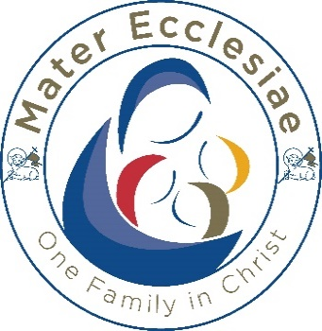

St. Augustine’s
Catholic Primary School
Member of the Mater Ecclesiae Multi Academy Trust

The Mater Ecclesiae Trust and Governors of St Augustine’s Catholic Primary School wish to appoint a temporary teacher to join our happy and successful team from end of Spring term/beginning of Summer term 2026
CLASS TEACHER KS1
QUALIFICATIONS: Qualified Teacher status
SALARY: Main Scale depending on experience
WORKING PATTERN: part time:
5 mornings and 3 afternoons (PPA included)
CONTRACT: Fixed Term from tbc to 31.12.26
We are looking for someone to embrace our Mission Statement:
“Our Catholic school is united in God’s love, enabling everyone to grow in love for one another and to develop in faith. We strive for all children to achieve their best by becoming active and confident learners in a nurturing and caring environment. We guide everyone to shine in their own unique way.”
‘Unique and United in God’s love. We let our light shine’
We wish to appoint an excellent classroom practitioner dedicated to enabling all children to reach their full potential and who has the ability to nurture and inspire, challenge and motivate pupils and staff alike.

We can offer you:
- A caring, happy and successful school with a strong Catholic ethos where everyone is valued
- A strong, dedicated and welcoming team of governors, staff, parents, volunteers and children
- A committed, supportive Governing Body with a clear vision for the development of the school

The successful postholder will work in y1 in the mornings and Y1/2 across the three afternoons.

Safeguarding
Our Trust is committed to safeguarding and promoting the welfare of children and expects all staff and volunteers to share the commitment and undergo an enhanced DBS check. The successful candidate will be appointed under the terms and conditions of a CES contract which they will be required to sign. The employer will be the Mater Ecclesiae Catholic Multi Academy Trust.
The post you are applying for is covered by the Rehabilitation of Offenders Act 1974(Exceptions) Order 1975 (as amended in 2013), If successful you will be required to apply to the Disclosure and Barring Service (DBS) for a ‘Disclosure.’ Information provided by you or the Disclosure and Barring Service will be dealt with in a confidential manner in accordance with the DBS’s Code of Practice. You may view the Code of practice on the DBS website at www.gov.uk/dbs or alternatively a copy is available on request.
Mater Ecclesiae has adopted Lancashire County Council’s policy Statement on the Recruitment of Ex-offenders. This is available to all applicants upon request. Please note that in line with Keeping Children Safe in Education 2025 an online search will be carried out as part of our due diligence on shortlisted candidates.

