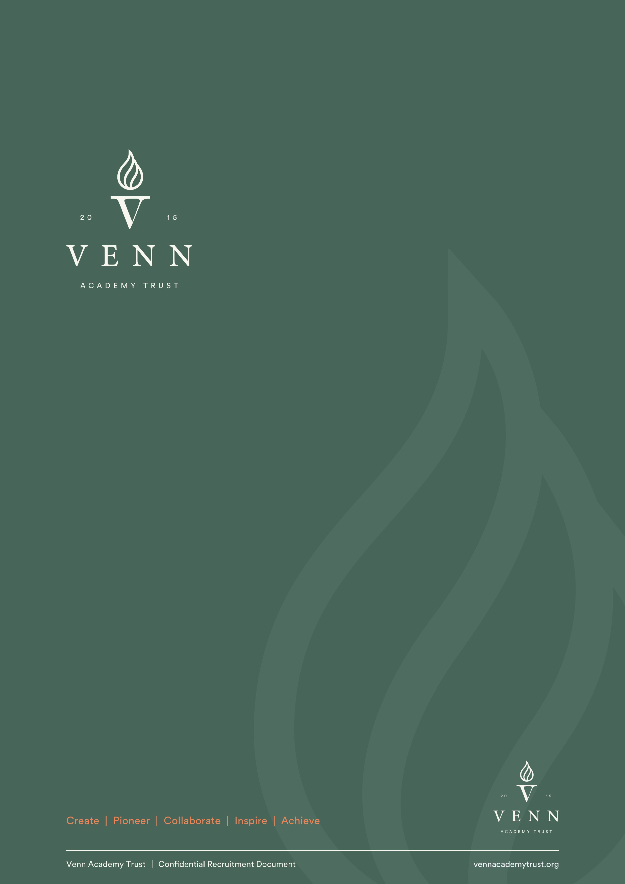
Regional Catering Manager

Appointment: September 2026

Salary: Grade 8 (£36363 - £39152 FTE)
Contract: Term time only, plus 5 training days, plus 5 days in the holidays
(actual salary £32509 – £35002)
Status: Permanent

Context

About Venn Academy Trust

Venn Academy Trust was established in 2015 through the partnership of two Headteachers determined to build something different: a trust rooted in inclusion, discipline and high expectations. Since then, Venn has grown to fourteen settings across four local authorities, spanning mainstream, specialist and alternative provision.
Our schools are independent in character and design. Each academy is shaped around the needs of its pupils and community, with its own curriculum model, staffing structure and operational approach. What binds them together is clarity of culture, disciplined safeguarding, strong behaviour systems and an unwavering belief that every child deserves a high quality education.
Venn has established a strong reputation for specialist provision across a broad range of need. This includes Social, Emotional and Mental Health needs, Speech, Language and Communication needs, Autism, Moderate and Severe Learning Difficulties, medical provision and alternative pathways. Our expertise lies not in one category of need, but in building environments where complex learners can succeed.
The central team, plays a key role in ensuring all our schools work as efficiently and effectively as they can.

Context

Venn’s Values

Pioneer
We design provision that meets need rather than convenience. Where existing systems are insufficient, we build new ones.

Inspire
We develop resilient, confident learners who are equipped to navigate challenge and embrace opportunity.

Achieve
We expect strong progress and meaningful personal development for every pupil, regardless of starting point.

Collaborate
We work alongside families, commissioners and communities to secure sustainable outcomes.

Create
We build cultures where all pupils are welcome, known and supported to achieve their full potential.

Role: Regional Catering Manager
Salary: Grade 8
Start Date: September 2026
Location: Based out of Adwick but working across all Venn schools in the South
Contract: TTO + 10 Permanent

  - Help us make fabulous school dinners the norm across our schools in the south.
We are looking for a Regional Catering Manager to lead and develop our catering service across our South hub schools. Under the leadership of the Director of Operations, you will oversee kitchen teams, support menu planning and production, and drive a consistently high-quality, great-value service that champions healthy eating and minimises waste. You will travel between sites, building relationships and inspiring excellence.
- Lead, support and develop kitchen teams across multiple school sites
- Work with Principals and School Business Managers to plan menus that are compliant, nutritious and popular
- Improve systems and standards across kitchens (including ordering, auditing and reducing food waste)
- Ensure excellent food hygiene, health & safety and allergy management across all sites
- Monitor suppliers and reporting to ensure value for money
- Cover when necessary to ensure continuity of service
If you are an experienced catering leader who is passionate about delivering great food for children and building strong kitchen teams, we would love to hear from you.
For an informal conversation please contact Lynsey Cook, Director of Operations lcook@vennacademy.org

Context

About this role

To lead and develop the Venn catering service in line with the catering strategy to ensure low cost meal prices, good quality food and zero waste.

The Catering Manager will oversee the management of kitchen staff and meal production and the entire catering service across their hub within the trust, ensuing value for money and championing healthy eating. The Catering Managers will work closely with the Principals and SBMs, under the direction of the DOO, to ensure the best service for each site, and across the trust.

Principle Accountabilities

Safeguarding
- To promote and safeguard the welfare of children, young people and/or vulnerable adults.
Staff Management
- Direct responsibility and supervisory guidance for the day to day management/supervision of all Head Cooks and General Catering Assistants, in liaison with SBM’s and Principal’s
- To keep morale of kitchen staff high
- To carry out the effective recruitment, selection and induction of all site based catering staff. To carry out probationary reviews, return to work interviews, performance management reviews and the like for all staff in the kitchen in partnership with the SBM/Headteacher.
- To keep communication high – to be responsible for dissemination of all relevant information, including leading team meetings, providing high quality advice and guidance to staff and leaders on all things catering related.
- To ensure all relevant and required training is assigned/delivered to kitchen staff, and staff have a good understanding of food hygiene, H&S, allergies and customer service.
- Ensure that staffing levels are sufficiently organised to meet customer demand and are cost effective.
- To provide leadership and support and training to catering staff so that they can develop and provide high quality services in each school, covering where needed for staff absence.
Meal Planning and Provision
- To work with principals to produce menus to ensure good value for money, adhere to government legislation, optimum nutritional value for growing children, and sufficient variety to maintain popularity
- Be creative in terms of theme days, school workforce census days,
marketing materials.
- Ensure all allergies are catered for and food appropriately label
Administration
- Ensure all catering staff kitchen training records are kept up to date
- Carry out regular audits across the kitchens to ensure compliance and report back any findings to the schools.
- Monitor compliance in terms of health and safety, environmental health, cleanliness and appropriateness of equipment, risk assessments and contracts of equipment.
- To roll out appropriate systems (eg School Grid) to ensure accuracy of ordering, and a reduction of food waste, centrally monitoring school meal take up.
- Under the direction of the DOO, promote a professional image to customers and external parties so as to build confidence in the services that Venn Catering can provide to new schools who join.
Accounting
- Oversee the keeping of records of orders, invoices, receipts, returns and issues in a form which is capable of audit.
- To monitor and review trust wide data to ensure best value with suppliers and a cost-effective, ever improving service is run.
- Liaise with the finance team to ensure all record keeping is accurate ensuring financial probity, and an accurate fiscal picture of the service.
- To produce reports on the catering service to the DOO, about the trust wide catering service.
- Ensure that staff costs, food costs and equipment costs remain within the set budget and highlight to heads/the Director of Finance/DOO any requirement to deviate from these.
Safety and Hygiene
- The Health and Safety at Work etc. Act 1974 and associated legislation places responsibilities for health and safety on the school, as your employer and you as an employee. In addition to the employer’s overall duties, the post holder has personal responsibility for their own health and safety and that of other employees; additional and more specific responsibilities are identified in the schools’ health and safety policy.

Job Description

Key Responsibilities

Responsibility for Staff
Lead the kitchen teams alongside the Principal/SBM at each site

Responsibility for Customers/Clients:
The post holder is responsible for the health, safety, welfare of staff in the kitchen area - this will include the compilation of formal risk assessments.
Responsibility for Budgets:
Influence over the headteacher’s budget for catering

Responsibility for Physical Resources
The post holder is responsible for the trust kitchens, alongside the headteacher, for the day-to-day care and cleanliness of the equipment in the designated area, including routine safety checks.

Working relationships

Within the wider Multi Academy Trust
The post holder will supervise and manage all kitchen staff, in partnership with Heads and SBMs.

With External Bodies to the Venn Multi Academy Trust
There will be a need to liaise with numerous bodies external to the trust with the
key contacts being:
- Health and Safety experts
- Environmental Health
- contractors.

Job Description

Structure Chart
Northern Hub
Catering Manager x 2
Southern Hub
Director of Operations
Person Specification
The information listed as essential (shaded column) is used as part of the job evaluation process. The requirements identified as desirable are used for recruitment purposes only. Codes: AF = Application Form, I = Interview, CQ = Certi cate of Quali cation, R = References (should only be used for posts requiring DBS), T = Test/Assessment, P = Presentation.

Criteria | Essential | Desirable | Identified
01. Qualifications
Degree or relevant experience at a manager level | x |  | AF/CQ
Recognised catering skill qualification (C&G at an appropriate level) | x |  | AF/CQ
Adequate level of literacy and numeracy (GCSE English & Maths) | x |  | AF/CQ
Level 3 H&S qualification (or willing to obtain) | x |  | AF/CQ
Level 3 Food Hygiene Certificate (or willing to obtain) | x |  | AF/CQ
02. Relevant Experience
Experience of working in a school or public sector establishment | x |  | AF
Experience of working within the catering industry | x |  | AF
Experience of manual handling procedures |  | x | AF
Experience of managing staff over a number of sites with success |  | x | AF
Experience of menu planning |  | x | AF/I/R
03. Skills
Motivation to work with children and young people | x |  | I
Ability to form and maintain appropriate relationships and personal boundaries with children and young people | x |  | I / R
Ability to use own initiative and prioritise work | x |  | I / R
Ability to work constructively as part of a team |  | x | R
Ability to work under pressure and to deadlines and plan in advance | x |  | I/R
IT skills to input into systems, and to extract and analyse data | x |  | I/R
Ability to write reports to a variety of audiences | x |  | I
04. Knowledge
A knowledge and commitment to safeguarding and promoting the welfare of children and young people | x |  | I/R
Sound knowledge and understanding of food guidelines and food safety legislation and health and safety legislation | x |  | I / R
A knowledge of nutrition and healthy eating issues | x |  | I
05. Interpersonal/Communication Skills:
Ability to establish professional, effective working relationships with a range of partners/colleagues and children and young people | x |  | R
Ability to interact using influencing skills, negotiating and training kitchen staff | x |  | I / R
Ability to managing a team of staff over several sites | x |  | I / R
Ability to discuss difficult situations and personal information with staff | x |  | I / R

06. Written Skills
Ability to produce written / email correspondence conveying simple instructions, guidance or information |  | x |  |  |  | R
Ability to draft reports including figures and input into relevant computer systems.
07. Other
Willingness to work at other schools within the trust is necessary and a vehicle to travel around in your own vehicle is essential |  | x |  |  |  | A, I
Additional Requirements
None
Disclosure of Criminal Record:
The successful candidate’s appointment will be subject to the Trust obtaining a satisfactory Enhanced and Barring List Disclosure from the Disclosure and Barring Service | x |  |  |  | DBS DISCLOSURE
If the postholder requires a DBS disclosure the candidate is required to declare full details of everything on their criminal record | x |  |  |  | AF (after short listing)
If the postholder does not require a DBS disclosure the candidate is required to declare unspent convictions only |  |  | N/A |  | AF (after short listing)

Context
Additional information

For an informal conversation about the role, please contact Lynsey Cook, Director of Operations lcook@vennacademy.org

Closing date: Wednesday 3 June 2026 at 9am
Interviews: w/c 8 June 2026

Venn Academy Trust is committed to achieving fairness and equality in employment and welcomes applications from all sections of the community.

Our Trust is fully committed to safeguarding and promoting the welfare of pupils and expects all staff to share this commitment.

The successful candidate will be required to undertake an Enhanced DBS check.
Online searches will be carried out as part of Venn Academy Trust’s recruitment due diligence
for all shortlisted candidates, in line with Keeping Children Safe in Education.

