



PT SEND Teaching Assistant Temporary
Tornedale Infant Academy

RECRUITMENT INFORMATION PACK

Contents
- Headteacher’s Letter
- Trust Vision, Value and Strategy
- Application Process
- Vacancy Advertisement
- Job Description
- Person Specification

5 May 2026

Dear Applicant
Thank you for your interest in this exciting position of SEND Teaching Assistant at Tornedale Infant Academy. The successful candidate will have the opportunity to have a positive impact on many young people’s lives.
Within this application pack you will find a job description and person specification, as well as information on the Academy and how to apply. I would strongly encourage you to visit our Academy website on www.tornedaleacademy.com and our x (formerly known as twitter) account @TornedaleInfant, to see up to date information on life at our Academy.
The successful applicant will be assured of a well-considered induction to the academy and support for your own professional development. We are looking for a person who is fully committed to making a difference, who has energy and determination, and wants to be part of a school where all staff work relentlessly to ensure that all students achieve their full potential.
Tornedale has a shared vision of community, where everyone works together for the children. We wish to provide a safe and inclusive school where everyone is challenged and supported to reach their own individual potential. We aim to be creative and innovative in our approach and welcome new ideas to enhance learning experiences for everyone. We want our children, staff and parents to feel safe and happy and enjoy the experiences that learning provides.
We hope that you feel Tornedale will be the right school for you, and you intend to apply for the role.
We believe that it is a great place to work and that you will find this role rewarding and enjoyable.
Yours faithfully
Lisa Almunshi
Headteacher



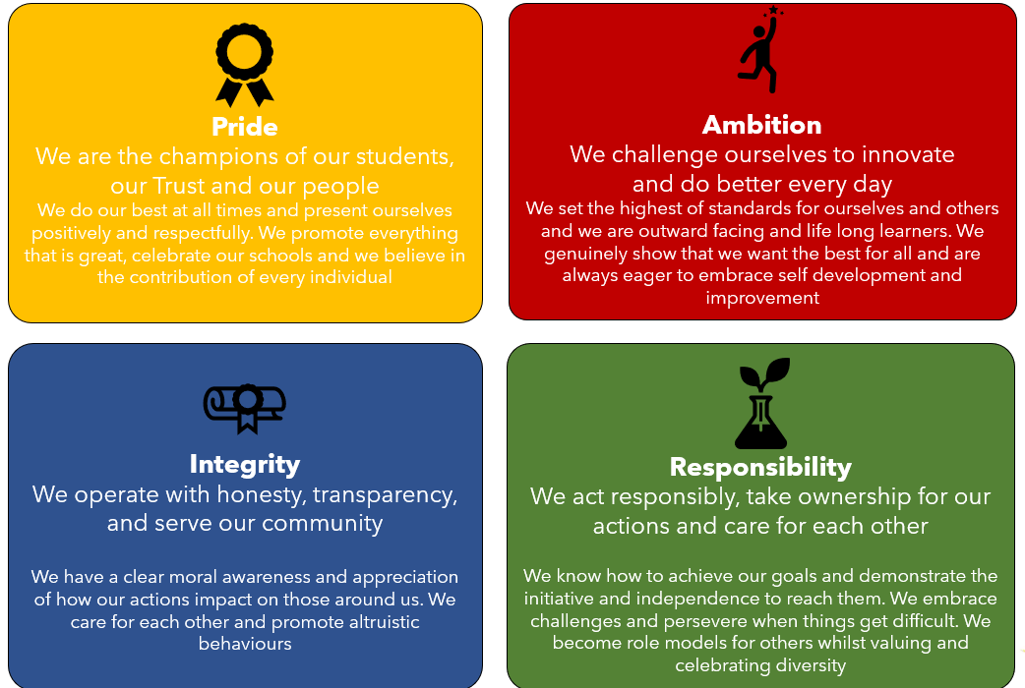
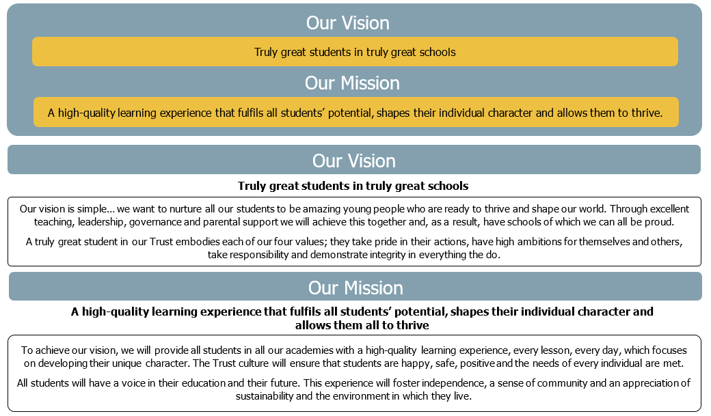

The Application Process
Further details about Leger Education Trust and Tornedale Infant Academy can be found on our website: www.tornedaleacademy.com and also the x feed (formerly known as twitter) @TornedaleInfant.
To complete an application please click on the link below (this will open up an online form via the ‘My New Term’ website):

ADD MYNEWTERM LINK

Shortlisted candidates will receive an email detailing the interview process.
If you have not heard from us within 2 weeks of the closing date, please assume your application has been unsuccessful.
Written references will be sought on all short-listed candidates before interview.
If you have any queries on any aspect of the application process or need additional information, please contact Tornedale Infant Academy.

Key dates:

Closing date for receipt of applications: Thursday 7 May 2026 at 3.00 pm

Shortlisting will take place: Friday 8 May 2026 after 10.00 am

Interviews will take place: Tuesday 19 May 2026

The Governors at Tornedale Infant Academy are committed to safeguarding and promoting the welfare of children. All applicants will undergo child protection screening appropriate to the post, including checks with past employers. The role is exempt from the Rehabilitation of Offenders Act 1974 and therefore candidates will be subject to an enhanced DBS certificate, the role is engaged in regulated activity and will therefore require a children’s barred list check. Shortlisted applicants will be required to complete a self-disclosure.

SEND Teaching Assistant Temporary

Leger Education Trust is a Multi-Academy Trust with sponsor status. Since its establishment in November 2018 the Trust has grown rapidly and now includes seven schools and an alternative provision in Doncaster.

The Trust is committed to safeguarding and promoting the welfare of children and young people and expects all staff and volunteers to share this commitment. This post is subject to an enhanced DBS check.

Job Description

Job Title: SEND Teaching Assistant Temporary
Grade and Salary: Grade 5 SCP 4-6 £25,185-£25,989 (pro rata) for 6 hours per week
Grade 3 SCP3 £24,796 (pro rata) for 2 hours per week
Hours of Work: 8 hours per week; term time only
Working 9.00 am until 1.00 pm
Responsible to: Headteacher/Assistant Headteacher/SENDCo
Job Purpose: To work on a one-to-one basis with a child with additional needs during lesson time and to work as a midday supervisor at lunchtime
Location: Tornedale Infant Academy
Term: Temporary until 17 July 2026

The Role of the SEND Teaching Assistant is to:
- Work as part of a team within Tornedale, under the direction of the class teacher/SENDCo/Headteacher, to promote the learning and welfare of pupils by providing practical and learning support to pupils, including those with special needs. The Teacher and Teaching Assistant work as a team – being ‘partners’ in supporting the pupils’ access to learning and their specific needs – physical, behavioural, medical and emotional.
- Provide dedicated one-to-one support, as and when required, to a pupil with an Education Health Care Plan providing individual assistance/specialist support, implementing action plans, to maximise achievement.
- Work, as and when required, with groups of pupils, including those with Education and Health Care Plans, providing individual assistance/specialist support, implementing action plans, to maximise achievement.
- Work closely with pupils individually or groups within schools/educational establishments or on educational visits, enabling them to achieve maximum access and participation in the National Curriculum.

Responsibilities
- Assisting in the planning/administration of tasks and monitoring/evaluation of the pupils learning, under the direction of the class teacher, ensuring that progress is clearly recorded and related to the learning objectives for that pupil.
- To help pupils to further develop literacy, numeracy, ICT, problem solving and study skills.
- To help pupils develop their language and reasoning skills and to assist pupils in the organisation, preparation and display of set assignment tasks.
- Giving in-class support to teachers, facilitating pupils’ access to the curriculum including assisting teachers of practical subjects as required with priority being given to health and safety.
- Supporting the school’s Relationships Policy to ensure high standards of pupil behaviour.
- Assisting in the writing of regular reports and reviews on pupils’ progress, to assist with general administration of records.
- Liaising with parents and other agencies as required (ie, Social Services, Health professionals, etc) as directed by the relevant professional.
- Informing other support staff/teachers on a daily basis regarding the progress of pupils.
- Contributing to the formation of measures that are directly connected to pupil achievement, in partnership with parents and under the direction of the relevant professional.
- Assisting with pupil pastoral issues.
- Playing an appropriate part in child protection procedures, such as relating relevant factual information and recording/reporting disclosures to the designated teacher/relevant professional.

Supervisory Responsibility
All school staff must uphold the standards of personal and professional conduct at all times ensuring honesty and integrity prevails in every situation. Staff who work with children must maintain appropriate professional boundaries and respect the unique position of trust they have at all times.

These duties and responsibilities should be regarded as neither exclusive nor exhaustive as the post holder may be required to undertake other reasonably determined duties and responsibilities that are commensurate with the level of the post.

Person Specification

 | Essential | Desirable | How Assessed
Qualifications:
- Willingness and ability to obtain and/or enhance qualifications and training for development in the post | ✓ |  | Application form  Interview
- Minimum grade C GCSE in Maths and English or equivalent | ✓ |  | Application form  Certificate Evidence
- NVQ Level 2 minimum |  | ✓ | Application form  Certificate Evidence
- First Aid Certificate |  | ✓ | Application form  Certificate Evidence
- Other specific courses and qualifications recently completed |  | ✓ | Application form  Certificate Evidence
Experience:
Previous experience in an educational environment and/or with children with SEND. | ✓ |  | Application form Interview  References
Use of ICT to support learning |  | ✓ | Application form Interview  References
Positive Handling Training |  | ✓ | Application form  Certificate Evidence
Knowledge, Skills and Abilities
- Competent oracy skills | ✓ |  | Application form Interview
- Good understanding of safeguarding procedures | ✓ |  | Application form Interview
- Positive behaviour management style | ✓ |  | Application form Interview
- Knowledge of the school curriculum and other learning programmes |  | ✓ | Application form Interview
- SEND specialism |  | ✓ | Application form Interview  Certificate Evidence
Other:
Ability to relate well to children and adults, and work as part of a team. | ✓ |  | Application form Interview  References
Ability to self-evaluate own practice and learning needs | ✓ |  | Application form Interview
A calm, flexible, pleasant and sympathetic manner | ✓ |  | Application form Interview  References

Resilience | ✓ |  | Application form Interview
Physically fit enough to undertake the duties associated with this role supporting children with additional needs | ✓ |  | Medical Questionnaire
Ability to attend to children’s personal care needs, eg, toileting | ✓ |  | Application form Interview

Leger Education Trust will require the appointed candidate to gain satisfactory relevant background checks in accordance with safer recruitment guidelines; this will include an Enhanced (with Barred) Disclosure check.

