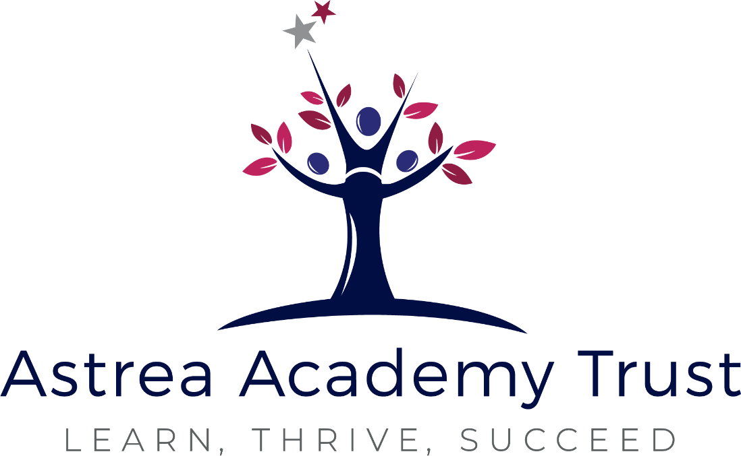

Role Profile

Apprentice Careers Advisor

Astrea Academy Woodfields

Role Specification

Academy / Department | Astrea Academy Woodfields
Post title | Apprentice Careers Advisor
Responsible to | Careers Leader
Full time Salary | £23,880 FTE
Pro-Rata Actual Salary | £17,152 pro rata salary
Working Pattern | Part Time / Fixed Term for the duration of the apprenticeship
Pension | Local Government Pension Scheme
Working Hours | 30hrs per week / 40 weeks per year

Role Purpose
This is a unique opportunity for someone passionate about helping scholars take ambitious next steps and inspired by the mission to disrupt disadvantage through high-quality careers education and guidance. As an Apprentice Careers Advisor, you will gain practical experience while studying towards a recognised Level 6 qualification in Careers Guidance. Working alongside experienced professionals, you will contribute to delivering a high-quality Careers Education, Information, Advice and Guidance (CEIAG) programme and help ensure that all scholars access ambitious and inclusive pathways.

Key Responsibilities
1. Support for CEIAG Delivery
- Provide general advice and guidance to scholars under the supervision of the Careers Leader or Senior Advisor.
- Assist in organising and promoting careers events, workplace visits, employer talks, work experience and post-16 information evenings.
- Help maintain and update careers displays, noticeboards, and the school website with accurate, engaging information.
- Support the logging of scholar participation in careers activities using platforms such as Unifrog or Compass+.
- Assist with basic administrative tasks such as scheduling appointments, collecting feedback, and managing career-related correspondence.
- Help prepare resources and presentations for CEIAG lessons, tutor time or assemblies.
- Maintain and sustain excellent relationships with local careers networks, apprenticeship providers, universities and employers

2. Apprenticeship Learning and Development
- Work towards a Level 4 or 6 qualification in Careers Guidance or equivalent, as agreed with your training provider.
- Participate in on-the-job training, including observations, shadowing, and supervised guidance activities.
- Engage in Trust-led CPD and careers team training sessions to build core professional skills.
- Maintain a reflective log and evidence portfolio for your apprenticeship programme.

3. Support for Personal Guidance and Transitions
- Help scholars with tasks such as CV writing, job applications, and research into post-16 or post-18 routes.
- Attend key transition events (e.g. Options Evenings, Results Day), supporting the team in scholar follow-up.
- Refer scholars to the Senior or Lead Careers Advisor when in-depth personal guidance is needed.

4. Team Collaboration
- Contribute to weekly planning or briefing meetings with the Careers Leader and Senior Advisor.
- Work positively and proactively with school staff and external partners.
- Uphold confidentiality, safeguarding, and professional conduct at all times.

Apprentice Support and Training
The Apprentice Careers Advisor will follow a structured development programme designed by the Cambridgeshire Careers Leader and Senior Advisor, including:
- Shadowing and co-delivery of personal guidance
- Mini-projects (e.g. organising one event, leading one workshop)
- Termly skills reviews
- Support preparing for end-point assessment (if required)

PERSON SPECIFICATION

 | Essential | Desirable
Education and Training
GCSEs (or equivalent) in English and Maths at Grade 4/C or above
A passion for working with young people and supporting their futures | •
Excellent communication and interpersonal skills | •
A willingness to learn and commit to professional development
Experience
Experience working with young people (e.g. youth work, mentoring, teaching assistant roles)
Familiarity with CEIAG or school environments
Knowledge
Good organisational and IT skills | •
Interest in careers, guidance, education or psychology sectors
Professional Skills
Act as a role model for ambition, inclusion, and professionalism | •
Follow the Astrea Trust Careers Framework and school policies | •
Attend and complete all required training and assessment
Commitment to safeguarding and data protection standards
Personal Qualities
Confident, enthusiastic and motivated | •
Commitment to self-development and continual improvement | •
Strong relationship building skills with the ability to work as part of a team understanding Trust roles and responsibilities and own position within these | •
Commitment to Diversity, Equality and Inclusion | •
High levels of resilience and emotional maturity | •
Inquisitive nature with sound problem solving skills, judgement and initiative | •
Can-do attitude and solution focused approach with an ability to manage expectations | •
Able to adapt to changing circumstances and new ideas | •
High level of integrity with an ability to self-evaluate and reflect | •

GENERAL RESPONSIBILITIES
- Contribute to the overall aims of the Trust and Academy Improvement Plans.
- Commitment to continual learning and development of skills.
- Behave in a manner that is professional, friendly and fair demonstrating and role modelling politeness and respectfulness.
- Demonstrate an excellent record of attendance and punctuality.
- Be aware of and comply with Trust policies and procedures including but not exhaustive of:
  - Acceptable Use of IT Policy
  - Code of Conduct
  - Keeping Children Safe in Education (KCSIE 2024)
  - Child Protection and Safeguarding Policy
- Work cooperatively as part of the Trust wide staff team.
- This role profile is not exhaustive and undertaking other duties may be required.

THIRD PARTY CHECK

Is this role subject to the following checks?

Disclosure Barring Service Enhanced Check (DBS) | Yes
Section 128 (S128) check  Is this role a Senior Leadership Role with management responsibility for the academy? | No

APPLICATION PROCESS
Due to the Education sector requirements and that we must comply with Keeping Children Safe in Education (KCSIE) an application form must be completed. We are unable to accept a CV as form of application. We recognise that our application forms are comprehensive. If you have any difficulties completing, please do contact recruitment@astreaacademytrust.org

