


Candidate Information Pack

Details of the Post
Job Title: | MFL Teacher
Start date: | 1 September 2026
Status of post: | Permanent
Closing date for application: | Friday 13 February 2026
Interview Date: | Thursday 26 February 2026

WELCOME – Headteacher
Dear Prospective Candidate,

Thank you for your interest in our post. I hope that after finding out more about Wood Green School, you will want to apply to be part of our dedicated staff team.

Wood Green School is an oversubscribed 11-18 comprehensive in Witney, close to the Cotswolds with excellent links to Oxford and London. We are an extremely supportive school, with staff wellbeing a priority. Our school stands out for its commitment to academic excellence and personal development. Our curriculum approach and teaching principles values subject specialism, giving strong department teams the freedom to share their love of their subject and to light fires. The extensive range of extracurricular activities encourages students to explore their wider talents and build leadership skills. Our dedicated, caring staff are passionate about nurturing each student’s academic and personal potential.

This is a very exciting time for Wood Green. We have created our Wood Green Baccalaureate, that encourages and celebrates everything that a school should develop in young people: engagement in all subjects, learning skills such as research and communication, and personal skills such as thoughtfulness for others. We believe strongly in a culture of mutual respect and strong relationships, demonstrated in our Behaviour Policy built on restorative principles and our Diversity, Equality and Inclusion Policy. Everything is underpinned by our LEARNWell values. Our strong reputation and results improving year-on-year have led to a rapid rise in student applications. This holistic approach ensures that we live out our mission to develop exceptional, well-qualified and well-rounded young people who make a positive contribution to our school, our community and the world.

I believe that investing in staff is crucial to achieving our mission. At Wood Green, we provide a comprehensive programme of staff development, sharing best practice in-school and giving staff the opportunity to work with other schools through our local and national partnerships. All teaching staff work with peer coaches in school and have opportunities for professional development through Trust Peer Reviews, Oxford University Department of Education and National Professional Qualifications.
Wood Green School is part of the Acer Multi-Academy Trust, consisting of nine schools: Wood Green School, Chalgrove Primary School, Stadhampton Primary School, Botley Primary School, Icknield Community College, Watlington Primary School, Glory Farm Primary School, Cooper School and Matthew Arnold School. All nine schools have strong track records of high performance or rapid improvement and share similar values. This partnership adds real benefit to Wood Green School, especially opportunities for staff development. The key values of the Acer Trust are Trust, Big-Heartedness and Ambition.

If this feels like a school where you can flourish, I look forward to hearing from you.

Yours sincerely
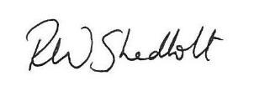
Rob Shadbolt, Headteacher

Mission, Values and Vision

Mission Statement

“Our mission is to develop exceptional, well-qualified and well-rounded young people who make a positive contribution to our school, our community and the world.”

Our Values

LEARNING EFFORT ASPIRATION RESPECT NURTURE WELLBEING
Our LEARNWell values reflect our commitment to developing the whole person and underpin everything we do:
- Learning – Wood Green students show curiosity, are creative thinkers, communicate powerfully, respond well to feedback, and find ways to learn that work for them
- Effort – Wood Green students are proud to try hard and to be successful, are not scared to fail, work well with others and by themselves
- Aspiration – Wood Green students achieve highly, believe they can improve, and leave prepared for their next exciting adventure​
- Respect - Wood Green students respect all others, take responsibility for their own actions, develop good relationships with all students and staff, and take care of their environment​
- Nurture - Wood Green students are kind to others and contribute to their community
- Wellbeing - Wood Green students manage themselves well emotionally, and know how to keep themselves healthy and safe

Department Information
In Autumn 2026, the Department will consist of six specialist teachers, including the Head of Department and the second in Department. We deliver French and German to A Level. Each full time MFL teacher has their own classroom, which has an interactive whiteboard and a high-quality sound system.
Ethos
The Department is committed to developing resilient and independent learners who are confident to speak French and German in lessons. We have a communicative based approach to our teaching with target language employed maximally in the classroom.
We aim to strike a balance between receptive skills (listening and reading) and productive skills (speaking and writing), whilst simultaneously building vocabulary and grammar.
The Department works together to develop the confidence and individuality of students and enable them to develop their personal skills in a happy, supportive and motivated environment.

Curriculum
The vast majority of students study French and German in Year 7 (1h of input per week) and 8 (3h of input per fortnight). Our current model is that at the end of Year 8 students select one language to to pursue in Year 9 (5h of input per fortnight).

Key Stage 3
Wherever possible and appropriate, lessons are delivered in the target language and at Key Stage 3. The broad and balanced curriculum encourages students to communicate confidently in the target language both orally and on paper to develop the key skills needed to become proficient linguists.
Key Stage 4
At Key Stage 4 students follow AQA for GCSE in both French and German and continue to build on the listening, speaking, reading and writing skills acquired at Key Stage 3 with a greater emphasis on grammar and extended structures while retaining a fun, communicative approach.

Key Stage 5
At KS5 students follow AQA, which we feel offers an interesting and challenging syllabus for our A level students.

Trips & Extra-Curricular
The department runs a French and a German Exchange for students in Year 9 each year. The German Exchange is with a school in Unterhaching near Munich and the French Exchange is to Aix-en-Provence.
We also offer a trip to the German Christmas market in Köln for our Year 8 students.
Students in Year 9 are trained to be Language Leaders, delivering language sessions in a local primary school.
2025 was our first year in running a combined German / History KS5 trip to Berlin, which we are hoping will be biennial moving forward.
We regularly engage with the MFL opportunities that arise through our strong connection with OUDES, such as A-Level Day and Creative Translation workshops.

Department Development and Future Plans
This year, the focus of our Department Development Plan is on the effective modelling of tasks and activities; we see the understanding of a task and how to go about it as crucial to engagement, participation and ultimately self-efficacy in languages.

Job Description
Job Title | Teacher of Modern Languages
Job Description | This job description forms part of the contract of employment of the successful applicant. The appointment is subject to the conditions of employment of Teachers contained in the School Teachers’ Pay and Conditions document and other current educational and employment legislation.
Review Date of Job Description | January 2024
Establishment | Wood Green School, Woodstock Road, Witney, OX28 1DX
Responsible to: | Head of Modern Languages
Responsible for: | Teaching and supporting all designated classes in Modern Languages
Purpose of Post | - To implement and deliver an appropriately broad, balanced, relevant and differentiated curriculum for students and to support a designated curriculum area as appropriate.  - To monitor and support the overall progress and development of students as a Teacher/Form Tutor.  - To facilitate and encourage a learning experience which provides students with the opportunity to achieve their individual potential.  - To contribute to raising standards of student attainment.  - To share and support the school’s responsibility to provide and monitor opportunities for personal and academic growth
Teaching | - To undertake a designated programme of teaching across all key stages  - Teach consistently high quality lessons  - Plan and deliver schemes of work and lessons that meet the requirements of the KS3, 4 and 5  - Be a role model for students, inspiring them to be actively interested in Modern Languages  - To maintain appropriate records and to provide relevant accurate and up-to-date information for BromCom, registers  - To complete the relevant documentation to assist in the tracking of students  - Set expectations for staff and students in relation to standards of achievement and the quality of learning & teaching  - Prioritise and manage time effectively, ensuring continued professional development in line with the role  - To follow the school policies and procedures  - To ensure the effective/efficient deployment of classroom support  - To maintain discipline in accordance with the school procedures, and to encourage good practice with regard to punctuality, behaviour, standards of work and homework  - Follow schemes of work for Modern Languages at all Key stages  - Promote aspects of Personal Development related to Modern Languages  - Updating professional knowledge and expertise as appropriate to keep up to date with developments in teaching practice and methodology, in general, and in the curriculum area of Modern Languages  - Promote Modern Languages learning through out of hours activities.  - Ensuring a high quality learning environment throughout the Modern Languages area.
Assessment, Feedback and Tracking | - To lead, monitor and evaluate the assessment and feedback to students in line with whole school and department policy  - To follow department monitoring and tracking systems relating to student’s attainment, progress and achievement  - Mark, grade and give written/verbal and diagnostic feedback as required  - Undertake assessment of students as requested by external examination bodies, curriculum areas and school procedures  - Assess, record and report on the attendance, progress, development and attainment of students and to keep such records as are required  - Complete the relevant documentation to assist in the tracking of students  - To follow department policy regarding department tracking of student progress and use information to inform learning and teaching  - Follow setting and co-ordinating assessment arrangements in MFL at all Key Stages, and in all areas as required by school policies, including standardising those assessments.
Staff Development | - To continue personal development in the relevant areas including subject knowledge and teaching methods  - To engage actively in the Performance Management process  - Participate in whole school CPD programmes  - To take part in the staff development programme by participating in arrangements for further training and professional development.
Student Support and Progress | - To be a Form Tutor to an assigned group of students  - To promote the general progress and well-being of individual students and the Tutor Group as a whole.  - To liaise with the relevant pastoral leaders to ensure the progress of students.  - To register students, accompany them to assemblies, encourage their full attendance at all lessons and their participation in other aspects of school life  - To evaluate and monitor the progress of students and keep up-to-date student records as may be required  - To lead the Wood Green Baccalaureate within the tutor group  - To contribute to the preparation of Action Plans and other reports as required  - To alert the appropriate staff to problems experienced by students  - To communicate as appropriate, with the parents of students and with persons or bodies outside the school concerned with the welfare of individual students, after consultation with the appropriate staff.  - To contribute to Learning 4 Life according to school policy  - To apply the Behaviour for Learning policy so that effective learning can take place  - Meet with students over whom there are concerns and contact home where necessary in conjunction with student support teams  - Meet with students over whom there are concerns and contact home where necessary in conjunction with student support team and department heads.
Safeguarding | Be keenly aware of the responsibility for safeguarding children and to help in the application of the Safeguarding and Safe Practices policy within the school  Comply with the school’s Safeguarding Policy in order to ensure the welfare of children and young persons.
Communications, Marketing and Liaison | - To communicate effectively with the parents of students as appropriate  - Where appropriate, to communicate and cooperate with persons or bodies outside the school.  - To follow agreed policies for communications in the school  - To take part in marketing and liaison activities such as Open Evenings, Parents’ Evenings, liaison events with partner schools, etc.
Personal Responsibilities | - To play a full part in the life of the school community, to support its distinctive mission and ethos and to encourage staff and students to follow this example  - To support the school in meeting its legal requirements for worship  - To actively promote school policies and procedures  - To be responsible for own continued professional development  - To comply with the school’s Health & Safety policy and undertake risk assessments as appropriate.  - To be courteous to colleagues, visitors and telephone callers and provide a welcoming environment  - To undertake duties before the school day, at break, and after the school day on a rota basis  - To attend meetings scheduled in the school calendar punctually  - To set cover work during any leave of absence  - To adhere to the School’s Safeguarding Policy.
Notes: | The above responsibilities are subject to the general duties and responsibilities contained in the statement of Conditions of Employment.  This job description allocates duties and responsibilities but does not direct the particular amount of time to be spent on carrying them out and no part of it may be so construed.  This job description is not necessarily a comprehensive definition of the post. It will be reviewed at least once a year and it may be subject to modification or amendment at any time after consultation with the holder of the post  The duties may be varied to meet the changing demands of the school at the reasonable discretion of the Headteacher.

Person Specification
Criteria | Essential | Desirable
Qualifications and experience | - Good honours degree or equivalent  - QTS or PGCE  - Have a secure knowledge of the Modern Languages curriculum and related pedagogy  - An awareness of the impact that their subject can make to the whole school  - Ability to teach French to KS3, 4 and 5 and German to at least KS3 | Coaching experience
Teaching | - Evidence of excellent classroom practice appropriate to career stage  - Excellent understanding of effective and engaging teaching methods that will ‘light fires’  - The ability to engage, enthuse and motivate all students.  - Able to use technology to enhance Teaching and Learning  - Able to incorporate assessment for learning practices into everyday practice | Evidence of using teaching to raise student attainment
Assessment | - Full understanding of the use of assessment to inform planning  - Able to mark, record and give feedback in line with whole school and departmental policy | Understanding of how to mark GCSE and A level
Planning | - The ability to plan well and logically sequenced lessons with clear objectives to ensure progression for all students  - The ability to adapt teaching to suit the needs of students and groups of students  - A clear understanding of planning for progression between the key stages | Experience of planning in accordance with the GCSE and A level specifications
Professional attributes | - Highly motivated and a willingness to continue learning  - A positive role model for staff and students  - Resilient and responds well to challenge  - Excellent communication skills  - Team player  - Initiative  - Able to prioritise and meet deadlines | Career teacher, interested in long term career development
Relationships with young people | - Have high expectations for all young people including a commitment to ensuring that they can achieve their full educational potential.  - Establishing fair, respectful, supportive and constructive relationships with students  - Hold positive values and attitudes and adopt high standards of behaviour in their professional role
Personal qualities | - Enthusiasm, drive and a love for the job  - Clear vision and an innovative approach to Teaching and Learning  - A passion for ensuring that all aspects of school life demonstrate integrity and respect  - Commitment to a high profile presence in and around the school  - A good sense of humour  - Excellent communication skills, both verbal and written  - Good time management  - Flexibility, adaptability and creativity | Ability to enthuse others and be a positive role model  Willingness to challenge others to produce positive outcomes

We are not looking for the impossible! If you think that you have at least some of these attributes, we would very much like to hear from you.
Appointment will be subject to enhanced DBS check, qualifications and experience checks and satisfactory references.



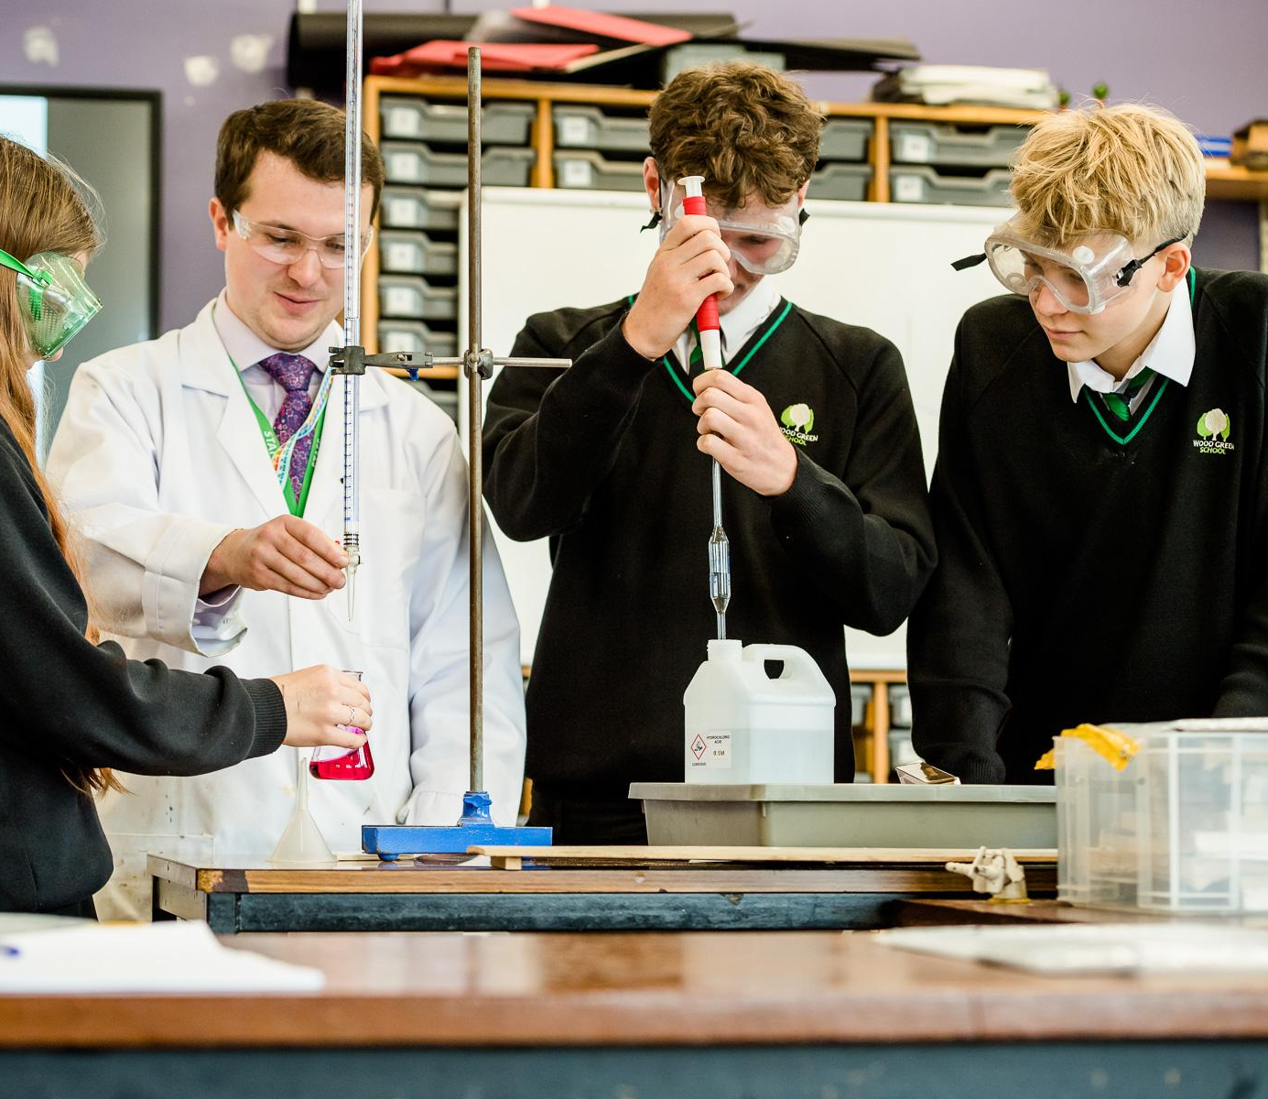

Wood Green School
Woodstock Road
Witney
OX28 1DX

01993 702355
hrwest@acertrust.org.uk
www.wgswitney.org.uk

