







The CAM Academy Trust
Attendance Support Assistant
Candidate information pack

WELCOME FROM
THE CHIEF EXECUTIVE

Thank you for your interest in joining The CAM Academy Trust. It’s a great time to join our team, as we enter an exciting phase of development and look to the future.

I feel highly privileged to lead our trust at this time. Our five year strategy – CAM30 – sets out our roadmap to becoming a truly exceptional family of schools.

We are a values-driven trust – our six principles underpin all that we do – and
we’re committed to excellence. As a teacher myself, and someone who has benefited hugely from an education, I absolutely believe in the transformational power of what we do in schools. This is particularly important for our most vulnerable young people, those who could become marginalised and not reach their potential due to their background or learning needs. It is up to us to make sure that doesn’t happen.

Vibrant learning communities are built when pupils of all abilities and backgrounds thrive together, and a truly excellent education enables choice and agency for all children. This is at the heart of our comprehensive principle.

We want people on our team who are excited by the prospect of having a deep and lasting impact on the lives of young people. We want people who are honest, curious, intellectually rigorous and committed to the challenges and opportunities of innovation and collaboration. We also want people who are committed to contributing to the wider education system.

As Chief Executive, I am committed to raising standards for young people, in a sustainable way through a strong MAT operating model and an insistence on excellence whilst understanding that schools need to retain their unique identity so they can be at the heart of their communities. I also know that investing in all our people is critical to success. It is our leaders, teachers and school staff that make the difference for children every day.

Join our team and we will work together to deliver ‘excellence for all’, enabling all pupils and staff to thrive and be successful. If this excites you; we want to hear from you!

Claire Heald

ABOUT US
The CAM Academy Trust was established in 2011 and currently comprises twelve primary schools and five secondary schools, four of which include sixth forms. In January 2026, ACES Academies Trust - a Huntingdon-based multi-academy trust - merged with CAM, adding five additional schools to our family.

Our primary schools are Cromwell Academy, Everton Heath Primary School (just inside Bedfordshire), Gamlingay Village Primary, Godmanchester Bridge Academy, Godmanchester Community Academy, Jeavons Wood Primary School, Offord Primary School, Hartford Infant and Pre-School, Hartford Junior School, Harston and Newton Primary School, Spaldwick Primary School and Thongsley Fields Primary and Nursery School. Bourn Primary Academy joined as the first Associate Member in 2021.

Our secondary schools are: Comberton Village College (and Sixth Form), Cambourne Village College (and Sixth Form), Hinchingbrooke School, Melbourn Village College and St Peter’s School (and Sixth Form).

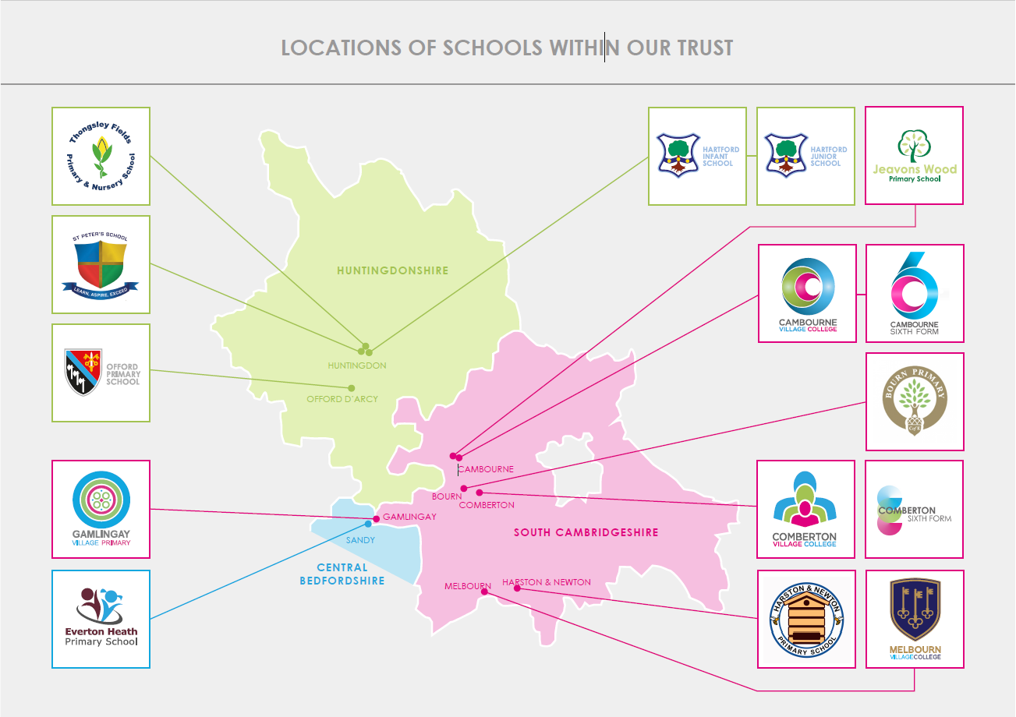
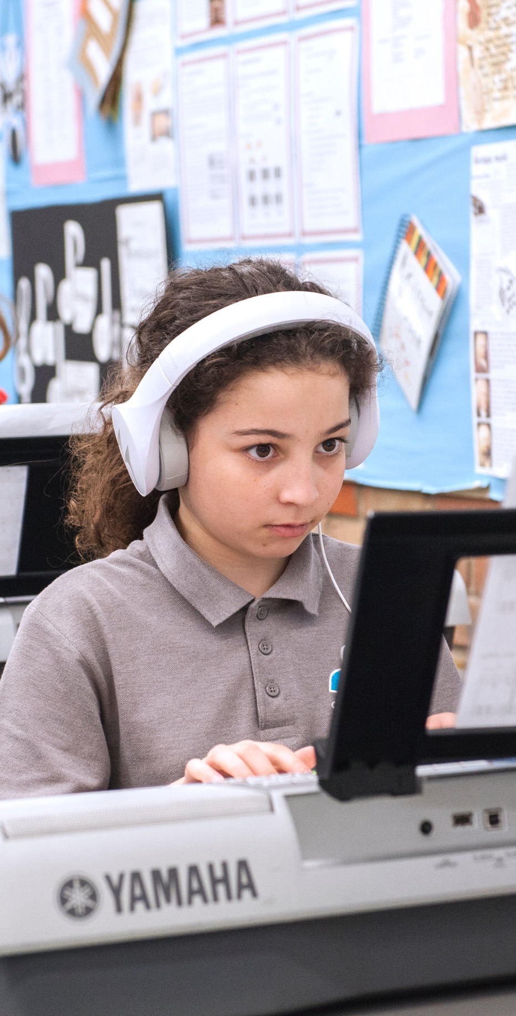
ABOUT US
Continued

Teacher training (CTSN)

The CAM Academy Trust supports the training of new teachers to become qualified members of the teaching profession. We does this through our SCITT (CTSN).

As a school-based provider of initial teacher training, CTSN SCITT is very much grounded in the life of its local schools and its tutors are experienced practising teachers drawn from, not only CAM Academy Trust schools, but also a wide network of schools across the region.

Our SCITT has a strong regional reputation.

Maths Hub

The CAM Academy Trust is proud to be the base for the Cambridge Maths Hub which is promoting excellence in maths teaching across Cambridgeshire, as well as Peterborough, West Suffolk, King’s Lynn and West Norfolk.

The Hub supports teachers to improve educational standards for students in our region from the youngest child in Early Years to Post-16.

The Cambridge Maths Hub offers free, high-quality professional development to maths teachers across the Hub area.

The Cabins

Our Cabin provisions are attached to four of our schools. The Cabins provide autistic students with an opportunity to be educated in mainstream settings.

We set high expectations for students but provide expert support from highly skilled and caring staff.

All our cabins strive to ensure that every pupil attains the highest possible academic achievement and offer high levels of pastoral support.

THE OPPORTUNITY
Title Attendance Support Assistant
Required September 2026
Salary NJC Scale 4 (Points 7–11)
Contract Term Time 38 weeks, 37 hours per week
Are you passionate about supporting young people to achieve their full potential? We are seeking an organised, proactive and compassionate Attendance Support Assistant to join our dedicated pastoral and attendance team. This is an exciting opportunity to play a key role in improving attendance, supporting families and ensuring that every student is safe, present and ready to learn.
WHY WORK AS AN ATTENDANCE SUPPORT ASSISTANT AT COMBERTON VILLAGE COLLEGE?
A vital role in student success You will play a central part in promoting excellent attendance and punctuality, helping students overcome barriers to learning and ensuring they have the best possible opportunity to thrive.
A highly collaborative environment Working closely with the Attendance Officer, pastoral staff, safeguarding colleagues, parents/carers and external agencies, you will be part of a committed team focused on improving outcomes for young people.
Making a difference every day From first-day absence calls and attendance monitoring to supporting families and conducting welfare checks, your work will have a direct impact on students' wellbeing, safety and achievement.
A varied and rewarding role No two days are the same. You will combine administration, family liaison, attendance interventions and student support, helping to ensure that all attendance processes are managed effectively and sensitively.
Professional development opportunities We are committed to supporting staff development through ongoing training in attendance, safeguarding and pastoral support.
WHAT WE OFFER: • A school culture that prioritises staff wellbeing and professional growth. • A supportive and experienced pastoral and attendance team. • Engaged and respectful students who embody our ethos of Caring, Confident and Capable. • Opportunities to make a genuine difference to students' lives every day. • Access to high-quality professional development and training.
"Pupils here are not taught just to pass exams. They acquire the skills and knowledge they need to thrive." (Ofsted, November 2024)
We are a highly successful, community mixed comprehensive school with Teaching School status in a pleasant rural setting just five miles from the centre of Cambridge. We have around 2,000 students aged 11–18, including a thriving sixth form.
We are seeking to appoint a committed, organised and resilient Attendance Support Assistant who will contribute to our strong attendance provision and help ensure that every student attends school regularly, feels supported and is able to achieve their full potential.
Our students are well motivated, staff morale is excellent and outcomes are strong across our comprehensive intake. The school has consistently been rated Outstanding by Ofsted, most recently in November 2024.
If you are enthusiastic about supporting young people, building positive relationships with families and helping students succeed through excellent attendance, we would love to hear from you.



HOW TO APPLY

To apply for this position, please submit your completed application form with supporting statement to Tania Tull, Head of People on MyNewTerm.

Your supporting statement should demonstrate how your career to date has prepared you for this post and be no longer than two sides of A4.

Applications will only be accepted from applicants completing the application form in full. Please note that we do not accept CVs.

Interviews will be offered to those applicants who best demonstrate how their skills, abilities and experience meet the person specification, taking into consideration the job description.

We reserve the right to interview and appoint within the application window. With this in mind, we encourage you to apply as soon as possible.

If you have any questions about this role, please visit www.combertonvc.org

Closing date: Monday 10th August 2026
Interview date: Thursday 13th August 2026

Thank you for your interest in The CAM Academy Trust.

JOB DESCRIPTION

Job Purpose
To support the school in promoting excellent attendance and punctuality by monitoring daily attendance, following up on unexplained absences, supporting attendance interventions, and assisting with administrative processes. The post holder will work closely with students, families, pastoral teams and external agencies to help improve attendance and ensure the safety and wellbeing of all pupils.

Attendance Monitoring and First-Day Response
- Support with the monitoring of daily student attendance and punctuality across the school.
- Check attendance registers throughout the school day to ensure they have been completed accurately and on time.
- Identify missing pupils and undertake appropriate follow-up procedures to establish their whereabouts.
- Investigate and follow up unexplained absences promptly in line with school safeguarding and attendance procedures.
- Make first-day absence calls, send messages and communicate with parents/carers regarding pupil absence.
- Record reasons for absence accurately on the school Management Information System (MIS).
- Escalate attendance concerns to the Attendance Officer, Safeguarding Team or relevant pastoral staff as appropriate.

Parent and Family Liaison
- Maintain regular communication with parents/carers regarding attendance, punctuality and absence concerns.
- Support parents in understanding attendance expectations and statutory requirements.
- Assist with arranging and attending meetings with parents/carers to discuss attendance concerns.
- Build positive relationships with families to encourage engagement and improve attendance outcomes.

Attendance Administration and Student Follow-Up
- Maintain accurate attendance records and ensure all attendance-related data is updated promptly.
- Prepare attendance reports, letters and documentation as required.
- Support attendance monitoring processes, including tracking persistent absence and punctuality concerns.
- Assist with attendance meetings and intervention programmes.
- Issue reminders to pupils regarding intervention sessions, detentions and other attendance-related commitments.
- Monitor attendance at interventions, detentions, mentoring sessions and other support programmes or sessions running in school.
- Assist with the management of attendance processes during examinations, internal and external.
- Follow up on pupil non-attendance at clubs, interventions, detentions and support sessions, liaising with staff and parents/carers where appropriate.
- Ensure attendance records comply with school policies and statutory guidance.

Home Visits and Attendance Support
- Support attendance staff with home visits where concerns exist regarding student attendance or welfare.
- Participate in welfare checks in accordance with school safeguarding procedures.
- Gather information during home visits to support attendance improvement plans.
- Record outcomes of visits and ensure appropriate follow-up actions are completed.
- Work sensitively and professionally with families experiencing barriers to attendance.

Safeguarding and Student Welfare
- Contribute to the school safeguarding responsibilities by ensuring all unexplained absences and missing pupil concerns are addressed promptly.
- Report any safeguarding concerns immediately in accordance with school policies and procedures.
- Support vulnerable students by working closely with pastoral staff and safeguarding colleagues to promote regular attendance.

General Responsibilities
- Maintain confidentiality and comply with GDPR and data protection requirements.
- Contribute to the wider work of the pastoral and attendance team.
- Participate in relevant training and development opportunities.
- Undertake other duties appropriate to the grade and nature of the post as required by the school.

Six core principles

At the heart of our work lie the six core principles of The CAM Academy Trust.

These drive everything that we do.


The CAM Academy Trust is committed to safeguarding and promoting the welfare of children and young people and expects all staff and volunteers to share this commitment. Successful candidates will be subject to an enhanced DBS check, barred list check and a medical questionnaire.
PERSON SPECIFICATION
CRITERIA | ESSENTIAL | DESIRABLE
Qualification and Experience
Experience of working in an administrative or school-based role. | X
Excellent communication and interpersonal skills. | X
Ability to communicate confidently and professionally with parents/carers | X
Good organisational skills and attention to detail | X
Experience of maintaining accurate records and databases | X
Ability to work under pressure and manage competing priorities | X
Competent ICT skills, including Microsoft Office applications | X
Understanding of confidentiality and safeguarding responsibilities | X
Ability to work independently and as part of a team | X
Willingness to undertake home visits when required | X
Experience working in attendance, pastoral support or education settings |  | X
Knowledge of attendance regulations and procedures in schools |  | X
Experience using school Management Information Systems (e.g. Arbor, Bromcom, SIMS). |  | X
Experience of working with young people and families |  | X
Knowledge of safeguarding and child protection procedures |  | X

BENEFITS

We offer the following benefits, designed to promote your wellbeing and make your time with The CAM Academy Trust satisfying and rewarding.

Core benefits
- Paid leave – enhanced sick pay, maternity pay, and adoption leave pay (linked to service) and paid leave for unforeseen personal situations.
- Pension – a generous pension scheme.
- Death in service payment – lump sum payment and an ongoing pension for your partner & children (subject to conditions & membership of our pension scheme).

Health and wellbeing
- Employee counselling and support – free, independent 24/7 help and advice for work related issues, as well as problems affecting your home life.
- Environment – good working environment with excellent facilities.
Professional development
- Professional development – full and part-funded training courses and a wide range of learning opportunities available to all staff.
Employee discounts
- Car parking – free and on-site.
- Hot drinks – tea & coffee making facilities provided.
- Cycle-to-work scheme – save £££ on a new bike and accessories.

Work-life balance
- Flexible working – all staff can make a request to work flexibly.


The CAM Academy Trust
Head Office | Cambourne Village College
Sheepfold Lane| Cambourne | CB23 6FR
info@catrust.co.uk
www.catrust.co.uk

