
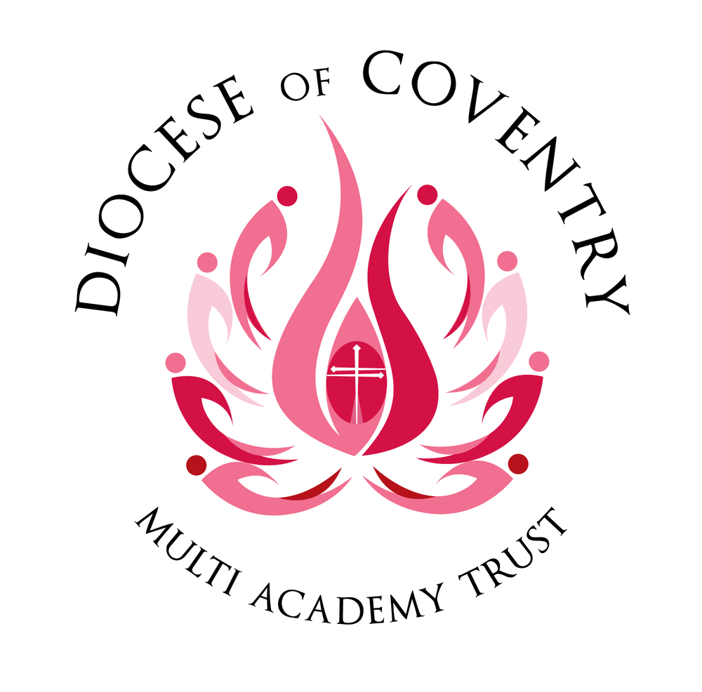

Information for job applicants

Together, pursuing life in all its fullness

Our Trust

Thank you for your interest in joining The Diocese of Coventry Multi Academy Trust, we are delighted to provide you with an application pack. It is hoped that the information will be of interest and will help you to begin your journey with us.
The Diocese of Coventry Multi Academy Trust was formed by the Diocese of Coventry in 2013 and is now one of 2,200 Academy Trusts in England. Our children, volunteers and staff come from all faiths and none, and the Diocese remains a key partner in all that we do.

The trust is now home to twenty-two academies spread across the Diocese of Coventry. This scale makes us one of the 100 largest Multi Academy Trusts in the country.

Our vision, “together, pursuing life in all its fullness”, is based on John 10:10 and reflects the Church of England’s vision for education. You will see this come to life in all of our academies every day. We offer a vision of human flourishing for all, one that embraces excellence and academic rigour, but sets them in a wider framework. We offer opportunities for children to realise their God given potential and flourish.
Our strategic plan focuses on five key stakeholder groups and recognises
that these groups will flourish together, far better than they will flourish alone. We aim to:
- Support colleagues to flourish
- Support children to flourish
- Support those involved with governance to flourish
- Support families to flourish
- Support the wider church school family to flourish

To work with us, you must aspire to be an outstanding colleague, be prepared to go the extra mile and be comfortable with high levels of accountability for the progress of over 5,000 children. You must be willing to share and learn. You must be kind, and able to support and challenge others in order to help them flourish. Above all else, you must like young people and aspire to make them outstanding citizens.

In return, we offer excellent working conditions, first class professional development, genuine career development and opportunities for growth. All of our teachers are offered membership of the Teachers Pensions Scheme and all support staff are offered membership of the Local Government Pension Scheme.

In short, we believe our Trust has a bright future and are looking for bright people to help us get there.

Thank you once more for your interest in The Diocese of Coventry Multi Academy Trust and in the position available. I hope that this introductory letter has given you a clear sense of our vision and I hope that this pack gives you a feel for what we need. We look forward to hearing from you and exploring your future with us through our selection process.

Michael Cowland, Chief Executive Officer

Our Diocese

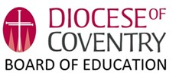
The Diocesan Board of Education seeks to serve and equip the church school family in a variety of ways. The Diocesan Director of Education, Reverend April Gold, is supported by a team of highly qualified, experienced and well-regarded professionals who aim to:

- ‘be there’ for our church school family and act as a central reference point supporting pastorally and professionally;
- facilitate creative and flexible networking between schools;
- promote excellence and distinctiveness within the family of church schools/academies and beyond;
- share best practice collectively;
- provide professional development: for staff at all stages of their careers and for governors;
- facilitate collaborative school improvement partnerships through the growth of our six CofE majority MATs;
- support the process of academy conversion;
- promote the establishment of new church schools;
- represent church schools to the wider church, to diocesan
groups, in the press, and in public and community debate;
- champion inclusion and equality including advising on
admissions policies and managing appeals;
- protect the status of church schools
- and promote the importance and the continuance of
the voluntary sector.

,

‘Our schools are a hugely significant part of the Church family of the Diocese. Seeking to build communities of care and understanding, they witness to God’s love for each and every person, and reflect God’s desire for the world to be a better place for us all to live in. I believe they are at the heart of the Church’s mission to the nation and play a very important role in the life of their own parishes and communities.

As a Diocese, our 76 Church of England schools serve 18,500 children, and their families. The 2000 members of staff and all the volunteers who support, as governors, directors, and other contributors, are seeking to offer both an excellent education and ensure that all our young people have the opportunity to live life to the full. We aim to do this by living, telling and sharing the values of
Jesus Christ. Thank you for being willing to share in this journey with us!’

Bishop of Coventry

About the Multi Academy Trust

Our Vision

Our vision, based on John 10:10, is for every adult, every child and every academy in our trust to come together in order that we may pursue life in all its fullness. We have a vision of building a better future for all within our academies, who in turn will positively impact their communities.

Our Strategic Goals

Our strategic plan focuses on five key stakeholder groups and recognises that these groups will flourish together, far better than they will flourish alone. We aim to:
- Support colleagues to flourish
- Support children to flourish
- Support those involved with governance to flourish
- Support families to flourish
- Support the wider church school family to flourish

Benefits Of Working For Us

We offer:
- A support network of professional colleagues
- A strong culture of professional development
- The opportunity to be part of an aspirational organization and contribute to its development and growth plans
- Employee Assistance Programme
- Cycle to Work Scheme
- Employee Benefits Scheme
- Eligibility to join Teachers’ Pension Scheme (teachers) or the Local Government Pension Scheme (support staff)

What our employees say about us

In our 2024 staff survey, the Trust scored above national benchmarks in almost every area. Support from colleagues is a particular strength of working for us: our staff value the respect and support they receive from their colleagues. Leadership is also an area of significant strength and staff rate their leaders highly. Finally, job satisfaction and employee communication are rated highly and above national benchmarks.

Staff support and relationships
How comfortable are you with asking your colleagues for help when you need it? | 93%
How respected by your colleagues do you feel? | 91%

Leadership
Leadership dynamics | 10% higher than national benchmark
Professional support from line manager | 3% higher than national benchmark

Job satisfaction and communication
Effective and regular communication with employees | 90%
Job satisfaction | 5% higher than national benchmark

Our Academies

