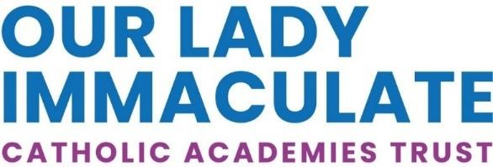


Cover Supervisor – Fixed Term 1 Year
St Thomas More Catholic Secondary School, Bedford
Salary: 3A Point 5 - £24,790 FTE
(Actual salary will be a pro-rata of the FTE)
8.45 – 3.45 Monday to Friday, term time plus five training days

Start Date: As soon as possible

The Directors of this successful, Catholic Secondary
School now seeks a Cover Supervisor
to join us at St Thomas More Catholic Secondary School

St Thomas More is looking to recruit a reliable, hardworking Cover Supervisor

We are looking for a capable and confident individual to join our teaching staff and provide classroom supervision in the absence of a regular teacher. You will not be responsible for setting work but will supervise and help students with their learning and be expected to maintain a positive learning environment in a classroom setting.
You will need to work effectively as part of a small team and have good communication skills. Previous experience of working in a school, preferably in a classroom support role and an understanding of the educational system are essential. This opportunity would suit applicants considering a teaching career in the future and need to gain classroom experience.

Closing Date: 12 NOON ON WEDNESDAY 21ST JANUARY 2026 Interviews: WEEK COMMENCING 26TH JANUARY 2026

St Thomas More is committed to safeguarding and promoting the welfare of children and young people and expects all employees and volunteers to share this commitment. The suitability of all prospective employees or volunteers will be assessed during the recruitment and selection process in line with this commitment. Successful applicants will be required to undertake an enhanced DBS check



St Thomas More Catholic Secondary School - www.st-thomasmore.org.uk | Telephone 01234 400 222

