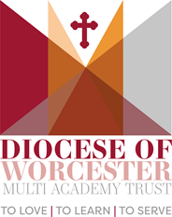

PERSON SPECIFICATION
EYFS Practitioner
 | Essential | Desirable
Qualifications
Excellent numeracy/literacy skills – equivalent to NVQ Level 2 in English and Maths | P
NVQ Level 3 Early Years equivalent qualification | P
Knowledge & Experience
Can use ICT effectively | P
Experience of working in a EYFS setting | P
Constantly improve own practice/knowledge through self-evaluation and learning from others | P
Able to build effective working relationships at all levels | P
Able to work in on initiative but also constructively as part of a team | P
Knowledge of relevant policies/codes of practice |  | P
Specific training or worked with children who have additional needs eg Dyslexia, ASD, ADHD | P
Understand and have knowledge of SEND and the EHCP process | P
Experience of using British Sign Language/Makaton |  | P
Values/Beliefs
Every person matters when contributing to the success of every child | P
Maintaining and respecting confidentiality | P
Respect for the opinions and contribution of others | P
Personal Qualities
Able to support the ethos and values of a Diocesan Multi Academy Trust | P
Commitment to achieving a high standards | P
Enthusiasm and a positive outlook | P
Excellent attendance and punctuality | P
Responsible, honest and reliable | P
Good personal organisation | P
Calm under pressure | P
A sense of humour | P

