




Applicant Information Booklet
Post Title: | Secondary School Improvement Lead
Salary: | £76,772- £84,699 (L17 – 21)
Contract: | Full Time (includes 0.4FTE teaching) or  Part Time (0.6FTE)
Start Date: | April 2026 (open to discussion)
Responsible to: | CEO
Application Deadline: | Friday 9 January 2026 (9am)

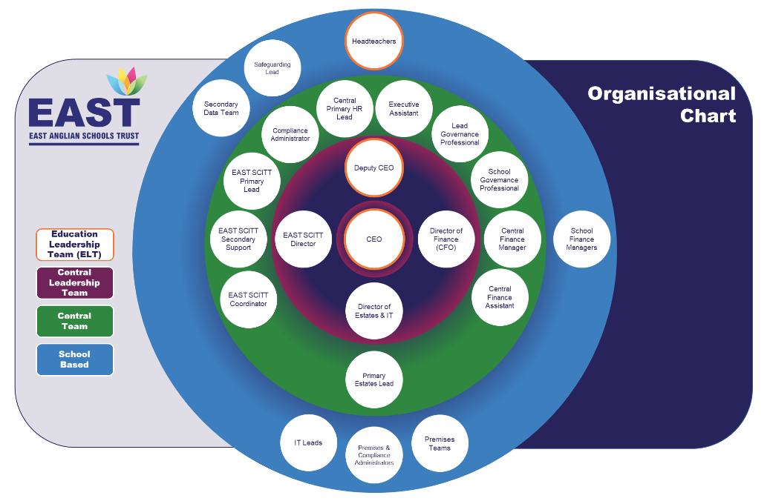
Contents
1 | Letter from CEO ………..…………………………………………………………………….. | 3
2 | Advertisement ..……………………………………………………………………………….. | 4
3 | Job Description ……………………………………………………………………………….. | 5
4 | Person Specification ..……………………………………………………………………….. | 8

Letter from CEO

Dear Applicant,

Thank you for your interest in the post of Secondary School Improvement Lead for the East Anglian Schools’ Trust (EAST).

As a growing Trust, we have a vacancy for an exciting new role in EAST’s central Education Team. This role will be pivotal in supporting school improvement with a particular focus on secondaries but also across the Trust. Working closely with the CEO, Headteachers & Education Directors, the successful individual will lead key aspects of our Trust-wide educational offer and work closely as part of a collaborative and team-orientated environment. Support and training will be provided to understand and develop knowledge of the role and our schools. The role is either full time and will include teaching in an EAST school (for approximately 0.4FTE) or part time (0.6FTE).

Over EAST’s first five years, as CEO, I have been the Director of Secondary Education, working closely with Headteachers. This is without doubt, the most exciting aspect of MAT leadership, and indeed a privilege. However, as we grow and develop, alongside our commitment to working collaboratively, the capacity and expertise we now require is much greater. With this new appointment, I am looking forward to working with someone equally committed and excited about developing Trust-wide systems and creative approaches to supporting school improvement.

Our Trust has a geographical spread in 11 schools across Suffolk, with our central office located in Wickham Market. With a number of in-person meetings and actively supporting school improvement, the individual will need to be comfortable and confident in travelling to schools to work with colleagues. The role will involve working in the central office and in schools to support teams and individuals directly.

This role will provide the opportunity to develop understanding of working in a successful multi- academy trust. It will also mean the successful candidate has the opportunity to develop expertise, knowledge and confidence in working across different school phases. A genuine resonance with the ethos and values of the Trust is essential.

We hope we have provided you with the details you require to build a good understanding of the role. Should you wish to discuss the post further, we would welcome an informal conversation. Please do not hesitate to contact Emma Power, Executive Assistant, using epower@eastmat.org (or by phone on 01728 746405 option 4 or 01728 554305) to arrange this with the CEO, Angelo Goduti.

We look forward to hearing from you.

Yours sincerely
Angelo Goduti
Chief Executive Officer

Advertisement
Secondary School Improvement Lead

Central Trust Office: | Wickham Market Primary School
Salary: | £76,772- £84,699 (L17 – 21)
Contract Status: | Full Time (includes 0.4FTE teaching) or  Part Time (0.6FTE)
Start Date: | April 2026 (open to discussion)
Reports to: | Chief Executive Officer (CEO)

As a growing Trust, we have a vacancy for an exciting new role in EAST’s Central Education Team. The role of Secondary School Improvement Lead will be significant in supporting school improvement with a particular focus on secondaries but also working across the Trust. Working closely with the CEO, Headteachers and Education Directors, the successful individual will lead key aspects of our Trust-wide educational offer and work closely as part of a collaborative and team-orientated environment. Support and training will be provided to understand and develop knowledge of the role and our schools. The role is either full time and will include teaching in an EAST school (for approximately 0.4FTE) or part time (0.6FTE).

We are looking for a secondary leader with Senior Leadership Team experience who understands and seeks to maximise the impact that an effective MAT can have. Trust-related experience is not essential and the successful candidate will be assured of support. Applicants should be confident with secondary data and school improvement strategies, have strong communication skills, excellent organisation, and be able to form strong, professional relationships. Individuals will be approachable and enthusiastic with a strong commitment to EAST.

Please note the role will involve travelling to schools across EAST and will be based in the central office in Wickham Market.

Should you wish to discuss the post further, we would welcome an informal conversation. Please do not hesitate to contact Emma Power, Executive Assistant, using epower@eastmat.org (or by phone on 01728 746405 option 4 or 01728 554305) to arrange this with the CEO, Angelo Goduti.

Applications should be completed using the MyNewTerm portal and should include completion of the application form with a letter of no more than 2 sides of A4 outlining your experience, expertise and how you would ensure the role is impactful.

Deadline for applications: Friday 9 January 2026 at 9am
Interviews in week commencing Monday 12 January 2026

Please visit our website for further details about EAST: https://www.eastmat.org
EAST is committed to safeguarding and promoting the welfare of children, young people and vulnerable adults and expects all staff and volunteers to share and adhere to this commitment. DBS checks required for all posts.

Secondary School Improvement Lead
Job Description

Role: | Secondary School Improvement Lead

Key Purpose

The new role of Secondary School Improvement Lead consists of two varied and broad strands:

- Coordinate school quality assurance, support and improvement strategies across the trust.
- Lead aspects of our Trust-wide offer and developments for the future.

It is likely to be a role that evolves and the secondary improvement agenda will be coupled with working across the Trust. The nature of the work will mean we will be looking for someone currently on SLT with experience of whole school secondary leadership. The role is either full time and will include teaching in an EAST school (for approximately 0.4FTE) or part time (0.6FTE).*

Main Responsibilities & Tasks

- Trust Improvement Strategy & Secondary Performance

- Coordinate key aspects of the School Improvement Strategic Action Plan
- Work with Headteachers and Education Directors to develop effective improvement strategies
- Explore systems to make monitoring and data sharing efficient
- Lead development and coordination of Trust-wide, educational quality assurance
- Organisation of bespoke School Reviews
- Organisation of Trust-wide educational reviews
- Develop information and systems required for effective secondary monitoring and accountability
- Develop ‘Data for Achievement’ across EAST
- Review and research future Trust-wide systems
- Oversight of Trust-wide attendance & reporting
- Oversight of Trust-School Improvement Calendar
- Develop and lead Trust Data Systems: KS3, KS4 and KS5*
- Support individuals & teams in school improvement activities
- Lead and support Trust activities tasks in line with position
*Data related activities are currently led by the Data Team. As the role develops, we will review how this is organised to maximise capacity and expertise.

- Professional Development and Collaboration

- Develop EAST’s CPD approach/rationale
- Lead CPD programme alongside Directors of Education which includes:
  - ECT & Developing Leaders Programmes
  - Leadership Development
  - Support Staff CPD Programme
- ‘Project Leads’ oversight & organisation as appropriate
- Support and coordination of Subject Networks
- Support and organisation of Leadership Networks
- Design. Lead and support relevant initiatives and developments
- Lead and coordination of other CPD/Collaboration Projects
- Identify and prioritise research and CPD opportunities for school improvement

- Relationships & Partners

- Develop strong relationships and effective working arrangements with Trust and school staff
- Represent the Trust at conferences and events
- Liaise with external agencies for the Trust as required
- Establish effective partnerships with other Trusts/Schools and Local Authorities
- Encourage the participation of leaders and teachers in relevant working parties and networks
- Ensure communication is supported across EAST

6. Funding/Budget Management

- Ensure budget allocations are used effectively to maximise impact of relevant areas
- In keeping the Trust’s finance policy and systems, ensure that budgetary controls are effective and expenditure is managed effectively

7. Accountability

- Be accountable to the Trust CEO
- Report as required, to the CEO, the Trust Board and Education Committee

8. Other Responsibilities

- Develop own professional practice and keep up to date with all policy developments
- Contribute to the wider work of the Trust
- Exercise a commitment to safeguarding and promoting the welfare of children, young people and vulnerable young adults.
- Carry out any such duties as may be reasonably required by the CEO

The duties listed in the job description are not intended to be an exhaustive list but are the general guidelines to the post, and other duties of a similar level/nature may be undertaken by the post holder. Tasks are not excluded from the post simply because they are not itemised. We need all staff to be flexible in their approach to support the Trust and its schools in this essential role.

*The Trust reserve the right to change the teaching proportions of the role based upon operational requirements.

EAST is committed to safeguarding and promoting the welfare of children, young people and vulnerable adults and expects all staff and volunteers to share and adhere to this commitment. DBS checks required for all posts.

Central Education Structure:

CEO (AG)

Director of Primary Education (HM)
Director of Secondary Education (AG)
Director of SEND (AM)

Secondary School Improvement Lead

Trust Data Team

Person Specification

Area | Essential | Desirable
Application
Fully supported by references. | ü
Well-structured application letter demonstrating experience, expertise and how you would ensure the role is impactful. | ü
Knowledge and understanding of current issues and relevance for the Trust | ü
Qualifications
Qualified Teacher Status & Secondary Expertise | ü
Degree | ü
Additional leadership qualifications |  | ü
Experience & Expertise
Ability to communicate and relate to all members of the Trust community | ü
Strong working knowledge and understanding of achievement data | ü
Experience of successfully supporting school improvement within school | ü
Experience of successfully supporting school improvement across schools |  | ü
Experience of contributing to the school quality assurance / monitoring | ü
Experience of the successful management of change | ü
Ability to work with staff effectively | ü
Understanding of school safeguarding procedures | ü
Professional Development
Evidence of attending and/or delivering relevant CPD |  | ü
Skills and knowledge
Demonstrate strong role-related knowledge | ü
Demonstrate effective inter-personal skills | ü
Ability to build on current achievements and continue to raise standards | ü
Ability to lead and work as part of a supportive team | ü
Have a clear understanding of the needs of children including those with additional needs such as disadvantaged, SEND and vulnerable | ü
Have a good understanding of the current Ofsted Inspection framework | ü
Ability to create a shared vision, motivating others towards this | ü
Ability to address challenge to sustain improvement initiatives | ü
Knowledge and understanding of current issues and relevance for the Trust | ü
Appreciation of the importance of exploration and development of effective and innovative approaches to school improvement | ü
Ability to build and sustain effective working relationships and partnerships with a broad range of stakeholders | ü
Ability to work in partnership with schools, key agencies and organisations | ü

*driving license and own car required as you will be travelling between schools

