
ENCO Dece
Woods Avenue, Hatfield, Hertfordshire, AL10 8NN
Telephone: 01707 276 504

Woods Avenue, Hatfield, Hertfordshire, AL10 8NN
Telephone: 01707 276 504

SOUTHFIELD SCHOOL

Candidate Information Pack
SENCO



Introduction

Southfield School are looking to recruit a SENCO / Pupil Champion & Inclusion Manager and Member of the Senior Leadership Team. Reporting to the Headteacher.

Contract Type
Full Time

Start Date
As soon as possible

Interview Date
TBC

Hours
Term Time only
32.5 hours a week – Monday to Friday

Salary
L2 – L8 (Fringe) FTE

SENCO - Recruitment Advertisement

Southfield is a primary school for approximately 100 pupils with Learning Difficulties, which include, Autism, Speech Language and Communication Needs, Global Developmental Delay, and other conditions.
Admissions are via the Local Authority, and the present criteria is that children are accessing learning approximately 50% below their chronological age. We follow the EYFS and Key Stage 1 National Curriculum and adapt these to meet the individual interests and needs of our pupils. We do this through a 3 Phase curriculum that is presently being developed. Priority is given to communication, self-regulation, independence and functional Literacy and maths. We use a wide range of approaches and strategies to support learning, including multi- sensory communication, social stories, TEACCH and Hertfordshire Steps. We also work with a range of professionals, from advisers in the Local Authority to Therapists and social care colleagues. Access to sporting and creative arts organisations, provide a range of enhanced learning opportunities, both in school and the local area.

Southfield is going through a period of rapid and exciting change, that you could be part of. It is a journey of challenge, in the pursuit of excellence, but one that provides huge rewards both personally, in your professional development and when you see the difference you make to the lives of our young people and their families.

Recruitment will be in line with our Safer Recruitment Policy and online searches may be conducted.



SENCO – The Role

We are seeking to appoint an initiative-taking SENCO, to support and promote an inclusive culture throughout the school, enabling all children to achieve their best, overcoming barriers to learning and participation. The SENCO / Pupil Champion & / Inclusion Manager holds a very important strategic role in the Senior Leadership Team of the school. It entails co-ordinating appropriate provision for children with special needs and liaising with colleagues, parents/carers and outside agencies. Responsibility for the school’s attendance strategy is also part of the post. The role also includes overseeing the provision and tracking progress for all pupils across school.

All pupils have an EHCP, which often states a diagnosis of Autism and associated Speech, Language and Communication needs. Children may demonstrate challenging behaviours.
Southfield school is ambitious and committed to the personal development of all staff. There are excellent opportunities for high-quality CPD, and we are keen to support you in your development.
In return, you will benefit from collaborating with a dedicated team of staff focused on delivering outstanding service. You will be actively encouraged to give your input, as we make significant improvements within the school.
Visits to the school for potential candidates are warmly welcomed. Please contact the school Office to book an appointment.



About You

Attributes | Criteria | Essential | Desirable
Qualification | Degree Level Qualification | √
 | Qualified Teacher Status | √
 | National Award for Special Educational Needs Coordination or in the process of application / completing this qualification. | √
 | Specialist SEN Qualification | √
Professional Knowledge, Skills, Abilities & Experience | Practicing SENCO/Asst. SENCO with experience and understanding of complex SEND. |  | √
 | Knowledge of inclusive practice and strategies relating to learners with special educational needs within Schools and the wider community |  | √
 | Sound knowledge of the SEND Code of Practice and other legislation, understanding how to be compliant. | √
 | Understanding of safeguarding and child protection procedures. | √
 | Experience of leading/coaching/mentoring teams and individuals, empowering them to work autonomously as needed and building high levels of team cohesion |  | √
 | Confident leadership skills and well-  developed interpersonal skills in working with teachers and support staff. | √
 | Able to develop positive working relationships with parents and a range of stakeholders. | √

About You (cont.)

Attributes | Criteria | Essential | Desirable
Professional Knowledge, Skills, Abilities & Experience  (cont.) | Child-centred approach, supporting students to be aspirational and encouraging them to work with increased independence, developing them for the future and life beyond school | √
 | Experience of clear and concise reporting of SEND data and supporting evidence. |  | √
 | Maintaining an up-to-date knowledge of both local and national educational/organisational strategies which may influence the school. | √
Other Relevant Skills | Excellent verbal and written communication skills with the ability to construct high quality reports. | √
 | Well-developed IT skills and a strong commitment to embracing the benefits of new technologies in teaching, learning and assessment | √
 | Able to work to tight deadlines and be flexible with the need to adapt work practices as needs arise | √
 | Able to work effectively across the whole organisation | √
 | Ability to balance workload and manage time effectively | √
Personal Attributes | Strong commitment to equality for children and staff | √
 | A recognition of the need to embrace and celebrate diversity and difference | √
 | An awareness of safeguarding/health and safety needs | √
 | High level of professional integrity and an ability to maintain confidentiality, acting with discretion and sensitivity | √
 | Remain optimistic and retain a sense of proportion | √

SENCO – Job Specification

Main Purpose of Job
To support and promote an inclusive culture throughout the school, enabling all children to achieve their best, overcoming barriers to learning and participation. The SENCO / Pupil Champion & / Inclusion Manager holds a very important strategic role in the Senior Leadership Team of the school. It entails co-ordinating appropriate provision for children with special needs and liaising with colleagues, parents/carers and outside agencies. Responsibility for the school’s attendance strategy is also part of the post. The role also includes overseeing the provision and tracking progress for all pupils across school.

It is expected that the post holder will have the NPQ SENCO or be working towards this qualification.

Professional Duties
In addition to carrying out the professional duties of a teacher as set out in the School Teachers’ Pay and Conditions document in accordance with the:

· National Standards for Qualified Teachers.
· EYFS & National Curriculum.
· School's aims, objectives, key priorities, values.
· Policies of Southfield School.

In addition, the specific requirements of the post, along with the duties expected of the post holder
undertake any additional duties as required.

SLT Responsibilities
- Support the vision, ethos and policies of the school which secure effective teaching, successful learning and promote high levels of achievement and self-esteem and confidence for all pupils, irrespective of background, ethnicity, gender or disability.
- To attend SLT, Internal Professional, Teachers and staff meetings.
- If required, undertake some teaching commitment, as needed, and provide an outstanding
professional model as a classroom practitioner, inspiring and motivating other staff.
- Ensure the effective and proficient use of pupil data from a variety of sources, both internal and external, in the process of target setting.
- Assist in the preparation, implementation and monitoring of the School Improvement Plan.
- Ensure the good conduct and behaviour of children throughout the school.
- Keeping up to date with developments in educational practice and statutory requirements.
- To be involved in teaching and learning observations with other members of staff to raise pupils’ standards of achievement and to evaluate practice.
- To lead, motivate, support, challenge and develop all staff to secure continual improvement including his/her own continual professional development.
- To support the Headteacher in accounting for the efficiency and effectiveness of the school to all relevant stakeholders.

- Working with the Headteacher to contribute to a strategic view for the school in its community and analyse and plan for its future needs and further development within the local and national context.
- At times, may be asked to Deputise for the Headteacher in their absence.
- Demonstrating high standards of personal integrity, loyalty, discretion and professionalism.

Special Educational Needs
Teaching and Learning
- Identify, adopt and monitor the most effective teaching approaches, including intervention programs where necessary, sharing such approaches with colleagues

Recording and Assessment
- Work with colleagues to set challenging targets for raising achievement across school.
- Ensure robust tracking systems are in place to collect and interpret specific pupil level assessment data to identify the impact of quality first teaching and intervention strategies.
- Set up systems for screening pupils at “point of entry” identifying, assessing across school.
- Provide reports for stakeholders as required’.
- Lead annual review meetings in ensuring that Education Health Care Plans are highly detailed for each individual pupil in ensuring progress is reviewed, new targets are set and determine strategies to improve attainment.
- Be available at parent consultation evenings to meet with parents. The post holder may be required to attend meetings with stakeholders as required out of school hours.
- Support in the reviewing of policies.
- To annually review and maintain the SEN Information Report to publish to all stakeholders on the school website.
- To support in obtaining necessary funding in meeting the needs for each individual pupil.
- Liaise with professionals outside of the school, make referrals, and co-ordinate assessments for individual pupils – inc. psychologists, health and social care providers, speech and language therapists and occupational therapists.

Leadership and Management
- Ensure the school’s tracking systems are fully up to date.
- Ensure that all members of staff to recognise and fulfil their statutory responsibilities to pupils with SEND.
- Take the lead in constructing the schools provision map ensuring intervention programmes target the right pupils and staff expertise is deployed appropriately.
- Provide training opportunities for teaching assistants, teachers and other stakeholders as required.
- Disseminate good practice in SEND across the school.
- Identify resources needed to meet the needs of pupils with SEND and advise the Headteacher of priorities for expenditure
- Contribute to Senior Leadership Meetings on the effectiveness of SEN provision in the school and be prepared to share this information with other stake holders.
- Take the lead in liaising, co-ordinating and managing the extended therapy team across school and other stakeholders as necessary.
- To support in the Performance Management systems across school.
- To support on the attendance for pupils.
- Maintain a sharp awareness and understanding of legislation which is central to the teaching of children and young people with special educational needs, inc. the legislative and policy frameworks which govern education at national and local levels.
- Maintain an awareness of current and proposed political, economic, social, religious, and technological influences (national and local) which may have an impact on the strategic and operational direction of the school.
- Produce reports for Governor’s meetings as required.
- Act as a line manager and carry out appraisals, adhering to the school’s policy including supporting continued professional development and training opportunities

Confidentiality
To always maintain the highest level of professionalism and confidentiality.

Safeguarding Children and Health & Safety
Southfield school is committed to safeguarding and supporting the welfare of pupils and expects all staff and volunteers to share this commitment. We are also committed to the equality of opportunity for all. Applicants for this post must be willing to undergo child protection screening, including reference checks with previous employers and the Disclosure and Barring service. We will also complete online social media checks.

This job description is not a comprehensive definition of the post. Discussions will take place on a regular basis to clarify individual responsibilities within the general framework and character of the post as identified below. The conditions of employment of teachers in the School Teachers’ Pay apply to this post, whose holder is expected to carry out the professional duties of a teacher as circumstances may require, under the reasonable direction of the Headteacher. The duties may be varied to meet changed circumstances in a manner compatible with the post held, at the reasonable direction of the Headteacher. This job description does not form part of the contract of employment. It describes the way in which the member of staff is expected and required to perform and complete the particular duties as set out above.

Letter from the Headteacher

Are you bored with life? Looking for a new challenge? Have a desire to work in an environment where you can make a ‘real’ difference to the lives of young people? If so, Southfield School is the right environment for you.
We are a family with approximately 110 pupils. No two students are alike, and no two members of staff are alike. Our pupils all have challenging ASD and associated conditions.
Our school vision is to support all children, so they thrive during their time at Southfield School and are prepared socially, emotionally, and academically for their next steps in education. Collaboration with parents and carers and the entire multi-disciplinary team who support our students is vital and key to our success.
Everyone plays a part in the future of our students with staff skills being used in order that we have a huge range of skill set and expertise. Everyone makes a difference to the lives of our students and families.
We are looking for like-minded, resilient staff who are passionate and who can work in a team.
If you have yet to find what it is that you were meant to do with your life – Southfield School may be what you have been searching for.

Come and join us and make a difference to the lives of children every day.


Angela O’Rourke
Headteacher

OUR VISION AND VALUES

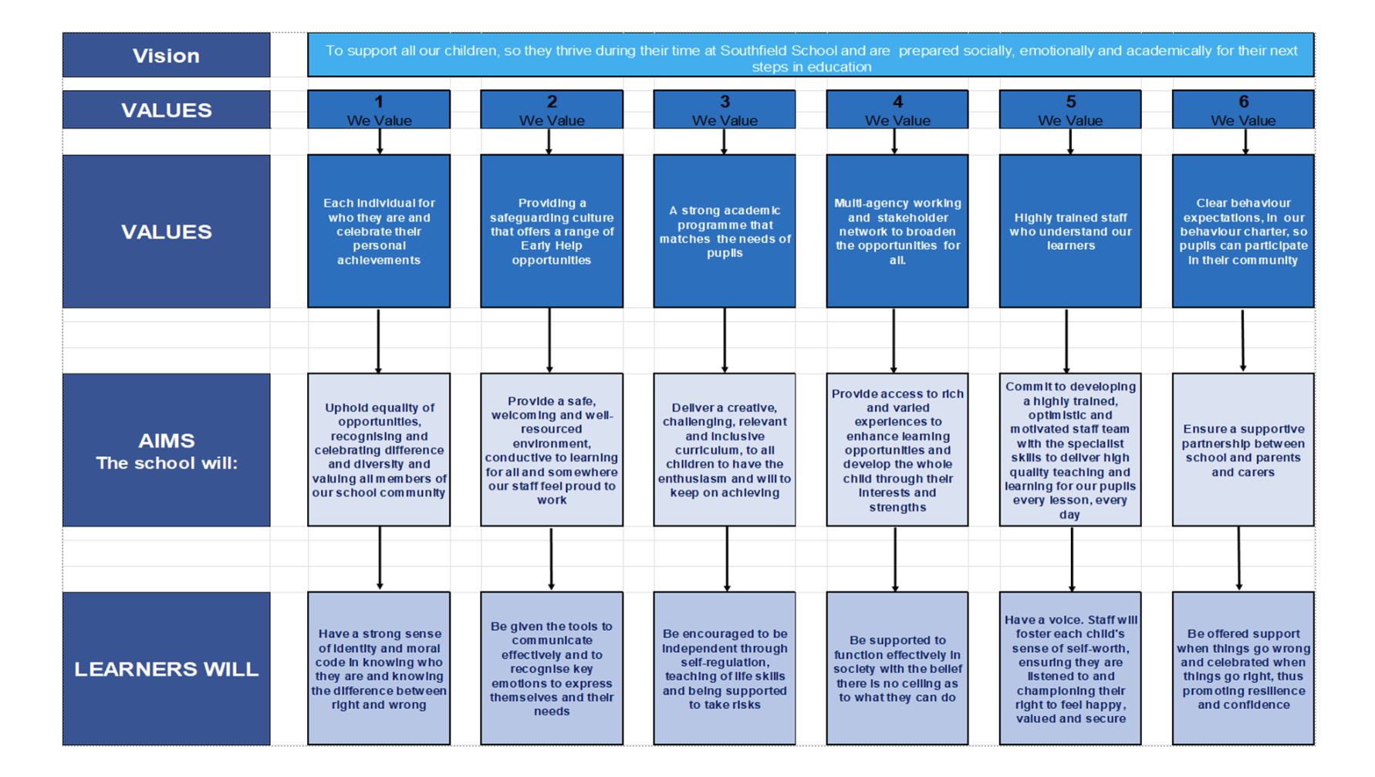
A Bright Future for ALL

