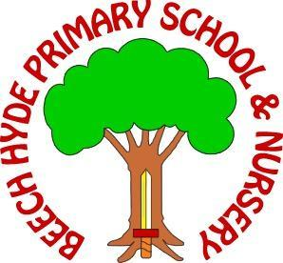
Cleaner Job Description

Purpose of Role To undertake cleaning duties to maintain a high standard of cleanliness within the school, as scheduled or required. Responsibilities will include undertaking of cleaning of allocated areas in line with specified standards and as directed.
Operate / use domestic and industrial cleaning equipment and materials, following
appropriate training.
Store allocated equipment and materials safely and securely.
Perform duties in line with health and safety regulations (COSHH) and take action
where hazards are identified, report serious hazards to line manager immediately
Collect and dispose of waste
Refill and replace soap, towels and other materials.
Undertake specialised cleaning programmes during school closures or other
designated periods

Person Specification
Personal Qualities:
The successful candidate will have:
Excellent verbal and written communication skills.
Excellent time management and organisation skills.
A flexible approach towards working practices.
High expectations of self and a desire to maintain professional standards.

