

Candidate Recruitment Pack

Teaching Assistant

UET Pathfinder School – Danby Wood

Applications considered upon receipt

www.unityeducationtrust.uk jkeyes@unityeducationtrust.uk

A welcome from the CEO
Dear Applicant,

Thank you for your interest in our vacancy at Unity Education Trust (UET).
As Chief Executive of the UET, I am delighted to offer you a warm welcome to our Trust. These are exciting times for all those associated to Unity Education Trust a Multi-Academy built on developing like-minded schools to be outstanding education providers through collaborative working that develops a ‘unity of purpose’ in all that we do.
UET has expanded its family of schools and education professionals. We welcome outstanding teachers, subject specialists, tutors, support staff and experienced leaders with a record of transformation in education.

All of our staff share the ethos of raising aspirations, unlocking potential and securing the best possible future for the 2700 young people attending our schools.

Our schools’ range in size from 20 to 1200 students and effective collaboration across our schools is an important part of who we are, whilst maintaining individual schools’ identity within their community.

I am proud that we are working in ‘Unity’ to meet the challenges in education head on and spearheading new developments for the benefit of all the children in our care.
We look forward to receiving your application.
Best wishes
Glyn Hambling
CEO


Our Story
Raising aspirations to fulfil potential

Raising Your text here
aspirations to fulfil potential

UET was established in March 2017. As of 2024, its family of schools have expanded providing education for 3 - 19 year olds across mainstream and alternative provision settings and now comprises the following:
Specialist
Pathfinder School –
Brooklands, Danby Wood, Douglas Bader, Hooper Lane, Brooklands, Rosebery

Compass –
Belton, Lingwood, West

- UET Earthsea
- Churchill Park Academy
- The Pinetree School
Mainstream
- Northgate High School and Dereham Sixth Form College
- Grove House Nursery and Infant School
- Kings Park Infant School
- Beeston Primary School
- Garvestone Primary School
- Great Dunham School
- Greyfriars Academy
- Highgate Infant School
- Kings Oak Academy
- Magdalen Academy
- St Germans Academy
- Wimbotsham & Stow Academy

The Trust sets high expectations in every aspect of our work, providing pupils with the best opportunities through outstanding teaching, the development of 21st century facilities, inspirational leadership and a growth mindset approach.
We will ensure that each of our academies maintains its unique identity at the heart of their community and engaging with all partners and stakeholders and other high performing educational organisations.

We have an unrelenting belief and focus that all students can achieve high standards, whatever their background and life experiences when given a positive climate of support, challenge and the development of Growth Mindset through outstanding teaching.
Furthermore we are committed to ‘raising aspirations to fulfil potential’ ensuring our learners are encouraged to build confidence, expand their leadership qualities and embrace British Values that enable all to thrive in an ever-changing society.

Our School – Pathfinder Danby Wood

Welcome to Danby Wood. The site offers short stay provision for students in year 1 to year 11 and whilst here, we aim to invest in and value each individual to be resilient, respectful and reflective. This is underpinned by our vales of trust, positivity, self-belief, respect, passions and interests, courage, opportunities as well as personal and collaborative goals.

Staff and students work collaboratively in order to grow and develop the young people we educate by offering a nurturing, inclusive package that supports students to build resilience, learning behaviours and self-esteem, to help them to grow into young, mature individuals who are able to progress onto college, to another specialist provision or return to mainstream.

Danby Wood has a strong, committed team who work collaboratively to ensure all students are on the right path. They have expertise and experience of knowing how to work with our young people and as a team, we further develop, listen to and do everything we can to ensure all students are positive, respectful, engaged and growing into well-round, secure individuals.

We raise aspirations, support young people to dissect and understand different ways of approaching situations in order to be successful. We are bespoke and fluid in our approach recognising that individuals need their own package of support. We build learning spaces and communities where the students develop personal responsibility, feel empowered and cultivate the skills to be successful.

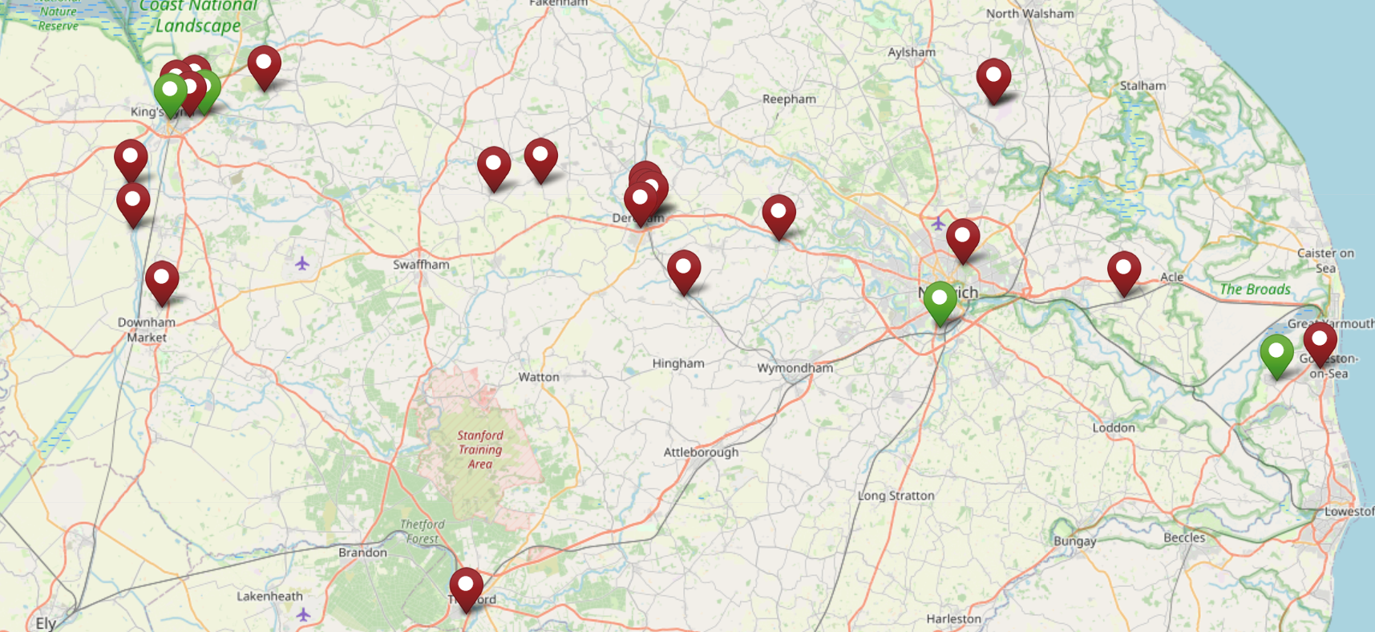

Underpinning principles




Supporting Our Staff

Unity Education Trust is committed to supporting all staff in their personal, professional and career aspirations by providing a range of development opportunities. We foster a culture which encourages you to develop your talent and strengths throughout your journey with us.

We are committed to providing the highest quality support to ensure our schools excel and give our students the education they deserve. Our Headteachers have a good deal of autonomy as school leaders within a framework developed collaboratively with our Director of Education and the Education Directorate.

Each Unity Education Trust school benefits from a comprehensive programme of support and challenge, including a strong emphasis on CPD and a regular programme of training events to improve performance across all sectors within our schools.

We believe it is very important that each of our academies plans in such a way that financial and human resources are deployed to support their educational strategies fully. This is supported by our experienced Central Service team, who are available to advise on financial planning, audit, HR, legal and property matters.



Job Description

Cleaner

JOB DESCRIPTION
Job Title |  | Cleaner
Location |  | Pathfinder School – Brooklands
Grade |  | Scale A
Effective Date |  | January 2026
Role and Context
Job Purpose | To clean a designated area of the school to the standard laid down by the school.
Context | Job Family: Site Management and Maintenance
Other Job Information (e.g. and special factors on constraints | Need to let the school know before 12 noon if you are unable to attend your shift.

Principal Accountabilities

- To clean a designated area of the school to the standard laid down by the school.

- To replenish sanitary materials (toilet paper, paper towels and soap).

- To periodically clean the store rooms in the designated areas.

- To ensure the cleaning equipment is kept in a clean and working order.

- It should be noted that occasionally there may be a need to change the designated area to cover for sickness or absenteeism.

- To be fully aware of and to comply with all departmental instructions and procedures relating to Health and Safety at Work and to recognise the responsibilities required under the Health and Safety at Work Act 1974.

- To be fully aware and to comply with the instructions under the Control of Substances Hazardous to Health (C.O.S.H.H.).

- To report any problems to the Caretaker.

- To perform such other duties of a like nature as required by the Headteacher.

General Information

- The job descriptions detail the main outcomes required and should only be updated to reflect major changes that impact on the outcomes of the job

- Job holders must be aware of and comply with all current guidance, policies and procedures relating to safeguarding and ensure that they are in accordance with statutory and school safeguarding requirements at all times.

- All work performed/duties undertaken must be carried out in accordance with relevant Academy policies and procedures, within legislation, and with regard to the needs of our customers and the diverse community we serve.

- Job holders will be expected to be flexible in their duties and carry out any other duties commensurate with the grade and falling within the general scope of the job, as requested by management.



Joining Us

LOCATION
The post will be located at Danby Wood. The Unity Education Trust reserves the right to transfer staff to alternative posts appropriate to the grade and/or alternative work places as is considered reasonable.
PROBATIONARY PERIOD
New employees of The Unity Education Trust will be required to serve a probationary period of six months.

REMUNERATION
The current salary for the post is within the range:
- Salary: Grade A3 - £9,271 Actually Annual (£24,796 FTE)
Subject to satisfactory service, salaries will rise within the scale by annual increments up to the maximum of the scale. Salary is paid in 12 equal instalments on or just before the 19th of each month. Payment is by credit transfer

HOURS OF WORK
The normal working week is one of 15 hours, Term Time + 4 weeks. This is a permanent position.
DRESS CODE
The post-holder will be expected to wear appropriate attire and will be supplied with appropriate Staff ID. This must be worn at all times to ensure that students, staff and visitors are able to identify UET colleagues.
BENEFITS
- Comprehensive induction
- Commitment to your ongoing training and career progression
- Pension scheme
- Eye care vouchers (if criteria are met)
- Paid for enhanced DBS
- Wellbeing support
- FastTrack treatment service including physiotherapy

Terms and Conditions

PRE-EMPLOYMENT CHECKS
All staff must be prepared to undergo a number of checks to confirm their suitability to work with children and young people. The Trust reserves the right to withdraw offers of employment where checks or references are deemed to be unsatisfactory.

EQUAL OPPORTUNITIES
UET has a policy that seeks to ensure that all employees are selected, trained and promoted on the basis of ability, the requirements of the post and other similar and objective criteria. The gender, marital status, ethnic origin, age, religion or sexual orientation of an applicant or employee does not affect the employment opportunities made available except as permitted by legislation. UET also requires full and fair consideration to be given to people with disabilities in the recruitment process. Applicants declaring a disability who meet the minimum (essential) criteria for the vacancy will be invited for interview.

DISCLOSURE AND BARRING SERVICE CHECK

This post is subject to a Disclosure and Barring Service Check. Disclosure and Barring Service and Disclosure of Convictions Policy for employment of persons with criminal convictions – refer to our website www.unityeducationtrust.uk
Immigration, Asylum and Nationality Act Information – refer to our website www.unityeducationtrust.uk
How to apply
Click on the Apply Now button. You can save your application and return to it later. Please ensure you have completed your application before the end date.
No CVs accepted – please complete an application form if you wish to be considered for this role.
Candidates are advised that they may be subject to an online check from information in the public domain.
We aim to be an equal opportunities employer and welcome applications irrespective of race, gender, religion, disability, sexual orientation and/or age. We value the individuality and creativity that every worker potentially brings to the workforce.
This post will come under the requirements of the Childcare (Disqualification) 2009 Regulations and the successful applicant will be required to complete a declaration form to establish whether they are disqualified under these regulations.
​​​​​​​Unity Education Trust is committed to safeguarding and promoting the welfare of children. All applicants must be willing to undergo safeguarding screening appropriate to the post, including checks with Disclosure & Barring Service and at least 2 references which cover the last 3 years; for all our services we will request references from where you have worked with either children or vulnerable adults. Please be advised that references may be requested prior to interview for roles within our schools.
This post is covered by Part 7 of the Immigration Act (2016) and therefore the ability to speak fluent English is an essential requirement for this role.
We reserve the right to withdraw this vacancy at any time ahead of the closing date if there is a sufficient level of response. Therefore, we recommend you submit your application as early as possible.
We also reserve to right to interview shortlisted candidates ahead of the closing date.

Interview process

Application will be considered upon receipt.

Interview process

- Candidates will be shortlisted
- References will be requested

The interview process will include:

- Tour and Task
- Interview
- Classroom Familiarisation

If you would like an informal discussion. Please contact Jenna Keyes, Head of School by emailing jkeyes@unityeducationtrust.uk



Unity Education Trust
C/O Dereham Sixth Form College
Crown Road
Dereham
Norfolk
NR20 4AG

