
Edgbarrow School

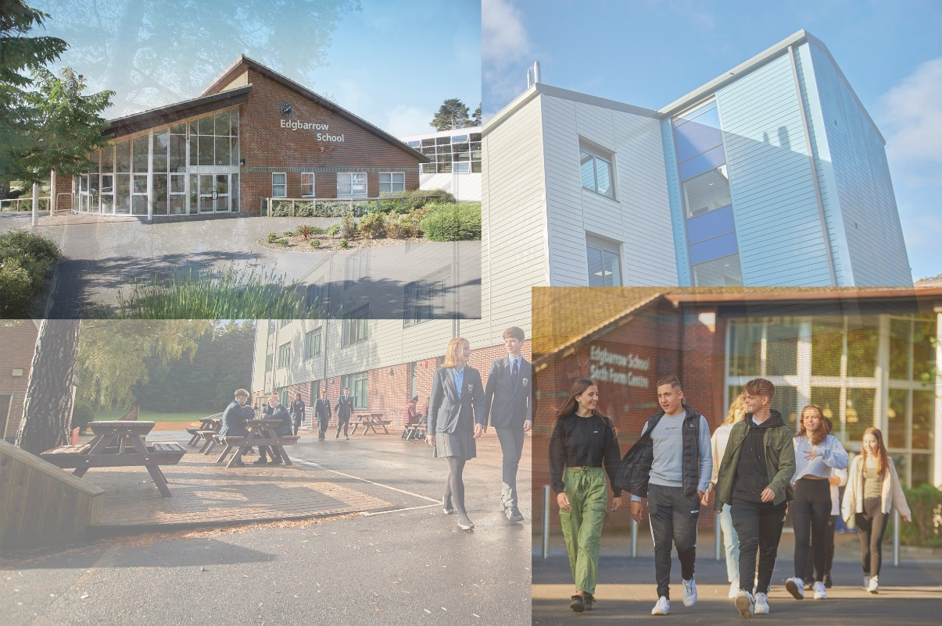

Edgbarrow School Grant Road, Crowthorne, Berkshire. RG45 7HZ TEL: 01344 772 658
Candidate Information
TEACHER OF MATHS

Contents

- Letter from the Headteacher
- Candidate Information:
  - School Information & Vision
  - Job Description
  - Person Specification
  - Department Description
  - How to Apply
- Further Information:
  - School Links
  - Curriculum
  - Exam Results

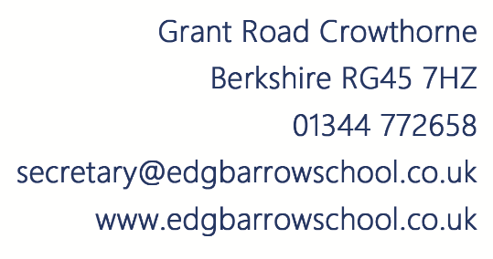

Dear Applicant
Thank you for taking an interest in the advertised post at Edgbarrow School. We hope you find the information helpful in making your decision to proceed further in the application process. We make every endeavour to provide all candidates with equality of opportunity in the selection process. If you have any additional queries, please do not hesitate to contact the school.
The Trust, Governors and school community fully support our vision of ‘Enjoy, Grow, Achieve’. We absolutely believe that academic progress can open doors and drive future success and happiness and we encourage candidates to have a love of learning. It is important that candidates also have a passion for ensuring that the curriculum meets the needs and aspirations of all our learners, regardless of ability. Academic progress happens when students are safe, happy and enjoying school life and therefore, personal development and co-curricular opportunities must be equally important and highly valued.
Edgbarrow School is an 11-18 mixed comprehensive academy and is a founder member of the Corvus Learning Trust. The school serves the students of Crowthorne Village in Bracknell Forest. There are approximately 1500 students on roll of which 400 are in the Sixth Form. Further information regarding the school can be obtained by visiting the school website at www.edgbarrowschool.co.uk.
Applications from suitably qualified and experienced candidates are welcomed via the online application system and any queries emailed to recruitment@edgbarrowschool.co.uk. This post is subject to an enhanced DBS and references.
Edgbarrow School is an outstanding, happy, and caring school and we look forward to receiving applications from suitable candidates for this important post. You will join a friendly, experienced and welcoming SLT who enjoy collaboratively working in the school. I would like to take this opportunity of expressing my best wishes to all those who apply and, whether or not you are successful in this particular application, to wish you success in your future career.

Yours sincerely

Mr Stuart Matthews
Headteacher

School Information & Vision

Thank you for your interest in this post. The enclosed literature is intended to give a better understanding of Edgbarrow School.

Edgbarrow School is a larger than average secondary school, one of six secondary schools within the Bracknell Forest borough, and the only one in the village of Crowthorne. The school is regularly oversubscribed, attracting over 500 applications for 210 places in 2025. The sixth form has grown considerably in the last five years (300 to 400).

We are very fortunate to have a stable, professional and highly committed group of teachers and support staff who work together to ensure that each student receives the best educational experience. Visitors, including parents, contractors and outside agencies frequently comment on the positive atmosphere that pervades the school, from a warm welcome at our reception that continues to be felt around the site. We are very proud of our students’ attitude towards their school, learning and the way they behave.

Our Vision
Edgbarrow School is a learning community where all students and staff:
- Enjoy school life and are supported in achieving their full potential in their academic, creative and physical, moral, spiritual and personal development.
- Understand that learning and teaching have the highest priority and benefit from working within a vibrant, purposeful environment.
- Know that they can make a positive contribution and are valued as individuals, fostering mutual respect within a safe, caring and supportive community.
- Have the opportunity to develop their talents and acquire skills for life-long learning in an increasingly technological society.
- Are encouraged to be confident, motivated, healthy, enterprising and responsible citizens.

In order to help you understand the school and our priorities, we have tried to identify what defines Edgbarrow for those of us who work here. These can be summarised under the following headings:

- Achievement
- Attainment – excellent results at all key stages
- Progress – excellent progress made by all students

- Reputation
The school at the centre of the community that trusts its young people will be cared for and provided with opportunities to develop all skills and talents

- Ethos
Staff and students enjoy purposeful working relationships to learn together in a safe, happy environment

- Ambition
Purposefully driven to be constantly improving by committed and hardworking governors, leaders, teachers and support staff reflected in the manner in which students engage and behave

- Post 16 Learning
Provision of an excellent resource to build a bridge between school and Higher Education or work.
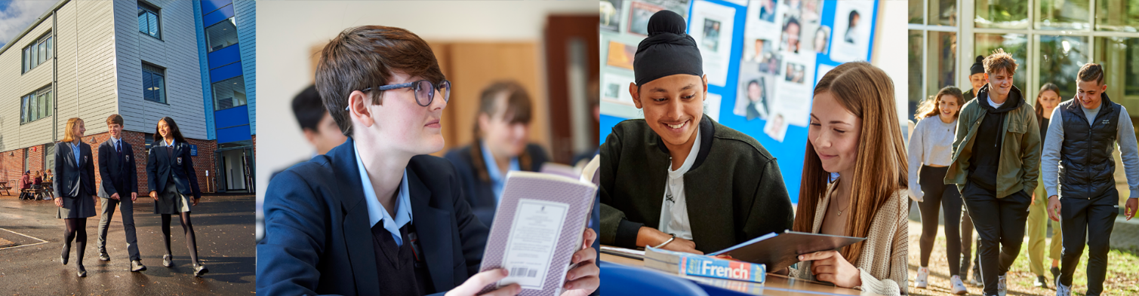
Job Description

Job Title: | Teacher of Maths
Knowledge

- Demonstrate subject competence and to keep up-to-date his/her knowledge of the National Curriculum for 11-16 year olds in relation to their subject; and where relevant to the post, other examination courses at KS4 and Post 16.
- To attend continuous professional development activities when required to update his/her knowledge of the National Curriculum, syllabus changes and national initiatives which impinge directly on teaching, pastoral or other responsibilities.
- For ECT (Early Career Teachers), to attend INSET and other professional development activities required in an agreed action plan so as to meet the national standards for the Induction Year.
- To keep informed about the key priorities identified in the School Development Plan, associated department development plans and his/her responsibilities agreed upon within it.

Planning, Teaching and Classroom Management

- To teach across a range of abilities and ages commensurate with his/her experience and skills and as agreed in consultation with the Headteacher and Head of Department.
- To plan lessons in accordance with the agreed departmental scheme of work and in line with the departmental teaching and learning policy.
- To plan lessons carefully with specific learning objectives and with special regard to prior attainment data, gender and race, fluency in English, SEN (including IEPs).
- Use a variety of teaching approaches which identify, build upon and develop pupil learning styles, and the ability to learn independently.
- To set clear targets for pupil improvement and monitor progress towards these.
- To work effectively with Learning Support Assistants to plan lessons and individual support for statemented pupils, including monitoring progress on IEPs.
- To set appropriate homework in line with school and departmental policies.
- Establish and maintain good standards of pupil behaviour in the classroom by implementing consistently and fairly the School Behaviour Policy.

Monitoring, Assessment, Recording and Reporting

- To assess how well learning objectives have been achieved and use this assessment to improve aspects of teaching.
- To develop the expertise to be able to recognise the level at which a pupil is achieving, and make accurate and valid assessments using school and departmental policies and procedures.
- To mark work on a regular basis in line with school and departmental policies and guidelines.
- To make careful records of attendance and pupil progress following carefully the departmental guidelines; mark books and pupil work should be available for scrutiny as required from time to time.
- To liaise effectively with pupils’ parents/carers through informative oral and written reports on pupils’ progress and achievements according to the school’s assessment and reporting schedule.
- To discuss with parents/carers appropriate targets for their child, and encourage them to support their child’s learning, behaviour and progress.
Other Professional Responsibilities
- To undertake the role of form tutor, if required to do so, and follow the guidance given by the Head of Year in relation to carrying out this role.
- To undertake supervisory duties before school, at break or after school as required.
- To attend department and other school meetings as required.
- To contribute to the work of the department.
- To support colleagues in maintaining the school’s behaviour policy.
- To maintain appropriate standards of professional appearance and conduct.
- To raise issues of concern with his/her line manager or with the appropriate member of SLT.
- For staff who have reached the Threshold, to keep evidence of their ability to maintain the Professional Standards.
- Comply with policies and procedures relating to child protection, health, safety,
welfare, security, confidentiality and data protection, reporting any concerns to the appropriate person.
- Actively support the School and Trust Equal Opportunities Policies.
- Contribute to the overall aims and targets of the school, appreciate and support the roles of other members of the school work team and attend and participate in relevant meetings as required.
- Be aware of and take part in the school’s performance management framework and participate in training and development activities as required.
- The post holder is responsible for ensuring that the school child safeguarding policy is adhered to and concerns are raised in accordance with this policy.
- Carry out tasks as reasonably required by the Headteacher.

Such other duties as may from time to time be necessary, compatible with the nature of the post. It should be noted that the above list of main duties and responsibilities is not necessarily a complete statement of the final duties of the post. It is intended to give an overall view of the position and should be taken as guidance only.
Details of Line Management
Teachers are line managed by Heads of Department and Heads of Year in respect to their work as a tutor.

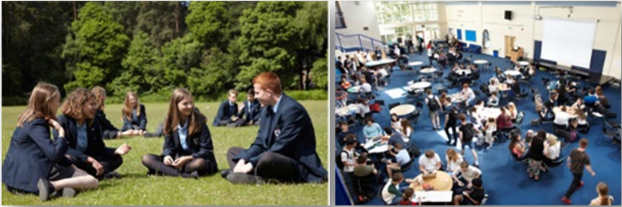
Person Specification

Key Criteria | Essential | Desirable
Qualifications and Training | Qualified Teacher status.  Good honours degree.  Good literacy/numeracy skills.  Relevant CPD during the last two years. | Evidence of further study.
Experience | Teaching of subject to pupils at KS3 and KS4.  Able to use ICT effectively to support learning and raise achievement.  Demonstrable experience of improving pupil outcomes.  High quality outcomes.  Able to work to professional standards, to develop effective working relationships, think independently and make judgements and to influence others through persuasion/ discussion.  Experience as a form tutor and/or pastoral work.  Leading and participating in co-curricular activities. | Experience of working in an educational environment.  Working knowledge of school timetable.
Professional skills and abilities | Extensive subject knowledge.  High expectations of pupils.  Developing and maintaining good relationships with colleagues.  Good or outstanding practitioner.  Good decision maker.  Excellent communication skills.  Able to work constructively individually, and as part of a team.  Able to work with students within an agreed behaviour management policy. | Willing to become involved in extra-curricular activities.
Personal Qualities | Very hard working.  A sense of purpose and drive, setting high expectations of pupils and raising standards of attainment.  Positive attitude, energy & commitment.  Well organised.  Well presented.  Able to work hard under pressure while maintaining a positive professional attitude.  Able to organise and prioritise workload and work on own initiative.  Commitment to personal career development.
Work Related Personal Requirements | Committed to equality of opportunity.  Ability to maintain strict confidentiality of information received and processed as part of the job role.
Other Work Requirements | Suitable to work with children.  Participate fully in the school Performance Appraisal Process  Participate in training and development opportunities to enhance and develop skills as required.  Follow the school’s ethos.

English Department
Mathematics Department

The Mathematics department at Edgbarrow is a strong and successful team. There are currently twelve Mathematics teachers in the department, seven full-time and five part-time, all of whom are specialists in the subject and also 1 HLTA and 1 apprentice.
The department is well resourced with nine classrooms (seven in the main block and two in the sixth form centre) all of which have interactive screens. The department has compiled a bank of stored resources for use on the interactive screen with all year groups, to which all staff contribute. There is also a central staff area that is used for storing equipment and teaching materials.
Pupils are set by ability on arrival at Edgbarrow. Years 7 and 8 are taught in two parallel half year groups. From Year 9 onwards, the whole year group is taught at the same time and there is a vertical setting arrangement.
Key Stage 3
Class sizes vary but we do have large top sets so that other sets can be smaller. Pupils have end of year assessments which are used to guide our setting for the following year.
Key Stage 4
The vertical setting arrangement continues throughout Key Stage 4. The current GCSE course leads to entry for Edexcel 1MA1.
All pupils are entered for GCSE examinations and the 9 - 4 pass rate in 2025 was 88%. 27.4% of pupils achieved grades 9 - 7.
Key Stage 5
Mathematics is a popular choice for A Level at Edgbarrow and there are usually three or four Mathematics A Level classes in each year group. There is a Further Mathematics group in each year and we have a Core Maths group in year 12. The course is well resourced, with pupils having access to online resources including Integral and a digital textbook via Kerboodle platform. Year 13 pupils achieve excellent results, with 100% of students achieving grade D or higher last year; 59.1% achieved grade A or A*.

By joining the Mathematics department at Edgbarrow, the successful applicant will have the opportunity to work with experienced and professional staff who are committed to raising standards through teamwork and exemplary practice.


Mrs Denise Holloway
Head of Maths

How to Apply
Complete the online application form via TES.
- References will be taken up for shortlisted candidates prior to the interview date. Corvus Learning Trust is committed to safeguarding and promoting the welfare of all students. Each student’s welfare is of paramount importance. Successful candidates will be required to undertake an enhanced DBS check.
- If you have any queries regarding this application process, please contact our HR department on 01344 772658 or email recruitment@edgbarrowschool.co.uk

CONTRACT TYPE: | Full Time
SALARY:  START DATE: | ECT/MPS/UPS  November 2026

Edgbarrow School is committed to safeguarding and promoting the welfare of children and young people and expects all who work at the school to share this commitment. Successful applicants will be subject to an Enhanced Disclosure from the Disclosure and Barring Service (DBS).
Any offer of employment is therefore conditional on clearance from the above, the receipt of two satisfactory references, a satisfactory medical questionnaire, proof of qualifications, overseas checks where applicable, and proof of right to reside and work in the UK.

Edgbarrow School is committed to protecting the health, safety and welfare of all employees. To this end, staff enjoy:
- Contributory Pension Scheme
- Employee Assistance Programme
- Working as part of a motivated and committed team
- Access to on site fitness gym
- Cycle to work Scheme
- Eye Care Voucher Scheme

Further Information

School Links:





Kennel Lane School






Sandhurst
The Bulmershe

- Edgbarrow School
- School Prospectus
- Corvus Learning Trust

Curriculum:

The curriculum is organised within a two-week cycle. Each week is composed of 25 lessons, each lasting for one hour.
The Progress Department will work with students, both individually and in small groups, who need support to improve their literacy skills.
Key Stage Four: Years 10 and 11 (ages 14-16)
All students study a core of subjects: English and English Literature, Mathematics, Science, Physical Education and PSHGEE (including Religious Education). Students may also be offered the opportunity to study Triple Science.
In addition, students may choose four further subjects from:
- GCSEs:
Art, Business Studies, Computing, Design and Technology (Food Engineering & Product Design), Drama, Economics, French, Geography, History, Information and Communication Technology, Music, Spanish, Physical Education, Religious Education and Science. However, all students are required to select at least one E-Bacc subject e.g. Geography, History, Computing, French, German or Spanish.
- BTECs, VCerts & Cambridge Nationals:
Information Technology, Business Studies, Sport, Performing Arts and Health and Social Care.
Sixth Form: Years 12 and 13 (ages 16-19)
In Years 12 & 13 students generally follow three subjects, leading to a full A level qualification and/or a Level 3 BTEC.
- A Level Courses:
Art and Design, Biology, Business Studies, Chemistry, Computing, Criminology, Design and Technology (Food Technology & Product Design), Economics, English Language and English Literature, French, German, Geography, Government and Politics, History, Mathematics, Media Studies, Music, Philosophy and Ethics, Photography, Physics, Psychology, Sociology, Spanish, Sport and PE and Theatre Studies.
- BTEC Courses:
Sport and Exercise Science, Business Studies, Health and Social Care and ICT.
Enrichment Opportunities
In addition to their examination courses, all students participate in an enrichment programme. This programme is focused on a range of activities designed to give students an opportunity to participate in, and benefit, their local community e.g. a range of sports teams, Duke of Edinburgh Award, Young Enterprise, Operation Wallacea as well as many department-based clubs.

School Examination Results:

- Level 2 GCSE and BTEC
We are very proud of the examination results achieved by our students over the past three years. Staff have worked hard with new data to track and monitor students and develop intervention strategies in order to help each individual to achieve their potential.
Whole School | P8 | A8 | 9-5 EM | 9-4 EM
2025 | +0.47* | 53.67 | 63% | 80%
2024 | +0.35 | 53.94 | 62% | 81%
2023 | +0.35 | 53.54 | 61% | 80%
2022 | +0.65 | 59.41 | 66% | 87%
2021 | N/A | 58.80 | 74% | 85%
* This figure is estimated using KS2 CATS data, as this year group did not complete CATS.

- Level 3 A Level and BTEC
In recent years we have worked hard to improve our examination results at post 16. A new Sixth Form building has certainly helped to provide an excellent learning environment and educational experience for our students. However, there is no doubt that staff have worked hard to develop the quality of teaching at post 16 and as a result the grades achieved by our students have improved significantly.
Whole School | A*-B | A*-C | Overall Pass Rate
2025 | 57% | 80% | 99%
2024 | 62% | 85% | 99.6%
2023 | 60% | 83% | 99%
2022 | 69% | 90% | 99%
2021 | 73% | 87% | 99%


