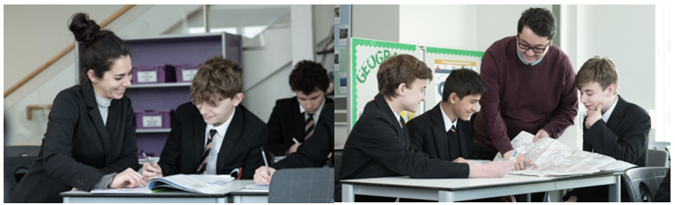



Business

At Northfleet Technology College, Business and Financial Studies are some of popular lessons with our students.
Our subject area gives an exciting opportunity for staff to further develop their business knowledge and teaching pedagogy within a secure and supportive team. Business and personal finance gives the opportunity to develop creative solutions to business situations. The subject area opens up many discussions surrounding both the finances of business owners and the wide topic of personal financial matters.
We have excellent IT facilities and a wealth of resources that are available for use in lessons. We encourage debating activities and ‘learning outside the box’ to enable our students to follow our ethos of Curious, Creative and Caring learners.
Team work is a key part of business and therefore you would be joining a very dedicated and efficient business team to work with. As a team, we teach across all three key stages, each one offering a different level of intensity in knowledge and application and a range of Business and Finance related subject topics.
At Key Stage 3 we aim to develop the basic knowledge for our students surrounding how a business even begins and where entrepreneurs start their journeys from. We look at the skills required and develop students’ research and investigative skills.
At Key Stage 4 we study the BTEC Level 2 Enterprise qualification which consists of three components studied across two years. Students will bring their research skills from KS3 to support their development towards completing the BTEC Level 2 course and moving into KS5.
At Key Stage 5 we study the BTEC Level 3 Extended Certificate in Business. This involves some independent study skills in order to be able to develop a marketing campaign for a given business, to look at their finances and also be aware of profit and non-profit making companies, together with recruitment and retention. We also study the London Institute of Banking and Finance Diploma in Financial Studies over two years at KS5, with students learning about how to be in control of their own money and hopefully make the best decisions in later life about their finances!
One of the exciting after school activities that we engage in is running a not for profit Business Enterprise Club, which is supported and run by our students, with a little help from the Business Enterprise Staff Team. This is a really enjoyable and fun part to the end of a busy day in the subject area!
This is an excellent opportunity for an individual who is as passionate about business and finance as we are, to join a supportive, friendly and committed team, who are dedicated to achieving the highest possible standards in both ourselves and our students.

