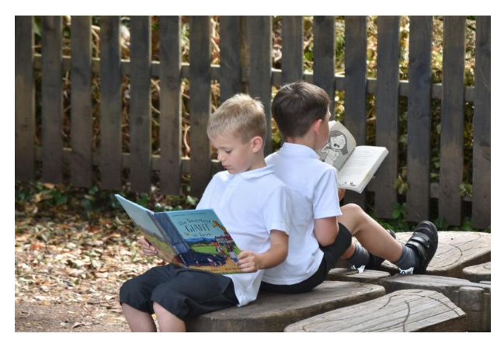


Achievement Assistant
SC1/TA1, Scale Point 2
Fixed Term Contract


Lickhill Primary School
Almond Way
Stourport-on-Severn
DY13 8UA

Tel: 01299 871803
Email: office@lickhill.crst.org.uk

Website: www.lickhillschool.org.uk

The Role

School: | Lickhill Primary School, Stourport-on-Severn
Position: | Achievement Assistant
Start date: | As soon as possible
Contract type: | Fixed term contract until 16/07/2027  Term time only (plus training days)  16 – 32.5 hours per week
Salary range: | SC1/TA1 – scale point 2 (actual salary £8,887.09 - £18,526.95 annually)
Closing date: | Thursday 3rd September at 12:00  NB we reserve the right to close the advert earlier should we receive sufficient response.
Interviews: | Monday 7th September

We are seeking to appoint a Grade 1 Achievement Assistant who is hard working and enthusiastic to join our team most likely based in Early Years Provision (Nursery & Reception).

The school is a one form entry primary in Stourport-on-Severn, which serves a mixed catchment area.

Lickhill Primary School is a good school with outstanding features and is an exciting, inclusive, and rewarding place to work with children who are enthusiastic about their learning, polite and supportive of one another. We work in collaboration with other schools within our Trust, which benefits our whole school community.

Visits to the school are encouraged.

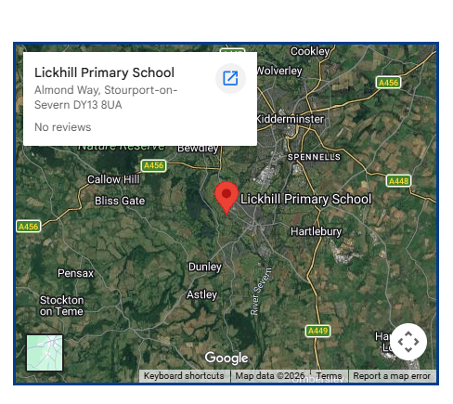

How to Apply

For more information about this role, please email Joanne Fortnam, Business Administrator.

Email – jfortnam@oldburypark.crst.org.uk

To apply for this role, please complete an application form via My New Term by Thursday 3rd September at 12:00

Cover letters and CV’s are not accepted.

We also encourage applicants to visit our schools website and the Central Region Schools Trust website.

Safeguarding Statement

Central Region Schools Trust is committed to safeguarding and promoting the welfare of children, young people and vulnerable adults and expects all staff and volunteers to share this commitment. As part of our stringent recruitment process, all applicants undergo thorough child protection screening, encompassing checks with previous employers and an enhanced DBS disclosure, in strict alignment with the 'Keeping Children Safe in Education' guidelines, which also includes an online search for all shortlisted candidates.

At Central Region Schools Trust, we stand as proud advocates for diversity and inclusivity across all our schools, serving as an equal-opportunities employer and we encourage applications from individuals of all backgrounds and communities.





The History of our Trust

As a trust, we were founded by the Royal Society for the encouragement of Arts, Manufactures and Commerce, more commonly known as the Royal Society of Arts or the RSA. The RSA has a history of developing ideas and projects to improve people’s lives, and our vision of ‘social justice through exceptional schools’ aligns closely with the social justice mission of the RSA. All our schools are improving in reputation, popularity, and quality of education.

Whilst we are now a DfE approved academy sponsor, recognising the collective strength of our trust and schools, we retain many programmes and partnerships from the original sponsorship. We have a strong school improvement force and now sponsor, in collaboration with the DfE and Regional Schools Commissioner, schools that will benefit from our structural, formal support. Our trust aims to influence the practice of our schools through the collaborative knowledge sharing we expect through our school improvement model and co-design structures.

We are outward facing, sharing, and learning from internal and external partners. Central Professional Learning, Research and Development (CPL,R&D) ensures the development of all employees at all levels of the organisation. We have developed excellence in central services, such as finance, HR, estates, which make a huge difference to our schools, not least by enabling Principals and staff to focus on delivery of excellence in teaching and learning. Teach Central, as part of CPL,R&D, recruits, and trains new teachers to the profession with a high level of success.

Our Mission, Vision, Strategic Objectives & Values

Mission: to promote opportunity and social justice for every child through exceptional schools.

Vision: As a trust founded by The Royal Society of Arts, our exceptional schools work together to create learning that is inspirational for all: igniting imagination and enabling creativity and curiosity which results in the highest achievement. People are valued and happy, developing their knowledge, attributes, skills and networks for success and fulfilment. In our empowered communities, everything is possible, and aspirations are high. Outcomes are highly impressive.

Strategic Objectives:
SO1: Exceptional Learners
SO2: Expert Professionals
SO3: Excellence in Infrastructure, Systems and Places
SO4: Empowered Communities and Lasting Partnerships

Values: Integrity, Excellence, Creativity, Community and Respect



Teach Central, formerly the RSA Academies’ Teaching School Alliance, recruits, and trains new entrants to the teaching profession, identifies leadership potential, and provides support for schools across the West Midlands, to transform outcomes for young people and bring about positive social change. We drive action research, undertake innovations in teaching, and optimise the talents and commitment of our staff to develop creative ways of providing education.
https://centralregionschoolstrust.co.uk/teach-central/



We believe that effective Research and Development begins with our students and a drive to improve their learning experience and educational outcomes. The power to transform education comes when schools collaborate, and an active Research and Development culture can be found across all the schools in our Alliance.
https://centralregionschoolstrust.co.uk/cplrd/

KASE
The leadership across our Trust has identified pupil knowledge, skills, and attributes that we believe are key to the current and future success of the young people in our schools. Each school creates their own approach to developing the skills and attributes. These skills and attributes have an identified leader across the Trust to lead expert collaboration where the most effective practice emerges from within the Trust and beyond, then standardisation of approach will be agreed as appropriate.

Knowledge: Working with pupils to know understand and have mastered key concepts so that they develop the expertise to become fluent and excel within and across subject disciplines, locating their experiences within the broader sense of society.

Attributes of Character: To create the conditions in which attributes of character are nurtured, so that pupils can lead full active and successful lives which support their communities and the wider world.

Skills: Helping pupils to develop the skills needed for a successful and happy personal and professional life.

Experiences: Ensuring our pupils enjoy, experience excitement, and find value in their school experience, through a very wide range of experiences that challenge and motivate them, providing aspiration and demanding responsibility from them.

Achievement Assistant

Lickhill Primary School
SC1/TA1, Scale Point 2

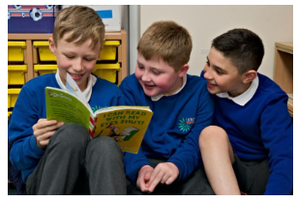
Job Description
and
Person Specification

Job description

Job title: | Achievement Assistant
Department: | Lickhill Primary School, Support Staff
Salary scale: | SC1/TA1 – scale point 2
Accountable to: | Executive Principal

Core purpose of the post

To support the classroom teacher with their responsibility for the development and education process by providing care to children, including those who have physical, emotional, and special educational needs, by utilising a good standard of practical knowledge and skills.

Job responsibilities and tasks
Under the direction and supervision of the Classroom Teacher

- Understanding and demonstrating the importance of keeping children safe by following all statutory safeguarding documentation and the schools safeguarding procedures.
- Building positive relationships with children, taking an interest in them
- Assisting the teacher with learning activities, generally in the classroom.
- Contributing to the planning of work to meet the expectations of the curriculum and individual needs of pupils.
- Carrying out appropriate activities as planned within the classroom or with groups of pupils.
- Intervening and skilfully supporting children’s participation in activities to effectively promote progress in their social, communication, emotional, intellectual, and physical development.
- Displaying and presenting children's work.
- Taking responsibility for visual aids.
- Prepare and organising teaching resources including the checking and maintaining of classroom equipment and materials including control of stock within the classroom.
- Preparing resources for lessons and activities.
- Assisting with the physical manipulation of objects and equipment.
- General supervision, counselling, and discipline of pupils, within the procedures of the school.
- Assisting the teacher in liaising with parents and professionals such as speech therapists.
- Assisting at an appropriate level with the provision of general care and welfare of children including:
- assistance with the personal hygiene routine, e.g. the changing of soiled clothing including its disposal in the appropriate way; dressing and undressing;
- assisting with children's injuries and where qualified, administering basic first aid;
- to assist with the identification and monitoring of children's general health and welfare.
- Helping the teacher with tasks.
- Hearing children read / reading to the children.
- Supporting children to be independent by helping them with tasks.
- Answering questions from pupils.
- Providing support for the English and Maths strategies.
- Assisting with supervision of children within the school.
- Assisting the pupils to access the normal routines of the classroom.
- Preparation or modification of the work for the children under the direction of the class teacher and supporting children in carrying out this work.
- Assisting in the implementation of programmes designed by other professionals such as educational psychologists, and speech and language therapists.
- Assisting with the provision of general care and welfare to pupils and to be mindful of the need to maintain a safe environment at all times.
- Adhering to and maintaining school routine and codes of conduct.
- Supporting the ethos of the school.
- To assist with the support of group activities within and away from the classroom, i.e. P.E., educational visits, forest school.
- Ensuring that pupils are able to safely use equipment and materials provided and be aware of the range of resources available.
- Promoting pupil independence in learning and reinforcing the child(ren)'s self esteem through praise and encouragement.
- Maintaining personal and professional development to meet the changing demands of the job, participate in appropriate training activities and encourage and support staff in their development and training.
- Using specialist skills, knowledge, strategies, and techniques to effectively support all aspects of the children’s development.
- Recognise own strengths and areas of specialist expertise and use these to advise and support others.
- Providing short term cover for teacher absence.
- Any other task deemed appropriate and reasonable.

The post holder will subscribe to the aims and specifically the Trust values:

Community
Creativity
Integrity
Excellence
Respect

This job description is current as of July 2026.
Person Specification

ATTRIBUTES | ESSENTIAL | DESIRABLE | HOW IDENTIFIED
Qualifications | - Good standard of education.  - Good literacy / numeracy skills (equivalent to Grade C/4 in GCSE English and Maths). |  | Application Form  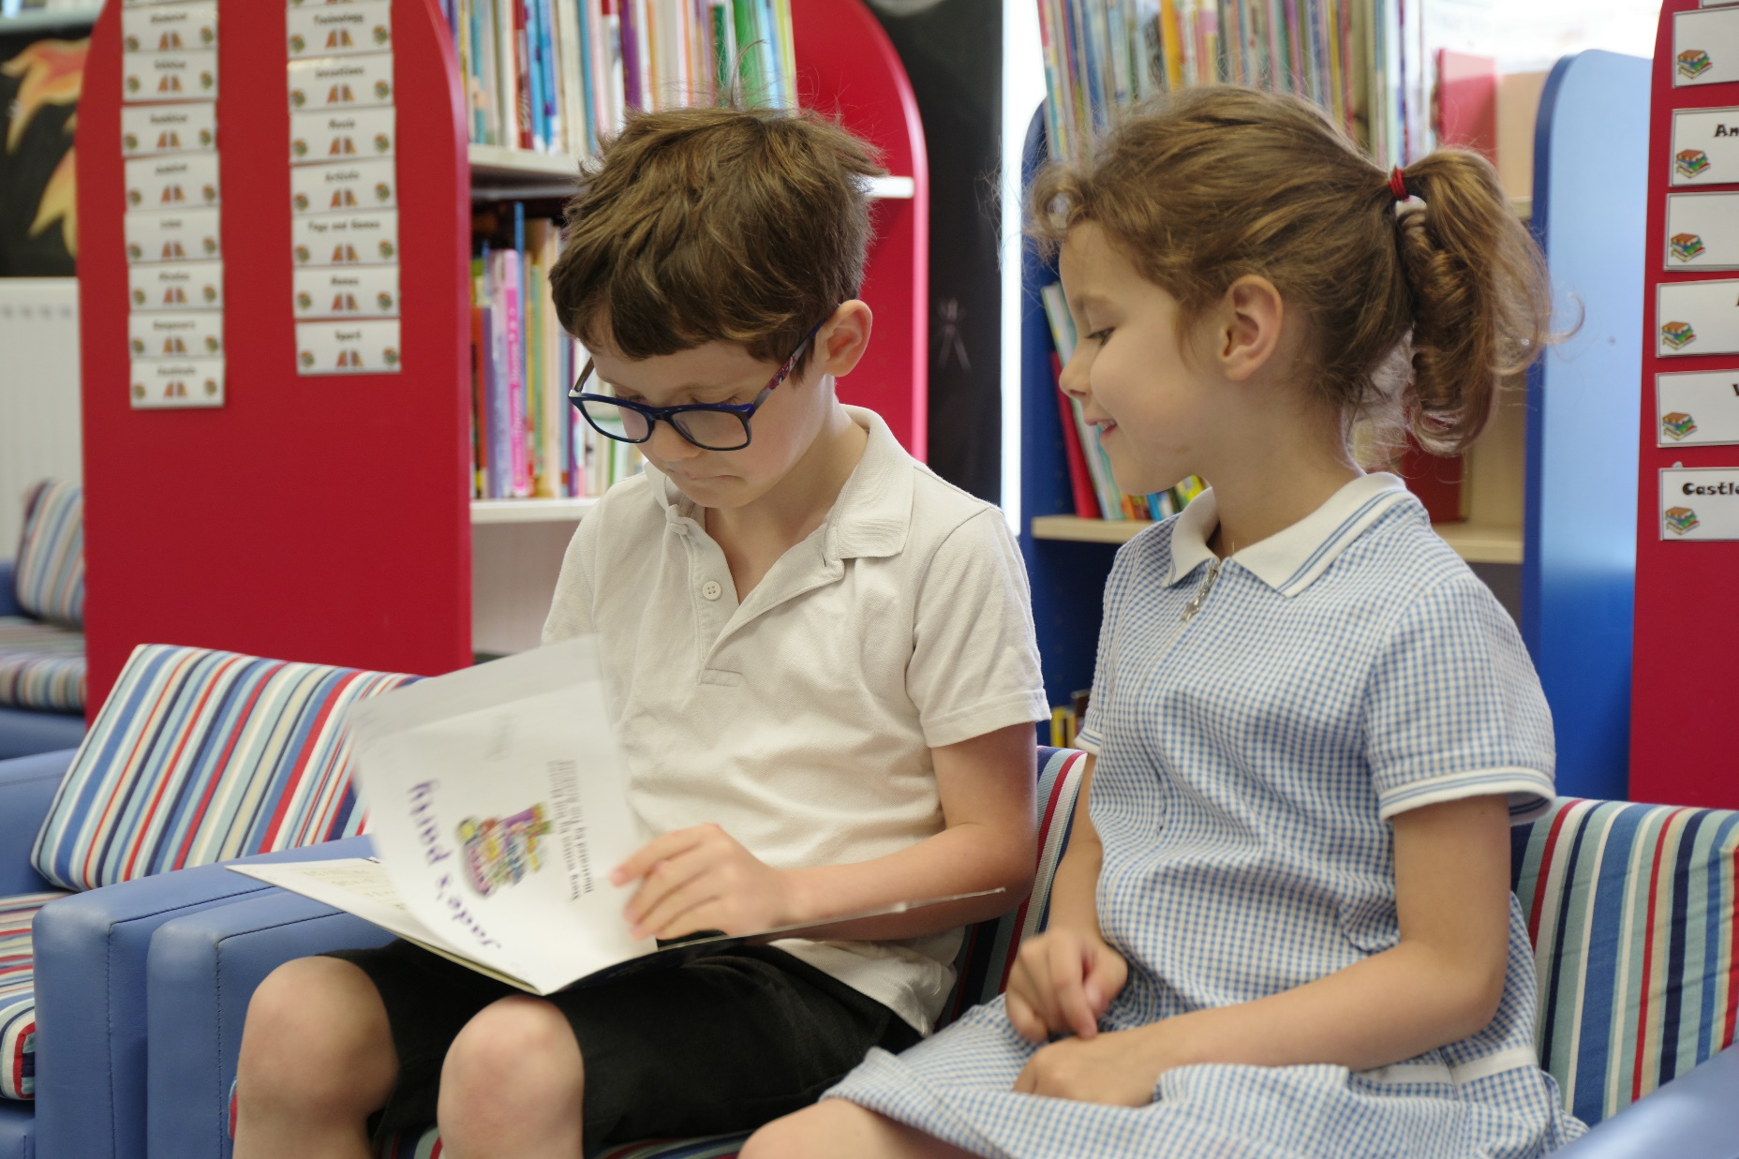  Certificates
Experience | - Ability to use ICT effectively.  - Ability to use other equipment / technology.  - Experience of working effectively with a range of people. | Experience of working with pre-school and primary age children.  Working with children with social, emotional, and mental health needs (SEMH). | Application Form  References  Interview process
Knowledge, Understanding and Skills | - Good communication skills, both written and verbal.  - Ability to self – evaluate learning needs and actively seek learning opportunities.  - At basic understanding of how children develop and learn.  - Ability to actively engage in the learning activities at a basic level and to assist in the personal and individual development of individuals or groups of pupils.  - Ability to supervise the activities of individuals or groups of children to ensure their safety and facilitate their physical and emotional development. | Working knowledge of relevant policies / codes of practice. | Application Form  References  Interview process
Motivation and Personality | - Able to work independently and to manage own time efficiently.  - Able to work as part of a team and to communicate effectively with staff at all levels.  - Able to liaise with staff to ensure children’s needs are met.  - Warm and caring personality, friendly and able to relate well to children and adults, with a high level of patience.  - Commitment to equal opportunities for all.  - Able to stay calm under pressure.  - Able to be adaptable to meet the needs of the children at all times.  - Able to react creatively to situations in order to support children. | Willingness to be involved in the wider life of the school. | Application Form  References  Interview process

