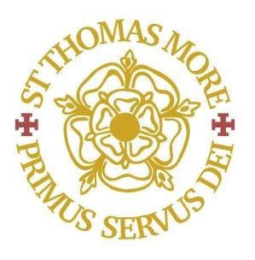
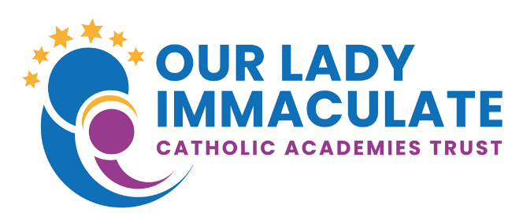

St Thomas More Catholic Secondary School
EXAM INVIGILATORS
Grade B point 2 - £12.65 per hour
Start Date: on-going

Casual contract during term time only during Exam periods

The Directors of this successful Catholic Secondary School are looking to appoint confident and enthusiastic exam invigilators to join our team! In return, we can offer a supportive and caring work environment.

No previous experience or knowledge is required as in-house training will be given. If you would like to receive more information regarding the role, please email LThorpe-Kingsley@stm.beds.olicatschools.org.

Suitable candidates may be interviewed before the closing date and the school reserves the right to withdraw the position if an early appointment is made. Applicants are therefore encouraged to apply early.

For an application pack please email hr@stm.beds.olicatschools.org or visit the school website www.stthomasmore.org.uk/join-us to download the pack.

St Thomas More is committed to safeguarding and promoting the welfare of children and young people and expects all employees and volunteers to share this commitment. The suitability of all prospective employees or volunteers will be assessed during the recruitment and selection process in line with this commitment. Successful applicants will be required to undertake an enhanced DBS check.
All staff uphold the core values and Catholic ethos of the school. All appointments are subject to an enhanced DBS clearance in line with our Safer Recruitment Policy.

Our Lady Immaculate Catholic Academies Trust is a large new Catholic Multi Academy Trust situated in the northern half of the Catholic Diocese of Northampton formed by the merger of three former Catholic Trusts in February 2020. The Trust currently leads and manages ten catholic primary schools located across the geographical area of Northamptonshire and Bedfordshire and two Catholic secondary schools – Thomas Becket in Northampton and St Thomas More in Bedford.

