

JOB PROFILE

Red Kite Learning Trust is committed to supporting work–life balance and recognise the benefits of flexible working. We welcome requests for flexible working arrangements as part of the recruitment process. While flexibility may be possible for many roles, each request will be considered on an individual basis.
Job Title: | Midday Supervisory Assistant (MSA) | School/Department: | Oatlands Junior School
Salary Grade: | Band 3 SCP 3 | Working Hours: | 10 per week
Contract Type: | Permanent | Location: | Harrogate
Responsible to: Headteacher
Role summary:

To work as part of a team monitoring pupil behaviour during the midday break to ensure a caring and safe environment. Required to work indoors and outdoors when supervising the children to ensure safety.

Special conditions of service:
No smoking policy, including e-cigarettes/vaping. Requirement to occasionally work outside of school hours and off school premises as required by the school.
Role specific responsibilities:
- To supervise the playgroup area, cloakrooms, and classrooms during the lunchtime break period
- To ensure the safety of all children and the creation of a calm and orderly atmosphere, where appropriate table manners and the independence of the children are encouraged
- To assist with the service of meals, including the distribution of food, clearing spills, supervising eating of packed lunches
- To assist with the removal of food and equipment once pupils have eaten their lunch
- Deal with minor first aid incidents; follow appropriate procedures for recording and reporting in line with school policies and procedures
- Assisting in the implementation of appropriate behaviour management strategies
- Observe a child’s behaviour, understand its context and notice any unexpected changes; report any issues to a senior member of staff
- Monitor pupil behaviour and mediate at times of conflict in a calm and respectful manner, using a restorative approach

- Assist in the supervision of other activities during the midday break, including setting out and storing equipment
- To escort the children to and from the dining area as required
- To supervise toilet arrangements and hand washing
- Establish rapport and respectful, trusting relationships with children, young people and those caring for them
- Report any concerns about pupil welfare to the appropriate member of staff in a confidential manner
- Communicate effectively and establish constructive relationships with all children, parents, families, carers, external agencies and other professionals
- Understand that communication is a two-way process
- Provide support and encouragement to children and young people
- To contribute to the overall ethos/work/aims of the school, in accordance with the role and the direction of the Headteacher
- Participate in the school’s appraisal scheme
All colleagues, regardless of career stage, will make a positive contribution to the wider life and community of our school, for example through sport, music, hobbies etc.
RK People responsibilities:
- Contribute to the overall aims and values of our Trust, appreciate and support the roles of other members of the wider team and attend and participate in relevant meetings as required
- Comply with all Trust policies and procedures including child protection, health, safety, welfare, security, confidentiality and data protection etc., reporting any concerns to the appropriate person
- Contribute to ensuring safeguarding procedures are in place and used effectively at all times.
The role holder must demonstrate a flexible approach to the delivery of the role. Consequently, the role holder may be required to perform work not specifically identified in the role profile but which is in line with the general scope, grade and responsibilities of the role.
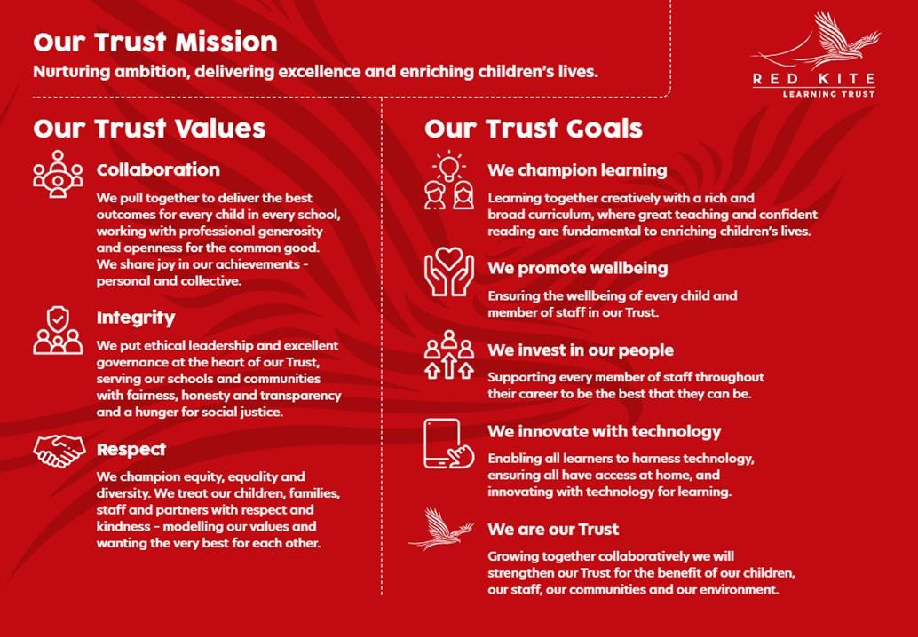
PEOPLE PROFILE
Aptitudes and Characteristics | Essential | Desirable
Have an enthusiasm for and an active interest in children’s play | *
Ability to relate well to, and work positively and effectively with, children and young people | *
Ability to challenge and motivate students, promote and reinforce self-esteem | *
Ability to manage pupil behaviour in a supportive and effective manner and understanding of individual children and young people’s needs | *
Ability to work constructively as part of a team, understanding roles and responsibilities and own position within these | *
Self-motivated and hard-working colleague with the ability to maintain effective working relationships | *
Willingness to be flexible and work to meet the best interests of the school | *
Self-motivated and hard-working | *
Ability to problem solve | *
Have a sense of humour and optimism | *
Committed to delivering the school’s ethos and policies | *
Willingness to participate in training, learning activities and performance development as required | *
Qualifications, Knowledge and Experience | Essential | Desirable
GCSE grade C or equivalent in English and Mathematics | *
Excellent interpersonal and communication skills | *
Experience of working with children and young people with a wide range of Special Educational Needs |  | *
Current first aid qualification or willingness to undertake training | *
Safeguarding and Promoting the Welfare of Students | Essential | Desirable
An appropriate motivation to work with children and young people | *
Ability to maintain appropriate relationships and personal boundaries with children and young people | *
Emotional resilience in working with challenging behaviours and appropriate attitudes to the use of authority and maintaining discipline | *

