


St Philip Howard

Catholic Voluntary Academy

Part of the St Ralph Sherwin Catholic Multi Academy Trust


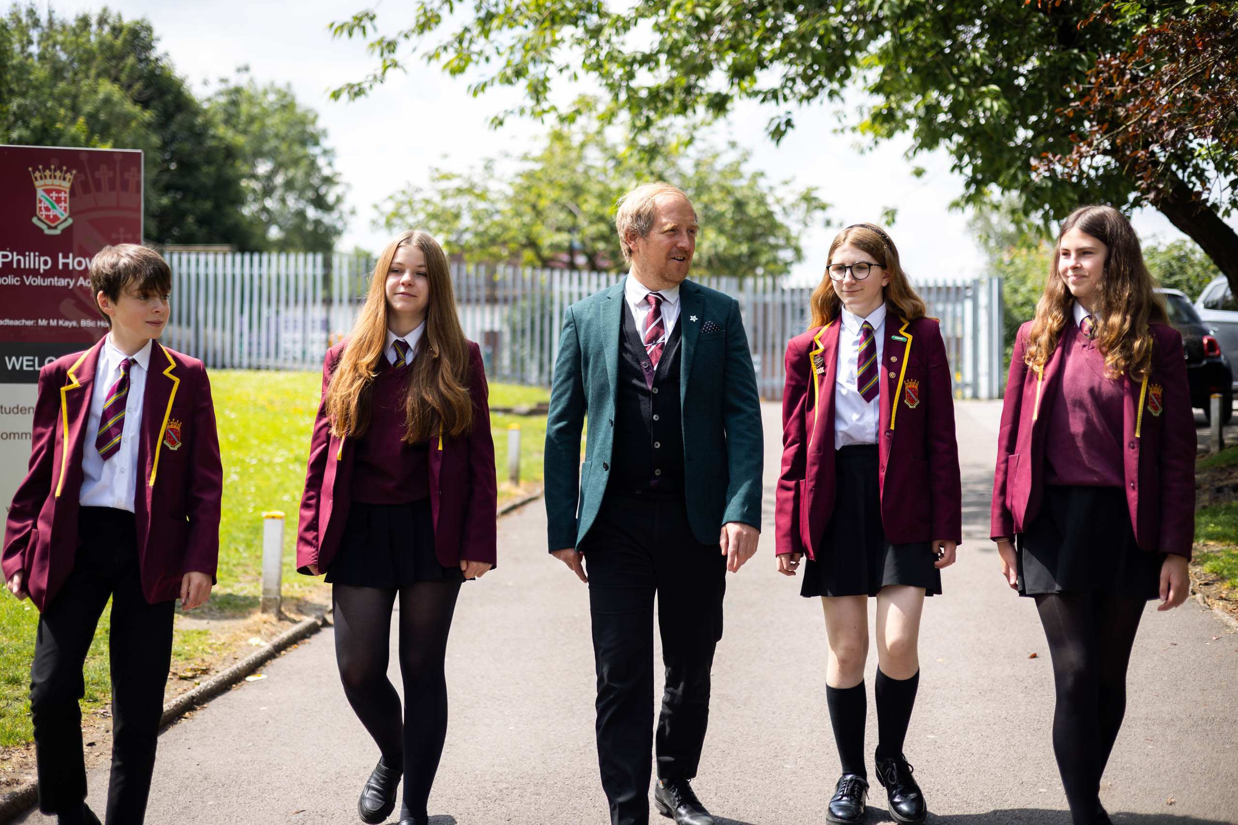


PE Teacher

Start Date: July 2026

Salary: MPS/UPS
Line-manager: HOD of Physical Education

Headteacher’s Welcome

Through a three – way partnership between home, school and parish we aim to work as a team to ensure our children achieve their potential. We believe that a happy child is a fulfilled child and therefore our strong pastoral system is of key importance to us. Our Catholic faith underpins everything that we do and ensures that our pupils are well rounded, confident young people with increasingly high aspirations. We are on an exciting journey at SPH and we firmly believe that by working together all our pupils will have a bright future ahead.

St Philip Howard Catholic Voluntary Academy is an exciting place for our students to grow and develop, building an enriching love of learning and a spiritual outlook that they will carry with them through life. We are an oversubscribed smaller than average Catholic Secondary school of 573 pupils located in Glossop, Derbyshire.

The successful applicant for this position will be joining a school where we care about our students and we care about our staff. Staff workload is regularly considered when decisions are made and the happiness and care of all who work with us are crucial. The school has undergone significant change in recent years and the school is now in a secure position.

This is an incredibly important appointment for our school and the middle leader appointed will have a key role in driving the Academy’s whole school agenda forward. If you are excited by this vacancy, I would welcome the opportunity to discuss the post with you, if you feel you want to be a part of our #TeamSPH journey.


Mr M Kays Headteacher

About this post


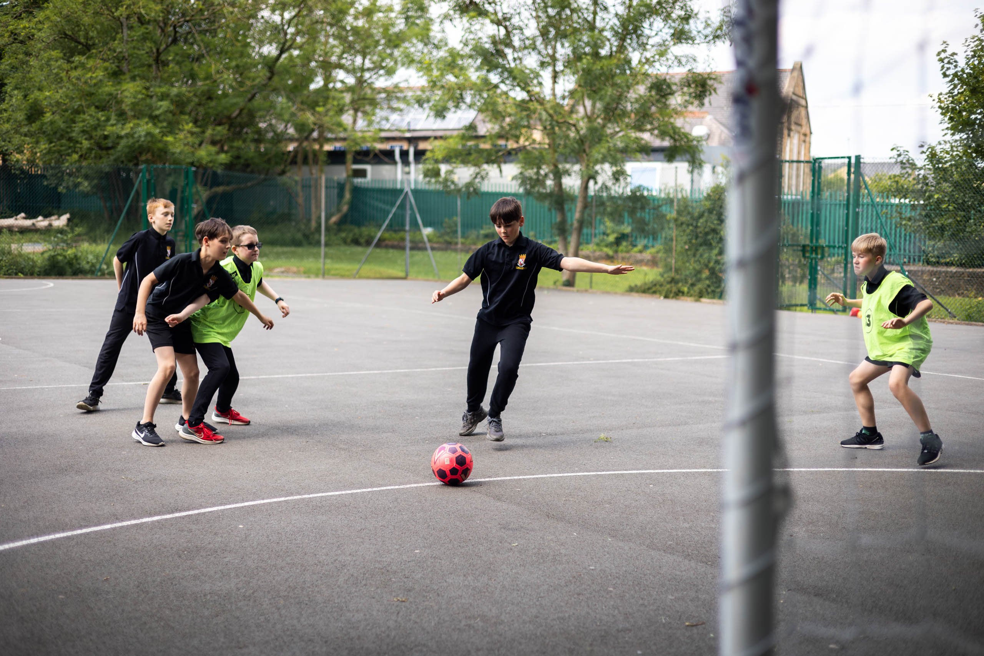

The Post
We are looking for an enthusiastic, determined and inspirational PE teacher with specialisms in football, basketball, cricket and rugby to lead the PE Department at Saint Philip Howard Catholic Voluntary Academy. This is an exciting opportunity to join #TEAMSPH as we continue on our journey.

The Role
The successful candidate will provide strategic leadership for our PE Department, ensuring that the needs of all students are met and promoting amongst the pupils a keen interest and desire to learn PE.


#TeamSPH: Together on the Journey
Together, we will make the SPH journey: safely, respectfully and with kindness as part of a united Catholic family.

God will be at the heart of our journey, supporting us to realise the potential of our God given talents.

Our Gospel Values will guide us on our journey, helping us to make brave choices along the way.

Respect for all will be at the spirit of our journey and we will
embrace the uniqueness of everyone we greet.

Inspiration and passion for learning will lead us all to have a
memorable and successful journey.


Person Specification

 | Essential Criteria | Desirable Criteria
Education &  Qualifications | - A Good Honours Degree  - Qualified teacher status | - Post-graduate qualification e.g. MA, PhD  or EdD  - Qualified to an appropriate level in line with JCQ guidelines to award access arrangements and complete necessary assessments
Competence Summary (knowledge, abilities, skills, experience) | - The ability and willingness to collaborate effectively with colleagues and to lead them  - Effective prioritising work habits and strong organisational skills  - Experience of working in a pressured environment and the ability to delegate and meet deadlines  - Skillful, effective and confident  classroom teacher  - A knowledge and commitment to safeguarding and promoting the welfare of children and young people.  - Thorough understanding of the National Curriculum and KS4 exam context in order to support effective teaching and learning.  - Secure subject specific knowledge.  - Commitment to raising standards.  - Understanding and knowledge of developments in learning and teaching.  - Exchange complicated or sensitive information to a range of audiences and write fairly complex.  - Ability to work with a range of colleagues.  - Understanding of the range of needs of young people within age group.  - To be committed to the objective of raising achievement in the school.  - To help raise standards of learning for pupils | - Experience in developing therapeutic thinking support strategies to overcome barriers to learning  - Experience of delivering programs to support learning and monitoring and evaluating individuals and cohorts of students which has led to improved outcomes  - Experience of KS2-KS3 transition  - Specialisms in football, basketball, cricket and rugby.

 | Essential Criteria | Desirable Criteria
Work related personal requirements | - Strong interpersonal, written and oral communication skills  - Genuine passion and a belief in the potential of every student, regardless of need – and the ability to raise  the self-esteem and expectations of children and young people.
Other requirements | - Ability to form and maintain appropriate relationships with colleagues, students and parents  - Ability to work both autonomously and as a member of a team  - Empathetic and approachable manner  - Highly motivated and pro-active  - Flexible  - Sense of humour  - This post is subject to an enhanced DBS disclosure  - Must be committed to safeguarding the welfare of children | - Willingness to contribute to the wider life of the school

Job Description

Main activities and responsibilities:

To teach PE, to actively promote the Catholic ethos of the academy and to secure high quality student outcomes.

Main activities and responsibilities:

- Establish a good working relationship with students, providing a disciplined, motivated environment where standards of teaching and learning are consistently high;

- Plan and deliver differentiated work suitable to stretch all students in every teaching group, with particular reference to students’ Individual Education Plans (IEPs);

- Provide personalised teaching, instruction and support; promoting appreciation, understanding and enjoyment of PE;

- Make maximum use of available resources to assist in teaching and learning;

- Mark classwork and homework effectively, in line with the schemes of work, as directed by the Head of Department/Assistant Headteacher;

- Monitor students’ progress, keeping a detailed record of the prior attainment and target levels / grades / outcomes for each child in each class, and an ongoing record of performance against these measures, completing regular assessments of students’ work and keeping up to date records;

- Plan and deliver appropriate opportunities to contribute to students’ spiritual, moral, social and cultural development, and the ECM outcomes;

- Provide plentiful opportunities for students to reach their full potential;

- Comply with the whole school assessment and reporting procedures;

- Assist in producing schemes of work, as appropriate;

- Follow departmental schemes of work and assessments;

- Attend calendared departmental meetings;

- Undertake the duties of a form tutor;

- Play a full and active role within the department and Pastoral team;

- Attend courses and undergo training as necessary and train any relevant personnel as required;

- Keep abreast of new initiatives by embracing professional development;

- Actively seek students’ views in reviewing teaching and learning and schemes of work; through student questionnaires and discussion, in order to continuously improve teaching and learning;

- Comply with the academy’s performance management policy on an annual basis;

- Attend calendared evening meetings as required;

- Provide clear, accurate and informative reporting to parents, whether oral or written, on student progress, as directed by the Head of Department/Assistant Headteacher;

- Contribute to departmental policies and developments;

- Contribute to the production of learning resources and internal test / examination papers;

- Ensure the requirements of the National Curriculum and external examinations are met, preparing students properly for internal and external examinations;

- Liaise with the Head of Department and Pastoral team with regard to any student whose progress is the cause of some concern or a real cause for celebration;

- Comply with all academy policies and procedures;

- Keep a full record of the attendance/absence of all students in lessons;

- Participate actively in the ‘rarely cover’ and duties programmes;

- Ensure the good order, appearance, dress and conduct of students, as they move around the academy.

Any other duties which may arise during the course of work and are authorised by the Headteacher or member of the Senior Leadership Team. Such duties will be commensurate with the general level of this post and will be subject to the skills and abilities of the post holder.



St Philip Howard CVA, Sunlaws Street, Glossop,
Derbyshire, SK13 8DR.

Email: Ssanxter@sph.srscmat.co.uk

Web: https://www.stphiliphowardglossop.srscmat.co.uk/

Twitter: @StPhilipHoward1 Tel: 01457 853 611

