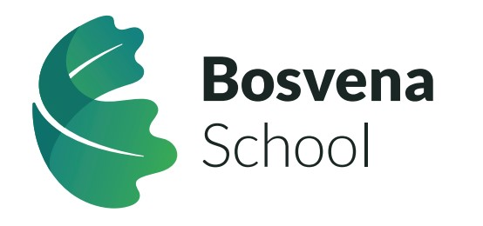

Job Title: Teaching Assistant
Closing Date: 30th June 2026 at 9am
Shortlisting: 2nd July 2026
Interview: 9th and 10th July 2026
Start Date: September 2026
Salary: £25,923 FTE per annum/pro rata
Hours: 34 hours per week. 39 working weeks per year (term time plus inset days). Paid working weeks are 45.450.
Location: Bosvena School, Bodmin
Contract type: Permanent

About Bosvena School
Bosvena is part of the Special Partnership Trust, an extraordinary education Trust that is redefining Special Educational Needs in the Southwest. Our mission is clear: we are a force for good in SEN and make a positive difference in people's lives. We challenge conventions, pioneer excellence, and work tirelessly to create better tomorrows for our young people and their families.
The Special Partnership Trust’s intent is to provide an outstanding special school for pupils with SEMH needs; a school that celebrates neurodiversity by accepting, respecting, recognising, and responding to developmental differences, thereby shaping each pupil’s educational offer to inform and improve their outcomes.
Bosvena School is research-focused, innovative, and aspirational in its practice, with the development of pupils’ SEMH skills at the centre of our work.
The school caters for 65 pupils aged 4 to 16 and serves the community of Cornwall.
Bosvena is located close to Bodmin, with easy access to the A30/A38. The school opened in September 2025, and the building works are complete.

About the Role:
We are looking for a caring and enthusiastic Teaching Assistant to join our Special Educational Needs (SEN) school, supporting students with Social, Emotional, and Mental Health (SEMH) needs and Autism Spectrum Disorder (ASD). This is a rewarding opportunity to make a real difference in the lives of young people by creating a nurturing and structured environment where every child can thrive.

Safeguarding:
The Special Partnership Trust is committed to safeguarding and promoting the welfare of children and young people and expects all staff and volunteers to share this commitment. All offers of employment are subject to the satisfactory completion of checks and references, including an Enhanced Disclosure and Barring Service (DBS) check. In accordance with guidance in Keeping Children Safe in Education; the Trust will undertake an online search of all shortlisted candidates.

Key Responsibilities:
- Provide 1:1 and small group support to students with SEMH and ASD.
- Assist in implementing Individual Education Plans (IEPs) and Behaviour Support Plans (BSPs).
- Support students in developing emotional regulation and social skills.
- Assist teachers in delivering engaging and structured lessons tailored to students’ needs.
- Encourage a positive and inclusive learning environment.
- Work collaboratively with teachers, therapists, and support staff.
- Provide personal care and well-being support where needed.
- Manage challenging behaviours using positive reinforcement strategies.
- Help students develop independence and life skills.

What We Are Looking For:
- Experience working with children with SEMH and/or ASD in an educational or care setting.
- A relevant qualification (e.g., Level 2 or Level 3 Teaching Assistant, CACHE, NVQ in Supporting Teaching and Learning) is desirable.
- A compassionate and patient approach to supporting students.
- Strong teamwork and communication skills.
- Understanding of safeguarding procedures and commitment to student welfare.
- Willingness to undertake further training (e.g., behaviour management, autism awareness).

Our Total Reward Offer:
The Special Partnership Trust recognises the importance of developing a properly implemented People Strategy to underpin the overall strategic aims of the Trust.
Our People Strategy is designed to help us attract prospective high calibre candidates, as well as drive engagement, productivity and retention of our high performing and high potential employees. It reflects our belief in putting our people first. This does not mean putting our learners second. It is based on the philosophy that if we create a positive and rewarding work environment, if our staff feel motivated, well managed and well supported, they in turn will provide the best possible outcome for our learners.
We recognise that our total reward offer, has got to consist of more than just money. We seek to provide our staff with a diverse range of benefits that support their day to day needs both at work and outside of work. These include generous leave entitlements and pension scheme as well as access to health/wellbeing tools, training & development, career pathways and opportunities to ensure they feel valued.
For further information, click here to visit the Special Partnership Trust website for our People Strategy and Benefits.
Are you ready to make a lasting impact? Join us today.

Contact Us
If you would like to discuss the role in confidence please contact Ella Knowles via recruitment@bosvena.org

Please visit the Special Partnership website, www.specialpartnership.org for further information about our Trust and an application pack.

