Achieving together in faith
Our Motto, Mission and Aims
Our Schools
Coventry
  Holy cross  Multi-Academy Company | CASUAL Exam Invigilator  APPLICATION PACK
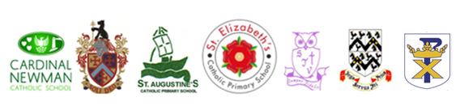

December 2025
Dear Candidate
On behalf of the Board of Directors for Holy Cross Catholic MAC, we would like to thank you for your interest in the post of Exam Invigilator at Cardinal Newman Catholic Secondary Academy within our Multi Academy Company. The school is one of the seven Catholic schools (2 secondary and 5 Primary) that are part of the Holy Cross Catholic Multi Academy Company (HCCMAC) which opened on 1 September 2019.
This letter is intended to help you complete the application form. Please read it carefully before the completion of your application form. If you have any difficulties, please contact the school.
The application form is your opportunity to provide all the information we will require to help us understand how you meet the requirements of the post advertised. Similarly, it plays an important part in the selection process allowing us to short-list candidates for interview and helping as a basis for the interview itself. To ensure fairness to all applicants, short-listing decisions are based solely on the information you supply on your application form. Even if we already know you as a current or previous employee, it is important that you complete the form in full.

All vacancies are accompanied by a job description and a person specification setting out the main duties and responsibilities of the post in the job description, and the knowledge, skills and experience we are looking for in the person specification.
Please read this information carefully as you will not be short-listed for interview unless you meet the essential criteria described in the Person Specification.
Depending on the number and quality of applications, it may not be possible to shortlist for interview all candidates who meet the Essential Criteria. However, we guarantee to interview all disabled applicants who meet the Essential Criteria.
We are unable to accept CVs so please do not attach your CV, references, or copies of educational certificates to your form. If there is insufficient room on the form in a particular section, you can simply attach an extra page and mark it clearly with your name and the job title, indicating the number of the relevant question.
The ‘Relevant skills & experience' section of the form is your opportunity to tell us specifically why you wish to apply and what makes you a suitable applicant. You should include anything you feel would be useful in support of your application telling us as much as possible about yourself in relation to all the items listed in the job description.
Please remember that those involved in the selection process cannot make assumptions about you. - tell us everything relevant to your application and complete all the sections on the form.
The closing date for receipt of applications is by 9.00am Friday 30th January 2026

Data Protection
Information provided by you as part of your application will be used in the recruitment process. Any data about you will be held securely with access restricted to those involved in dealing with your application and in the recruitment process. Once this process is completed the data relating to unsuccessful applicants will be stored for a maximum of 6 months and then destroyed. If you are the successful candidate, your application form will be retained and form the basis of your personnel record. By signing and submitting your completed application form you are giving your consent to your data being stored and processed for the purposes of the recruitment process, equal opportunities monitoring and your personnel record if you are the successful candidate. Holy Cross Catholic MAC reserve the right to check the validity and accuracy of your application if successful.

Equal Opportunities
Information provided by you on the Equal Opportunities Monitoring Form will be used to monitor our equal opportunities policy and practices. This part of the form will be detached from the main body of the application form and will not form any part of the selection process.

Work Permits
Under the Asylum and Immigration Act, we are required to check that anyone taking up employment with us has the legal right to work in the UK. Shortlisted applicants will be asked to provide us with documentary evidence to support their entitlement to work in the UK prior to any offer of employment being made.

DBS Checks
In line with our safeguarding and child protection policy, all employees and volunteers working in specific roles at the Academy will be subject to satisfactory clearance being obtained from the Disclosure and Barring Service. The check will be undertaken as part of the appointment process with the successful candidates. If you are invited to interview, you will be asked to bring this information with you.

PLEASE NOTE We will take up references for all shortlisted candidates prior to interview and reserve the right to validate all information entered on the application form. Please ensure that any person who is asked to act as a Referee knows this information and is available to give a reference during this time.
We expect all our staff and employees to be in sympathy with our Catholic values and help us to achieve the vision that we have set ourselves to work towards.

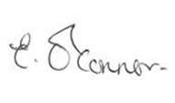
Yours faithfully

Ms E O’Connor
Headteacher
Cardinal Newman Catholic School

Motto
Achieving Together in Faith.
Mission
Our school communities are united as the family of God to provide an outstanding Catholic education for all our pupils. With Christ at the centre of all we do, we will inspire every child to be the best person they can be by developing their God given gifts and talents.
Aims:
High aspirations for all
Outstanding education - To create an ethos of collective responsibility, through which we will promote achievement and improve pupil performance
Living out Gospel values and celebrating the Catholic ethos in all our schools with reconciliation and peacefulness at the heart of all we do
Young people – who are resilient and make a positive contribution to their diverse and changing communities
Community - strengthening and nurturing the Catholic life of our schools
Realising talent by developing pupils, staff, academy representatives and Directors for the benefit of the Holy Cross community
Optimising our resources to realise best-value by sharing assets and using economies of scale
Standards - To maintain the highest quality of Catholic education by ensuring accountability at all levels
Service to God by serving others in our school and local communities and national and international communities in need.

JOB DESCRIPTION

Job Title: Exam Invigilator
Salary/Grade: Grade 1 / Point 2: £12.65 per hour
Responsible to: MIS Manager
Hours: Casual

Liaising with: MIS, Curriculum and Timetabling Manager, Head Invigilator and students.

Exam Invigilator:
Duties:
- Assisting with the packing of exam papers, stationery and equipment prior to the exam and delivery to and from the venues as appropriate.
- Assisting candidates prior to the start of exams by directing them to their seats and advising them about possessions permitted in exam venues.
- Help with the collection and storage of student mobile devices prior to the examination and the safe return to students at the end of the examination.
- Distributing examination papers.
- Provide support to ensure there is an orderly start to the examination.
- Supervising students during the duration of the examination.
- Assist in checking the attendance registers and informing the relevant person of any absences.
- Invigilating during exams, dealing with queries raised by candidates.
- Collecting and collating scripts at the end of the exam in accordance with procedures.
- Assisting with the preparation of script envelopes.
- Supervising candidates leaving exam venues, ensuring that candidates do not remove equipment or stationery from the venue without authorisation and ensuring that candidates leave venues in an orderly and quiet manner.
- Ensure you are aware of the examination regulations which will be required prior to and during the examination.
- Collect the examination papers at the conclusion of the examination.
- Be aware of and comply with policies and procedures relating to child protection, health and safety, security, confidentiality and data protection. Reporting all concerns to the appropriate person.
- Contribute to the overall ethos/work/aims of the school.

All duties and responsibilities must be carried out with due regard to the school’s Health and Safety Policy.

Postholders will be accountable for carrying out all duties and responsibilities with due regard.

Duties which include processing of any personal data, must be undertaken within the corporate Data Protection Guidelines (Data Protection Act 2018)
Date Reviewed: December 2023
The above is not intended to be an exhaustive list of all tasks to be undertaken, but rather a general outline of the main duties and responsibilities of the post holder. You may be asked to undertake other duties appropriate to the grade of the post, elsewhere in school, at the discretion of the Headteacher.
This post is subject to receiving a satisfactory DBS clearance.

Our Schools

Our school is named after one of England’s foremost Catholics, the Blessed John Henry Newman and we are very proud to be associated with his love of learning and his strong commitment to providing the best pastoral support for those in his care.
Our mission statement “Knowledge through the light of faith” is at the heart of all we do and we endeavor to make known to every student that they are made for greatness because they are a child of God and are uniquely created and loved by God.
Every student is called to live out the gospel values by loving God, others and themselves and by being prepared to always do their best and be the best person they can be.
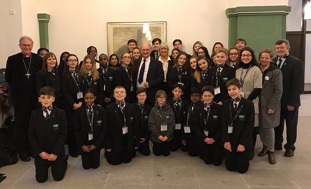
We insist on the highest standards of behaviour, uniform, attitude to learning and respect for one another and the environment. By providing a traditional, yet broad and balanced curriculum for all our students regardless of ability and background, we are able to recognise and develop individual talents and interests including academic, creative and sporting provision that is appropriate for every child from our special needs students to our Oxbridge applicants. We also have a varied extra-curricular activities programme that includes a wide variety of clubs as well as day and residential visits to enhance each student’s learning experience.
We are blessed to have an amazing staff who work tirelessly for our students so that they are given every opportunity to fulfil their true potential and we pride ourselves on excellent relationships, where we work together to form a happy, loving and caring community, based on clear boundaries, accepted values and high expectations.
We are determined to continue to improve to meet the needs of our students in an ever-changing world and we are confident that we will achieve our vision, which is simple: to become an outstanding catholic school in all we do.
At Cardinal Newman we want for your child exactly what you want as parents – the best and nothing but the best.
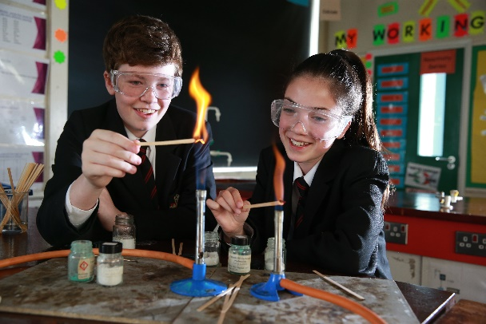
At Bishop Ullathorne Catholic Secondary Academy, we recognise the uniqueness of each child and the need to build upon the firm family Catholic values established in the home and in our partner primary schools. Our mission as a Catholic school is to be an active Christian community of love and service where all feel they belong and are valued. We believe strongly that each child has a right to excellence and to be actively encouraged to be the person God wants them to be.
Working together, we enable our students to recognise and to have confidence in their own abilities. It is important to us to raise the aspirations of each of our students and provide them with the love and support to grow as the very special person that they are. We focus on rounded development: spiritually, morally, socially, physically and academically. Every member of our school community is valued and their sense of belonging is paramount. Whilst great emphasis is placed on each student’s academic achievement, we also foster traditional values. Your child’s sense of belonging at school contributes to our sense of community in a happy supportive atmosphere. Hard working, caring and sympathetic staff work in partnership with parents to ensure that your child’s secondary school career is enjoyable and successful.

Our outstanding Catholic school has a long-standing record of high-quality education and academic excellence. Student achievement is a continued strength at both key stage 4 and key stage 5. All progress and attainment measures significantly exceed the national averages. Each member of our school community is highly valued.
We are guided daily through our own expectations, known as the Ullathorne Way. This calls us to be:
- Compassionate
- Faith filled and Prophetic
- Attentive
- Eloquent
- Curious and Wise
- Grateful
Only by extolling these virtues can we show the love of Christ in our daily actions and grow to be our true self.

Christ the King Catholic Primary Academy provides an excellent, Christ centred education through inspirational teaching and empowerment of all pupils to reach their full potential spiritually, intellectually, physically, socially and morally, in a happy, caring, stimulating environment promoting self-esteem and confidence. Our school offers all-through primary education for 420 pupils, complemented by 52 nursery places.
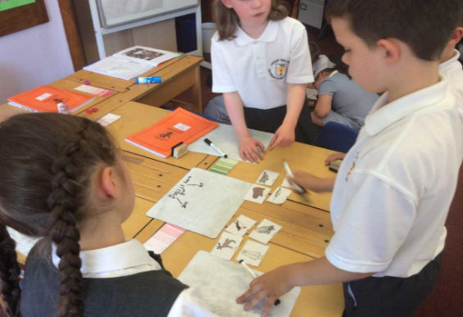
Our teaching philosophy is centred on an environment of mutual respect where the staff, the pupils and the whole community work together for the common aim of educating to achieve the highest standards of competence and ability and to be responsible and worthy citizens of the world.
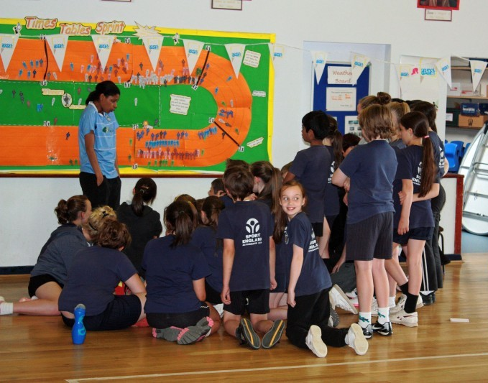
The diverse backgrounds represented by our pupils and staff contribute to a rich learning environment where the communication of knowledge is informed by professional expertise and personal experience. A differentiated teaching programme delivers the curriculum at the rate appropriate to the individual child.
We aim to develop and extend every pupil to enable them to achieve their full potential, irrespective of academic ability or social background. Our curriculum encompasses the widest range of concepts, attitudes, skills, responsibilities and cross-curricular issues relevant to a pupil’s life in its widest perspective.
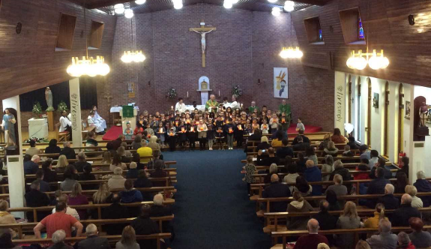

The school offers a wide range of sporting and artistic activities to complement the core academic expectations of the National Curriculum.
Our pupils make excellent academic progress, and impressive results are achieved on the sports field and in the arts arena.

St Augustine’s Catholic Primary Academy is located in the heart of Radford in Coventry. We are a happy and vibrant two form of entry school with a Nursery. As a school we aim to work in partnership with parents, guardians, the parish and the Academy family of schools to support our children and families on their journey of Faith. As part of the family of God we work hand in hand.
‘To listen to God’s call, to learn from God’s word and to share God’s love through service.’
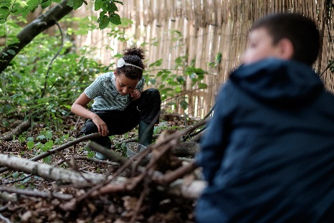

Our extensive grounds include a Forest School site which is used to develop a range of skills with pupils, a Thrive nurture room, a sports Muga and counselling facilities.


Our staff here are committed to working together to support our children to be the best they can be spiritually, morally, academically, mentally and physically. We aim to provide a broad and balanced curriculum that will both engage and educate our pupils shaping them into caring future disciples and knowledgeable, responsible citizens.

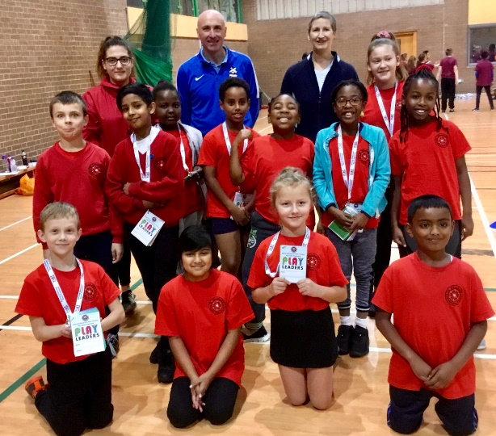
St Elizabeth’s is truly a special place, a happy place where staff, parents, governors and children work in harmony together. The school has developed an individual identity since its creation over 100 years ago which combines the best of traditional educational values with a modern vibrant vision.
At St Elizabeth’s we pride ourselves on celebrating the cultural diversity of our locality. We are a school community in which all children are welcomed and valued as unique members of God’s family, a family of different faiths and backgrounds living, loving and learning together joyfully following in the footsteps of Jesus Christ.
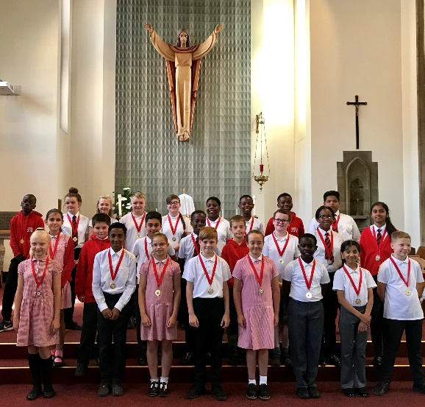
Central to our philosophy are the values and virtues Christ taught us through the Gospels, these values run through every aspect of school life like a golden thread, intertwined and bound throughout all of our relationships and the experiences we provide for our children. Our reliance on these values ensures the spiritual formation of every member of our school family.
We aim to provide a rich and diverse curriculum that develops our children morally and socially as well as academically. Children leave St Elizabeth’s as faithful, aspirational, responsible and resilient young people ready to make positive contributions to the wider communities in which they live.

At St Elizabeth’s we take enormous pride in knowing all of our children and families very well. We are fully committed to ensuring that each child is offered the finest start to their education in a stimulating, caring and loving environment, an environment which influences a lifelong love of learning and one in which our children thrive and live life to the full.
Welcome to St John Vianney where Christ is at the centre of everything we do. We have one school rule which is:
Love one another as I have loved you

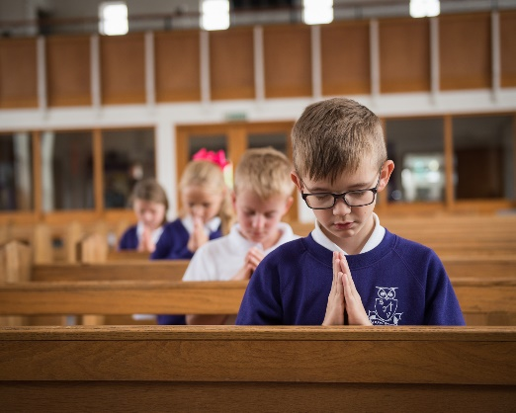
We strive to promote the values of our Christian faith throughout our daily life. We provide a religious syllabus, which develops our children's knowledge and understanding of our faith. However, more important to this school are those values, which we try to relate to all the aspects of our life within the faith community of St John Vianney Parish.
St John Vianney is a happy and caring school where every child is known and loved. We seek to challenge and support all our children and make them excellent citizens of the future, knowing how important it is to do their best and care for those around them.
We are conscious of the necessity to provide our pupils with a broad and balanced curriculum and constantly review and evaluate the achievements of the school. Our curriculum is exciting and engaging aiming to bring the humanities alive through first- hand experience wherever possible. We aim to provide both high academic and non- academic standards, a good faith basis and involvement in the wider community. Moreover, developing the whole child by enabling them to acquire knowledge, appreciate their creative abilities and master the challenges of physical education and sport.
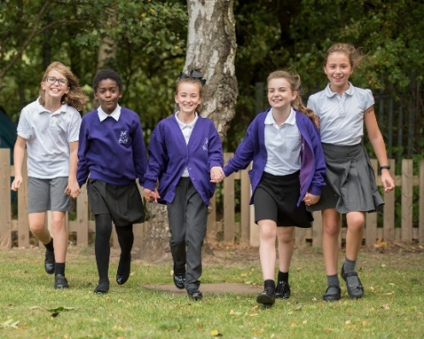
St John Vianney Catholic Primary Academy strives to achieve its aims through a strong partnership between governors, staff, children, parents and Parish. Most of our governors are parents or past parents and members of our Church community. We believe that this improves the level of co-operation and the sense of shared commitment and responsibility. We believe that we can only achieve the best for your child by close co-operation between home and school. Without the involvement of parents, our task is that much more difficult and less enjoyable. We hope that parents will take a close interest in what their children are doing in school and will encourage learning and its importance in later life.
It is our view that Primary School years lay the foundations for a lifetime of learning and work hard to cultivate the fundamental partnership between Home and School by welcoming parents to become involved in their child’s education.

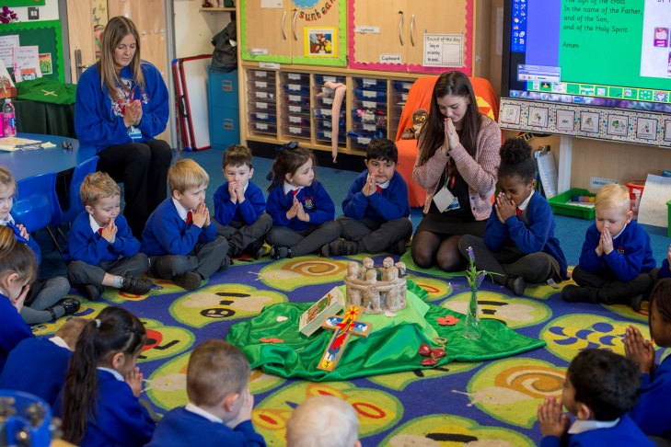
St Thomas More’s motto is “Learn and Grow as God’s Holy People” and this underpins everything we do at the school. We believe that every child should be pushed and supported to achieve their God-given potential and that it is our responsibility to get the best out of all of our students – academically, socially and spiritually. We are a very diverse, multi-ethnic community with a highly inclusive ethos. Children are happy to come to school here and they thrive on the nurture and support offered. We are situated in a suburban residential area of south Coventry, a 30-minute walk from the city centre, but we draw our children from a much wider catchment area. The school is housed in a modern building which opened in September 2014 and we have very generous grounds which include a large field, allotment, forest school, a pond and a chicken pen.
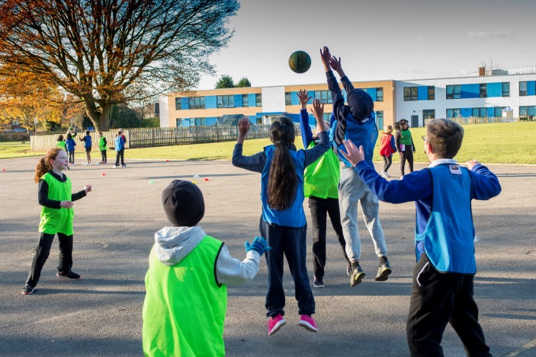
We are committed to academic excellence and are always keen to innovate, using research-based methods to develop and improve our practices further. We keep our curriculum under constant review so that it is appealing and relevant to our current situation and we place great emphasis on the importance of a consistent approach from Nursery to Year six. Our children’s learning experience is very hands-on: an example of this is our maths mastery programme which focuses on underlying mathematical concepts and number sense through the use of manipulatives all the way from Reception to Year 6. We see it as our duty to produce well-mannered, respectful and motivated young people and our behaviour and discipline policies are reflective of this. Children leave St Thomas More with all the qualities they need to make a positive contribution to society. We have excellent relationships with our local parish and the children make good use of the church. Our vocation to Catholic life is evident across the curriculum and throughout the school. Our families are very supportive of our ethos and work well with school leaders to ensure positive outcomes for all. Many parents comment that St Thomas More is like an extension of the family.
The school received a highly positive Ofsted inspection in January 2018 and we aim to build on this as we continue to improve and push ourselves to be the best we can possibly be.
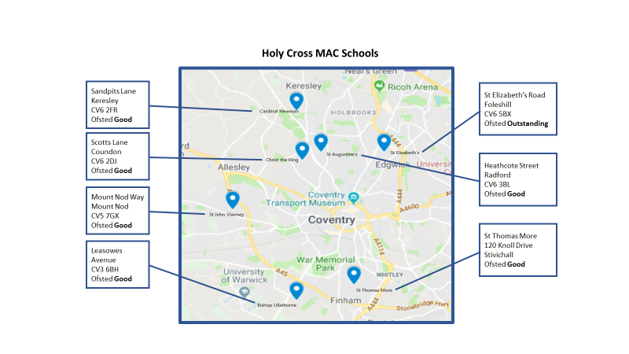

Why work in Coventry?



Coventry is an innovative city that boasts two cathedrals, old and new. It combines medieval architecture with vibrant regeneration which is rich in bars, restaurants and culture. Coventry has recently been awarded the City of Culture for 2021. You will find both the Belgrade theatre and the Warwick Arts centre on the doorstep, along with open green spaces such as the War Memorial Park and Coombe Abbey.

The Ricoh Arena hosts both football and rugby, along with music concerts. Road and rail links are exceptional. Birmingham and Leamington Spa are under 15 minutes by train and London just over an hour. Stratford upon Avon, Warwick and Solihull are also nearby. From Coventry it is only one rail stop to Birmingham International Airport and the National Exhibition Centre. In December, Birmingham was named host city for the 2022 Commonwealth Games, and local town, Leamington Spa, was recently named as one of the best places to live in the Midlands in 2017 by the Sunday Times. The city hosts a variety of annual events such as the Coventry Half Marathon, the SkyRide and the Godiva Festival, which is the biggest free family festival in the UK.

Coventry also has two universities, Coventry University which was awarded' University of the Year for ‘Student Experience' by The Times in 2014 and the University of Warwick, which is in the top 10 on the league tables. Both universities have links with three of the city’s biggest employers, Jaguar Land Rover, the NHS Trust and Coventry City Council.

