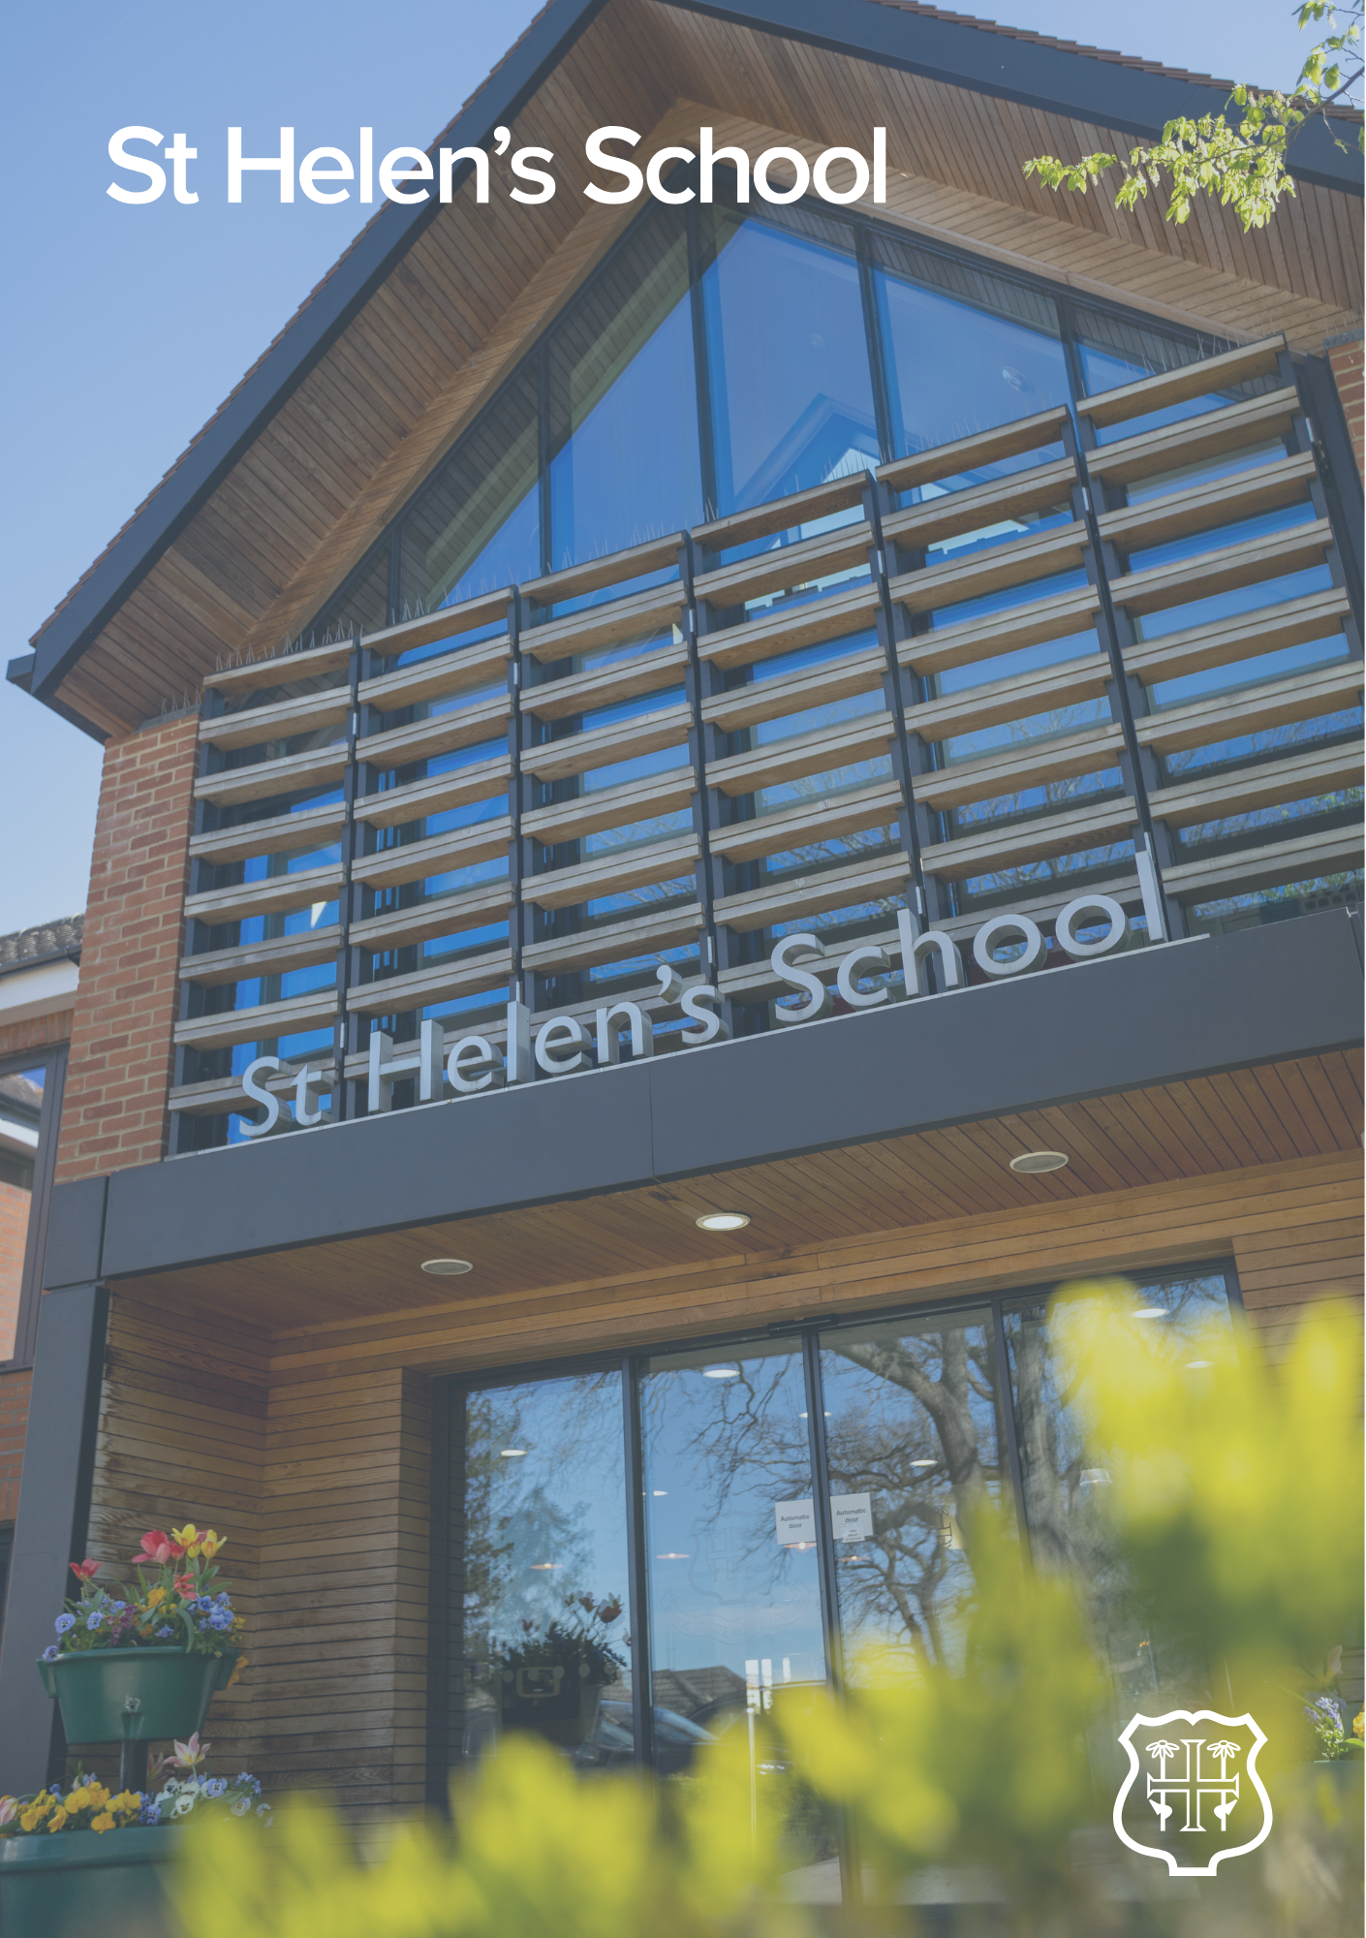

Bank Teacher of Ballet
– Job Description

JOB DESCRIPTION
Bank Teacher of Ballet
The Purpose
To lead and develop high-quality Classical Ballet lessons that fosters participation, performance, and a lifelong love of dance. The post holder will also promote excellence, inclusivity, and engagement across all age groups.

We are looking to appoint a Bank Ballet Teacher to work 5 hours each Friday, 12.30pm – 5.30pm, during term time plus attendance at INSET Days.

The Post
HOURS: 12:30-17:30 when required on a Friday.
The role will report to: Lead Ballet Teacher

Main Responsibilities
- Preparing and delivering Classical Ballet lessons of the highest quality
- Promoting the highest standards of Ballet for each individual pupil.
- Contributing as required to the development of appropriate schemes of work.
- Preparing students for Royal Academy of Dance Ballet examinations – Primary to Grade 8.
- Sharing information as required – with parents and teachers – on the progress of pupils.
- Maintaining an understanding of the requirements of the Royal Academy of Dance examination requirements, and of current developments in the teaching of Classical Ballet.
- Attending termly inset meetings, the content of which will be agreed by the Lead Teacher of Ballet, Director of Sport, Health and Safety Manager and the Deputy Heads.
Other Duties:
- Carry out such duties as may reasonably be required by the Lead Ballet Teacher and Director of Sport.
- Support and promote the school’s ethos, aims and objectives.
- Work towards and support the school vision and the current school objectives outlined in the School Strategic Plan
- Promote and safeguard the welfare of pupils and adhere to and ensure compliance with the School’s Safeguarding and Child Protection Policy
- Promote and support pupil wellbeing by providing pastoral care, monitoring student progress, and fostering a positive and inclusive classroom environment as a dedicated form tutor.
- Maintaining good order and discipline among the pupils and safeguarding their health and safety both when they are on the school premises and when they are engaged in authorised school activities elsewhere.
- Promote equality of opportunity for all students and staff
- Help sustain a school culture and curriculum which promotes an ethical education for all including promoting positive strategies for challenging discrimination of any kind.
- Maintain high professional standards of attendance, punctuality, appearance, conduct and positive, courteous relations with pupils, parents, and colleagues.
- Undertake other reasonable duties related to the job purpose required from time to time.

The Person
It is essential for the successful candidate to have the following qualifications, experience, and personal attributes:
- Experience of teaching Ballet and preparing students for Royal Academy of Dance examinations
- A level 4 dance teaching qualification endorsed by a recognised education body
- A passion and enthusiasm for Ballet as a subject.
- A love of teaching and learning and a commitment to further professional development.
- Be able to work well with others and develop the curriculum through collaborative planning.
- Ability to plan and prioritise workload to meet deadline, including managing multiple tasks/ projects/priorities simultaneously.
- Calm under pressure, ability to remain articulate, and be a confident communicator.

It is desirable for the successful candidate to have the following qualifications, experience, and personal attributes:
- Undergraduate qualification in dance
- Experience of teaching Ballet in an independent school setting

APPLICATION PROCESS
Closing date: Midnight Sunday 21st June 2026
Please apply as soon as possible as shortlisting/interviews will progress up until the closing date. Should a suitable candidate be appointed, we reserve the right to close the advert early.
Due to the volume of applicants, we receive, if you do not hear from us within 4 weeks of the closing date, please assume we will not be progressing your application further on this occasion.

