Teaching Assistant Level 2






Welcome from the CEO

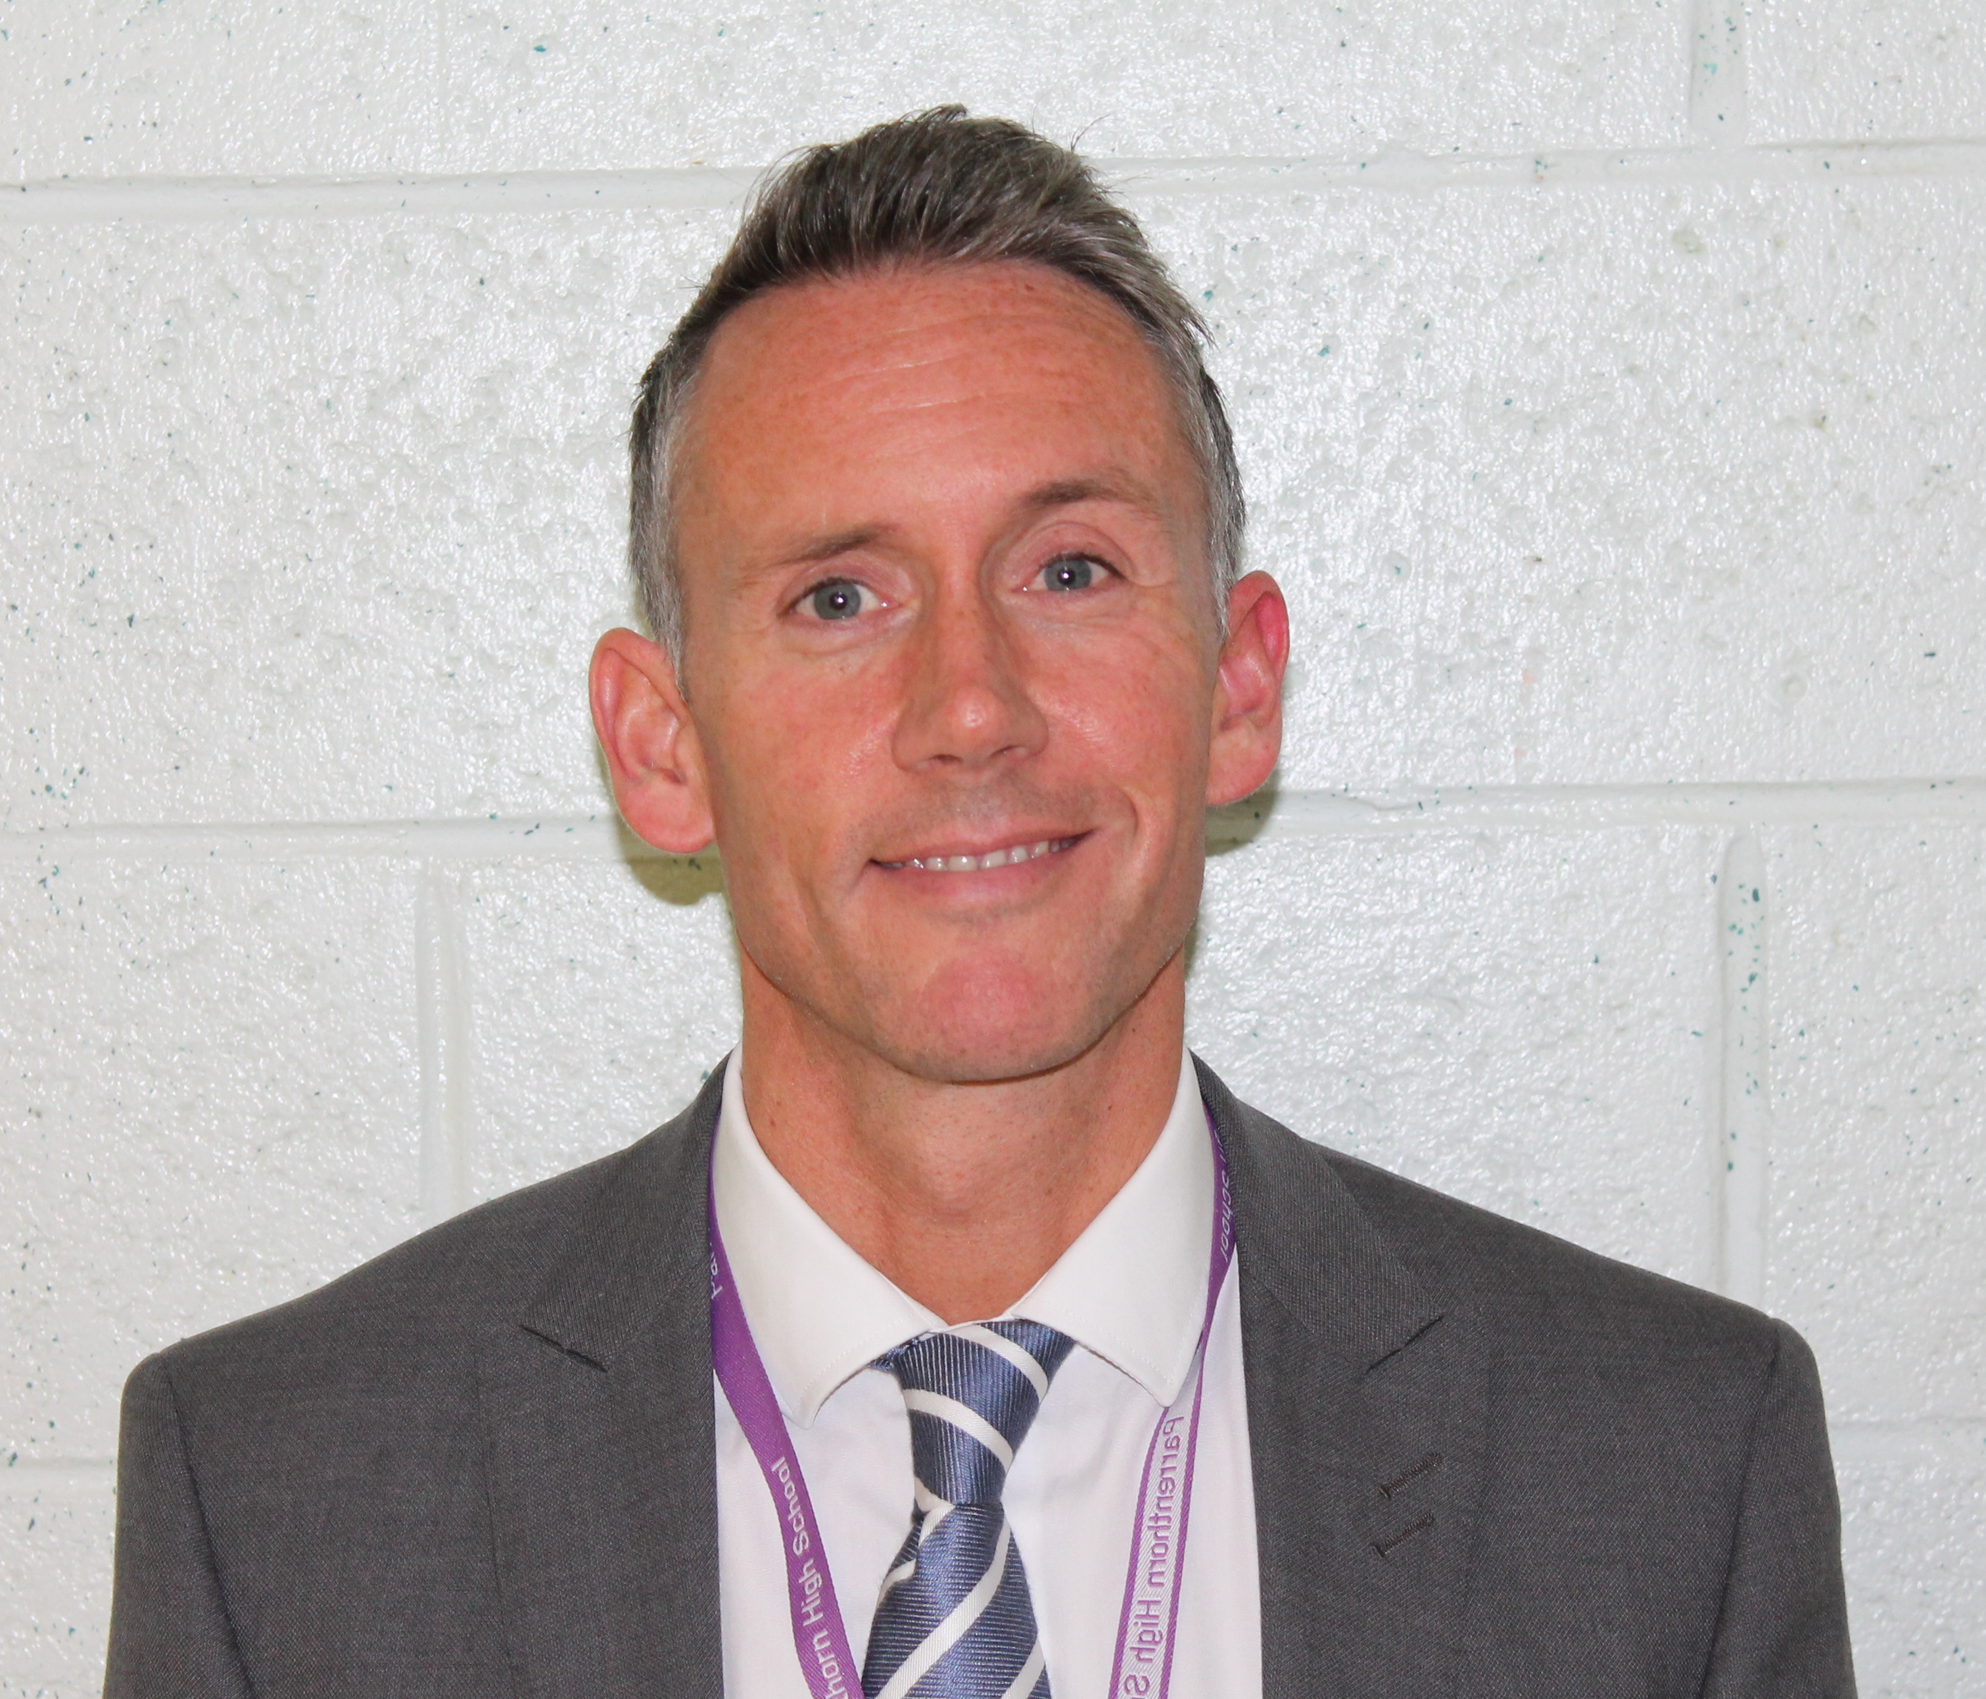  Welcome to our multi academy trust.
Thank you for your interest in joining Vision Multi Academy Trust as a Teaching Assistant Level 2 at Higher Lane Primary School.
We are very proud of our Trust. Our Members, Trustees and Staff work relentlessly in collaboration to ensure our pupils have an exceptional education.
Vision MAT was formed in July 2017. It came into fruition as a natural development of positive relationships built between neighbouring schools in the local area. We continue to work in partnership with all schools in the locality and beyond. We believe that collaboration is the key to a successful education system.
All Schools within Vision MAT have the commitment to share their ideas, their expertise and their unique experiences, so that children and staff can learn, develop and grow together.
We take collective responsibility for our pupils; pooling our energy to find solutions to problems that arise and removing barriers that may prevent success.
As the Chief Executive Officers, it is our role to oversee the teams and strategies the MAT uses to ensure that we are consistently delivering the highest quality teaching and learning and operate with effectiveness. We focus on being good, or better every day. We are delighted that all schools within Vision MAT have been graded good by Ofsted. Our aspirational culture ensures that we work tirelessly to support and challenge our pupils to be the very best that they can be.
If you believe you can make a positive contribution to our Trust and its schools, then we would be delighted to hear from you.

Kathryn Mort and Chris Bell
Interim Chief Executive Officers

Dear Candidate
The Governors of Higher Lane Primary School are seeking to employ an enthusiastic and passionate Teaching Assistant Level 2 to support children in EYFS. This post is temporary. Hours of work are 30 hours per week, term time only worked in accordance with service requirements. The salary is £18186 per annum.
Higher Lane Primary School is a good school which enables pupils to learn in a climate which motivates and engages.
Are you…
- A good or outstanding Teaching Assistant with high standards and an eye to detail?
- Do you have the drive to make a difference within our school?
If yes, we want you to apply for this post.
You must possess a willingness to participate in relevant training and development opportunities.
You will be welcomed into a team committed to continually raising standards and upholding the distinctive ethos of this friendly and inclusive school.
Employees of Higher Lane Primary School have a responsibility for, and must be committed to, safeguarding and promoting the welfare of children and young people and for ensuring they are protected from harm.
If you wish to visit the school prior to making an application please contact the school on 0161 766 2005 or by e-mail at jmccoy.higherlane@visionmat.com
Closing date on Friday 20 March 2026 at 12noon
Shortlisting to take place on Friday 20 March 2026
Interviews to take place on Wednesday 25 March 2026
We have a commitment to safeguard and promote the welfare of children, so an enhanced criminal record check will be undertaken for the successful candidate. The offer of employment is also subject to two satisfactory references, one being from your current or most recent employer. We will also require confirmation of qualifications, proof of your identity and your right to work in the UK.
Thank you for your interest in Vision Multi Academy Trust and Higher Lane Primary School. Best wishes for your application.
Yours faithfully,
Mrs K Mort and Mr C Bell, Interim CEOs
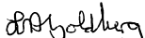
Mr Laurence Goldberg, Chair of Trustees



VISION MULTI ACADEMY TRUST
JOB DESCRIPTION & PERSONAL SPECIFICATION
Post Title: TEACHING ASSISTANT LEVEL 2
Salary: £ 18186 per annum | Post Grade: 6
Location: Higher Lane Primary School, Egerton Road, Whitefield, Manchester, M45 7EX | Post Hours: 30 hours per week
Purpose and Objectives of Post:
The main aim of this role is to support children and work alongside the EYFS year group class teachers to tailor work and activities to meet the children’s needs. You will have the opportunity to develop your skills and take ownership of the role, by ensuring learning is fun and engaging.
Accountable to: Headteacher and SENCo
Immediately Responsible to: Headteacher
Control of Resources:

Duties/Responsibilities

General duties
• Work with children in all year groups but predominantly EYFS.
• Assist the teacher to prepare classrooms for lessons and activities with a specific focus on supporting
pupils with special educational needs and disabilities.
• Encourage pupils to interact with others and engage in activities led by teaching staff.
• Supervise pupils’ work and offer support where necessary.
• Provide administrative and clerical support to teaching staff and other TAs regarding lesson and
resources.
• Monitor the needs and behaviour of pupils, and report these to teaching staff where appropriate.
• Undertake pupil record keeping as requested, e.g. logging safeguarding concerns as appropriate.
• Assist teaching staff and other TAs with creating and maintaining displays throughout the school.
• Establish and maintain constructive relationships with pupils’ parents.
• Be a good role model to pupils in terms of behaviour and attitude.
• Be proactive in managing pupil behaviour.

Supporting the school
• Contribute to the ethos, value and aims of the school.
• Comply with all relevant legislation and school policies, including those relating to safeguarding, health and safety and data protection.
• Promote inclusion and acceptance of all pupils.
• Assist with the supervision of pupils out of lesson times, including lunchtimes.

Teaching and learning
• Develop a secure knowledge of the learning support needs of individual pupils.
• Identify where pupils are struggling, e.g. engaging with a particular topic, and support them in
understanding the information and complete the work.
• Support the use of ICT and computing in learning activities, and develop pupils’ competence and
independence in its use.
• Undertake activities set by teaching staff with individuals, or groups of pupils, to support pupils’ learning.
• Assist teaching staff to implement a variety of teaching strategies that support pupils in achieving their
learning goals.
• Assist teaching staff and the SENCO with the creation of individual learning plans for pupils.

Communication and coordination
• Work closely with teaching staff, other TAs and the SENCO to close the attainment gap between individual pupils, groups of pupils, and their peers.

PERSON SPECIFICATION

TEACHING ASSISTANT LEVEL 2
TA2 Person Specification
 | Qualifications and training
 | Essential | Desirable
 | - Two or more GCSEs at grades 9 to 4 or equivalent, including English and maths. | - A degree in a relevant field or other relevant qualification.  - First aid training.  - Safeguarding training.  - Evidence of recent CPD.
 | Skills and experience
 | Essential | Desirable
 | - Experience of working with children.  - Effective oral and written communication skills.  - Demonstrable levels of numeracy and literacy.  - Excellent communication skills.  - Effective problem-solving skills.  - The ability to remain calm under pressure.  - The ability to be proactive in seeking solutions.  - Good organisational skills and time management. | - Experience of record keeping and monitoring.  - Experience of working in an educational environment.  - Experience working with children and young people with additional needs.  - Experience in multi-agency working.
 | Knowledge
 | Essential | Desirable
 | - Knowledge of areas of legislation relevant to child protection and safeguarding.  - Knowledge of relevant school policies. | - Knowledge of the curriculum.  - Knowledge of legislation and statutory guidance specific to EYFS and primary school phase.
 | Personal traits
 | The successful candidate will be
- Able to work independently but also as part of a team.
- Dedicated to their practice.
- Punctual and professional.
- Able to maintain successful working relationships with colleagues.
- Reliable and able to be flexible in their approach to work.
- Positive and engaging.
- Able to plan and take control of situations.
- Capable of handling demanding workload and successfully prioritising work.
- Empathetic to those who face barriers to their learning.
- Patient with pupils who take longer to understand information.
Additional Requirements
The successful candidate will have
- The capacity to work flexibly.
- An enhanced DBS check.
- Available references from a previous employer or organisation

