

Candidate Recruitment Pack

Level 3 Early Years Practitioner

Kings Oak Academy

Applications considered upon receipt

www.unityeducationtrust.uk head@kgo.unity-ed.uk

A welcome from the CEO
Dear Applicant,

Thank you for your interest in our vacancy at Unity Education Trust (UET).
As Chief Executive of the UET, I am delighted to offer you a warm welcome to our Trust. These are exciting times for all those associated to Unity Education Trust a Multi-Academy built on developing like-minded schools to be outstanding education providers through collaborative working that develops a ‘unity of purpose’ in all that we do.
UET has expanded its family of schools and education professionals. Our collaborative work over the last 6 months has ensured a measured evolution into our new formal Trust arrangements. We’re welcoming outstanding teachers, subject specialists, tutors, support staff and experienced leaders with a record of transformation in education.

Teachers and support staff now number 795. All of our staff share the ethos of raising aspirations, unlocking potential and securing the best possible future for the 2700 young people attending our schools.

Our schools range in size from 20 to 1200 students and effective collaboration across our schools is an important part of who we are.

I am proud that we are working in ‘Unity’ to meet the challenges in education head on and spearheading new developments for the benefit of all the children in our care.
We look forward to receiving your application.
Best wishes
Glyn Hambling
CEO


Our Story

Raising aspirations to fulfil potential
UET was established in March 2017. As of 2024, its family of schools have expanded providing education for 3 - 19 year olds across mainstream and alternative provision settings and now comprises the following:
Specialist
Pathfinder School –
Brooklands, Danby Wood, Douglas Bader, Hooper Lane, Brooklands, Rosebery

Compass –
Belton, Lingwood, West

- UET Earthsea
- Churchill Park Academy
- The Pinetree School
Mainstream
- Northgate High School and Dereham Sixth Form College
- Grove House Nursery and Infant School
- Kings Park Infant School
- Beeston Primary School
- Garvestone Primary School
- Great Dunham School
- Greyfriars Academy
- Highgate Infant School
- Kings Oak Academy
- Magdalen Academy
- St Germans Academy
- Wimbotsham & Stow Academy

The Trust sets high expectations in every aspect of our work, providing pupils with the best opportunities through outstanding teaching, the development of 21st century facilities, inspirational leadership and a growth mindset approach.
We will ensure that each of our academies maintains its unique identity at the heart of their community and engaging with all partners and stakeholders and other high performing educational organisations.

We have an unrelenting belief and focus that all students can achieve high standards, whatever their background and life experiences when given a positive climate of support, challenge and the development of Growth Mindset through outstanding teaching.
Furthermore we are committed to ‘raising aspirations to fulfil potential’ ensuring our learners are encouraged to build confidence, expand their leadership qualities and embrace British Values that enable all to thrive in an ever-changing society.

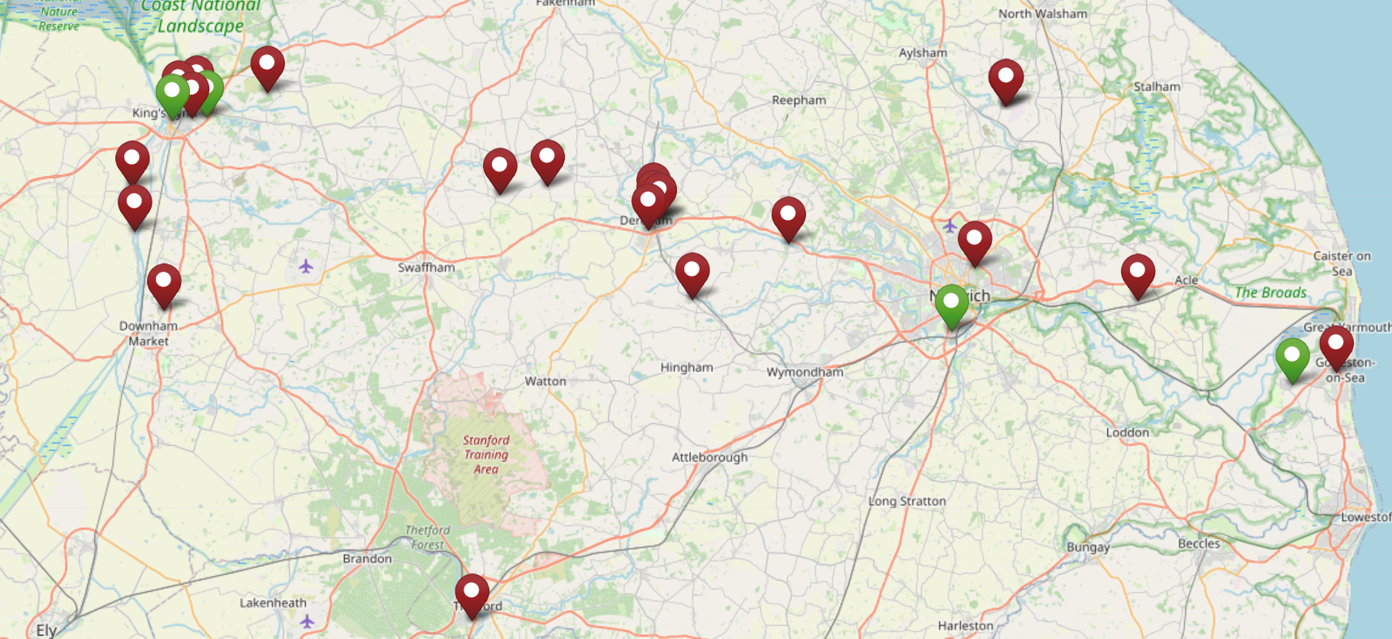

At King’s Oak Academy we work hard to provide a stimulating, supportive and challenging learning environment in which children feel confident and want to learn and do their best. Through our engaging and creative curriculum, we ensure that children develop a passion for learning that will help to develop high aspirations which can be carried forward to the next stage of their educational journey. We believe every child wants to succeed and has the potential to achieve great things. We aim to meet the needs of everyone; by ensuring we provide them with the opportunities, support and encouragement needed to develop their social, emotional, creative, academic and physical abilities to the full. We use our value ‘SHINE’ in everything we do. We believe it is essential that your child feels happy, secure and makes good progress in their learning. We value the contribution parents and carers make in helping children achieve this. We work in partnership with parents and carers to ensure every child does the best they can. All the adults at King’s Oak Academy, whether they are staff members, parents, carers, governors, support workers or specialist providers, are role models to our children. By respecting each other and by valuing each child as an active and important member of our school and local community we will encourage children to develop a sense of responsibility for themselves and a respect for others. We want your child to flourish and feel happy and secure during their time with us in order that they realise King’s Oak Academy is a place where aspirations and ambitions come true. We want every child to be their own success story and look forward to working in partnership with you, to give your child the best start possible to their education and lifelong learning
Underpinning principles




Supporting Our Staff

Unity Education Trust is committed to supporting all staff in their personal, professional and career aspirations by providing a range of development opportunities. We foster a culture which encourages you to develop your talent and strengths throughout your journey with us.

We are committed to providing the highest quality support to ensure our schools excel and give our students the education they deserve. Our Headteachers have a good deal of autonomy as school leaders within a framework developed collaboratively with our Director of Education and the Education Directorate.

Each Unity Education Trust school benefits from a comprehensive programme of support and challenge, including a strong emphasis on CPD and a regular programme of training events to improve performance across all sectors within our schools.

We believe it is very important that each of our academies plans in such a way that financial and human resources are deployed to support their educational strategies fully. This is supported by our experienced Central Service team, who are available to advise on financial planning, audit, HR, legal and property matters.



Job Description

Early Years Practitioner

Job details
Job title | Early Years Practitioner
School | Kings Oak Academy
Responsible to | Responsible to the Executive Headteacher
Responsible for | Providing learning experiences and support for pupils. Acting as a key worker for individual pupils
Liaising With | Senior Management Team, teaching/ support staff, school representatives, external agencies and parents

Purpose of Job
Job purpose
- To implement and deliver an appropriately broad, balanced, relevant and differentiated curriculum for pupils with support from EYFS lead
- To monitor and support the overall progress and development of pupils
- To facilitate and encourage a learning experience which provides pupils with the opportunity to achieve their individual potential
- To contribute to raising standards of pupil attainment and behaviour
- To share and support the school’s responsibility to provide and monitor opportunities for personal and academic growth

Main Duties
Operational / Strategic Planning:
- To contribute to curriculum areas.
- To plan and prepare lessons with oversight from EYFS lead.
- To contribute to the whole school’s planning activities.
Staff Development:
- To take part in staff development programmes by participating in arrangements for further training and professional development.
- To continue personal development in the relevant areas including subject knowledge and teaching methods.
- To engage actively in the Performance Management review process.
- To support in the effective/efficient deployment of teaching assistants.
- To work as a member of the EYFS team and to contribute positively to effective working relations.

Assessment:
- To assess the progress of pupils and direct the work of teaching assistants within the classroom.
- To maintain appropriate records and to provide relevant accurate and up to date information to the Executive Headteacher.
- To complete the relevant documentation to assist in the tracking of students.
- To track student progress and use information to inform teaching and learning and respond to SENCo, EYFS lead and Executive Headteacher
Quality Assurance
- To help to implement school quality procedures and to adhere to those.
- To contribute to the process of monitoring and evaluation with teaching staff. To seek/implement modification and improvement where required
- To take part in reviewing methods of teaching and programmes of work.
- To take part, as may be required, in the review, development and management of activities relating to the curriculum, organisation and pastoral functions of the school with all staff.
Communications:
- To communicate effectively with the parents of students as appropriate.
- To co‐operate and communicate with other teaching and support staff.
- Where appropriate, to communicate and co‐operate with outside agencies.
- To follow agreed policies for communications in the school.
Management of Resources:
- To support the process of the ordering and allocation of equipment and materials with relevant staff.
- To identify resource needs and to contribute to the efficient/effective use of physical resources.
- To co‐operate with other staff to ensure a sharing and effective usage of resources to the benefit of all.
Teaching:
- To teach students according to their educational needs.
- To assess record and report on the attendance, progress, development and attainment of students and to keep such records as are required by SENCO and Executive Headteacher.
- To contribute to written assessments, reports relating to individual pupils.
- To ensure a high quality learning experience for pupils.
- To prepare materials for the day.
- To maintain discipline in accordance with the schools procedures.
- To follow our marking and feedback policy for EYFS.
Additional Duties:
- To play a full part in the life the school’s community, to support its vision and ethos and to be a good role model for all pupils
Other Specific Duties:
- To continue professional development as agreed.
- To engage actively in the performance review process

Person specification
Essential | Desirable
Qualifications
- Hold a full and relevant Early Years Level 3 qualification as defined on the DfE Early Years Qualification list.  - Hold a Pediatric first aid certificate or be prepared to engage in immediate training  - Hold a suitable Level 2 qualification in English and Maths | - Good literacy and Numeracy skills
Experience
- Experience of working in an Early Years capacity in a school or nursery with pupils of relevant age or in an appropriate learning environment.
Skills/Knowledge
- Understanding of relevant policies and procedures.  - Ability to apply behaviour management policies and strategies so as to contribute to purposeful learning environment. | - Working knowledge and skills of ICT to support learning and administration is highly desirable.

General information
- ▪ The job descriptions detail the main outcomes required and should only be updated to reflect major changes that impact on the outcomes of the job
- ▪ Job holders must be aware of and comply with all current guidance, policies and procedures relating to safeguarding and ensure that they are in accordance with statutory and school safeguarding requirements at all times.
- ▪ All work performed/duties undertaken must be carried out in accordance with relevant Academy policies and procedures, within legislation, and with regard to the needs of our customers and the diverse community we serve.
- ▪ Job holders will be expected to be flexible in their duties and carry out any other duties commensurate with the grade and falling within the general scope of the job, as requested by management.



Joining Us
LOCATION
The post will be located at Kings Oak Academy. The Unity Education Trust reserves the right to transfer staff to alternative posts appropriate to the grade and/or alternative work places as is considered reasonable.
PROBATIONARY PERIOD
New employees of The Unity Education Trust will be required to serve a probationary period of six months.
REMUNERATION
The current salary for the post is within the range:
Salary:
This post is Scale E, Point 7-11 £19,859 – £21,167 Annual Actually - £26,403 - £28,142 FTE
. Subject to satisfactory service, salaries will rise within the scale by annual increments up to the maximum of the scale. Salary is paid in 12 equal instalments on or just before the 19th of each month. Payment is by credit transfer
HOURS OF WORK
The normal working week is one of 32.5 hours per week, Term Time + 1 week. This is a permanent position.
DRESS CODE
The post-holder will be expected to wear appropriate business attire and will be supplied with appropriate Staff ID. This must be worn at all times to ensure that students, staff and visitors are able to identify UET colleagues.
BENEFITS
- Comprehensive induction
- Commitment to your ongoing training and career progression
- Pension scheme
- Eye care vouchers (if criteria are met)
- Paid for enhanced DBS
- Wellbeing support
- FastTrack treatment service including physiotherapy

Terms and Conditions

PRE-EMPLOYMENT CHECKS
All staff must be prepared to undergo a number of checks to confirm their suitability to work with children and young people. The Trust reserves the right to withdraw offers of employment where checks or references are deemed to be unsatisfactory.

EQUAL OPPORTUNITIES
UET has a policy that seeks to ensure that all employees are selected, trained and promoted on the basis of ability, the requirements of the post and other similar and objective criteria. The gender, marital status, ethnic origin, age, religion or sexual orientation of an applicant or employee does not affect the employment opportunities made available except as permitted by legislation. UET also requires full and fair consideration to be given to people with disabilities in the recruitment process. Applicants declaring a disability who meet the minimum (essential) criteria for the vacancy will be invited for interview.

DISCLOSURE AND BARRING SERVICE CHECK

This post is subject to a Disclosure and Barring Service Check. Disclosure and Barring Service and Disclosure of Convictions Policy for employment of persons with criminal convictions – refer to our website www.unityeducationtrust.uk
Immigration, Asylum and Nationality Act Information – refer to our website www.unityeduationtrust.uk

How to apply
Click on the Apply Now button. You can save your application and return to it later. Please ensure you have completed your application before the end date.
No CVs accepted – please complete an application form if you wish to be considered for this role.
Candidates are advised that they may be subject to an online check from information in the public domain.
We aim to be an equal opportunities employer and welcome applications irrespective of race, gender, religion, disability, sexual orientation and/or age. We value the individuality and creativity that every worker potentially brings to the workforce.
This post will come under the requirements of the Childcare (Disqualification) 2009 Regulations and the successful applicant will be required to complete a declaration form to establish whether they are disqualified under these regulations.
​​​​​​​Unity Education Trust is committed to safeguarding and promoting the welfare of children. All applicants must be willing to undergo safeguarding screening appropriate to the post, including checks with Disclosure & Barring Service and at least 2 references which cover the last 3 years; for all our services we will request references from where you have worked with either children or vulnerable adults. Please be advised that references may be requested prior to interview for roles within our schools.
This post is covered by Part 7 of the Immigration Act (2016) and therefore the ability to speak fluent English is an essential requirement for this role.
We reserve the right to withdraw this vacancy at any time ahead of the closing date if there is a sufficient level of response. Therefore, we recommend you submit your application as early as possible.
We also reserve to right to interview shortlisted candidates ahead of the closing date.

Interview process

Applications will be considered upon receipt.

Interview process

- Candidates will be shortlisted
- References will be requested

The interview process will include:

- Tour and Task
- Interview

If you would like an informal discussion, please contact Mark Cuenca-Farrow, Acting Executive Headteacher on Tel: 01362 694379 or by emailing office@ghn.unity-ed.uk



Unity Education Trust
C/O Dereham Sixth Form College
Crown Road
Dereham
Norfolk
NR20 4AG

