
Further Information
for applicants for the post of Headteacher
Homerton Early Years Centre
December 2025

Contents
- Letter from the Chair of Governors Page 2
- Letter from the current Headteacher Page 3
- Information about our Centre Page 4
- Our Aims and Vision Page 7
- Staff List Page 9
- The Governing Body Page 11
- Map and Parking Page 12
- How to Apply Page 13

Homerton Early Years Centre
Holbrook Road
Cambridge
CB3 9LE

Tel: 01223 508 766
Email: office@homerton.cambs.sch.uk
Website: www.homerton.cambs.sch.uk

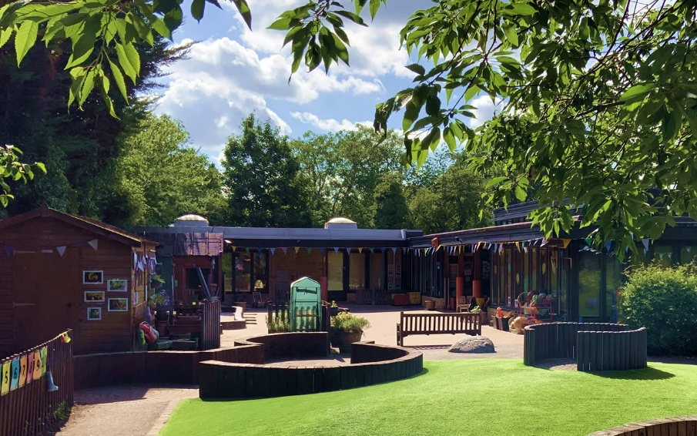
Letter from our Chair of Governors


Homerton Early Years Centre
Holbrook Road, Cambridge CB1 7ST

Tel: 01223 508766
email: office@homerton.cambs.sch.uk
website: www.homerton.cambs.sch.uk

December 2025
Dear Applicant

Thank you for your interest in the role of Headteacher at Homerton Early Years Centre.

We are looking for an excellent Early Years practitioner with senior leadership experience, who will enjoy working with governors and leading a strong staff team to achieve delivery and development of outstanding early years education and care, within and beyond the Centre.

We are seeking a leader with significant successful experience of Early Years Education who, like our staff and governors, is passionate about giving children the best start in life and supporting their families to achieve this. We need a team player with excellent interpersonal skills, to take the lead in determining the strategic direction of the Centre, with a forward thinking, creative approach to meeting the challenges presented by the current political and financial context.

We would love to meet you and do hope you will visit us before making your application. Do please get in touch to make arrangements.

We look forward to hearing from you and receiving your application. Please use the application form in the pack. A concise accompanying letter addressing the attributes identified in the Person Specification would also be welcome.

Best wishes

Professor Ken Ong, Chair of Governors

Letter from our current Head

Homerton Early Years Centre
Holbrook Road, Cambridge, CB1 7ST
Tel: 01223 508766
email: office@homerton.cambs.sch.uk
website: www.homerton.cambs.sch.uk

December 2025
Dear Applicant,

Thank you for your interest in Homerton Early Years Centre. I hope this application pack will give you an insight into our exceptional centre and inspire you to become part of Homerton’s journey in the future.

I will be retiring in August 2026. I have loved being a Headteacher at Homerton. My involvement with Homerton goes back to 2001 when my children attended the nursery school. I initially started as a volunteer in their classes, and then in 2005 I was first employed by Homerton as a teacher in our South Room class. I then became Assistant Head and then Head from 2017. Part of the role of Headteacher here is to be outward facing, working collaboratively with the other Local Nursery Schools, the Faculty of Education and our local Primary school cluster. Homerton has had very few Heads, once we come to Homerton we don’t want to leave! This is also true of the staff, some who have been with us for 21 years. This makes for a very stable Centre where quality has been built upon and new personnel quickly rise to the high level expectations of the staff, governors, families and community.

We have a playful curriculum, following the principles of the Early Years Foundation Stage. We celebrate every individual and work hard to ensure Homerton is a place in which everyone can enjoy, learn and develop. We work closely with parents and carers and are committed to making a difference for more vulnerable members of our community.

Homerton is a place where you can make a difference and I have found the job extremely rewarding and fulfilling. We have wonderful governors and staff who are dedicated to our strategic direction of retaining and building on Homerton as an outstanding Centre. I wish you the same fulfilment that I have had in leading such a wonderful team.

With Best Regards
Alex Pearson, Headteacher
Information about the Centre

Homerton Early Years Centre is an outstanding Nursery School and extended provision in Cambridge City. We aim to make children’s experiences of Homerton happy, exciting and full of playful discovery. All children are encouraged to be confident learners. Highly qualified and experienced practitioners guide them in making choices, developing their independence and expanding on their interests in the world around them. We provide stimulating environments and support children in developing curiosity, playfulness and a desire to learn. Children delight at meeting challenges and taking risks whilst benefiting from a safe, caring and secure environment.

Homerton Early Years Centre has always achieved Outstanding judgements from OFSTED. It has an exceptional reputation locally and nationally. We are fortunate to have such a high quality provision and therefore take this beyond Homerton’s walls to build quality for all.

‘Homerton Early Years Centre continues to be an outstanding school’.
OFSTED 2021

‘Children in this Nursery become enthusiastic learners within a vibrant
Community. From the start of the day, children are ready to learn’.
OFSTED 2021

‘Children take to opportunities they are given to connect to the
natural world. They learn to grow, look after and harvest their own
Vegetables in the school’s allotment’.
OFSTED 2021

‘Leaders have designed a curriculum that ensures all children will be
ready for fulltime school, regardless of their different starting points.’

OFSTED 2021

‘All staff share leaders’ high aspirations for the children in the community’
OFSTED 2021

Homerton Early Centre is committed to safeguarding and promoting the welfare of children, young people and vulnerable adults and expects all staff to share this commitment.

Our History
Homerton was originally a Nursery School built in 1942 in the grounds of Homerton College on Hills Road, with the intention of providing care for evacuee children and for training opportunities for Homerton students. It moved to its present site on Holbrook Road in 1968 and was extended to include a large multi-use community room in 1999. We are located in a quiet residential area in the City of Cambridge, just off Hills Road.
In recognition of our achievements as providers of quality early years education, the school was awarded Centre of Excellence status in 2003, and had an extensive building programme providing additional classroom and office space for our two year old ‘Nest’ provision. The outside area has been landscaped and includes improved facilities for children’s outdoor play.

Nursery School
The Nursery School is the foundation of Homerton. We offer 110 spaces across three classrooms with children accessing their 15 (or where applicable 30) hour entitlement, in mornings, afternoons, two and a half days/three days or full days Monday to Friday. Parents wishing to access greater hours can buy into our wrap-around-care and Holiday Club.
Children learn through play with planned experiences, including less common opportunities such as learning to grow vegetables in our nearby allotment and discovering how to make music from the skills of a specialist music teacher. We have large and well designed gardens, providing as much opportunity to learn outside as in the classrooms.
We follow the Early Years Foundation Stage curriculum and aim to develop each and every child’s full potential and build a firm foundation for life-long skills.

I couldn’t recommend Homerton highly enough. It is the most wonderful, happy and caring environment I could have wished for’ Parent comment OFSTED 2021

The Nest
In April 2012 we opened The Nest, our provision for 2 year olds. This enables children to be with us from 2 – 4 years old with the large majority accessing their 15 (or where applicable 30) free hour educational entitlement. Parents can buy into sessions in The Nest or take up the 15 hour free educational grant for 2 year olds. The Nest offers places for approximately 40 children across the week. It has a separate garden to the Nursery so that we can provide appropriate experiences for 2 year olds.

‘I cannot praise Homerton highly enough. They provide my child with a safe, reliable and enriching environment, more than fulfilling his every need, and enabling him to grow both physically and emotionally’. Parent Comment July 2025

Owlets and Holiday Club
We offer extended hours, ‘Owlets’ in addition to 15 or 30 hours free Nursery sessions per week. Owlets is run by Homerton staff, as is the Holiday Club. The Holiday club runs across half terms, a week at Easter and 3-4 weeks in the summer.

The vision for Owlets and Holiday Club is to provide a space for play, discovery and fun with the highest quality care where children progress at their own pace supported by highly experienced and qualified staff.

Training and Visitors
Long before we became a Teaching School we delivered training for local practitioners and nationally for Local authorities. Visitors come a few times a term to see the practice at Homerton. Our national reputation has largely come from the delivery of high-quality training and because of this we appear in practitioner training films and articles in educational magazines.

Supporting, educating and caring together
For babies and young children this is a unique and important time in their development and we consider it to be a privilege to share in this part of their lives.
Homerton Early Years Centre provides a welcoming environment with exciting and enriching experiences where every individual is valued and nurtured.
We are a thriving Centre in the heart of the community that pays the highest regard to the needs of young children and their families. We are a centre for learning, offering support and information.
We work in partnership with families and their babies and children, early years settings and their practitioners, childminders and nannies, agencies supporting families, further education, schools and advisers

OUR Aims AND VISION

Our Aims
Our Centre is a place where:
- families and individuals are supported to develop confidence, independence and self esteem
- relationships are built in an environment of understanding and respect
- we listen to everyone and explore ways to improve the lives of families in our community
- we prioritise those in greatest need
- we work in partnership with families to promote their children’s learning and development
- quality experiences are offered which involve exploration, investigation and creativity
- the environment is safe and caring so that children, families and staff can feel secure
- we develop a shared understanding of spiritual, social and cultural diversity
- we intervene to achieve better outcomes for all children and work to abolish prejudice.

Our Vision
Providing and sustaining a warm and welcoming atmosphere
From our front desk and seamlessly throughout our centre we create a warm, relaxed and motivating environment in which all are helped to feel welcome and belong.
Keeping safe
We have an ethos of emotional and physical safety that secures Homerton as a place where all can learn and develop. Everyone is valued and respected, with everyone’s concerns taken seriously.
Promoting and supporting the well-being of all
This is based on our shared belief that we all thrive and develop to our full potential with supportive relationships.
A rich, pleasurable and exciting environment
This makes for an invigorating place to work and play. Homerton is full of light and engaging resources that we use effectively to enrich children’s learning in imaginative ways. We work hard to ensure indoor and outdoor play are equally challenging and enjoyable environments in which to play and learn.
Early Years practice
We are proud of our Early Years knowledge and practice. We strongly believe in Homerton offering the best for young children’s development and their families through high quality staff and learning environments.
Everyone is treated equally
All children, families, carers, other professionals and staff are equally valued and important to us, irrespective of their gender, race, culture, religion, ability and age. We embrace diversity and take account of life differences to meet the needs of all.
Partnership with families
We value hearing how welcomed families feel, that they build relationships and trust with the staff. We recognise the importance of listening, are open to change and aim to meet families’ and children’s needs.
Learning community
At Homerton we all learn and continue to learn. Through a supportive and non-judgemental approach we are able to make mistakes safely and value learning through experience. Everyone has opportunities for professional development and to continue along their learning path.
Staff Teams
There are a number of teams within Homerton but none of these work in isolation. We are all part of the big Homerton team and proud of it! Our social events, and having time to listen to each other and being supportive of each other’s lives beyond the centre are a valued part of our life at Homerton. At Homerton we have both friends and an extended family. We value good communication, friendliness, honesty, respect and humour and aim to practise these by working hard at our relationships.
Parents, carers families and the community
Homerton takes a particular pride in its excellent relationships with parents, carers and the local community. Parents know their children best and working closely together helps us develop their children’s learning and match our planning closely to their children’s interests. The staff have a great deal of knowledge of child development and share this with parents supporting them in the pleasures and challenges of parenting.
Parents, Carers and the community can access our drop in Messy Play sessions on a Friday morning with younger children. For parents and carers of children in the Nursery and Nest we hold regular events throughout the year for parents and carers to join in with their children.

STAFF LIST SEPTEMBER 2025

Alex Pearson Headteacher and Head of Centre

South Room Red Class
Tamsin Fry Teacher
Laura Price Teaching Assistant L3
Aoife Cafferkey-Lindsay Teaching Assistant studying for L3
Bridget Cafferkey Nursery Nurse

West Room
Jacqui Sheppard Teacher
Dong Sun Teaching Assistant L3
Antonella Mazzucco 1:1 Teaching Assistant
Melody Wright Owlets Manager L3

East Room
Mitali Peckham Class Teacher
Debbie Stebbings Teaching Assistant L3
Hannah Keate Teaching Assistant L3
Sarah Williams Teaching Assistant L3 and Lunch Lead
Bernie Cafferkey Class Teacher/SENCO
Kate Daenke Teaching Assistant L3
Masami Rogers Teaching Assistant L3

Owlets
Melody Wright Owlets Manager L3
Chloe Lister Owlets Playworker
Bridget Cafferkey Nursery Nurse
Aoife Cafferkey Teaching Assistant
Alexandra Rolfe Owlets Playworker

The Nest
Michelle Cooper Nest Leader Teaching Assistant L3
Becky Dunn Teaching Assistant
Hyun Mi Lee Teaching Assistant L3
Natalie Kurklu Teaching Assistant L2
Maria Rolph Teaching Assistant L2
Katy Lai Teaching Assistant L3
Charley Kidman Teaching Assistant L3
Gemma Clark Teaching Assistant L2
Nicola Bond Playworker L3
Melody Wright Teaching Assistant L3 and Nest administrator

Office
Suzy Hughes Office and Finance Manager
Tracey Wheddon Clerical Assistant
Heather Owen Clerical Assistant
Rebecca Dalla-Libera Clerical Assistant
Helen Haughton Clerical Assistant
Lucy Kirby Finance Clerical Assistant

Lunchtime Team
Rebecca Dalla-Libera Lunchtime Supervisor
Alison Knights Lunchtime Supervisor
Julia Creed Lunchtime Supervisor
Sarah Williams Lunchtime Supervisor
Gemma Richards Lunchtime Supervisor
Bob Negus Lunchtime Supervisor
Zarlasht Sadat Lunchtime Supervisor
Jennifer Ference Lunchtime Supervisor
Kimberley Wright Lunchtime Supervisor
Liane Skeels Lunchtime Supervisor
Yang Yang Lunchtime Supervisor
Marlena Barrett Lunchtime Supervisor
Ning Zhang Lunchtime Supervisor
Georgia Lewis Lunchtime Supervisor
Clare Lewis Lunchtime Supervisor
Angela Bushell Caterer
Helen Haughton Assistant Caterer

Cleaning and Maintenance
Cleaners from Malco cleaning company
Bob Negus Caretaker

The Governing Body

Professor Ken Ong Chair of the Governing Body and Lead for Safeguarding and Child Protection
Mrs Tandy Harrison Deputy Chair of the Governing Body, Chair of the Curriculum Committee and Lead for Special Educational Needs and Disability/Use of Pupil Premium
Mrs Isa Garcia Deputy Chair of the Governing Body, Chair of the Resources Committee and Lead for Equal Opportunities/Monitoring Racial Incidents
Mrs Alex Pearson Headteacher
Miss Bernie Cafferkey Co-opted Governor
Dr Nelli Ferenczi-Houlden Parent Governor
Mr Sameer Garyali Co-opted Governor and Deputy Lead for Health and Safety
Dr Eirini Gkouskou Parent Governor
Mrs Elizabeth Head Co-opted Governor
Dr Amani Maihoub Parent Governor and Representative for the Nest and Owlets
Mr Mick Patel Co-opted Governor and Lead for Health and Safety
Dr Robin Payne Parent Governor and Deputy Lead for Special Educational Needs and Disability/Use of Pupil Premium
Mrs Mitali Peckham Co-opted Governor and Lead for Safer Recruitment
Dr Surabhi Singh Associate Member
Ms Ning Zhang Staff Governor
Mrs Gwyneth Barton Clerk to the Governors

Map and Parking

E-mail: office@homerton.cambs.sch.uk
Phone: 01223 508766
Post: Holbrook Road, Cambridge, CB1 7ST

Trains
We are 20 minutes walk, or 5 minutes by taxi, from Cambridge Train Station.

Roads
Take exit 11 of the M11 and head north towards Cambridge City. Turn right onto Long Road (A1134), then left onto Hills Road (A1307), and the first right onto Holbrook Road.

No Parking at the Centre
We have a small car park; you may need to park in front of another car and might be asked to move your car during your visit. Please be respectful to our neighbours and park on Holbrook Road only if there is a space that does not block entrances. There is some parking on Glebe Road. If you park half way down Glebe Road, you can take the footpath to Holbrook Road that runs through the allotments (next to House number 48). Bikes may be parked inside the Centre grounds.
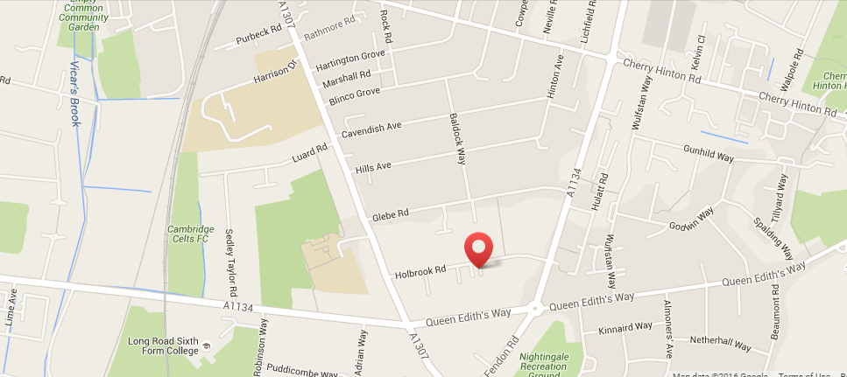

How to Apply

Closing Date: 9th January 2026
Interview Date: 20th January 2026
Start Date: September 2026

Please submit your completed application form via My New Term; CVs or other methods of application will not be accepted. References will be sought for shortlisted candidates prior to the interview date.

We highly recommend that you visit our school before applying. To arrange a visit, please contact our office on 01223 508766 or email: head@homerton.cambs.sch.uk.

