

Moat Farm Infant School
Catering Assistant
27.5 hrs per week
Recruitment Pack
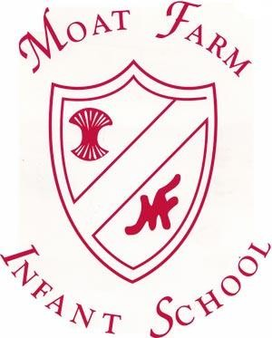



Moat Farm Infant School
CATERING ASSISTANT
27.5 hour per week, Term Time only (39 weeks a year)
Monday to Friday
9:00am to 2:30pm

Grade 2, SCP4 Hourly Rate £13.05
(Salary FTE £25,185– Actual £16,158)
(subject to annual NJC pay review)

Permanent Position

Moat Farm Infant School, a member of the Stour Vale Academy Trust, is seeking to appoint a Catering Assistant to join our dedicated team. The successful candidate will support the preparation and serving of meals, maintain high standards of hygiene and food safety, and help create a positive dining experience for our pupils. The role is available to start as soon as possible.

Stour Vale is committed to safeguarding and promoting the welfare of children and expects all staff and volunteers to share this commitment. We will carry out pre-appointment checks including DBS and will disqualify any applicant where we consider the outcomes to be unsatisfactory. This post is exempt from the Rehabilitation of Offenders Act (ROA) 1974.
We are equally committed to ensuring that no applicant will be disadvantaged or discriminated against because of their protected characteristics under the Equality Act 2010.
For informal talks and to arrange a visit to the school, please contact:
Neil Bradley
School Business Manager
0121 552 1885
neil.bradley@mfi.school

Please visit our website for further information: moatfarm-inf.sandwell.sch.uk

Closing date: 13th July 2026 @ 12 noon

Interview date: TBC

About Moat Farm Infant School


Welcome from the Head Teacher

Moat Farm Infant School is a four-form entry school which has 430 pupils on roll, with a School Nursery and Day Nursery housing children between the ages of 0 and 7. We are a member school of Stour Vale Academy Trust. Our school is situated on a pleasant site, surrounded by the playground, grassed areas and trees. The main school building was built in 1938, this part of school comprises of 9 classrooms for Key Stage 1 classes and a SEND hub classroom.

The children are grouped into classes according to their admittance years and all classes are named after British wildlife. There is also a separate EYFS building on site which comprises of four Reception classes and a Nursery class which offers provision to two, three and four-year-old children. We also offer the extended entitlement of 30 hours provision to eligible families.

At Moat Farm Infant School, we believe each child is a unique individual who has the potential to grow and learn. We believe that children are active, curious, intelligent and full members of society and it is our role to provide them with a caring, friendly, secure environment which is also challenging and stimulating where they can learn and grow in body, mind and spirit.

Our school motto is “At Moat Farm Infants everyday;

we learn, achieve, have fund and play!”

Our school has six core values that guides our thinking and behaviour. At Moat Farm Infant School, every child is valued for who they are an what they contribute to school. Our values are intended to support the personal, social and spiritual development of every pupil in school.

Collaboration, Respect, Creativity, Perseverance, Caring and Reflectiveness

Moat Farm Infant School serves an established community; many parents and grandparents of current pupils also attended the school. The pupils at Moat Farm Infant School demonstrate an eagerness to learn. They are very proud of their school and enjoy welcoming visitors. We have created a pleasant, modern learning and working environment for both pupils and staff. The school office is a central point for parents, pupils and staff. Enabling every member of the school community to achieve our school values to become successful learners, responsible citizens and resilient individuals is our mission that we are committed to.
Finally, I would like to thank you for your interest in the post of Cleaner at Moat farm Infant School and wish you the best of luck with your application.

ABOUT STOUR VALE ACADEMY TRUST

Our multi-academy trust was founded in 2017 and developed from collaboration between schools, the significant positive impact of which convinced three schools, two secondary and one primary, that together we would have much greater capacity to continuously improve. Over time, Stour Vale has steadily grown. We began as a cross-phase multi-academy trust and as we have grown, both secondary and primary schools have joined us. There are currently eleven member schools, five primary, one junior, one infant, one day Nursery and four secondaries.

As a successful family of schools, delivering high-quality education for the communities we serve, Stour Vale values its diversity. Each school brings their own distinct character, community, history and identity. We celebrate the uniqueness of member schools, recognising that there is a great deal to learn from education in different contexts. This is also the reason why we remain outward-looking, committed to learning from research and excellent practice across the education system.

Our vision and values

Stour Vale Academy Trust holds children and young people at the heart of all that we do. We recognise that as a multi-academy trust we exist in order to advance education for the public good. Our mission, therefore, is to improve life opportunities for children and young people by both providing the best possible education and care to pupils in Stour Vale member schools and by having a positive impact across the wider education system. Our values are encapsulated in four words:

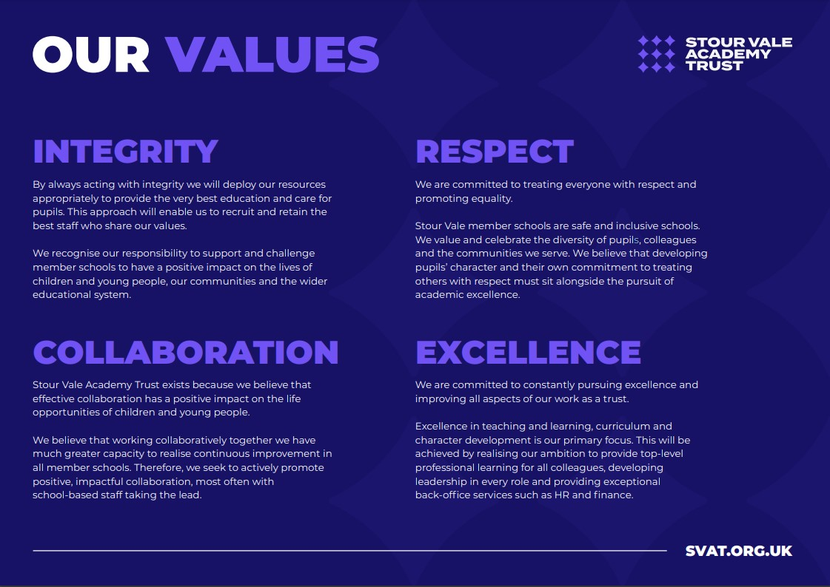

We describe our shared approach to school improvement as ‘secure autonomy’. Headteachers, with school leadership teams and staff, have autonomy to lead school improvement in their own schools, responsively and in collaboration with others within and beyond our trust.
We believe that this approach enables us to grow, attract and retain excellent school leaders and to develop the most innovative and impactful school improvement strategies.
We recognise that this autonomy must be secured within the structure of the multi-academy trust, and our model of challenge and support for impact, underpinned by our shared values, ensures sustained school improvement and a sharp focus on outcomes for pupils.
This in turn realises our ambition that Stour Vale member schools will create the difference together.



Job Description
Core Purpose:

- Assisting with the preparation and service of food and the cleaning of premises and equipment. This is a physical / manual role.

Legal and Statutory Requirements
The Catering Assistant’s professional duties must be carried out in accordance with the following:

- The Stour Vale Academy Trust scheme of delegation
- The provisions of all applicable legislation
- Keeping Children Safe in Education (KCSIE)
- The Funding Agreements of the Schools within the Trust and the Academies Financial Handbook
- Stour Vale Academy Trust’s internal financial controls and procedures

Main Activities

- Preparing and cooking of vegetables and preparation of salads.
- Assisting Cooks with preparation of main courses, sweets and sauces.
- Serving food in an efficient, friendly manner.
- Washing up kitchen equipment and tableware.
- Setting out and putting away dining furniture.
- Cleaning dining area and kitchen premises.
- Cleaning kitchen equipment.
- Cleaning outside kitchen area, including drains and dustbin area.
- Be aware of company procedures for food allergies and ensure dietary requirements are met.
- Complete kitchen documentation, e.g. cleaning schedules.

Hygiene and Safety
To be aware of the need for good hygiene practices and ensure high standards of:
- Personal hygiene
- Kitchen hygiene in the preparation and service of food.
- Cleanliness of equipment and premises.

Hours of Work
Hours and times of work may be varied at any time in accordance with meal numbers to meet the needs of the School.
Other
- Be aware of, and comply with, policies and procedures relating to safeguarding, child protection, health and safety, confidentiality and data protection, recording/ reporting all concerns to the appropriate person and disclosures to the relevant professional.
- Be aware of and support difference and ensure all pupils have equal access to opportunities to learn and develop;
- Contribute to the overall vision and values of Stour Vale Academy Trust;
- Attend and participate in meetings, training and other learning activities and performance development as required;
- Any other duties commensurate with the duties/responsibilities/grade of the post

Duties may vary according to the organisational structure within the school. The structure may include additional posts that are focused on either delivering or supporting the delivery of one or more of the responsibilities outlined above.

The duties above are neither exclusive nor exhaustive and the post holder may be required by the Headteacher/senior leader to carry out appropriate duties within the context of the job, skills and grade. It is the practice of Stour Vale Academy Trust to periodically review job descriptions to ensure that they relate to the job performed and to incorporate any changes. In these circumstances, Stour Vale Academy Trust will seek to reach agreement on reasonable changes but, where agreement is not reached, Stour Vale Academy Trust reserves the right to make changes to the job description, following consultation.

Stour Vale Academy Trust is committed to safeguarding and promoting the welfare of children and young people and expects all staff and volunteers to share in this commitment. As this post meets the requirements in respect of exempted questions under the Rehabilitation of Offenders Act 1974, all applicants who are offered employment will be subject to an Enhanced Disclosure and Barring Service Check (DBS) before the appointment is confirmed. This will include details of ALL cautions, reprimands or final warnings as well as convictions, whether “spent” or “unspent”. Criminal convictions will only be taken into account when they are relevant to the post.

Personal Specification
Job Title | Catering Assistant
Grade | Grade 2
Responsible to: | Catering Manager
Responsible for: | Not applicable
Working days / hours: | 38 working weeks during term time.  27.5 hours per week

No | Categories | Essential | Desirable
QUALIFICATIONS
1. | Must hold a valid Food Safety qualification or be willing to undertake training.
EXPERIENCE
2. | Experience of serving of food within a large catering operation (e.g. at a school, factory or large restaurant)
3. | Face to Face, experience of dealing with people
ABILITIES, SKILLS & KNOWLEDGE
4. | Basic food preparation skills.
5. | Able to use general catering equipment, safely and correctly
6. | Able to communicate at all levels verbally
7. | Able to work calmly and efficiently under pressure
PERSONAL QUALITIES
8. | Capable of moderate physical activity, i.e. lifting saucepans, standing for long periods of time.
9. | Able to apply and adhere to Health and Safety Hygiene Procedures.
10. | Capable and willing to work on own initiative.
11. | Willing and capable to be flexible and adjust to various workplaces duties and hours.
12. | Willing and able to undertake further training.
13. | Commitment to safeguarding and promoting the welfare of children and young people
14. | Genuine respect for others and desire for equality of opportunity and diversity
15. | Ability to work as part of a team understanding Trust roles and responsibilities and your own position within these
16. | Can-do attitude and solution-focused approach with an ability to manage expectations and not over promise
17. | Have a willingness to demonstrate commitment to the values and ethos of Stour Vale Academy Trust

