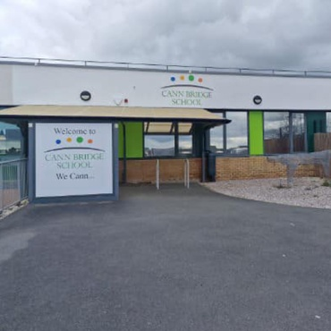

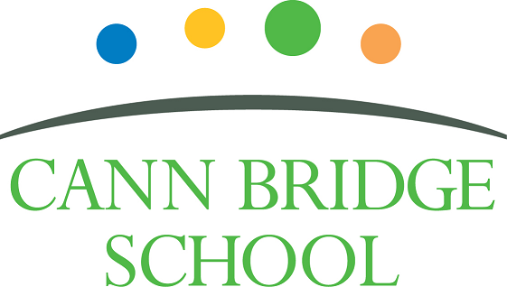

Class Teacher
Candidate Information Pack

April 2026

Welcome

Dear Prospective Candidate,

Thank you for your interest in joining our dedicated and compassionate team at Cann Bridge School. As Headteacher, I am delighted to introduce you to our school and to the exciting opportunities that await you here.

Cann Bridge School, located in Estover, Plymouth, is a local authority-maintained special school serving children and young people aged 3 to 19 from Plymouth, Devon, and Cornwall. With a capacity of 108 pupils, we are a consistently oversubscribed school, reflecting the high demand for our specialist provision.

Our school is uniquely designed to meet the needs of learners with complex cognition and learning difficulties. Every pupil has an Education, Health and Care Plan (EHCP) identifying either a Severe Learning Difficulty (SLD) or Profound and Multiple Learning Difficulty (PMLD). Many of our pupils also have additional needs linked to Down’s Syndrome, Autism Spectrum Condition, speech and language difficulties, physical disabilities, or complex medical conditions.

To learn more about life at Cann Bridge School and to stay up to date with our latest news, please visit:
- Website: www.cannbridgeschool.co.uk
- Facebook: www.facebook.com/cannbridgeschool
- School Newsletters: www.cannbridgeschool.co.uk/families/newsletters

At Cann Bridge School, we are committed to creating a nurturing and inclusive environment where every learner is supported to thrive. We are relentlessly learner-focused, and our mission is to deliver high-quality, individualised education that is carefully adapted to each child’s needs. Our dedicated staff foster a calm and purposeful atmosphere, delivering personalised learning through our Pathways to Independence curriculum.

With a proud history spanning more than 60 years—formerly as Downham School—Cann Bridge moved to its current purpose-built site in 2012. We are located on the Tor Bridge Partnership site with Tor Bridge High, Tor Bridge Primary, and Plym Bridge Nursery, offering opportunities for shared learning and community links. Since then, we have continued to grow: opening our Post-16 provision, Post Bridge College (2016); undertaking extensive remodelling (2022); and most recently adding two new modular classrooms (2024). Our excellent facilities include sensory rooms, an immersive room, a library, a warm water pool, a science garden, soft playroom, and a Forest School area. These resources are continually developed through fundraising and the support of our active PTFA, Friends of Cann Bridge.

We are also on an ambitious improvement journey, guided by our School Development Plan and recent Ofsted reports—both available on our website. Ofsted has recognised the significant and rapid improvements across the school, highlighting the strong foundations now in place for future success.

The role of a Class Teacher at Cann Bridge School is both challenging and immensely rewarding. You will have the opportunity to make a profound difference in the lives of our learners, helping them achieve their full potential and develop essential life skills. Our curriculum is designed to be flexible and responsive, addressing each learner’s individual strengths and needs. We are seeking a dynamic an aspirational Class Teacher who shares our commitment, vision, and values to the education of children and young people with SEND. Together, we prioritise meeting the unique needs of our learners, ensuring they are well-prepared for their futures.

If you are ready to make a meaningful contribution to our vibrant school community, we warmly encourage you to apply. We also welcome and encourage prospective candidates to visit us prior to applying—please contact the school to arrange a tour.


Thank you once again for your interest in the role of Class Teacher at Cann Bridge School. I look forward to receiving your application.

Warm regards,


Shane Baker
Headteacher

Our Vision & Values

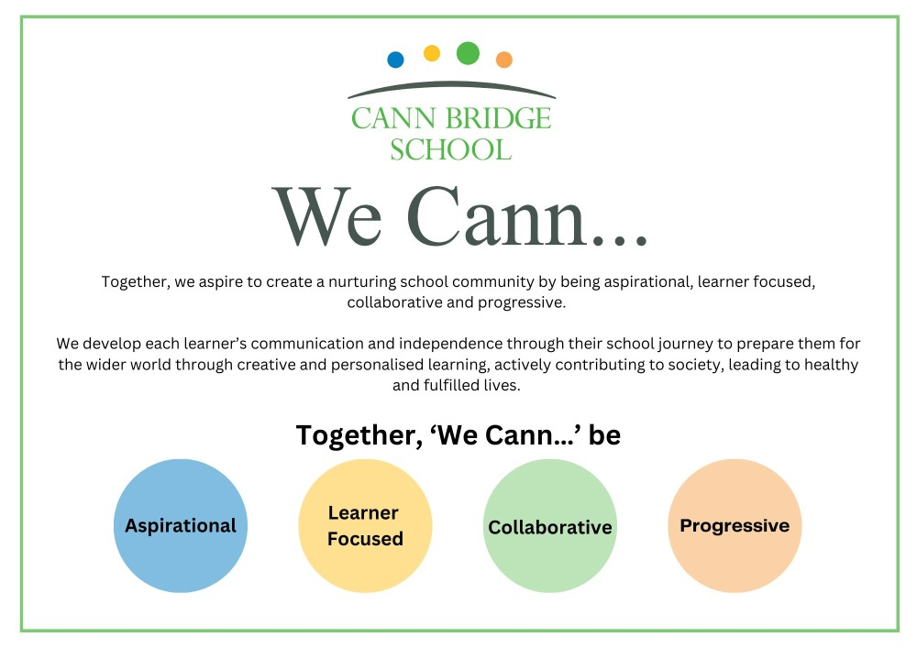

The Role

The role of a Class Teacher at Cann Bridge School is to deliver high-quality teaching and learning to learners with severe learning difficulties. This involves creating and implementing personalised lesson plans that address the unique needs of each learner, ensuring their educational, social, and emotional development. Teachers will work closely with a multidisciplinary team, including therapists and support staff, to provide a comprehensive learning experience that integrates Personalised Learning Goals with necessary therapeutic interventions. The aim is to help learners achieve their full potential and develop essential life skills in a supportive and nurturing environment.
In addition to classroom responsibilities, a Class Teacher at Cann Bridge School is expected to engage in ongoing professional development to stay current with best practices in special education. They will contribute to the continuous improvement of the school’s curriculum and participate in school-wide initiatives as outlined in the School Development Plan. The role requires a commitment to fostering a positive and inclusive school culture, collaborating with colleagues, and maintaining open communication with parents and carers to support each learner's progress and well-being.

Recruitment Timeline
We warmly encourage prospective candidates to visit Cann Bridge School to gain a real insight into our community, values, and vision.

- Opportunities to visit Cann Bridge School: Please contact the school to arrange your visit 01752 207909 or HR@cannbridge.co.uk
- Application closing date: 9am Monday 11th May
- Candidate shortlisting: Afternoon Monday 11th May
- Interviews: Monday 18th May

Please find a link to our school safeguarding page https://www.cannbridgeschool.co.uk/about-us/safeguarding
Our policies and staff code of conduct can be found here https://www.cannbridgeschool.co.uk/about-us/policies-procedures

Employee Benefits

At Cann Bridge School, we cultivate an environment where both learners and staff can thrive. Our learners benefit from a well-structured curriculum, a supportive staff team, and a purposeful learning environment, all designed to help them grow into confident, well-rounded, and independent young adults. This success is made possible by our talented and dedicated team, who work together to ensure that every child has the opportunity to succeed both academically and personally.

When you join Cann Bridge School, you’ll become part of a committed team that values your professional growth.

We offer:
- Bespoke Continuing Professional Development (CPD) tailored to your individual needs and career goals
- Specialist weekly and ongoing training and development to keep you at the forefront of best practices
- Clear Career Progression pathways, providing opportunities for long-term career growth
- Access to the Local Government Pension Scheme or Teacher Pension Scheme for future financial security
- An excellent Employee Assistance Programme, offering physiotherapy, counselling, wellbeing services, and private healthcare options (where applicable) through Education Mutual
- Staff Discounts on a wide range of products and services through the Blue Card and professional student discount scheme
- A comprehensive Staff Health & Wellbeing Offer
- Excellent internal and external communications to keep everyone informed about what is happening
- DSE Eyecare Scheme for those based 80% at a screen
- The opportunity to work with incredible children, young people, and a dedicated staff team

Guidance for Applicants

If, after reading the background information, you feel this is the right opportunity for you, please follow the guidance below to support your application:
- Read and follow the instructions on the application form carefully on MyNewTerm.
- Review both the Job Description and Person Specification thoroughly. If you do not meet the essential criteria outlined in the Person Specification, it is unlikely that you will be shortlisted.
- Use the Person Specification as a checklist to structure your supporting statement. We recommend addressing each point in order, providing clear evidence of your skills, knowledge and experience. Wherever possible, include relevant examples from your professional and personal life.
- Please note: providing false or misleading information at any stage of the recruitment process may result in disqualification or, if appointed, dismissal without notice.
- If you are shortlisted for interview, you will be asked to bring relevant documentation with you. Full details will be provided in your interview invitation letter.
- We warmly welcome visits to the school. Seeing our setting in action can help you decide whether Cann Bridge School is the right fit for you.

All applicants must complete the application form on MyNewTerm. We do not accept CVs or letters of application. Using a standard application form ensures a fair and consistent process for all candidates. The shortlisting panel receive all applications anonymised.

Please ensure all relevant sections of the application form are completed in full and provide as much detail as possible, as this will be used to determine whether you are shortlisted for interview.

Check the application deadline carefully. Late applications cannot be considered, and it is your responsibility to ensure your submission reaches us on time. Please note the closing date is for guidance only. Successful applicants will be invited to interview at the earliest available opportunity. Cann Bridge School reserves the right to close the vacancy early if a suitable candidate is found.

We look forward to receiving your application.

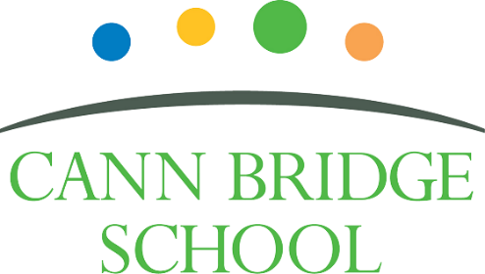

Job Description: Class Teacher

Cann Bridge School is committed to creating a diverse workforce. We’ll consider all qualified applicants for employment without regard to sex, race, religion, belief, sexual orientation, gender reassignment, pregnancy, maternity, age, disability, marriage, or civil partnership.

Job details
Position: Class Teacher
Location: Cann Bridge School, Estover, Plymouth
Salary: Main Pay Range 1 to 6 or Upper Pay Range 1 to 3, plus Special Educational Needs Allowance 1.
Contract type: Full-time, Part time, Permanent & Temporary.
Reporting to: Key Stage Lead and Senior Leadership Team
Responsible for: Class based support staff
Start Date: September 2026

Main purpose
The class teacher will:
- Deliver high-quality education to learners with severe learning difficulties (SLD).
- Create and implement personalised lesson plans addressing each learner's unique needs.
- Ensure the educational, social, and emotional development of learners.
- Collaborate with a multidisciplinary team, including therapists and support staff.
- Develop and manage a team of support staff to enhance teaching, learning, assessment and well-being.
- Integrate educational goals with necessary therapeutic interventions.
- Help learners achieve their full potential and develop essential life skills.
- Monitor and evaluate pupil progress through ongoing formative and summative assessments.
- Report to families and school leaders on learner progress and outcomes.
- Engage in ongoing professional development to stay current with best practices in special education.
- Contribute to the continuous improvement of the school’s curriculum by being an active member of a curriculum team.
- Participate in school-wide initiatives as outlined in the School Development Plan.
- Foster a positive and inclusive school culture, adopting and adhere to the school policies and procedures.
- Develop a high-quality total communication learning environment.
- Maintain open communication with parents and carers to support learner progress and well-being.
- Fulfil the professional responsibilities of a teacher, as set out in the School Teachers’ Pay and Conditions Document
- Meet the expectations set out in the Teachers’ Standards.

Duties and responsibilities
Teaching
- Plan and teach well-structured lessons to assigned class/es, following the school’s plans, curriculum and schemes of work
- Assess, monitor, record and report on the learning needs, progress and achievements of assigned learners, making accurate and productive use of assessment
- Adapt teaching to respond to the strengths and needs of learners
- Set high expectations which inspire, motivate and challenge learners
- Promote good progress and outcomes by learners
- Demonstrate good subject and curriculum knowledge

Whole-school organisation, strategy and development
- Contribute to the development, implementation and evaluation of the school’s policies, practices and procedures, so as to support the school’s vision and values
- Make a positive contribution to the wider life and ethos of the school
- Work with others on curriculum and learner development to secure co-ordinated outcomes

Health, safety and discipline
- Promote the safety and wellbeing of learners and staff
- Maintain good order and discipline among learners, managing behaviour effectively to ensure a good and safe learning environment
- Maintain and develop a learning environment in line with the school’s policies maintaining good housekeeping and health and safety expectations

Professional development
- Take part in the school’s appraisal procedures
- Take part in further training and development in order to improve own teaching
- Take part in the appraisal and professional development of others, where appropriate

Communication
- Communicate effectively with learners, parents and carers and staff
- Lead a weekly class meeting with own class team

Working with colleagues and other relevant professionals
- Collaborate and work with colleagues and other relevant professionals within and beyond the school
- Develop effective professional relationships with colleagues

Personal and professional conduct
- Uphold public trust in the profession and maintain high standards of ethics and behaviour, within and outside school
- Have proper and professional regard for the ethos, policies and practices of the school, and maintain high standards of attendance and punctuality
- Understand and act within the statutory frameworks setting out their professional duties and responsibilities

Management of staff and resources
- Direct and supervise support staff assigned to them, and where appropriate, other teachers
- Contribute to the recruitment and professional development of other teachers and support staff
- Deploy resources delegated to them

Safeguarding
- Work in line with statutory safeguarding guidance (e.g. Keeping Children Safe in Education, Prevent) and our safeguarding and child protection policies
- Work with the designated safeguarding lead (DSL) to promote the best interests of learners, including sharing concerns where necessary
- Promote the safeguarding of all learners in the school

Please note that this is illustrative of the general nature and level of responsibility of the role. It is not a comprehensive list of all tasks that the teacher will carry out. The postholder may be required to do other duties appropriate to the level of the role, as directed by the headteacher or line manager.

Person Specification: Class Teacher

Criteria | Qualities  Essential | Qualities  Desirable | Method of Assessment
Qualifications and training | - Qualified Teacher Status (QTS), Qualified Teacher Learning and Skills status (QTLS) or equivalent  - Relevant Degree | - Qualification in Special Educational Needs | Application form
Experience | - Successful teaching experience in a primary/secondary/special education setting.  - Proven experience working with learners with SEND  - Teaching, learning and assessment practices which demonstrate improved learner outcomes over time.  - Creating Individualised Education Plans (IEPs) (known as Personalised Learning Goals at Cann Bridge School).  - Adapting teaching methods and resources to meet the needs of diverse learners.  - Implementing positive behaviour management strategies consistently in line with schools’ policies and procedures. | - Demonstrable evidence of raising the standards of teaching, learning and assessment  - Experience of leading subject/curriculum development across a whole school  - Experience of teaching children and young people with severe learning difficulties  - Effective collaboration with external agencies  - Experience of using systems such as Bromcom, CPOMS, Evisense, Connecting Steps/B Squared, Immersive Studio, National College, Evolve and Microsoft applications. | Application form  Interview process
Skills & Knowledge | - Knowledge of effective teaching and learning strategies  - A good understanding of how children learn  - Excellent communication skills, both verbal and written, with the ability to engage effectively with learners, families, and colleagues.  - Ability to build effective professional working relationships  - Able to use technology systems integrally to monitor and support the raising of learner achievement  - Good understanding of safeguarding and child protection  - Knowledge of effective positive behaviour support strategies  - Good ICT skills, particularly using ICT to support learning  - Knowledge of Keeping Children Safe in Education (KSCiE) and Prevent  - Knowledge of the National Curriculum | - Leading support staff appraisal processes  - Good understanding of the Education, Health, and Care Plan (EHCP) and how these can be used to personalise learning.  - Experience and/or knowledge of CPI Safety Intervention or similar i.e. Team Teach.  - Experience and/or knowledge trauma informed practice/schools.  - Experience and/or knowledge SoSAFE!  - Demonstratable knowledge of current research-based teaching principles and strategies i.e EEF and Rosenshine Principles  - Knowledge and understanding of the Preparation for adulthood agenda  - Experience of assessing learners using the Engagement Model | Application form  Interview process
Personal qualities | - A commitment to getting the best outcomes for all learners and promoting the ethos and values of the school  - High expectations for children’s attainment and progress, improving outcomes for children with SEND.  - Ability to work under pressure and prioritise effectively, ensuring a work-life balance  - Commitment to maintaining confidentiality at all times  - Commitment to safeguarding and equality and diversity, ensuring that personal beliefs are not expressed in ways that exploit the position  - Empathetic and patient, with a strong understanding of the challenges faced by learners with special needs.  - Motivated, with a positive attitude and the ability to inspire and engage learners.  - Able to work collaboratively and build effective teams with good presence  - Strong personal integrity, honesty, dedication, reliability, and resilience  - Demonstrate initiative in solving problems  - Good organisational skills  - Maintain and promote the expected professional standards of self and others (Teachers’ Standards)  - Aware of own strengths and areas for development with a commitment to own professional development. | - Able to manage and resolve conflict | Application form  Interview process

This job description may be amended at any time in consultation with the postholder.

Last review date: November 2024

Line manager’s signature: _______________________________________
Date: _______________________________________

Postholder’s signature: _______________________________________
Date: _______________________________________

