


JOB PROFILE
Job Title: | Cover Supervisor | School/Department: | Temple Moor High School and Sixth Form
Salary Grade: | C3  Actual salary: £10,761 - £11,311 per annum  Full-Time/Full Year Equivalent: £32,061 - £33,699 | Working Hours: | 14.5 hours per week  Term-Time Only + 5 training days (39 weeks)
Contract Type: | Fixed Term | Location: | Leeds
Responsible to: Cover Manager and Leader/s of Department

Role summary:
To work under the guidance of teaching/senior staff and within an agreed system of supervision, to implement agreed work programmes with individual groups, in or out of the classroom. This role will provide short-term cover for absent teaching staff, allocating pre-prepared work, keeping pupils on task and positively managing the behaviour of pupils during class. Cover supervisors will need to respond to questions and generally assist students to undertake set activities. This role will also provide administrative support to faculties, where required, when not required for cover supervision. Marking and assessment activities are limited to those where answers are predetermined, and no element of professional judgement is required.
Red Kite Learning Trust is committed to safeguarding and promoting the welfare of students and expects all colleagues and volunteers to share this commitment.
Special conditions of service:
No smoking policy, including e-cigarettes.
Role Specific Responsibilities:
- To use specialist (curriculum/learning) knowledge, skills, training and experience to support students’ learning.
- To establish productive working relationships with students, acting as a role model and setting high expectations.
- To promote the inclusion and acceptance of all students within the classroom, including by implementing actions on SEND plans and passports.
- To support students consistently whilst recognising and responding to their individual needs.
- To encourage students to interact and work co-operatively with others and engage all students in activities.
- To implement consistently the school’s ‘Behaviour for Learning’ system.
- To provide feedback to students in relation to progress and achievement within the classroom.
- To work with the teacher to establish an appropriate learning environment.
- To work with the teacher in lesson planning, evaluating and adjusting lessons/work plans as appropriate.
- To monitor and evaluate students’ responses to learning activities.
- To provide objective and accurate feedback and reports to the teacher, as required, on student achievement, progress and other matters, ensuring the availability of appropriate evidence.
- To be responsible for keeping and updating records, as agreed with the teacher, contributing to reviews of systems/records as requested.
- To promote positive values, attitudes and good student behaviour, dealing promptly with conflict and incidents in line with established policy and encourage students to take responsibility for their own behaviour.
- To have high standards and expectations of yourself and young people to ensure that learning is purposeful.
- To follow the school’s policy in relation to working with young people.
- To liaise sensitively and effectively with parents/carers, as agreed with the teacher, within your role/responsibility and participate in feedback sessions/meetings with parents with, or as directed by the teacher.
- To administer and assess routine tests which have predetermined answers and involve no element of professional judgement or assessment. Accurately recording of achievement/progress.
- To provide general clerical administrative support for departments e.g. admin relating to the planning of enrichment activities, processing of assessment data, the administration of speaking and written assessments, production of worksheets for agreed activities, maintenance of spreadsheets etc.
- To implement agreed learning activities/programmes, adjusting activities according to student response/needs.
- To implement local and national learning strategies e.g. literacy, KS3 and make effective use of opportunities provided by other learning activities to support the development of relevant skills.
- To support the use of ICT in learning activities and develop students’ competence and independence in its use.
- To determine the need for, prepare and maintain general and specialist equipment and resources.
- To help students to access learning activities through specialist support.
- To be aware and comply with policies and procedures relating to child protection, health, safety and security, confidentiality and data protection (GDPR), reporting safeguarding concerns to an appropriate person.
- To be aware of, and support differences, and ensure all students have equal access to opportunities to learn and develop.
- To contribute to the overall ethos/work/aims of the school.
- To establish constructive relationships and communicate with other agencies/professionals in liaison with the teacher, to support achievement and progress of students.
- To provide appropriate guidance and supervision and assist in the training and development of staff as appropriate.
- To recognise own strengths and areas of expertise and use these to advise and support others.
- To attend and participate in regular meetings, training and other learning activities as required.
- To supervise students on visits, trips and out of school hours learning activities which fall within the remit and hours of the post, as required.
- To undertake supervision of students’ out of hours learning activities, which fall within the remit and hours of the post.
- To take part in the Performance Appraisal process employed at the school.
- To engage fully in professional development that is relevant to the role.
- To follow and implement school policies, in full.

RK People responsibilities:
- Contribute to the overall aims and values of our Trust, appreciate and support the roles of other members of the wider team and attend and participate in relevant meetings as required.
- Comply with all Trust policies and procedures including child protection, health, safety, welfare, security, confidentiality and data protection, reporting any concerns to the appropriate person.
- Contribute to ensuring safeguarding procedures are in place and used effectively at all times.
The role holder must demonstrate a flexible approach to the delivery of the role. Consequently, the role holder may be required to perform work not specifically identified in the job profile, but which is in line with the general scope, grade and responsibilities of the role.

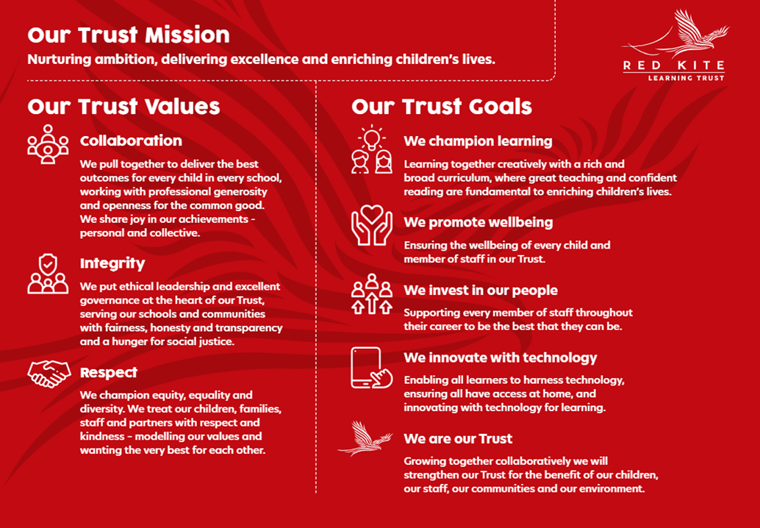
PEOPLE PROFILE
Aptitudes and Characteristics | Essential | Desirable
Commitment to raising levels of achievement for all students | 
Commitment to equality of opportunity
Commitment to the safeguarding of our students
Organised, ability to work under pressure and meet deadlines
Committed to continuing professional development
Committed to promotion of fundamental British values
Qualifications, Knowledge and Experience | Essential | Desirable
Experience of working with young people and developing them
GCSE level of education
A good level of appropriate ICT skills, and well-developed literacy and numeracy skills
Ability to relate well to children and adults, and build positive relationships
High expectations and standards
Classroom experience
Experience of working with pupils within an agreed behaviour management policy
Experience of working with other adults in lesson planning
Ability to monitor and evaluate pupil responses to learning activities
Equivalent to NVQ 3
Safeguarding and Promoting the Welfare of Students | Essential | Desirable
An appropriate motivation to work with children and young people
Ability to maintain appropriate relationships and personal boundaries with children and young people
Emotional resilience in working with challenging behaviours and appropriate attitudes to the use of authority and maintaining discipline

