i


Lead SEND TA
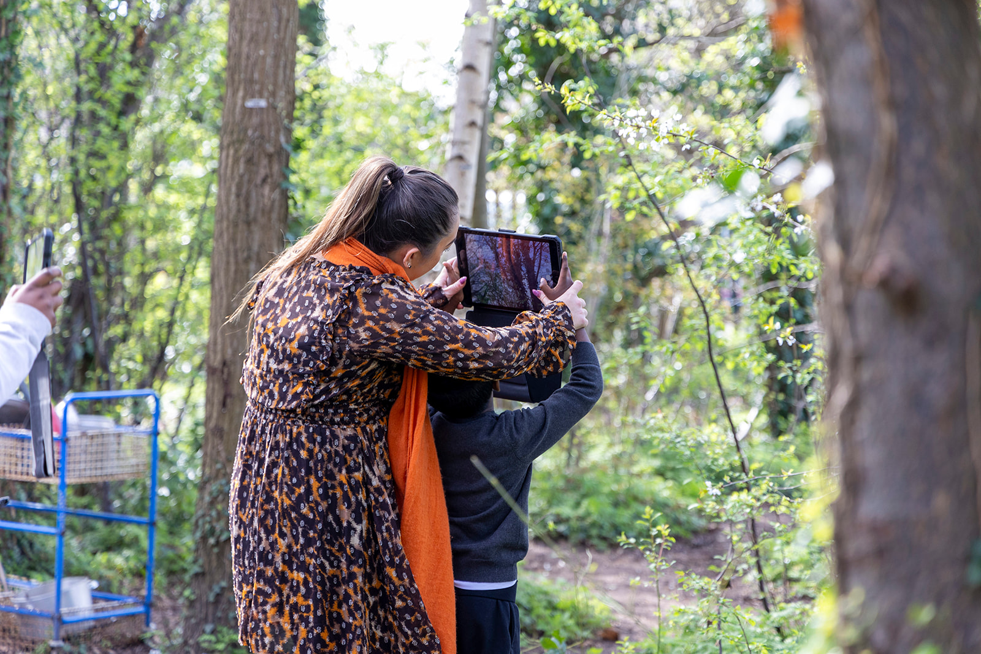
Applicant Information Pack



Dear Applicant,
Welcome from the CEO
Thank you for expressing an interest in this role at Woodland Academy Trust. Woodland Academy Trust is a small but ambitious Trust that puts the children and community first. We are on an exciting journey to achieve the best possible outcomes and excellence for all.
To support us on our journey, we are welcoming applications from skilled and committed applicants who have vision, drive and ambition and would be keen to hear about your experiences and what skills you can bring to this role. We seek to attract staff who have a growth mindset, strong values and work ethic and care deeply about serving communities.

This is an exciting time to join Woodland Academy Trust as we further strengthen our school improvement offer across the Trust. You will benefit from working with a strong team, receive the very best professional development and have the opportunity to make a real difference to the daily learning experiences of our wonderful children.
We look forward to your application.
Yours faithfully,
Nav Sanghara, Trust Leader (CEO)
About our Trust

The Woodland Academy Trust was formed in September 2011 and currently consists of five primary schools, four of which are located in the London Borough of Bexley and one in Kent.

All our schools share the same mission; ignite the spark, reveal the champion. We are an inclusive and ambitious Trust, striving to achieve the best possible outcomes for our children. Our aim is to provide the highest quality learning experiences for every child by creating an ethical culture of empowerment and growth for all. We believe deeply in the importance of nurturing strong partnerships with our local communities and beyond.

Discover more about the Woodland Academy Trust by watching our video here
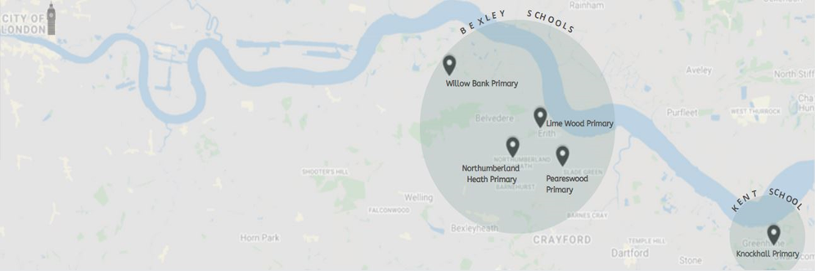

Welcome for the Headteacher
Thank you for your interest in joining our team at Knockhall Primary School.

At Knockhall Primary, we believe in fostering a community where kindness is at the core of everything we do. Our school is not just a place for academic growth; it is a place where we nurture compassion, empathy, and understanding. We are committed to creating an environment where every individual feels valued and respected.
Inclusion is a cornerstone of our educational philosophy. We celebrate the uniqueness of each student, recognising that our differences make us stronger as a community. Here, diversity is not just accepted; it is embraced. We strive to create a learning space where everyone feels seen, heard, and appreciated.
Our school is more than just a building; it is a community of learners, educators, and families working together towards a common goal – the success and well-being of our students. As we embark on this academic journey together, let us build bonds that go beyond the classroom. Let us create a sense of belonging that extends to every corner of our school.
I invite you to join us in cultivating a culture of kindness, promoting inclusion, and building a strong sense of community. Together, we can make Knockhall Primary School a place where everyone feels welcome, supported, and inspired to reach their full potential.
If you would like to find out more, or arrange a visit, please do not hesitate to get in touch. We’d love to hear from you.

Miss Yiannadji, Headteacher

About Our School
Knockhall Primary School is situated at the heart of the community in Greenhithe, Kent. While traditionally a two-form entry school, some of our year groups have now expanded to three-form entry to accommodate our increasing number of pupils.
It has recently had a brand-new build for the Early Years and Foundation stage children in addition to a recent extension for key stage 2.
We want to capture the minds of our learners by creating an inspirational curriculum that adults enjoy delivering. We always strive to improve on our outcomes to ensure or children get the very best from their time with us. More than anything however, we do this as peers, supporting each other along the way with a focus on our core purpose.
We are committed to our school values which are:
Teamwork-We work together as a team to help each other to achieve our goals by sharing
ideas and helping one another.
Respect- We are kind and polite to everyone, listening to others, and treating each other the
way we want to be treated.
Honesty- We always tell the truth and are truthful in what we say and do.
Pride- We accomplish great things and the efforts we make in school help us to feel happy.

Embedding these values into everything we do enables our pupils to go on and have successful
life experiences.

Discover more about us by watching our video! Click here- Welcome to Knockhall Primary.

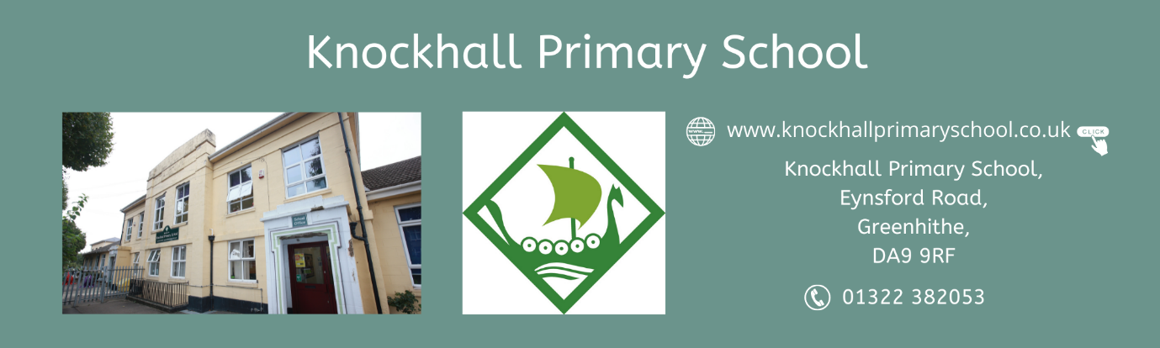

The Vacancy

Job title: Lead SEND TA
Status: Permanent
Hours: 36 hours
Working weeks per year: 39 weeks per year
Grade: KSD 1-3 (£26,393-£27,713, pro rata £22,185-£23,295)
Post Start Date: ASAP
Closing Date for Applications: 31st December 2025

Are you passionate about making a difference in children’s lives? Do you have the empathy, resilience and commitment to help every pupil reach their potential? If so, Knockhall Primary School would love to hear from you.
We are seeking to appoint a compassionate, proactive and inclusive Lead SEND TA to join our dedicated inclusion team. This role plays a vital part in supporting children to overcome barriers to learning and thrive – both in and out of the classroom.
This is a fantastic opportunity to join us as we continue to develop our inclusive dedicated staff team. The purpose of this role will be to support key children linked to high need funding or with an EHCP or an ILP. The role is varied and will change depending on the needs of our children. You may spend time in our NEST provision overseeing the team and implementing a bespoke curriculum for the children, you may also be based in the classroom, providing support to groups of children as well as 1:1 support for individuals.
No day is ever the same in this role and we are looking for adaptable and flexible individuals who thrive in an environment with changing priorities.

Your job role will include:
- Working in a team lead by the Deputy Head for Inclusion to deliver excellent support with teaching and learning.
- Working with children on a 1:1 or group basis.
- Accompanying groups on trips.
- Supporting assessment and evidencing learning.
- Working with teachers to create stimulating classroom displays and learning resources.
- Maintaining a safe and positive environment for all children.
- Creating opportunities for all children to reach their potential, irrespective of ability.
- Supporting a child/children with special educational needs, however the role will vary from day to day, you will be expected to use your initiative and respond calmly in challenging situations.
- Giving the opportunity to make a huge social impact, changing the path of a child’s life.

What you will need to succeed:
- A relevant supporting teaching and learning in schools’ qualification.
- A qualification specific to early years would be an advantage.
- A passion for working with young people who require additional support in order to access education and social development.
- Must have previous experience in supporting children with SEND, specifically in ASD/SEMH interventions, i.e., with sensory circuits, speech and language etc.
- Be a proactive and positive person who is always striving to meet children’s learning needs.
- Contribute to whole-school SEND initiatives and help embed a culture of positive behaviour and inclusion
- Have excellent communication and organisational skills, with the ability to remain calm under pressure
- Have the ability to build a rapport with children.
- A commitment to the happiness, well-being, self-esteem and progress of everyone at the school.
We welcome applications from candidates with a relevant Level 3 qualification and a genuine passion for improving the lives of children. Experience of safeguarding responsibilities, play therapy or mentoring is also desirable.
Candidates should refer to the job description/person specification and explain within their expression of interest how they meet the criteria, whilst also describing what they will bring to the post from their own knowledge and experience.
We reserve the right to close this vacancy early should a suitable candidate be found; therefore, early application is encouraged.
Join us and help ignite the spark, reveal the champion.

Applications
Please apply by visiting our school website vacancies page at: Knockhall Primary School Vacancies

Or if you would prefer to complete a word application form, please contact the school via email at: sbmkhp@watschools.org.uk

Application Deadline: 31st December 2025
Interviews: To be arranged

Visits to the school are welcomed and can be organised by contacting the school at sbmkhp@watschools.org.uk
For more information about our school please visit: Knockhall Primary School website

Diversity & Inclusion

We strive to achieve a diverse workforce, fully representative of our diverse society and the ethnic make-up of the pupil population in the UK. People of colour are currently under-represented on our staff teams. We are keen to attract applications from a diverse pool of candidates and determined to be a fully inclusive employer, and a great workplace for people of ethnic minority heritage as well as white heritage.

Our Offer
Woodland Academy Trust seek to appoint colleagues who share in our values and mission to ignite the spark and reveal the champion. We recognise that in order to offer the best outcomes for our children, our staff teams need the opportunity to be the very best they can be too. We do this by ensuring we have in place for all staff:
- Continuous professional learning focusing on core areas;
- Working collaboratively with agencies around us and offering formal training opportunities, bespoke and targeted professional development as well as in-house, bespoke training from our many experts and coaching and mentoring;
- Embedding initiatives to support with reducing teacher workload;
- A strong supportive ethos with dedicated line management structures and clear communication channels;
- Well-being assistance and support including a dedicated employee assistance helpline and occupational health;
- Opportunities to take part in exciting initiatives and projects that help shape the way our children will learn in the future;
- Wide range of family friendly policies in place for staff;
- Recognising national terms and conditions for staff;
- Teachers and Local Government pension schemes;
- Cycle to work schemes.

Safeguarding Children and Young People

Woodland Academy Trust is committed to safeguarding and promoting the welfare of children and young people. All staff and volunteers are therefore expected to behave in such a way that supports this commitment. Appointment to this post will be subject to the following satisfactory pre-employment checks:
- Health
- Identity
- Relevant work qualifications
- Right to work in the UK
- Barred List Check (previously List 99)
- Disclosure & Barring Service Check (for all staff and volunteers)
- References
We are committed to ensuring a positive work environment and selecting candidates who align with our values and culture. As part of our thorough recruitment process, in accordance with DfE Keeping Children Safe in Education 2023, an online search will be completed on all shortlisted applicants prior to interview. Any relevant information will be discussed further with the applicant during the recruitment process.
Any information we come across will be handled confidentially and considered in a professional manner. Our aim is to better understand your qualifications and suitability for the role. If you have any concerns or questions about this process, please contact us for more information.

Knockhall Primary
Teamwork Respect Honesty Pride



JOB TITLE  JOB DESCRIPTION AND PERSON SPECIFICATION | Lead SEND TA
RESPONSIBLE TO | Inclusion Lead
GRADE | KSD 1-3
HOURS | 36 hours per week / 39 weeks per year
ALL STAFF RESPONSIBILITIES | - To live our Trust values, demonstrating ambition, collaboration, compassion, excellence, and inclusivity in your everyday work life.  - To value professional development and welcome any training opportunities to develop personal skills and knowledge  - To agree to follow the school and Trust’s policies and procedures  - Be aware of and comply with policies and procedures relating to child protection, health, safety and security, confidentiality, and data protection, reporting all concerns to an appropriate person.
MAIN PURPOSE OF THE ROLE | - To work under the instruction and guidance of senior leaders to undertake work, care and support programmes which enable access to learning for all pupils including those with special needs including SEMH.  - To assist the senior leaders in the management of pupils, the classroom and break times within all areas of the school.
Duties & Responsibilities | Support the Senior Leadership Team in:  - Demonstrating the vision and values of the school in everyday work and practice  - Motivating and working with others to create a shared culture and positive climate  - Carry out pupil supervision duties before or after the day and at break and lunchtimes.  - To participate in a programme of self / professional development to ensure skills, knowledge and understanding are added to and kept up to date.  - To carry out any other general office duties consistent with the grade of the post that may be required from time to time.  General  - Assist senior leaders and teachers in ensuring all pupils’ continuing educational development through structured and agreed learning activities/teaching programmes including activities identified in Education and Health Care Plans.  - Assist teachers in fostering attractive learning environments to ensure that pupils spend their school life in stimulating surroundings.  - Prepare, maintain, and use equipment and resources required to meet lesson plans and activities, assisting pupils in use.  - Administer routine tests, invigilate exams, and undertake routine marking of pupil’s work.  - Supervise and assist with any toileting/medical needs as required.  - Promote good pupil behaviour inside and outside the classroom, dealing promptly with conflict and incidents in line with established policy and encourage pupils to take responsibility for their own behaviour.  - Establish constructive relationships with parent/carers.  - Develop pupils’ competence in independently using of IT in learning activities.  - Work within predetermined guidance, policies, procedures, and teachers’ guidance.  - Accompany teaching staff and pupils on visits, trips and out of school activities as required and take responsibility for a group under the supervision of the teacher.  - Attend weekly meetings and discussions, which contribute to the overall ethos/work/aims of the school.  - Be aware of and support difference and ensure all pupils have equal access to opportunities to learn and develop.  - Use initiative and common sense and be assertive and consistent in any contact with pupils in order to achieve the level of discipline required to maintain order.  - Any other reasonable activity as directed by the line manager/Headteacher.  - Contribute to the overall ethos/work/aims of the school.  - Support the delivery of the graduated approach (Assess–Plan–Do–Review) including recording outcomes for EHCP targets and Support pupils’ use of assistive technologies in line with individual needs.  Inclusion  - With teaching and associate staff, participate in the comprehensive assessment of children selected by the appropriate senior leaders to identify those who need extra help to overcome the barriers to learning inside and outside school.  - Work with senior leaders to support and implement strategies and practices that ensure an effective link between the well-being of pupils and their academic progress. This may include liaising with Learning Mentors across the Trust to ensure that specialist provision is also offered e.g., Play Therapy, Social Skills groups and nurture provision etc.,  - Deliver and implement a bespoke curriculum for those children who attend NEST provision.  - Support the NEST team and wider support staff with the implementation of specialist interventions such as Attention Bucket, PECs etc  Pupil Coaching and Mentoring  - Develop a 1:1 mentoring relationship and individual programme for children identified as needing particular support to achieve the goals defined in the action plan and to help them learn more effectively.  - Support programmes for small groups of children that take place in the school day, at play times, lunch times and after school to help children learn more effectively.  - Keep detailed records to monitor and chart the progress of pupils with whom you are working. This includes group working or working with individuals to encompass positive behaviour management where applicable.  - Monitor, evaluate, review and report on the effectiveness of plans and activities undertaken with individuals and small groups of children.  - Gather data and provide statistical and narrative progress reports as required.  - Maintain regular contact with families/carers of children in need of extra support, to keep them informed of the child’s needs and progress, and to secure positive family support and involvement.  - Supervise and support pupils, including those with high needs, ensuring their safety and encouraging interaction and engagement in activities led by the teacher.  - Promote the speedy and effective transfer of pupil information from pre-school settings, primary schools, secondary schools and also within school, and to ensure that arrangements for those moving schools or other settings is managed effectively.  - Support the development of appropriate “exit” and “entry” strategies for pupils and their families to support their move to another school, or their move into the school.  - Take an active role in supporting the work of partners and other agencies, so that the mentor’s work meets the need of the child in a focused and integrated way e.g., CAFs, PSPs, Nurture Groups, CP Conferences, etc.  - Operate within the agreed legal and ethical boundaries when working with children and young people and to support the well-being of the young people within our school.  - Influencing parents/carers, e.g., parenting classes leading to a change in behaviour, delivering workshops for parents/carers.

Person Specification
 | Essential | Desirable
Education, Qualifications and Training | - Good numeracy/literacy skills demonstrated through at least the level of GCSE point 9-1 or equivalent.  - Level 3 qualification relevant to the field | - Evidence of further or continued professional development  - Safeguarding Training  - Training in the relevant learning strategies, e.g. literacy.  - Recent qualifications in relation to the provision of specialist support  - First Aid Training as appropriate.
Experience | - Experience of working with children, young people, parents/carers, and families, preferably within an educational context  - Previous experience in supporting children with SEND, specifically in ASD/SEMH interventions, i.e., with sensory circuits, speech and language etc.  - Experience of a safeguarding role in relation to young people. | - Experience of mentoring/ play therapy  - Experience of managing staff  - Experience of liaising and building relations with internal and external partners in a school environment
Knowledge and Skills | - Ability to prioritise work and deliver deadlines  - ICT Skills including word processing and excel  - Excellent communication negotiating and skills to support with restorative conversations.  - Good organisational skills, ability to show initiative and to pay close attention to detail  - Good interpersonal skills  - Flexibility  - Ability to remain calm under pressure with excellent problem-solving skills  - Ability to demonstrate a good level of oral and written communication skills, with strong attention to detail  - Understanding of the barriers to achievement and wellbeing as well as safeguarding and promotion of the welfare of children  - Knowledge of Equality and Diversity and an understanding of issues faced by vulnerable families.  - Willingness to learn and develop new skills  - Ability to work with children in a variety of settings including one to one work.  - Knowledge of the basic routines and structures of a school.  - Knowledge of the SEND Code of Practice.
Personal  Qualities | - Considerable personal enthusiasm with a high level of integrity and professionalism  - Resilience – underpinned by good personal administrative and time management skills – the ability to work to deadlines and ensure completion  - Operate with a consistent and clear set of moral values that are compatible with the mission and values of the Trust  - Commitment to the highest standards of child protection  - Ability to work constructively as part of a team.  - A desire to work with young people to help them achieve their best in school.

?": "

Knockhall Primary School,
Eynsford Road,
Greenhithe,
DA9 9RF
01322 382053

www.knockhallprimaryschool.co.uk

Ignite the spark,
reveal the champion







