
Job Title: Head of Year

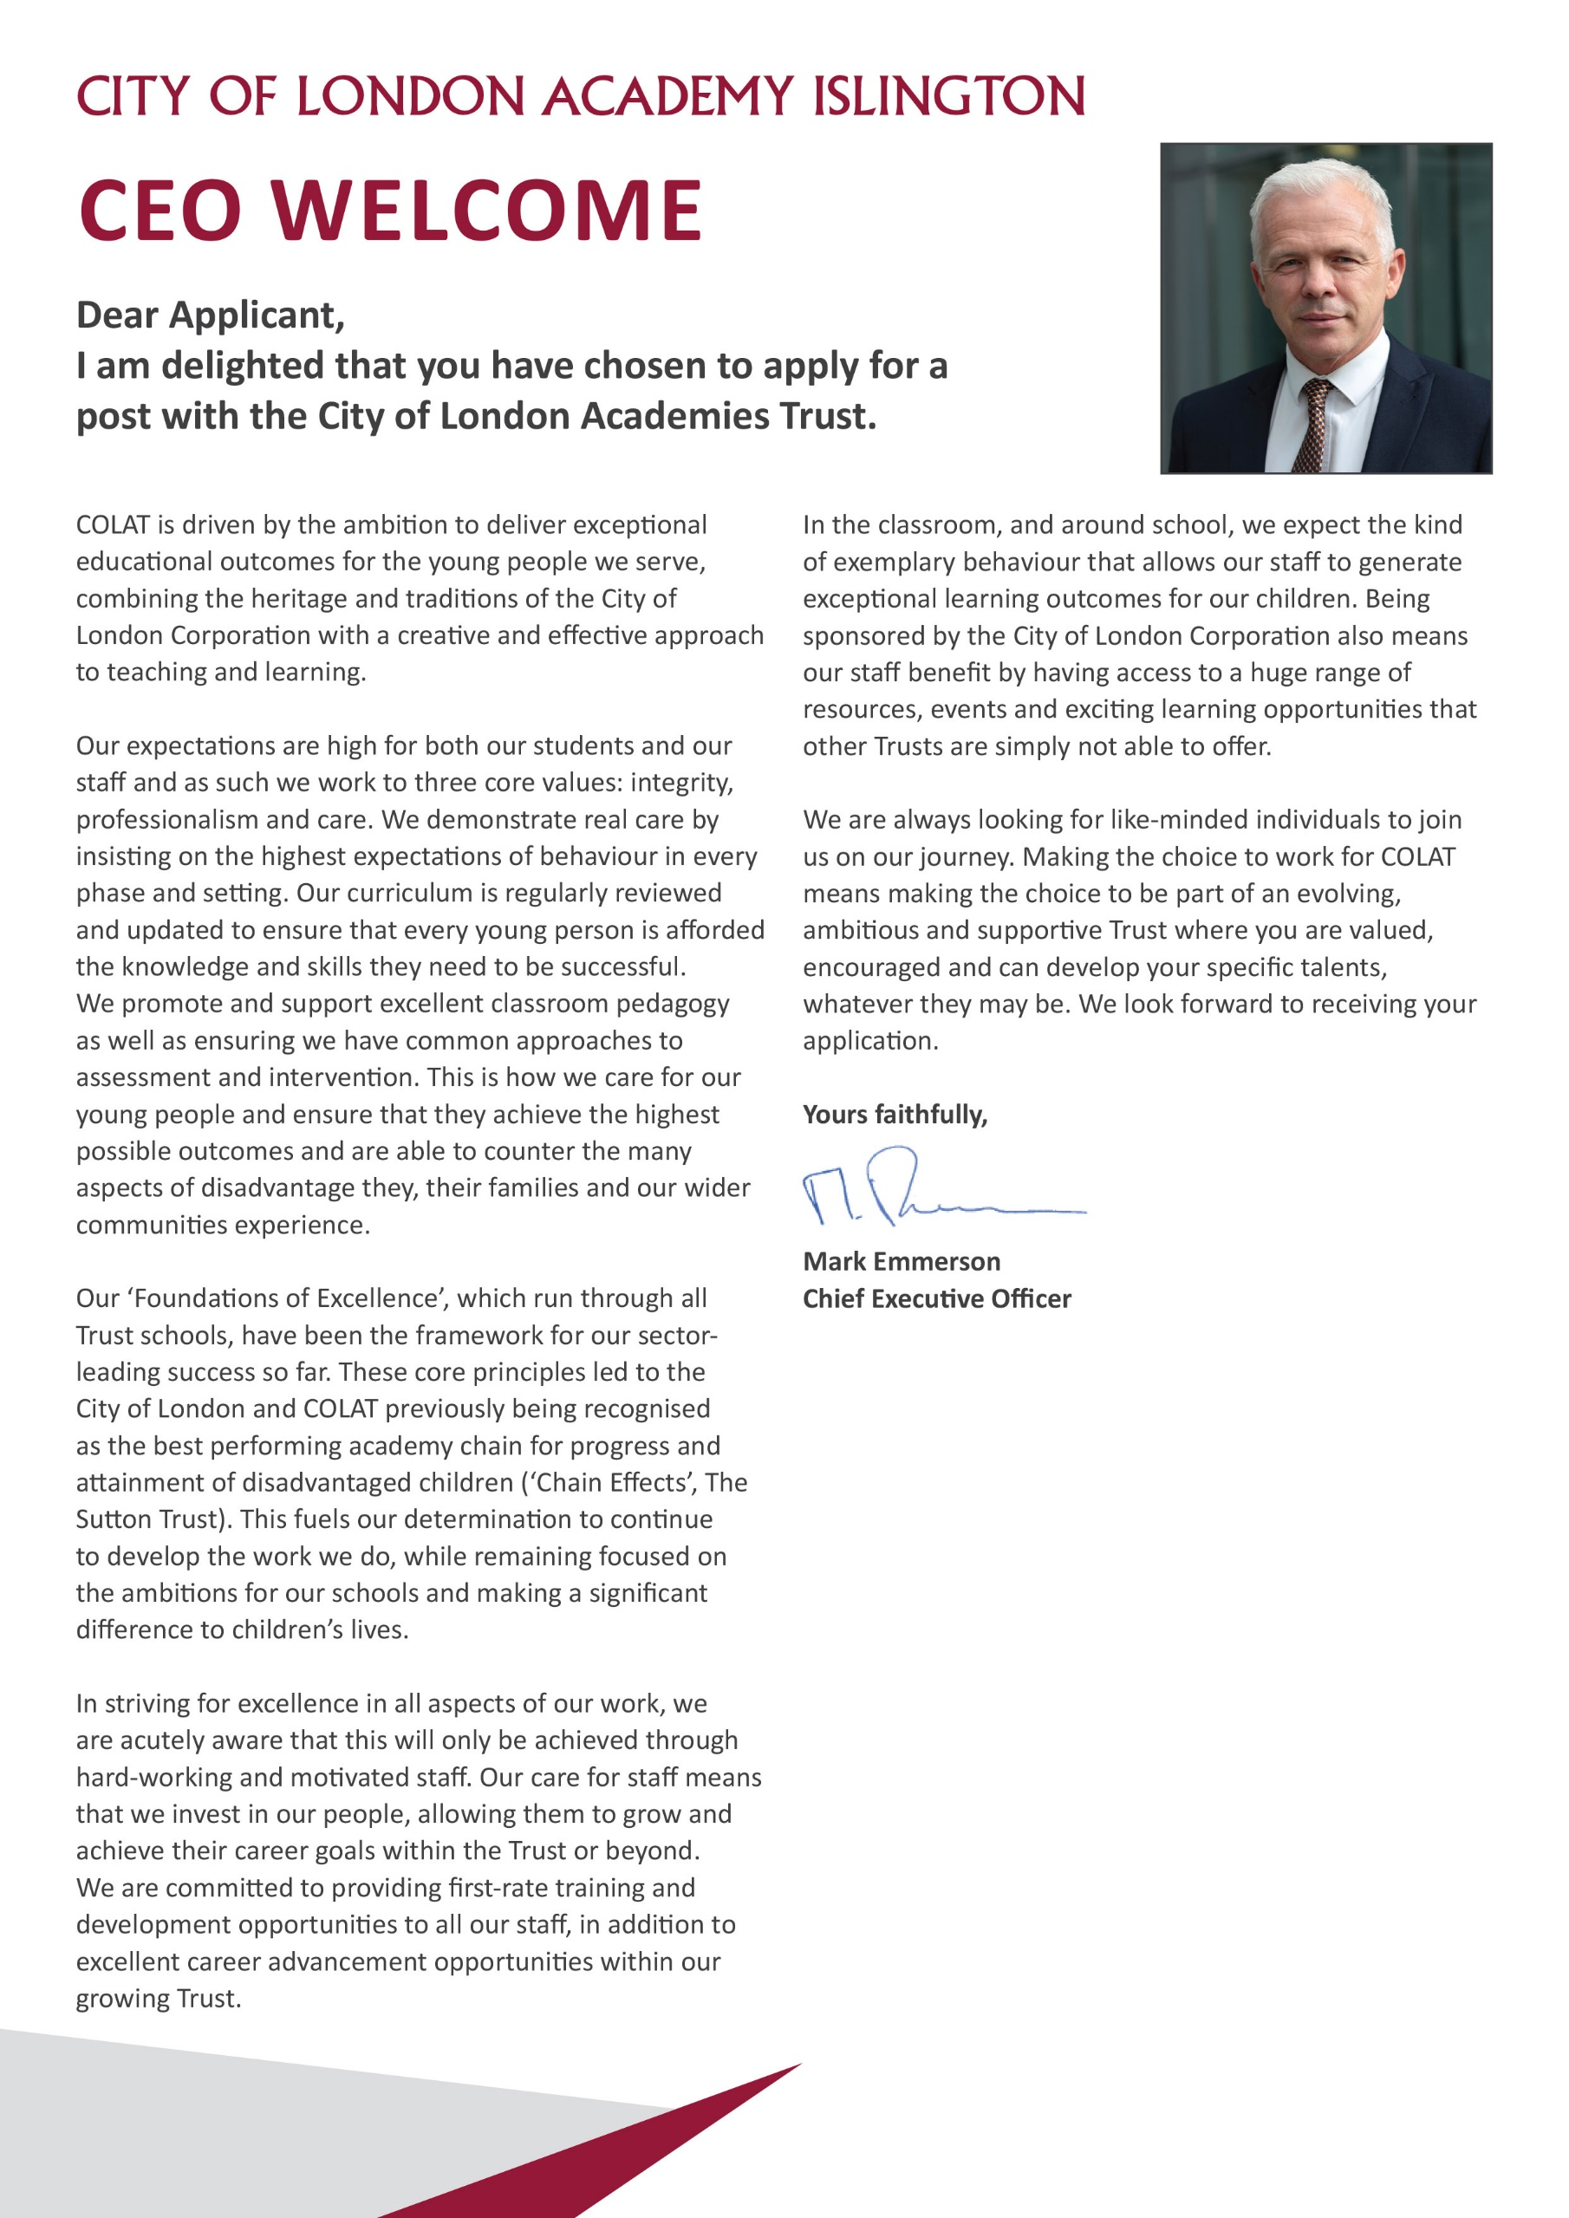

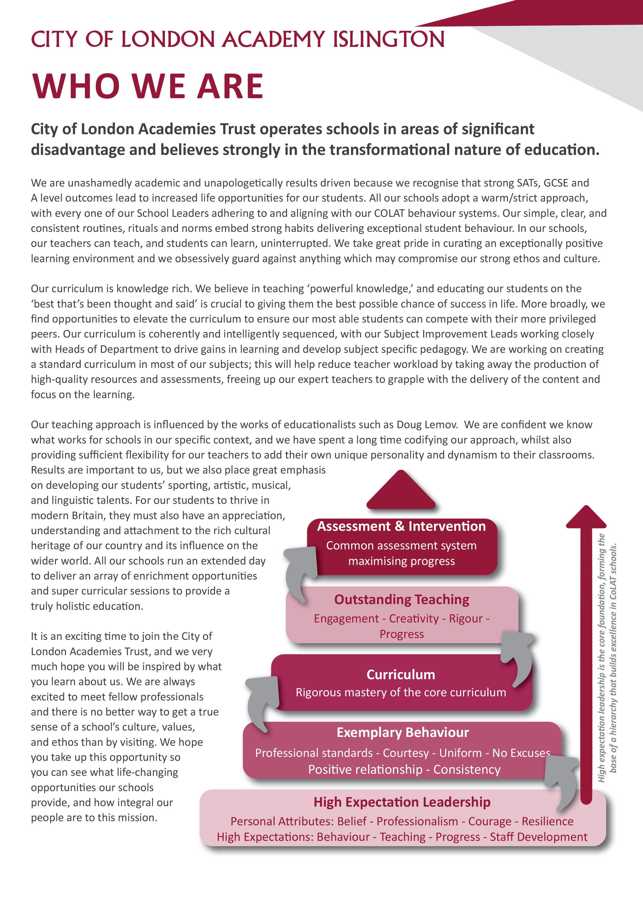


Principal’s Welcome

City of London Academy Islington is a dynamic and ambitious school that serves a truly diverse student body in the heart of Islington, minutes away from Essex Road, Upper Street and Angel. As a mixed, non-selective, and non-denominational secondary school and sixth form, we focus on delivering an exceptional education aimed at improving the life chances of our students.

The Academy's mission centres around academic excellence, underpinned by our core values of respect, responsibility, and integrity. Alongside a strong academic foundation, we have a comprehensive character curriculum and tutor programme, and also offers a wide range of extra-curricular activities, including clubs, trips, and visits. This reflects our commitment to providing a well-rounded educational experience to all our students.

Adopting a "warm-strict" approach, routines and systems are in place to support excellent behaviour, built on high expectations for all students. The Academy is dedicated to developing staff, offering a comprehensive continuing professional development (CPD) programme, and the support of an experienced Senior Leadership Team that seeks to maximise staff impact while reducing any unnecessary administrative burden. City of London Academy Islington is part of the City of London Academies Trust, which presents a wealth of opportunities for career progression.

We are actively seeking dedicated and inspirational staff members who are passionate about making a difference in the lives of young people, regardless of their background or circumstances.

If this sounds like the environment where you want to take the next step in your career, we welcome your application for a position with us.

Laurie Glees
Principal

Ofsted
In 2019, Ofsted awarded the Academy an outstanding rating, noting that “the school has been transformed into an exciting environment where pupils and staff thrive. Outcomes are outstanding and pupils’ progress is exceptional. This is a school where ‘no child is left behind.”

Head of Year - Job Description

Post: | Head of Year
Accountable to: | Vice Principal for Behaviour and Safeguarding
Grade / Range: | MPS / UPS + TLR 1A (Inner London)
Salary: | MPS / UPS + £10,174 per annum
Contract: | Permanent
Location | City of London Academy Islington
Disclosure level: | Enhanced
Responsible for: | Pastoral Support Manager

Main Purpose
- To provide professional leadership and management for a year group and to support high standards of pastoral care, learning and achievement for all students
- To assist the Senior Leadership Team in the overall management and development of the Academy’s pastoral support system
- You will be required to carry out the duties of a teacher as set out in the current School Teachers’ Pay and Conditions document

Key Accountabilities

Achievement
- Support the Senior Leadership Team in all aspects of support for students with a range of learning, pastoral and social support needs
- Participate in the Academy’s performance management system. Invest in your professional development and support the development of others
- Support whole-school self-evaluation strategies and processes, and use the data produced to implement improvements
- Address underachievement of individual students and/or cohorts of students by developing and implementing intervention strategies and processes
- Use data effectively to identify students who are underachieving in the year group and create and implement effective plans of action to support those students
- Work with the Senior Leadership Team and other staff with SEN expertise to ensure that individual education plans are used to set subject-specific targets and to ensure that students’ learning needs are met
- Monitor the setting and completion of homework for the year group
- Assist with the organisation of Parents’ Evenings
- To teach subjects and classes as required by the Academy

Behaviour/Pastoral Support
- Lead on all aspects of behavioural and pastoral support through the design and implementation of an effective year group pastoral system
- Lead on implementation of behaviour management strategies and the evaluation of their impact
- To lead tutors in the development and delivery of the tutoring and pastoral care programme
- Be responsible for maintaining a high standard of behaviour within the year group by upholding the agreed Academy expectations concerning uniform, behaviour, attendance and discipline
- Patrol corridors and visit lessons daily to ensure a high standard of behaviour around the Academy site.
- Supervise detentions
- Attend inclusion meetings
- Support personal development and enrichment activities to enhance students’ wellbeing and learning experiences
- Support the Academy’s student leadership and rewards programme to foster an aspirational culture amongst students
- Work closely and collaboratively with parents and carers to ensure effective home-school liaison

Attendance
- Support improvements in pupil attendance and punctuality by contributing to whole-school attendance strategies and procedures
- Regularly monitoring student progress, attainment, behaviour and attendance across a year group, finding ways of improving their engagement and outcomes

Safeguarding
- Support the safeguarding of young people by ensuring that regular training is undertaken and there is an awareness of and identification of risks and needs, and effective support for young people at risk

Additional Specific Responsibilities
- Organise and manage a tutor team, including development of tutor time resources
- Liaise with outside agencies such as educational welfare officers, social services, police liaison officers, volunteers etc
- Organise and take assemblies according to the pattern established by the Senior Leadership Team.
- Prepare and lead weekly tutor team briefings
- Attend regular whole staff and departmental meetings and school functions as published in the Academy’s calendar
- Contribute to the school’s extra-curricular and enrichment programme
- Carry out lunch, break and cover duties as reasonably assigned by SLT
- Attend assemblies
- Take part in the Professional Development programme including the opportunity for a personal appraisal and the participation in the appraisal of other teachers

Students
- Ensure the effective implementation of whole school assessment, recording and reporting policies, preparing individual student and group reports and analysing and reporting on summative data
- Ensure that statutory requirements, e.g. in relation to health and safety with regard to students, are met
- Promote performances, exhibitions and displays of students’ work
- Uphold the policies of the Academy ensuring, for example, that the Academy’s Behaviour Policy is implemented effectively, so that good order and discipline are maintained

Teaching Staff and Non-teaching Staff
- Demonstrate and encourage high standards of professionalism from all staff involved in the pastoral support of the year group
- Demonstrate and inspire an enthusiastic and committed approach to supporting students academically and pastorally
- Support students to achieve excellent academic outcomes by providing them with challenging and engaging learning experiences

Administration
- Demonstrate high levels of professionalism in the accurate completion of the administration needs of the role, meeting all deadlines and completing tasks to high standards
- Ensure that books and other resources are catalogued and stored in a systematic and secure fashion, that they are easily accessible and checked regularly
- Take responsibility for the fabric and furnishing of your teaching area and department
- Implement, develop and review teaching and pastoral policies, plans, targets and practices within the context of the Academy’s aims and policies

Standards/ Quality Assurance and Additional Responsibilities
- Adhere at all times to professional business standards of dress, courtesy and efficiency in line with the ethos of the Academy
- Attend and participate in open evenings and student performances
- Uphold the Academy’s behaviour policy and uniform regulations
- Participate in staff training and development
- Attend team and staff meetings

Key Organisational Objectives
The postholder will contribute to the Academy’s objectives in service delivery by:
- Following Health and Safety requirements and initiatives as directed
- Ensuring compliance with Data Protection legislation
- The Academy is committed to safeguarding and promoting the welfare of children and young people and we expect all staff to share this commitment
- At all times operating within the Academy’s Equalities policies, demonstrating a commitment and contribution to improving standards of attainment for all students
- Adopting customer care and quality assurance initiatives
- Fulfilling the role of mentor if required
- Contributing to the maintenance of a caring and stimulating environment for young people

Safeguarding Children
COLAT is committed to safeguarding and promoting the welfare of children and young people. We expect all staff to share this commitment and to undergo appropriate checks, including enhanced DBS checks.

The above responsibilities are subject to the general duties and responsibilities contained in the Statement of Conditions of Employment. The duties of this post may vary from time to time without changing the general character of the post or level of responsibility entailed.

The person undertaking this role is expected to work within the policies, ethos and aims of the Trust and to carry out such other duties as may reasonably be assigned. The post holder will be expected to have an agreed flexible working pattern to ensure that all relevant functions are fulfilled through direct dialogue with employees, contractors and community members.

English Duty
This role is covered under part 7 of the Immigration Act 2016 and therefore the ability to speak fluent spoken English is an essential requirement for this role.

Our Values and Vision
The City of London Academies Trust, sponsored by the City of London Corporation, aims to provide high-quality education for students and pioneer educational innovation. We are driven by the ambition to provide world-class experiences and deliver exceptional educational outcomes for the young people we serve.

All City of London schools and academies draw upon the traditions, institutions, heritage and historical successes of London to furnish each of their diverse communities with life-transforming learning experiences. In doing so, we believe that the young people we serve develop into successful, compassionate young adults, who make a positive contribution to their local, national and global communities.

Our schools are characterised by a common understanding of what makes outstanding schools, based on five key principles which are known as our 'Foundations of Excellence'​.

Our Staff
Our staff have high expectations, are consistent and driven to provide the best teaching and opportunities for our students. Teachers work in a well-disciplined environment where they are able to teach creative and engaging lessons, and all staff are given exciting opportunities to develop and learn from exceptional practitioners.

Equal Opportunities
The postholder will be expected to carry out all duties in the context of and in compliance with the academy Equalities policies.

Head of Year – Person Specification

 | Essential | Desirable
Qualifications
Educated to Degree level or equivalent in a mainstream secondary school subject | P
Qualified Teacher Status | P
Experience, Skills and Knowledge
Ability to teach one or more mainstream secondary school subject | P
Experience of successfully teaching across the secondary age and ability range | P
Experience of providing pastoral support to young people | P
Ability to use IT effectively |  | P
Use IT to raise achievement and as a management tool |  | P
Demonstrate experience of effective performance management and quality improvement within a school environment | P
Collaborative teaching methods and working with colleagues in the preparation, assessment and monitoring work to ensure high quality outcomes | P
Demonstrable experience of improving student outcomes | P
A record of continuous professional and career development |  | P
Experience as a form tutor or a similar pastoral role | P
Strategies to raise standards and achievement of students | P
Must be well-organised | P
Must be well-presented | P
Excellent communication skills and ability to adapt to communication with different stakeholders/audiences | P
Ability to analyse data effectively to assess and improve performance | P
Ability to work hard under pressure while maintaining a positive, professional attitude | P
Ability to organise and prioritise workload and work on own initiative | P
Good Interpersonal skills and the ability to work collaboratively, leading to professional development of staff, to the achievement of the Academy aims and to the efficient running of all departments | P
Outstanding teaching ability | P
Commitment to personal career development |  | P
Willingness to engage with parents in order to encourage their close involvement in the education of their children | P
Developments in the National Curriculum | P
Developing differentiated Schemes of Work | P
Effective strategies for supporting students to improve outcomes | P
Have a good understanding of positive effective strategies for whole school behaviour management | P
A thorough understanding of the intervention packages available to support accelerated learning |  | P
Knowledge and understanding of the needs and care of students with SEN | P
Must be able to teach at least one mainstream secondary school subject to Key Stages 3 and 4 | P
Understanding of assessment systems | P
Understanding of different social backgrounds of students |  | P
Understanding the needs of students and the appropriate policies and strategies to support them | P
Understand the needs of bilingual students |  | P
Other
Commitment to safeguarding and promoting the welfare of children and young people
Willingness to undergo appropriate checks, including enhanced DBS Checks
Motivation to work with children and young people
Ability to form and maintain appropriate relationships and personal boundaries with children and young people

HOW TO COMPLETE THE APPLICATION

Title: Head of Year
Vacancy Description: Permanent
Monday 22 June at 9am
Closing date: 27th January 2025
Submission: Applications must be submitted via the MNT portal

