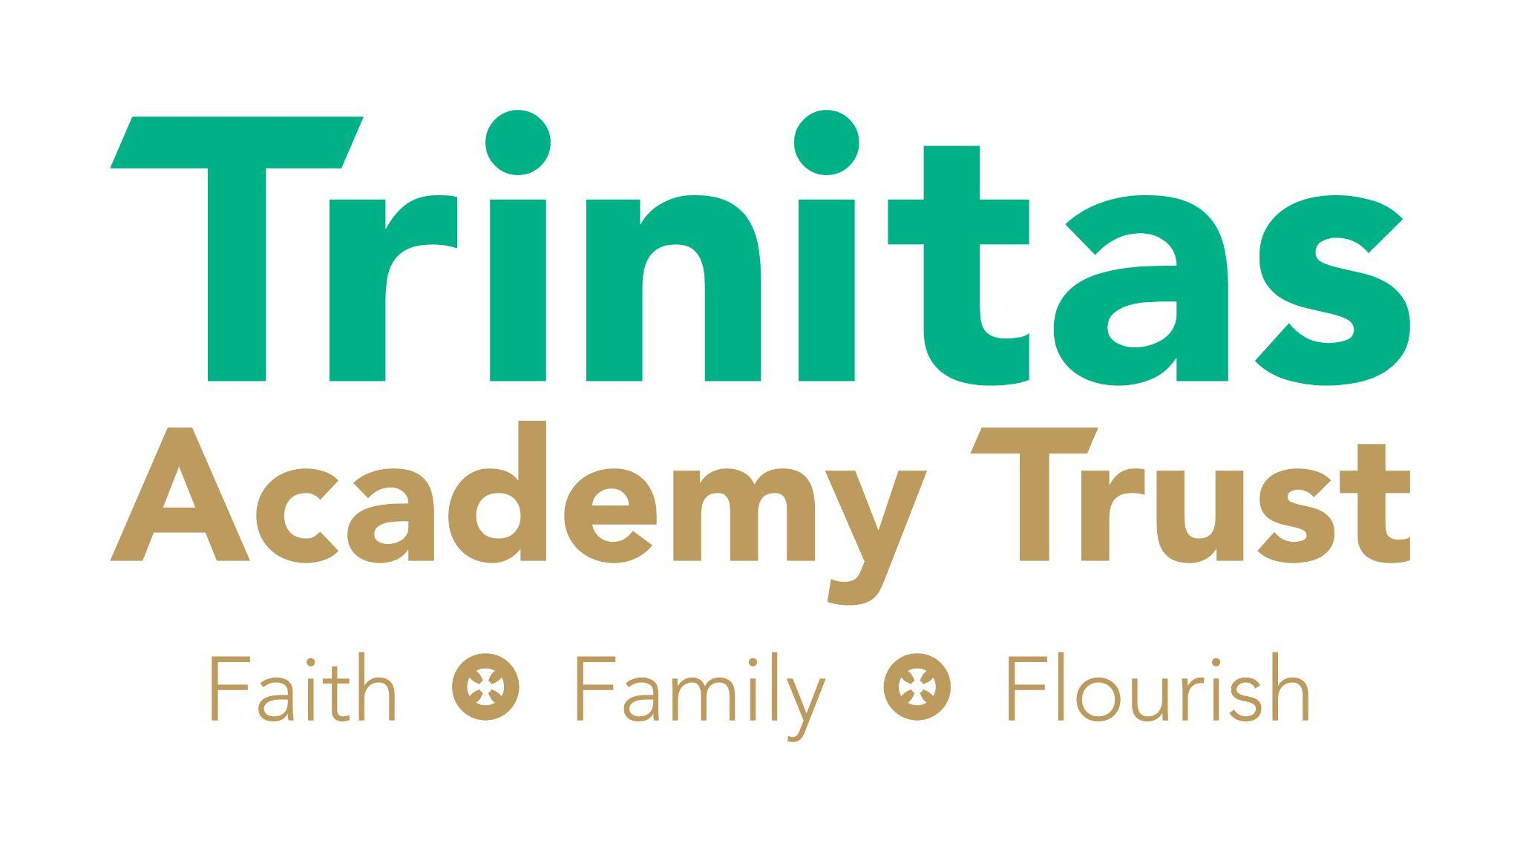

We believe that all children deserve the best education, and all staff deserve to be valued and developed. Our Trinitas family, Christian faith, and an unrelenting desire to improve society, underpin everything we do. Creativity, compassion and high expectations drive the trust to ensure that every person within its community flourishes.
Trinitas – Faith, Family, Flourish!

SAFER RECRUITMENT POLICY

Date reviewed and approved: | 1st October 2024
Updates (where relevant): | N/A
Next review due: | September 2025

CONTENTS
- Introduction | 2
- Recruitment Process Selection | 2
- Equal Opportunities | 3
- The Interview/Selection Process | 3
- Retention of Records | 4
- Offers of Employment | 4
- Supply/Agency Staff | 5
- Contractors | 5
- Single Central Register | 5
- Managing Allegations Against Staff | 6
- Managing Allegations Against Governors and Trustees | 6
Annex A – Definition of ‘Regulated Activity’ | 7

SAFER RECRUITMENT POLICY

1. INTRODUCTION

In accordance with the ‘Keeping Children Safe in Education (September 2024)’ statutory guidance, Trinitas Academy Trust is committed to safeguarding and promoting the welfare of children and young people and expects all staff and volunteers to share this commitment.
This guidance within the Keeping Children Safe in Education (KCSIE), focuses on ensuring potential applicants are given the right messages about the Trust’s commitment to recruit suitable people.
Trinitas Academy Trust is committed to recruiting and selecting high quality staff with the necessary skills, experience and aptitude to care for, nurture and enable the pupils to learn and thrive in a happy, caring and safe environment.
All staff and volunteers at Trinitas Academy Trust engaged in ‘Regulated Activity’ (please see appendix A for definition of ‘regulated activity’) will be required to undertake an enhanced disclosure via the Disclosure and Barring Service (DBS).
Trustees and Governors at all schools within the Trust are required to undertake an enhanced disclosure via the Disclosure and Barring Service (DBS).
2. RECRUITMENT PROCESS SELECTION
KCSIE guidance states that Governing bodies and proprietors should ensure that those involved with the recruitment and employment of staff to work with children have received appropriate safer recruitment training.
Therefore, within the Trust, as a minimum, at least one person involved in the recruitment process at each school should undertake safer recruitment training.
All permanent and long-term temporary posts will be advertised using the most appropriate method. Adverts will detail, the skills, abilities, experience, attitude, and behaviours required for the post; and the safeguarding requirements, i.e. to what extent will the role involve contact with children and engagement in regulated activity relevant to children and make clear the Trust’s commitment to safeguarding and promoting the welfare of children and make clear that safeguarding checks will be undertaken.
All applicants for any post within the Trust will be required to complete an application form (CVs will not be accepted). Applications are completed through our online application portal and will require applicants to provide:
- personal details - current and former names, current address and national insurance number
  - details of their present (or last) employment and reason for leaving
  - full employment history, (since leaving school, including education, employment
and voluntary work) including reasons for any gaps in employment
  - qualifications, the awarding body and date of award
  - details of referees/references
- a statement of the personal qualities and experience that the applicant believes are relevant to their suitability for the post advertised and how they meet the person specification

All applicants will be asked to provide two referees, one of whom should be the applicant’s current or most recent employer.
- Where the current or most recent employer is in education the referee should be the Principal or equivalent person.
- Where an applicant is currently employed within the Trust and is applying for a vacancy within the same school, the appointing Principal must not act as a referee. In such cases, the reference from the current employer should be provided by the applicant’s line manager or the appropriate member of the senior leadership team (SLT).
Where an applicant who is not currently working with children, has done so in the past, it is important that a reference is also obtained from the employer by whom the person was most recently employed in work with children.
References will be sought directly from the referee.
Open references and testimonials will not be accepted.
References by relatives or friends will not be accepted.
All applicants shortlisted will have references taken up before interview.
During the short-listing process, it is important that applications are scrutinised, that information provided is consistent and does not contain any discrepancies, and any gaps in employment are identified.
Incomplete applications will not be accepted, and will be returned for completion.
3. EQUAL OPPORTUNITIES
The Trust will pay due regard to equality of opportunity for all applicants. The Trust will abide by the existing legislation and, in particular, will not discriminate on the ground of any of the protected characteristics listed in the Equality Act (2010), these being: age, disability, gender reassignment, race, religion or belief, sex, sexual orientation, marriage and civil partnership, and pregnancy and maternity.

The Trust will promote equality in all aspects of school life.
4. THE INTERVIEW/SELECTION PROCESS
All applicants who are invited to an interview will be required to bring evidence of identity, address, qualifications and their right to work in the UK.

Shortlisted candidates will be asked to declare their criminal record and provide any information that would make them unsuitable to work with children.

Shortlisted candidates will be asked to sign a declaration confirming the information they have provided is true.

In accordance with the KCSIE guidance, shortlisted candidates should be aware that the Trust are required to conduct online searches as part of their shortlisting process in order to identify any incidents or concerns which are publicly available online. Shortlisted candidates will be made aware of this via the online application portal.

During the interview, any discrepancies noted from the shortlisting, including any gaps in employment and findings from online searches, will be explored. If the interviewing panel is not satisfied with any explanation given, the applicant will not be successful.

5. RETENTION OF RECORDS
If an applicant is appointed, the School will retain any relevant information provided on their application form (together with any attachments) on their personnel file, in accordance with the Trinitas ‘Privacy Notice for Staff’ and ‘Records Management’ policy.
In accordance with the KCSIE guidance, copies of documents used to verify a successful candidate’s identity, right to work and required qualifications will be kept on their personnel file. Copies of DBS certificates and records of criminal information disclosed by a candidate will not be kept on file, however the school will record that the DBS check has been carried out and the details of the check.
If the application is unsuccessful, all documentation relating to the application will be confidentially destroyed after six months in accordance with the aforementioned policies.
6. OFFERS OF EMPLOYMENT
A successful candidate will be offered a conditional offer of employment; subject to a series of checks which are carried out by the HR Department:
- receipt of at least two satisfactory references, confirming that the referee knows of no reason why the candidate should be prohibited from working with young people;

- verification of the candidate’s identity – best practice is checking the name on their birth certificate, where this is available;

- verification of the candidate’s right to work in the UK;

- enhanced DBS Disclosure, including Barred List information;

- separate Barred List check which should be considered as part of an overall risk assessment if the candidate is to start prior to DBS clearance;

- verification of the candidate’s medical fitness;

- verification of professional qualifications and status (i.e. QTS, NPQH, etc);

- teaching posts - verification of successful completion of Statutory Induction period (applies to those who obtained QTS after 7 May 1999);

- prohibition check for qualified teachers and those in ‘teaching work’;

- General Teaching Council for England (GTCE) check for historic sanctions and restrictions (imposed by the GTC prior to its abolition in 2012);

- check for any restrictions imposed by countries in the European Economic Area (EEA);

- check for the existence of directions made by the Secretary of State under s.128 of the Education and Skills Act 2008 - Section 128 of the Education and Skills Act 2008 prohibits unsuitable staff and proprietors from “taking part in the management of an independent School.” For the purposes of this legislation, Academies and Free Schools are included in the definition of an “Independent School” therefore checks are required to confirm that a relevant person is not prohibited under the terms of this legislation;

- childcare disqualification is an additional requirement to the general child safeguarding arrangements provided under the Disclosure and Barring Service (DBS) regime, which apply to all children. The childcare disqualification arrangements apply to staff working with young children in childcare settings, including primary schools. The arrangements predominantly apply to individuals working with children aged 5 and under, including reception classes.

- childcare disqualification is an additional requirement to the general child safeguarding arrangements provided under the Disclosure and Barring Service (DBS) regime, which apply to all children. The childcare disqualification arrangements apply to staff working with young children in relevant childcare settings, including primary schools. Specifically, the arrangements predominantly apply to:

  - individuals working with children aged 5 and under, including nursery and reception classes;
  - individuals working with children under the age of 8 outside school hours (e.g., breakfast and after-school clubs),
  - individuals involved in the day-to-day management of these settings.

- Where a candidate has lived, worked or studied lived overseas for a period of six months or more within the last five years, in addition to Barred List information and an enhanced DBS check, they will be required to provide an original police check from the relevant country. To be considered valid, the police check must meet all of the following criteria:

- The original document must be provided (photocopies or scans will not be accepted)

- If the police check is not in English, it must be accompanied by a certified English translation.

- The check must have been issued no earlier than six months prior to the candidates’ departure from the country; or after the candidate’s departure, provided they have not returned to that country for a significant period since.

Information and documentation relating to the above checks will be retained securely within the individual’s HR file.
7. SUPPLY/AGENCY/THIRD-PARTY STAFF
We will ensure that the any agency supplying staff, ies or any third-party organisation whose individuals visit a school or Trust in a professional capacity, responsible for individuals provides written confirmation (letter of assurance) evidence that all required pre-employment checks have been completed, of including an in date enhanced DBS check, identity check, professional qualifications check, and if applicable, overseas checks.
Upon arrival to reception and before an individual begins working, they will be required to provide a form of photographic ID, from which their identity will be checked against the letter of assurance of agency workers will be checked alongside the information received from the agency or organisation.
Before an agency worker begins work, they must provide the School/Trust with the original enhanced DBS certificate obtained by the agency. This must be shared with the School/Trust regardless of whether the certificate discloses any information.

8. CONTRACTORS
We will ensure that any contractor, or any employee of the contractor, who is to work at the school has been subject to the appropriate level of DBS check. Contractors engaging in regulated activity will require an enhanced DBS certificate (including barred list information).
Principals are responsible for the safeguarding of the children and vulnerable adults in their care and they shall be responsible for ensuring that adequate measures are in place to safeguard pupils whilst contractors are on the premises.
9. SINGLE CENTRAL REGISTER
It has been a requirement since 2007 that all schools must maintain a Single Central Record of recruitment and vetting checks. There is a Single Central Record kept in each school detailing every member of staff, members of the proprietor body and volunteers undertaking ‘regulated activity’.
The register will show which checks have been carried out, when they were carried out and by whom. This will include:
- an identity check;
- a children’s barred list check;
- an enhanced DBS check – or a check against the DBS update service if the candidate is subscribed to this;
- a prohibition from teaching check for Qualified Teachers and those in carrying out ‘teaching work’;
- further checks on people that have lived or worked outside the UK;
- a check on professional qualifications (where required);
- a check to establish on an individual’s right to work in the UK;
- a section 128 check for those in management positions, including Governors/Trustees;
- a childcare disqualification check (where required);

The details of an individual will be removed from the Single Central Record once they no longer work at the School/Trust.

Trustees and Governors are responsible for ensuring that the Single Central Record is maintained in accordance with this policy.

- MANAGING ALLEGATIONS AGAINST STAFF
Part four of KCSIE is about managing cases of allegations that might indicate a person poses a risk of harm if they continue to work in their present position or in any capacity with children in a school or college and is split into two sections.
Section one: Allegations that may meet the harm threshold Guidance from the DBS here
Section two: Allegations/concerns that do not meet the harms threshold which may be referred to as ‘low level concerns’.
Any allegation against a member of staff or volunteer working within the trust will be treated seriously and in line with Bexley Child Protection Procedures, allegations that meet the harm threshold will be reported to the Local Authority Designated Officer (LADO). Any allegation made against the Chief Executive Officer will be dealt with by Trustees.

Concerns (including allegations) which do not meet the harm threshold, may arise in several ways and from a number of sources. For example: suspicion; complaint; or disclosure made by a child, parent or other adult within or outside of the organisation; or as a result of vetting checks undertaken. Any such concerns will be reported to the Trust Lead for Safeguarding and the HR Director and appropriate action will be taken to safeguard children and manage and record any such concerns.

During induction for all staff, procedures for safeguarding children and reporting concerns are shared.

- MANAGING ALLEGATIONS AGAINST GOVERNORS AND TRUSTEES

If an allegation is made against a Governor or Trustee, the school will follow our normal allegation procedures. Where an allegation is substantiated, we will consider removing the member from office.

Employees involved in the recruitment and selection of staff are responsible for familiarising themselves with and complying with the provisions of this policy. The monitoring of the recruitment process and induction arrangements will be carried out by the Trustees of Trinitas Academy Trust.

It is important that this policy is read in conjunction with the school’s Safeguarding and Child Protection Policy and Guidance.

Annex A – Definition of ‘Regulated Activity’

For most appointments an enhanced DBS certificate, which includes barred list information will be required, as the vast majority of staff will be engaged in regulated activity.

Regulated activity

The full legal definition of regulated activity is set out in Schedule 4 of the Safeguarding Vulnerable Groups Act 2006 as amended by the Protection of Freedoms Act 2012.

HM Government has produced Factual note on regulated activity in relation to children

Regulated activity includes:

- teaching, training, instructing, caring for (see (c) below) or supervising children if the person is unsupervised, or providing advice or guidance on physical, emotional or educational well-being, or driving a vehicle only for children

- work for a limited range of establishments (known as ‘specified places’, which include schools and colleges), with the opportunity for contact with children, but not including work done by supervised volunteers.

Work under (a) or (b) is regulated activity only if done regularly. Some activities are always regulated activities, regardless of frequency or whether they are supervised or not.

This includes:

- c. relevant personal care, or health care provided by or provided under the supervision of a health care professional:

- personal care includes helping a child with eating and drinking for reasons of illness or disability or in connection with toileting, washing, bathing and dressing for reasons of age, illness of disability

- health care means care for children provided by, or under the direction or supervision of, a regulated health care professional.

Regulated activity will not be:

Paid work in specified places which is occasional and temporary and does not involve teaching, training, and supervised activity which is paid in non-specified settings such as youth clubs,
sports clubs etc.

If you are unclear about the requirements – please seek guidance from the HR Department

