

Candidate information pack

Welcome from Jen Rylance, the Headteacher, Thornhill Junior & Infant School.

Dear applicant,

Thank you for taking an interest in the Assistant Headteacher vacancy at Thornhill Junior and Infant School.

Our popular School is situated in the village of Thornhill, Dewsbury, West Yorkshire, serving a large residential area of private and local authority housing. The school's planned admission number is 420 and the school’s admission limit is 60 per year group. The number of children on roll currently stands at 360. Approximately 46% of our children are entitled to free school meals, 15% have Special Educational Needs and 5% come from homes where English is not their first language.
Our school is popular with local families and has a reputation for being friendly and welcoming. There are good links with the local community through various activities and we enjoy positive relationships with neighboring schools as part of the Dewsbury Learning Partnership.
Key messages from our most recent Ofsted report in 2024:
- At Thornhill Junior and Infant School, pupils are happy and grow in confidence. They show curiosity in their learning. Pupils build their self-esteem in a safe and positive atmosphere.
- The school maintains a calm and orderly environment. Pupils behave respectfully both in and outside the classroom. They follow instructions, engage well in group discussions and listen to each other.
- The school prepares pupils well for life in modern Britain. It adapts the curriculum expertly to broaden pupils’ horizons. They are taught and remember essential life skills. Pupils learn how to stay safe and make empowered choices.
- The school offers a broad and ambitious curriculum. Pupils’ respectful and engaged behaviour contributes to their progress across the curriculum. They are well prepared for the next stage of their education.
- The school identifies, assesses and meets the needs of pupils with special educational needs and/or disabilities well. They are fully immersed in this inclusive curriculum, supported by trained staff who provide both academic and emotional assistance.
- Pupils’ personal development and cultural awareness are expertly enriched by tailored curriculum decisions. For example, the extensive music offer allows pupils to learn about a range of musicians from different cultures.
- Pupils understand equality and advocate for fairness. These experiences help pupils become independent, compassionate and well-rounded individuals. They articulate their thoughts clearly and express themselves with maturity. Pupils are ambitious for their future.
- Leaders support staff well-being and workload. The trust and school ensure that staff, including early-career staff, receive the professional development that they need. Leaders at all levels provide effective wraparound support and challenge.

I am extremely proud to be the Headteacher at Thornhill Junior and Infant School and believe it is a rich and vibrant place to learn and work. I would be very happy to answer any questions that you may have.
We hope that you will find this information pack helpful in finding out more about this post. You are very welcome to make an appointment to visit the school and meet with me. Please contact the school office on 01924 453259, to make an appointment.
If you would like a further conversation about any aspect of this post or about working as part of Focus-Trust, please do not hesitate to email thornhill@focus-trust.co.uk or contact the school office who will arrange a telephone call.
Please contact us if you require any further information.
Jen Rylance
Headteacher



Welcome from Paul Spencer, Chair of Governors

Dear applicant,

Thank you for taking the time to consider applying for the post of Assistant Headteacher at Thornhill Junior and Infant School. As Chair of the Governing Body, I would like to take this opportunity to tell you a little bit about the context of our school.

Thornhill Junior and Infant School is a two-form entry school, situated in Thornhill on the outskirts of Dewsbury, West Yorkshire. We have PAN of 420 primary aged pupils with an admission limit of 60 pupils per year group. A small percentage of pupils come from homes where English may not be the first language.

We are proud to be part of the Focus Academy Trust and recognise the value of support, ethos, challenge, and collective efficacy embodied within the trust.

This is a very friendly school where children are happy, and staff work exceptionally well as part of a team. The large staff of teachers and teaching assistants are led by a dedicated, highly respected Senior Leadership Team.

There are 15 spacious and well-equipped classrooms. The school has a large hall which is used as a gymnasium, dining room and assembly hall. Our school is surrounded by secure playgrounds and a large, grassed area which includes an orchard. The building is a mixture of old and new and there has been much renovation and interior development over the last five years.

We offer a wide range of extra-curricular activities and clubs, and the school is renowned as a lead in music provision.

Parents are made very welcome in the school and provide much valuable support; they run the ‘Friends of Thornhill’ group which organises social and fund-raising activities.
Our school is popular with local families and has a reputation for being friendly and welcoming. There are good links with the local community through various activities and positive relationships with neighboring schools, including the local High School.

I hope I have given you a flavor of Thornhill Junior and Infant School and that it makes you feel that you would like to become a part of our school community.

Yours sincerely,

Paul Spencer
Chair of the Governing Body

3

Academy details
Address Thornhill Junior & Infant School
Edge Lane
Thornhill
Dewsbury
West Yorkshire
WF12 0QT

Telephone 01924 453259
Website www.thornhilljischool.co.uk

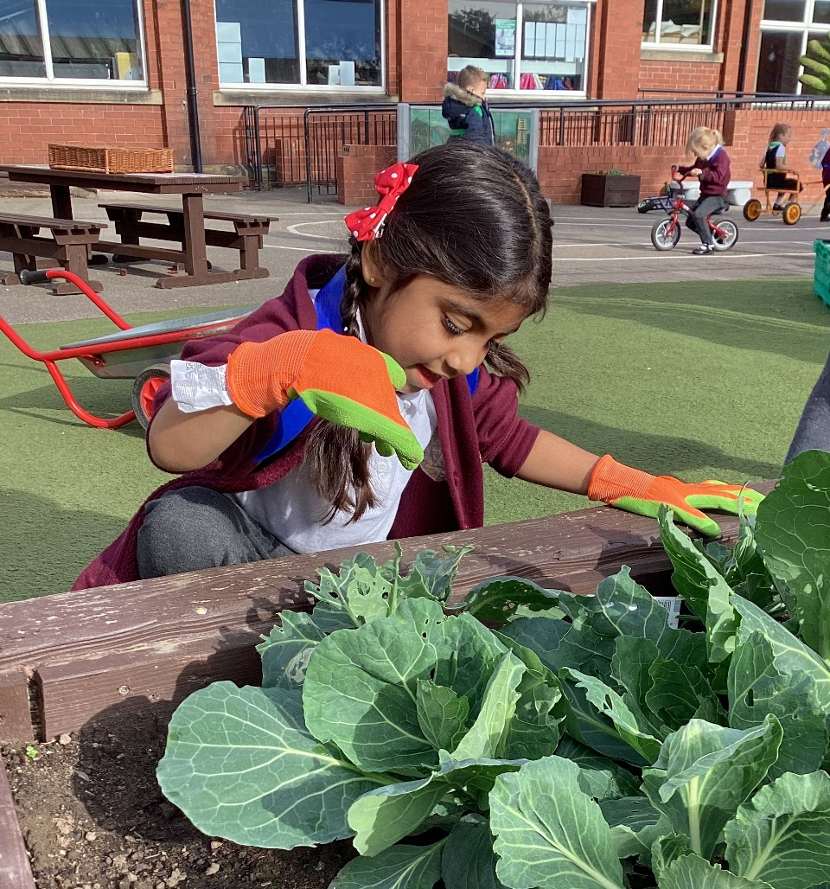

Job Description

Job title | Assistant Headteacher  With responsibility for standards across school
Grade | Leadership scale L3- L7
Accountable to | The Headteacher
Key Purpose
To assist the Headteacher and Deputy Headteacher with the leadership, management and organisation of the Academy in seeking to achieve the highest standards of pupil achievement and Academy efficiency.

To play a major role in assisting the Headteacher to:
- Formulate and model the aims and the objectives of the Academy
- Establish the policies and guidance through which objectives are to be achieved
- Manage staff and resources to achieve the objectives of the Academy and the improvement plan
- Lead on the improvement of teaching, curriculum and assessment in order to achieve the best outcomes for all learners through modelling, demonstration coaching and evaluation
- Monitor and evaluate progress towards their achievement for all learners
- Improve standards across the Academy

Key relationships
- Children, parents and staff
- Local governing body
- Members of the Focus-Trust team
- Other Academy principals
- The Directors of Focus Trust and trustees
- Other local Academies and stakeholders

Key responsibilities
The following information is not intended to be exhaustive but included to give an indication of the type of duties associated with the role of Assistant Headteacher in order to realise the Academy’s vision and outcomes of the Academy. The key duties are set out under the following headings:
- Shaping the future
- Leading teaching, learning and assessment
- Developing self and working with others
- Managing the organisation
- Securing accountability
- Strengthening community
- Child protection and safeguarding
- Equality
- Deputise
- Specific responsibilities

Shaping the future
  - Ensure the vision for the Academy is clearly articulated, shared, understood and acted upon effectively by all.
  - Motivate and work with others to create a shared culture and positive climate
- Work with individual staff and teams to translate the Academy's vision into agreed objectives and operational plans which will promote and sustain improvement throughout the Academy.
- Review, evaluate and develop the effectiveness of the school’s policies and developments and analyse their impact on a core subject and phase.

Leading teaching and learning
- Be a consistently excellent role model to all staff within the Key Stage having a stimulating and challenging learning environment which secures outstanding learning and provides outstanding standards of achievement, behaviour and safety
- Demonstrate and articulate high expectation; setting ambitious targets for all children
- Monitor, evaluate and review classroom practice and manage improvement strategies holding staff to account
- Analyse and interpret performance data to inform classroom practice across the Academy, setting challenging targets for improvement
- In partnership with the Headteacher and Deputy Headteacher take responsibility for the monitoring of teaching and learning and curriculum provision
- Take responsibility for the monitoring of teaching and learning of a core curriculum area
- Work alongside the Pastoral team to develop links with parents
- Liaise with other academies/schools and providers to ensure continuity of support and learning when transferring pupils

Developing self and working with others
- Manage positive working relationships with all staff.
- Motivate and challenge all staff to maintain high expectations of professional standards and behaviours.
- Develop and maintain effective strategies and procedures for staff induction, professional development and performance review for teachers and support assistants
- Lead staff in developmental activities and evaluate outcomes; providing appropriate training for staff where necessary
- Be a source of best practice for teaching and learning by ensuring that national research and initiatives are used to inform targets for improvement

Managing the organisation
- Support the Headteacher and Deputy Headteacher to recruit, retain and deploy staff
- Implement evidence-based Academy improvement plans and policies, monitoring the effectiveness of spending and usage of resources.
- Ensure that literacy policies and practices take account of Trust, national and local policies and initiatives
- Manage the learning environment throughout the Academy to ensure that the Academy meets all health and safety regulations

Securing accountability
- Manage staff roles and ensure that responsibilities are clearly defined, understood and agreed within school
- Work with the governing body to enable them to meet their statutory responsibilities
- Present key information to a range of audiences; parents, governors, Trust officers and other external agencies
- Present key information to a range of audiences: parents, governors, Trust officers and other external agencies.

Strengthening the community
- Work with other agencies to ensure learning experiences and opportunities for pupils are integrated into the wider community
- Build the reputation of the Academy with the outside community
- Create and maintain partnerships with parents and carers to support and improve pupils’ achievement and personal development
- Ensure that parents are well informed about the curriculum, targets, children’s progress and attainment throughout the Academy.

Child protection and safe guarding
- Ensure that the child protection policies and procedures are fully implemented and followed by all staff
- Ensure that sufficient resources and time are allocated to enable staff to discharge their child protection related responsibilities effectively.

Equality
- Ensure that the Academy reflects a vibrant and inclusive ethos which
actively values and promotes diversity, community cohesion, and supports pupils to
become successful integrated citizens.
- Actively challenge and address discrimination.

Deputise
- Deputise for the Headteacher/Deputy Headteacher

Specific responsibilities (including teaching responsibilities)
- Teaching commitment: Class Teacher in KS1 or KS2
- Develop teaching and learning of a core area in order to promote high standards of attainment at every stage and excellent progress;
- Analyse and interpret data in order to develop a secure understanding of effectiveness of provision and standards
- Plan strategically with the Headteacher and Deputy Headteacher in order to ensure all groups of pupils move forward
- Develop a secure knowledge of provision and standards through scrutiny of work and planning, as well as lesson observations, pupil voice and discussions, in order to offer feedback, challenge underperformance and move colleagues forward in their practice providing better outcomes for all children.

Beliefs, attitudes and personal attributes
- Focused on students achievement; puts children ahead of personal or political interests.
- Resilient and persistent in goals, but adaptable to context and people.
- Willing to develop a deep understanding of people and context.
- Willing to take risks and challenge accepted beliefs and behaviours.
- Self-aware and able to learn.
- Optimistic and enthusiastic.

The post holder is expected to:
- Actively support the work and ethos of the Focus-Trust.
- Undertake such additional duties as may reasonably be requested by the Headteacher and Deputy Headteacher
- Respect confidentiality of staff, pupils, families and visitors and not breach this trust.
- Participate in arrangements for appraisal and in the identification of areas in which s/he would benefit from training and undergo such training.
- Proactively keep abreast of developments in relation to the post, and whenever possible and appropriate, attend professional development opportunities.
- Comply with and support all policies of the Focus-Trust and Academy.
- Ensure that all statutory requirements are met.

This job description is neither exhaustive nor exclusive, and it may, after consultation with the post holder be subject to modification and amendment in accordance with the needs of the Academy and/or Trust.
About Our School

Thornhill Junior and Infant School vision:

‘Together we will make the difference’.

Thornhill Junior and Infant school aims to nurture: happy, confident, inquisitive, responsible citizens with high aspirations for themselves and others.

We seek to achieve this through:

- Working together to create a happy school full of learning, laughter and friendship where individual contributions and opinions are valued.
- Promoting each pupil’s self-esteem by building and developing individual strengths and talents so that children feel able to take risks within a safe, positive environment.
- Providing opportunities to explore, investigate and question the world around them through a broad and balanced curriculum enabling children to develop their natural inquisitiveness.
- Creating a stimulating environment, with high quality teaching, where children are encouraged to think for themselves, express their opinions and take responsibility for their learning.
- Supporting children to make the right choices for themselves and others, enabling them to make a valuable contribution to society and become responsible citizens.

Our pupils
The very large majority of pupils are of White British heritage and some have a first language other than English. The proportion of pupils known to be eligible for free school meals is above average. The proportion of disabled pupils or who are supported on the SEND register are above average. Attainment on entry is broadly in line with age-related expectations.

Our staff
Our leadership team comprises the Headteacher, Deputy Headteacher, two Assistant Headteachers and two senior leaders. In addition to teachers and teaching assistants, we have behaviour and pastoral leads who work with children and families, staff and outside agencies to offer support for wellbeing and develop parental engagement. The running of the school is also supported by admin, site, kitchen and lunchtime teams.

Our facilities
Thornhill is a two-form entry school. The classrooms are light and spacious and well equipped to ensure the children have a learning environment conducive to the 21st century. We are extremely fortunate to have large grounds which have been designed and developed to support children’s learning.

Our school organisation
Our pupil admission number is 420 and there are two classes for each year group, from Reception to Year 6. In addition to class teachers, learning is supported in classes by teaching assistants – the number of these depends on needs within classes and year groups.

Our curriculum
We offer a broad and balanced curriculum which gives the children a wide range of experiences to develop the whole child. Our curriculum is geared to giving children a firm grounding and the necessary skills to succeed in an ever-changing world as well as providing them with the solid foundations of Reading, writing and Maths. We are very proud to be an Arts Mark School as well as having achieved the Platinum Sing Up Award.

Our extra-curricular activities
As well as our extensive range of music clubs we have lots of other extra-curricular activities that run throughout the year including; football, cooking, Scalextric, board games, homework, Lego and arts and crafts. We have an After School and Holiday Club to provide affordable childcare and to meet the needs of our working parents.

School Quick Facts

Type of school | Primary
Age range | 4-11
Location/LA | Kirklees
Number of children | 360
Number of teaching staff | 21
Number of support staff | 40
% FSM | 45.56%
% SEN | 18.33 %
% EAL | 3.89 %

Our geographical area

Our popular school is situated in the village of Thornhill, Dewsbury, West Yorkshire, serving a large residential area of private and local authority housing.

Thornhill Junior & Infant School is one of two in the village.

In addition to our partner academies within Focus-Trust, we work collaboratively with schools in our local partnership and with a range of secondary schools in the nearby areas to which our pupils transfer at the end of Year 6.

Facts about Thornhill

- Thornhill is a village and former township in Dewsbury, Kirklees, West Yorkshire, England.
- It is situated on a hill on the south side of the River Calder, and has extensive views of Dewsbury, Ossett and Wakefield.
- Historically, Thornhill was part of the West Riding of Yorkshire.
- The village is known for its collection of Anglo-Saxon crosses.
- Thornhill was a centre for coal mining and stone quarrying during the Industrial Revolution.
- Thornhill Parish Church, dedicated to St. Michael and All Angels, is a Grade I listed building.
- The village is also home to the Grade II* listed Thornhill Rectory, which was built in the 18th century.
- The village has a community academy, Thornhill Community Academy, which was featured in the Channel 4 documentary series ‘Educating Yorkshire’.
- Thornhill is also home to a rugby league club, Thornhill Trojans, which plays in the National Conference League.

What you might want to know about Focus Trust
Who are we?
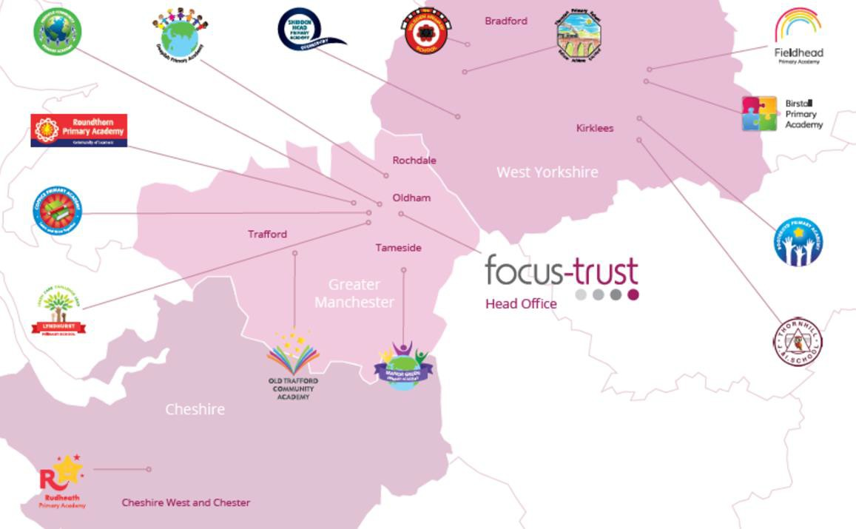
Focus-Trust was incorporated in May 2012 as a primary trust. The Trust has links with the sponsor, Focus Education, but is an entirely separate legal entity. As with all academy trusts, the Trust is a company limited by guarantee and an exempt charity. The Trust’s offices are situated in a newly converted historic mill conversion in Chadderton, Oldham with excellent motorway networks to access our schools.

The defining feature of Focus-Trust is that it is a specialist primary phase trust. This means that the work of the Trust is driven by the distinctive needs of primary schools. Whilst the Trust has robust systems for accountability, each school has their own distinctive identity, ethos and culture, and this is a commitment to every school when they convert and join the Trust.

Focus-Trust currently has a small centrally employed team. The members of the team are highly skilled and committed to the vision, culture and values of the Trust.

All the schools within the Trust are willing partners who have actively chosen to join Focus-Trust and there is a very high degree of consensus, cooperation and commitment from within the group.

The Trust has robust policies and systems in place to govern and guide its work. These have been gradually implemented as the Trust has grown. The Trust has well-established productive relationships with trade unions and meets half termly with a group of national trade union representatives to discuss policy development. This has enabled us to introduce and change a range of policies in a streamlined and cooperative way.

Equality of opportunity

Focus-Trust is an equal opportunity employer, dedicated to a policy of non-discrimination in employment on any basis including age, gender, race, colour, nationality, ethnic origin, disability, gender, religion, age, marital status, sexual orientation and/or medical condition.

Safeguarding

Focus-Trust is committed to safeguarding and promoting the welfare of all children and young people. There is an explicit expectation that all employees share this commitment and adhere to all safeguarding policies and procedures. Applicants should be aware that the recruitment process will include an assessment of your suitability to work with children.

Right to work in the UK

Under the Asylum and Immigration Act 1996, it is a criminal offence to employ anyone who is not entitled to live or work in the United Kingdom. Applicants can expect us to ask for proof of this at interview stage, where you will be asked to provide some original documentation to confirm that you are eligible to work within the UK. Photographic proof of identity will also be required.

Validation of qualifications and identity

All shortlisted candidates will be asked to bring original certificates or relevant qualifications and identity documents to interview. These will be photocopied and kept on file and, if appropriate, may be confirmed as genuine with the relevant awarding bodies. The copies of the successful candidate will be retained on their personnel file. The copies of unsuccessful candidates will be treated as confidential waste and disposed of appropriately.

References and Social Media Checks

If you are shortlisted, we will take up references before the interview date, unless you state otherwise on your application form. However, two satisfactory references must be received before we can confirm any offer of an appointment. One of your referees must be your current or most recent employer. The information we request will relate to salary, length of service, skills and abilities, suitability for the job, disciplinary record, and suitability to work with children. Copies of references or open references will not be accepted. On receipt of references, your referees may be contacted to verify any discrepancies, anomalies, or relevant issues as part of the recruitment verification process.

In line with our safer recruitment policy, on-line presence checks will be undertaken if you are shortlisted. This check is designed to complement the range of standard recruitment checks and allows us to identify a candidate’s online presence, which potentially could damage the organisation’s reputation.

Disability

To comply with the Equality Act 2010, we are legally required to consider making reasonable adjustments to ensure that disabled people are not disadvantaged in the recruitment and selection process. We are therefore committed to meeting, wherever possible, any needs you specify on the application form. Please contact the named person on the advert, if you need to discuss this in any detail. We will consider any reasonable adjustment under the terms of the Act to enable an applicant with a disability (as defined under the Act) to meet the requirements of the post.

Disclosure of a criminal record

Employment in this role is subject to an enhanced check with the Disclosure and Barring Service (DBS). Checks will also be made against the lists showing people barred from working with children. All checks must be satisfactory before any offer of employment can be confirmed and before commencement of work can take place.

Dress code

We expect all staff to dress professionally and appropriately for the roles undertaken. We pride ourselves on the high standards of dress of both our pupils and staff; these standards are led by our staff who we expect to set an example.

Knowledge and skills profile

This is an important part of your application and is your opportunity to explain how you meet the person specification for the post. You should demonstrate, using no more than 2000 characters, your skills, knowledge and experience and give short examples. Describe how you match the requirements of the role; include experience gained from previous jobs, community, or voluntary work. Ensure that the information you give is well organised, relevant, and brief. You may find it helpful to use sub-headings to keep your statement well focused. If you do not submit this profile, you will not be considered for short listing.

Policies

Focus-Trust and the schools have a range of policies and handbooks that help to make clear our expectations and ways of working. These are always shared openly with staff and are accessible to everyone. There are several policies that prospective employees should be aware of when making an application. These can be found on the Trust website www.focus-trust.co.uk and school websites. All members of staff will be asked to sign a declaration as part of the induction process to acknowledge that they have read and understand the Code of Conduct and some of the key policies, e.g. Safeguarding and Child Protection, Health and Safety, Acceptable use of IT.

Pensions

Focus-Trust contributes to Teachers’ Pensions and Local Government pensions in the same way and with the same level of contribution as local authorities.

Employer Relations

Focus-Trust has a Trade Union agreement which recognises the teacher and support staff unions. This is further supported by an ongoing and productive relationship with key trade union officials.
Thank you for taking the time to read this information pack. We wish you every
success in any application you may make.

Thornhill Junior & Infant School
Edge Lane
Thornhill
Dewsbury
WF12 0QT

E: thornhill@focus-trust.co.uk

