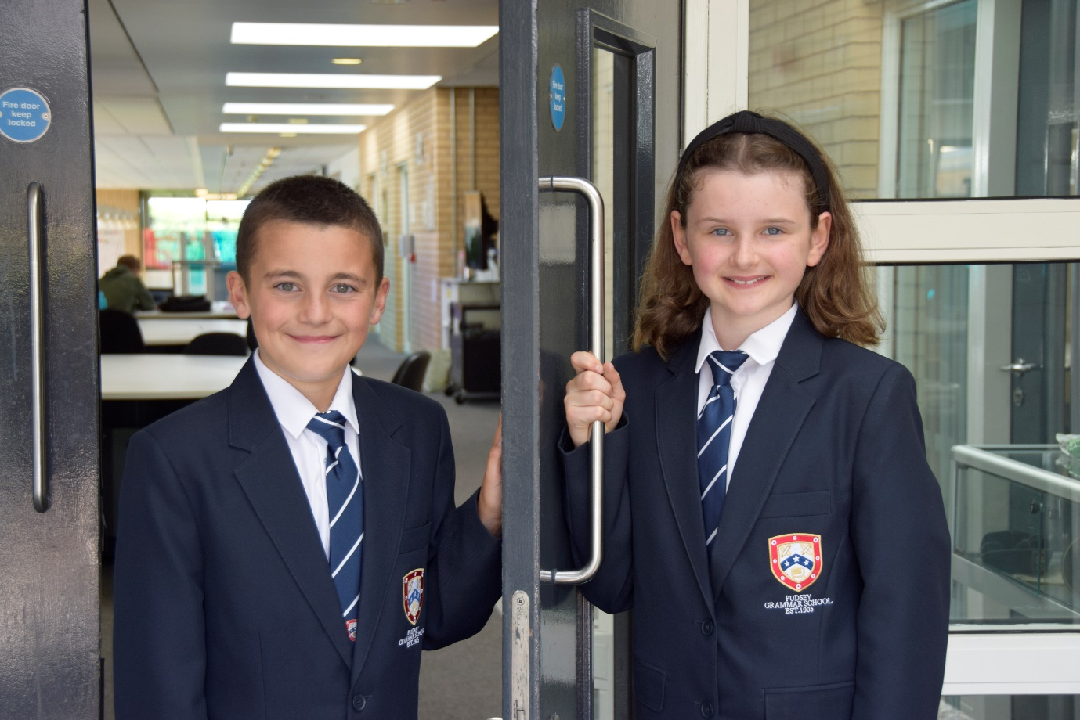

TEACHER OF
ENGLISH

APPLICATION PACK

Academic Support Tutor
(Medical Needs)

C1 pt, (12-17) £28,598 - £31,022 FTE
Actual salary £21,606 - £23,437
32.5 hours per week term time only
plus 5 days
Monday to Thursdays 8.00am - 3.15pm
Fridays 8.00am – 2.15pm

Start Date: As soon as possible

Contents

- Introduction from the Headteacher
- Information on the post
- Job description
- Person specification
- Enhanced disclosure
- School Location and Travel Information

Introduction from the Headteacher

Thank you for the interest you have shown in the post of Academic Support Tutor (Medical Needs) at our school. This is an excellent opportunity to join our dynamic SEND team.

Pudsey Grammar School is a heavily oversubscribed mixed comprehensive secondary school located in the heart of the market town of Pudsey. Situated between Leeds and Bradford, the town has always valued its independence from its two larger neighbours. The school has a long and proud history stretching back to 1905. The school has 1350 students with a thriving and expanding Sixth Form of over 250 students, all taught in a state of the art building. The innovative and unique style of the building creates a calm atmosphere very different to many secondary schools.

I was appointed in 2014 and since then we have received a letter from Amanda Spielman (HMCI Ofsted) which stated we ‘have transformed all aspects of the school.’ This assertion was further underlined in 2018 when the increase in our exam results resulted in the school being the most improved school in Leeds and one of the most improved in the country (we were delighted to follow these achievements up with our best ever GCSE exam results in 2019 which were above the national average). The pattern of improvement continued in 2020 with our Year 11 students achieving grades which were outstanding. The school had a highly successful Ofsted inspection in April 2019 and was judged as good in all areas, including our Sixth Form. The school underwent an ungraded inspection in April 2024 which saw, for the first time in the school’s history, a second successive Ofsted judgement of being a good school. This is testament to the consistently high quality of education which the school provides for all of our students and is one of the reasons why we remain one of the most popular schools across the city of Leeds with over 900 applications received for 215 Year 7 places for September 2024.

In 2022 the school was selected to be a national Behaviour Hub school. This was a Department for Education programme led by the Governments’ School Behaviour Advisor Tom Bennett which identifies school who have ‘an exemplary behaviour culture’. We were one of only 20 secondary schools out of 4000 who have achieved this prestigious accolade, and we worked with other schools across the north of England to improve their behaviour cultures.

We have a comprehensive House system which runs across all year groups with over 30 diverse competitions across the year for students and one each half term for staff too. House assemblies take place once every three weeks lead by our four House Leaders. At the end of each academic year, the winning House is awarded our 80-year-old Victor Ludorum Cup.

We are aiming to be a Centre of Excellence, and every indicator shows that we will achieve this goal. Continuing to recruit high calibre staff is a key priority of our strategy.

The following quotes are taken from the latest Ofsted report:

- The school is welcoming, and pupils respect the differences in other people.
- Safeguarding is very well led, and pupils feel safe
- Pupils get on very well with each other
- Teachers have strong subject knowledge
- Pupils behave well in lessons and the vast majority focus on their work
- The school has developed an ambitious curriculum for pupils
- Staff have high expectations of all pupils. The vast majority of pupils rise to these expectations and work hard
- Pupils benefit from the curriculum and are well prepared for their next steps
- The House system plays a central role in the school and provides a sense of belonging. Pupils who earn House ties for their dedication to House competitions wear them with pride
- If bullying happens, pupils are confident that staff will deal with it quickly.
The school has a long tradition in the town, being established as Pudsey Grammar School in 1905. Although the school is taught in a state of the art building, our core values of respect, resilience, integrity, compassion and ambition are highly traditional and are based on the goal of ensuring that every student reaches their true potential.

Our school is not just about the students gaining knowledge and qualifications, although these are extremely important. We believe in teaching young people core values of decency, social skills and how to be a good citizen in an ever changing world. We want their character to develop and grow, and for them to leave us with an inquiring and independent mind. We want our students to gain the best qualifications they are capable of whilst experiencing a range of opportunities which are second to none. As a result, the school is extremely popular with our community and is significantly over-subscribed every year.

Our Sixth Form, which is rated as good by Ofsted, has grown rapidly in recent years following significant investment and we now have over 250 Post-16 students studying at Pudsey Grammar. We have a strong tradition of ensuring students access the best universities, including Oxford and Cambridge.

Our staff show exceptional dedication and commitment to our students. Relationships in the school are extremely strong and this underpins the ethos of the school. We pride ourselves in the care and support that we give our staff and, as a result, there is a real team spirit in the school where people enjoy being part of our school community. Teaching and learning is the key focus of the organisation and everything that we do is designed to ensure that the classroom experience for
the students is excellent. We are currently redesigning our curriculum to ensure that the education we offer is second to none.

We offer fantastic support and professional development to staff, which ensures that they are equipped with all the necessary skills to deliver excellent lessons to the students on a daily basis.

The school is a Foundation Trust school and our partners include global companies such as ASDA and HSBC bank, alongside leading local business and training provider, Appris. These high quality links allow our school to offer excellent careers
opportunities to students across the ability range. As a result, the school has 0% NEETs at Year 11.

We are currently part of The Leeds Teaching HUB, which is providing outstanding opportunities and CPD for all our staff. Subject Leaders attend their Collaborative Learning Groups, which allows them to network and share best practice. This is further disseminated through the school via regular Department meetings and weekly Teaching & Learning briefings.

This clearly is an exciting time to join our school.

If you have a desire to be part of one of the most exciting and rewarding schools to work in, which will also provide you with excellent development opportunities, please complete the application form. Any further details can be obtained directly from the school's HR Team: recruitment@pudseygrammar.co.uk) or our website www.pudseygrammar.co.uk

Mark McKelvie
Headteacher
Pudsey Grammar School

Pudsey Grammar School
Pudsey Grammar School is a thriving secondary school and sixth form educating students aged 11-18. Established in 1905, our school boasts a long and proud history combined with a modern, state-of-the-art building designed to inspire learning and achievement. We are heavily oversubscribed with 1,350 students in the main school and 250 in the sixth form.
Rated Good by Ofsted in 2024, we were proudly selected as a National Behaviour Hub School in 2022. As part of the Leeds Teaching Hubs, we offer outstanding opportunities for continuing professional development (CPD), enabling our staff to grow and thrive in their careers. At Pudsey Grammar, we are committed to fostering a supportive and dynamic environment where both students and staff succeed.
Details of advert

Job Title: Academic Support Tutor (Medical Needs)
Hours and working pattern: 32.5 hpw, plus 5 days
Monday to Thursday 8.00am – 3.15pm, Friday 8.00am – 2.15pm
Grade: C1, 12 - 17
Salary: £28,598 - £ 31,022 FTE (£21,606 - £23,437 Actual)
Start date: As soon as possible

We are looking to appoint an exceptional individual to join our SEND team.
To support students with an array of challenging learning needs and behaviours as well as complex medical needs, to remove their barriers to learning through a flexible and adaptable approach, with a willingness to undergo training to develop key skills and knowledge to advance the support that school can offer SEND students.

Who are we looking for, someone with:
- Passion to support students learning
- Calm, patient, and empathetic approach
- Support students with medical, physical, or complex needs
- Support independence, confidence and wellbeing
- Support the learner to access learning activities and resources

Applicants will need to demonstrate:
- Excellent attention to detail, effective analytical skills and strong inter-personal and communication skills are essential, together with the ability to work as part of a successful team.
- Applicants should have appropriate qualifications and/or relevant experience in working with young people.
- A commitment to:
  - Working in line with statutory safeguarding guidance (e.g. Keeping Children Safe in Education, prevent and our safeguarding and child protection policies)
  - Working with the designated safeguarding lead (DSL) to promote the best interests of students, including sharing concerns where necessary
  - Promoting the safeguarding of all students in the school
Why work at Pudsey Grammar School?

- Be part of a rapidly improving school
- Work for an organisation which has staff wellbeing as its core
- Embrace the opportunity to play a key part in the continuing transformation of the school
- Be part of a dynamic and enthusiastic team of staff who are ensuring our students are successful in every way
- Work alongside hub-schools in the Yorkshire and Humber region and University College London, with access to high quality Teaching and Learning training, networking events, CPD
- Belong to a supportive organisation which prides itself on high standards for staff and students
- Work in an award-winning state of art building

This school is committed to safeguarding and promoting the welfare of children and expects all staff and volunteers to share this commitment. Appointments will be subject to an enhanced DBS disclosure. If shortlisted, you will be required to disclose relevant information regarding criminal history and an on-line search will be conducted. This includes only information publicly available on-line.

We promote diversity and want a workforce that reflects the population of Leeds.

Employment is conditional on confirmation of the right to work in the UK – either as a UK or Irish citizen, under the EU Settlement scheme or having secured any other relevant work visa. If you do not have the right to work in the UK and the role does not meet eligibility for sponsorship, please consider carefully whether you meet the eligibility to apply for this position.

Application Process
Should you wish to apply for this position, please see below:
- Please be aware that we do not accept Curriculum Vitaes.
- In support of your application, you may include a cover letter. This should be in addition to the completed application form.
- Application form and full job description can be found on the school website: www.pudseygrammar.co.uk vacancies – My New Term link

Closing date for applications: Monday 2nd March 2026 at 8.00am
Successful candidates will be contacted direct with details of the interview.
Interview date: TBC

Job Description
Post Title: | Academic Support Tutor – Medical Needs
Post Purpose: | To provide focused support to accelerate the learning of our most vulnerable under-achieving or SEND students, meeting their specific needs and ensuring the highest levels of engagement. This will involve supporting students with a range of learning needs which could be physical, medical or special education needs.  To support students with an array of challenging learning needs and behaviours as well as complex medical needs, to remove their barriers to learning through a flexible and adaptable approach, with a willingness to undergo training to develop key skills and knowledge to advance the support that school can offer SEND students.  To support a range of students with SEND needs, specifically involving working with any students who have complex medical needs.
Reporting to: | Assistant Headteacher – Inclusion and SEND  (Deputy Director of SEND in the absence of the AHT)
Working time: | 32.5hpw, term time plus 5 days. Monday – Thursday 8.00am – 3.15pm and Fridays 8.00am – 2.15pm
Salary/Grade: | C1, pt. 12 – 17 £28,598 - £31,022  Actual salary - £21,606 - £23,437
Main (Core) Duties:
- Assist, advise and provide support for individual students, as appropriate.
- To support the SENCO in identifying the special need requirements of assigned students.

Working to guidance outlined in EHCPs/Provision Maps/relevant policies and other documentation and under direction of the SENCo and/or Deputy Director of SEND:

- Provide regular one-to-one/small group support for students to monitor progress and outcomes
- Attend to students’ personal needs, and implement related personal programmes, including social, health, physical, hygiene, medical, first aid and welfare matters
- Provide support to students who may have complex medical needs and who may need emergency medical support
- Provide support to students with speech difficulties under the guidance of a Speech Therapist to support individual specific needs.
- Support students who because of their physical needs may need moving and handling care and/or in transported in wheelchairs.
- Administer medication and support children with medical interventions
- Supervise and support students ensuring their safety and access to learning
- Provide physical intervene where students are at risk of harming themselves. Some students may bite, kick, nip and punch etc. themselves, staff and or other pupils.
- Willingness to undergo Team Teach/relevant training as required to ensure all students and specific needs can be met safely.
- Support with selecting, adapting and devising materials for use with assigned students.
- Maintain records of ongoing support and support needs, ensuring Individual Provision Maps are updated and records are complete.
- Collate evidence of impact of the support provided to individual students.
- Support with referrals to/from external professionals and agencies.
- Assist students to use equipment/resources effectively.
- Assist and support the SENCO in student/parent meetings and provide regular feedback, ensuring effective communication by email, phone call and face to face.
- Provide administrative support to the SEND team as required.
- Support and assist assigned students with integration/re-engagement into the school community and environment, including supporting students based off-site and in the Inclusion Room
- Deliver 1-1 and group support to students with emotional difficulties, anger management, self-esteem, and friendship/relationship difficulties or when they are dysregulated and assist them in developing strategies which will improve their behaviour and help them overcome barriers to learning.
- Record data and support with setting targets as part of Individual Education Planning development for pupils with SEND.
- Support in the SEND area as part of the schools on call system.
- Assist with the running of the SEND Homework Club
- Maintain a SEND in-class support folder that contains the annotated seating plans for the classes in which you support, provision maps, the most recent class data and, as a minimum, schemes of work for the classes you are supporting.
- Administer routine tests, invigilate exams and assist with and provide access arrangements.
- Monitor and record pupil’s responses to learning activities, providing feedback to stakeholders seeking guidance and support as required.
- To undertake any other duties that are compatible with the post.
Manage Own Performance and Development | - Present a positive and professional personal image, contributing to a welcoming environment  - Undertake research and obtain information to inform decisions  - Be aware of, comply with and assist with the development of systems and procedures e.g. health, safety and security, confidentiality and data protection, reporting all concerns to the appropriate person  - Be aware of and support difference and ensure equal opportunities for all  - Contribute to the overall ethos/work/aims of the school  - Participate in training and other learning activities and performance development as required to enable continuous growth and development  Attend all appropriate meetings as required by the Line Manager
Relationships | - The post-holder will be required to work flexibly to deliver an efficient Service  - There will be regular contact with students, colleagues, other members of staff, line managers and internal and external customers
Safeguarding | - To work in line with statutory safeguarding guidance (e.g. Keeping Children Safe in Education, prevent and our safeguarding and child protection policies)  - To work with the designated safeguarding lead (DSL) to promote the best interests of students, including sharing concerns where necessary  - To promote the safeguarding of all students in the school.
Physical Conditions | - The post is based at Pudsey Grammar School  - The school is accessible by stairs, ramps and lifts  - This post is subject to an enhanced Disclose and Barring Service check  - The school operates a non-smoking policy
Prospects | Whilst there is no automatic progression to any more senior posts, opportunities do exist for advancement and promotion, dependent upon normal staff movements and on the capabilities of the individual post holder.
Any Special Conditions of Service: No smoking policy

This job description is to assist staff joining Pudsey Grammar School to understand and appreciate the work content of their post and the role they are to play in the organisation.

Whilst every endeavour has been made to outline the main duties and responsibilities of the post, a document such as this does not permit every item to be specified in detail. This job description is not a definitive list of responsibilities but identifies the key components of the role. The post holder will, therefore, be required to undertake other reasonable duties commensurate with the purpose and salary level of this post.

Employees should not refuse to undertake work, which is not specified on this form, but they should record any additional duties they are required to perform, and these will be taken into account when the post is reviewed.

All new appointments of support staff are made subject to the satisfactory completion of a six-month probationary period.

Statement:
All appointments are subject to satisfactory references.

Pudsey Grammar School is an equal opportunities employer and requires its employees to comply with all current equality policies both in terms of equal opportunity for employment and access to the school’s services.

We promote diversity and want a workforce which reflects the population of Leeds.
Dated: 5th February 2026

Person Specification

SKILLS | Ess | Des
Very good numeracy/literacy skills | *
Passion for the role and improving learner life chances | *
Ability to relate well to children and adults, building positive relationships | *
Confidence in working with students with Special Educational Needs and Disabilities | *
Ability to work constructively as part of a team | *
Flexible and able to use own initiative | *
Negotiating skills | *
Good written and spoken communication skills | *
Ability to work flexibly and manage changing priorities, showing independence and being proactive | *
Good organisational skills | *
Ability to use IT systems competently to aid analysis (e.g. Arbor, Classcharts) | *

KNOWLEDGE/QUALIFICATIONS | Ess | Des
At least Level 3 NVQ equivalent or higher | *
Evidence of relevant training and/or qualifications or equivalent through experience | *
Willingness to undertake further training relevant to the post | *
Experience of contributing to and implementing Individual Learning Plans for learners. |  | *
Specific training undertaken to support students – lifting/handling, personal care, team teach etc |  | *
Good understanding of different types of SEND |  | *
Understand EHCP’s and the statutory requirements schools must meet to remove barriers to learning |  | *
Experience working with children of relevant age | *
Training in relevant strategies e.g. literacy and/or in  particular curriculum or learning area e.g. bi-lingual,  sign language, dyslexia, ICT, maths, English etc. |  | *

EXPERIENCE | Ess | Des
Experience working with children or young people in an educational setting |  | *
Experience providing targeted support based on individual needs |  | *
Experience providing 121 or group interventions |  | *
Experience of supporting students with different types of SEND |  | *
Experience of supporting students in exams and assessments with their individual access arrangements |  | *

BEHAVIOURAL AND OTHER RELATED CHARACTERISTICS | Ess | Des
Willing to abide by the Council’s Equal Opportunities Policy in the duties of the post, and as an employee of the Council. | *
Willing to carry out all duties having regard to an employee’s responsibility under the Council’s Health and Safety Policies | *
To display a responsible and co-operative attitude to working towards the achievement of the school’s aims and objectives | *
An ability to respect sensitive and confidential work. | *
A supportive and empathetic approach to students and the ability to relate well to staff | *
Commitment to own personal development and learning. | *
Able to work collaboratively with the wider Student Support Team | *
A willingness to become involved in the wider aspects of the school | *

Thank you for your interest in this post at Pudsey Grammar School. The post you are applying for involves working with young people. It is therefore exempt from the Rehabilitation of Offenders Act, and any offer of employment will be subject to an Enhanced Disclosure.
As this post is exempt from the Rehabilitation of Offenders Act, you must declare any convictions, including pending convictions, cautions, reprimands and warnings which would otherwise be regarded as “spent” under this Act. Further details will be sought prior to appointment.

An Enhanced Disclosure is carried out by the Criminal Records Bureau and will check criminal records for information on any convictions, cautions, reprimands and warnings held on the Police National Computer and on local Police records.

All information on criminal records provided both by you and within the Enhanced Disclosure will be used, stored and disposed of in confidence and in line with the Criminal Records Bureau Code of Practice of Disclosure Information.

If your application is successful, you will receive further information on how to complete the Enhanced Disclosure.

We are committed to safeguarding and promoting the welfare of our pupils and expect all staff and volunteers to share this commitment.

School Location and Travel Information

Pudsey Grammar School
Mount Pleasant Road
Pudsey
Leeds
LS28 7ND

Tel: 0113 2558277

www.pudseygrammar.co.uk
Instagram/Twitter/Facebook - @PudseyGS

